

Kabul University
Faculty of Computer Science
Software Engineering Department

FINAL YEAR PROJECT REPORT

Nokta Academy Management System

A Project Submitted in Partial Fulfillment
of the Requirements for the Degree of
Bachelor of Science in Software Engineering

By

Mohammad Maiwand Osmani
Mohammad Khalid Sahil

Supervisor: Associate Professor Abdul Wahid Samadzai

July 2026



APPROVAL PAGE
This project report titled “Nokta Academy Management System” is hereby approved as a satisfactory report in partial fulfillment of the requirements for the Bachelor of Science in Software Engineering.
Role | Name | Signature | Date
Project Supervisor | ________________________________ | _______________ | ____________
Department Head | ________________________________ | _______________ | ____________
External Examiner | ________________________________ | _______________ | ____________
The undersigned certify that they have read this project report and that, in their opinion, it is satisfactory in scope and quality as a final-year project report for the degree of Bachelor of Science in Software Engineering.
Place of approval: Department of Software Engineering, Kabul University
Academic year: ____________________

DECLARATION OF ORIGINALITY
We Mohammad Maiwand Osmani, Mohammad Khalid declare that this final-year project report titled “Nokta Academy Management System” is my original work, completed under the academic requirements of the Bachelor of Science in Software Engineering at Kabul University.
I confirm that all sources, references, and quoted materials used in this report have been duly acknowledged and cited in accordance with the American Psychological Association (APA) 7th edition referencing standard adopted for this monograph. Where the ideas, data, figures, or wording of other authors have been used, appropriate in-text citations and a complete reference list have been provided.
I further declare that this work has not been submitted previously, in whole or in part, for any other degree, diploma, or academic award at Kabul University or at any other institution. Any contribution of software tools, libraries, or institutional data used in the development of the Nokta Academy Management System has been used solely for academic purposes and is described honestly in the report.
I understand that failure to maintain academic integrity, including plagiarism or unacknowledged use of another person’s work, may result in academic penalties in accordance with the regulations of Kabul University.
Mohammad Maiwand Osmani : __________ Signature: ______Date: ____ / ____ / ______ _

Mohammad Khalid Sahil : __________ Signature: ______Date: ____ / ____ / ______ _

Abstract
Private academies that still rely on paper files, spreadsheets, and informal messaging often face fragmented student records, delayed reporting, weak parent communication, and limited financial transparency. This monograph presents the design and implementation of the Nokta Academy Management System (NAMS), an integrated web and mobile-oriented platform developed to centralize academic, administrative, and financial operations for Nokta Academy and similar private learning centers. The study used an applied mixed-methods approach: a structured questionnaire completed by 20 academies informed feature priorities, while workflow and role analysis guided functional and non-functional requirements. Development followed Agile Scrum within a documented software life-cycle, delivered in three reviewed prototypes. Prototype 1 provided the core baseline for authentication, student and teacher management, classes and subjects, manual attendance, examinations and results, fee collection, and baseline payroll, without AI exam generation, online meeting attendance automation, or full government tax packaging. Prototype 2 added AI-assisted question generation, online class meeting links, and automatic parental attendance visibility after 18 of the 20 academies requested these features; two newly opened academies offered no specific opinion. Prototype 3 introduced quarterly and annual government tax reporting at Nokta Academy’s request. System design used layered architecture with Node.js/Express, MongoDB, and React, supported by use-case, sequence, and entity-relationship models and verified through unit, integration, and user-acceptance testing. Results indicate strong adoption intent and clear demand for integrated fee, attendance, examination, parent-communication, and tax-reporting capabilities. The project concludes that an iteratively delivered, academy-specific management system can reduce manual workload, improve information quality, and support compliance-oriented financial reporting within the stated scope and sample limitations.
Keywords: Nokta Academy Management System, student enrollment and fee management, teacher payroll and academy tax reporting, parent attendance visibility, multilingual academy portal

Table of content
CHAPTER1: INTRODUCTION 1
1.1 Background 1
1.2 Problem Statement 2
1.4 Scope and Limitations 4
1.4.1 Scope (Inclusions) 4
1.4.2 Limitations (Exclusions) 4
1.6 Organization of the Report 6
CHAPTER 2: LITERATURE REVIEW 7
CHAPTER 3: METHODOLOGY 18
3.1 Research Methodology 18
3.1.1 Requirements Elicitation 18
3.1.2 Population and Sampling 19
3.1.3 Data Collection 19
3.1.4 Data Analysis and Presentation 20
3.1.5 Functional Requirements 20
3.1.6 Non-Functional Requirements 21
3.1.7 Data Requirements 22
3.2 Development Methodology 23
3.2.1 Agile Development Approach 23
3.2.2 Scrum-Based Project Organization 23
3.2.3 Development Iterations 24
3.2.4 Prototype Development and User Review 24
3.2.4.1 Prototype 1 Core Integrated Baseline 24
3.2.4.2 Prototype 2 Survey-Driven Academic and Parent Enhancements 27
3.2.4.3 Prototype 3 Government Tax Reporting (Quarterly and Annual) 30
3.3 System Design 32
3.3.1 Use Case Model 32
3.3.2 Sequence Diagrams 33
3.3.3 Architectural Design 35
3.3.4 Database Design 37
3.4 Implementation 38
3.4.1 Development Environment 38
3.4.2 Implementation Phases 39
3.4.3 Key Modules Implemented 39
3.4.4 Challenges and Solutions 39
3.5 Testing 40
3.5.1 Unit Testing 40
3.5.2 Integration Testing 41
3.5.3 User Acceptance Testing 41
CHAPTER 4: RESULTS 42
4.1 Questionnaire Results 42
4.1.1 Respondent Profile 42
4.1.2 Current Preparation and Access 43
4.1.3 Feature Interest and Priorities 44
4.1.4 Perceived Impact 46
4.1.5 Summary of Findings 48
CHAPTER 5: DISCUSSION 50
5.1 Main Findings 50
5.2 Relation to Objectives and Research Questions 50
5.3 Relation to Literature and Existing Systems 51
5.4 Practical Implications of NAMS 51
5.5 Limitations of the Findings and System 51
CHAPTER 6: CONCLUSION AND FUTURE WORK 53
6.1 Summary of Work Done 53
6.2 Key Contributions 53
6.3 Achievement of Objectives 53
6.4 Future Enhancements 54
REFERENCES 55
APPENDIX A: QUESTIONNAIRES 58
A.1 Requirements Elicitation Questionnaire 58
D.1 Administrator 59
D.2 Teacher 59
D.3 Student 59
D.4 Parent 59
D.5 Owner / Super Admin 59

LIST OF FIGURES
Figure 3. 1Agile Scrum cycle applied to NAMS prototype stages 23
Figure 3. 2 Prototype 1 admin dashboard for core academy operations 25
Figure 3. 3 Prototype 1 student, class, teacher, and timetable management screens 26
Figure 3. 4 Prototype 1 manual attendance and basic examination workflow 26
Figure 3. 5 Prototype 1 fee collection and baseline payroll view 27
Figure 3. 6 Prototype 2 AI-assisted examination question generation 28
Figure 3. 7 Prototype 2 online class link and automatic parental attendance visibility 29
Figure 3. 8 Prototype 2 feature package justified by the 20-academy questionnaire 29
Figure 3. 9Prototype 3 government tax dashboard requested by Nokta Academy 30
Figure 3. 10 Prototype 3 quarterly tax report filters and totals 31
Figure 3. 11 Prototype 3 annual tax package and export workspace 31
Figure 3. 12 Prototype 3 payroll–tax integration overview 32
Figure 3. 13 Use case diagram for the Nokta Academy Management System 33
Figure 3. 14Sequence diagram for student enrollment and fee payment 34
Figure 3. 15 Sequence diagram for attendance and examination processing 34
Figure 3. 16 Sequence diagram for payroll, tax, and financial reporting 35

LIST OF TABLES
Table 2. 1 Conceptual Framework of the Nokta Academy Management System (NAMS) 10
Table 2. 2 Comparison of Educational Systems 12
Table 2. 3 Implementation Status and Development Stages of NAMS 14

Table 3. 1 Population, Sample, and Response Profile for NAMS Requirements Validation 19
Table 3. 2 Selected Functional Requirements for NAMS 20
Table 3. 3 Selected Non-Functional Requirements for NAMS 21
Table 3. 4 Technology Stack and Rationale for NAMS 36

LIST OF ABBREVIATIONS
The following abbreviations are used in this monograph. They are listed in alphabetical order.
AFN | — Afghan Afghani (currency unit used in fee and payroll modules)
AI | — Artificial Intelligence
API | — Application Programming Interface
APA | — American Psychological Association
BRT | — Business Receipt Tax (academy-level tax treatment used in NAMS reports)
CRUD | Create, Read, Update, Delete
DBMS | Database Management System
ERD | Entity–Relationship Diagram
FK | Foreign Key (application-level ObjectId reference in MongoDB schemas)
FR | Functional Requirement
IEEE | Institute of Electrical and Electronics Engineers
JWT | JSON Web Token
LMS | Learning Management System
MIS | Management Information System
NAMS | Nokta Academy Management System
NFR | Non-Functional Requirement
PDF | Portable Document Format
PK | Primary Key
PWA | Progressive Web Application
RBAC | Role-Based Access Control
REST | Representational State Transfer
RTL | Right-to-Left (script direction for Dari and Pashto interfaces)
SDLC | Software Development Life Cycle
SPA | Single-Page Application
UAT | User Acceptance Testing
UI | User Interface
UQ | Unique (unique index / unique business key)
UX | User Experience

CHAPTER1: INTRODUCTION

1.1 Background
Educational institutions worldwide are increasingly adopting information and communication technologies (ICT) to manage academic and administrative work. Private academies, in particular, depend on timely access to student records, attendance data, and financial information to coordinate daily operations. Where processes remain paper-based or spread across separate files, staff spend disproportionate time on data entry and reconciliation rather than on teaching support, (Aldowah et al., 2019).
In contexts where digital infrastructure is still developing, the gap between institutional needs and available tools is often wider. Schools and academies may use spreadsheets, messaging applications, or partial software solutions that do not share a common database. Learning analytics research shows that when educational data are collected systematically, institutions can monitor student progress more accurately and respond to academic difficulties at an earlier stage ,(Siemens, 2013)
Manual and fragmented systems also weaken internal communication. Announcements, schedule changes, and performance feedback reach students and teachers through informal channels, which increases the likelihood of missed or inconsistent information. Studies on technology-mediated education confirm that integrated platforms improve coordination among learners, instructors, and administrators ,(V. Forrester, 2019a)
Recent advances in web and mobile development have made it feasible to build unified academic systems at lower cost. Server-side frameworks such as Node.js support concurrent requests from multiple users, while React and Flutter allow responsive web and cross-platform mobile interfaces,(Tilkov et al., 2010).
Document-oriented databases such as MongoDB accommodate evolving record structures without frequent schema migrations, which suits institutions whose requirements change over time ,(Chodorow, 2013)
Educational data mining and performance analytics have further extended what management systems can offer beyond basic record keeping. By examining attendance trends, assessment results, and engagement indicators, institutions can identify students who may need additional support and adjust instructional strategies accordingly,(Romero et al., 2020)
Nokta Academy currently lacks such a unified environment. The proposed Nokta Academy Management System (NAMS) is intended to combine administrative automation, secure data management, and analytics within a single web-mobile platform tailored to the academy's operational context.

1.2 Problem Statement
Nokta Academy currently manages its academic and administrative activities through manual procedures and disconnected digital tools. Key processes such as student registration, attendance tracking, grade management, fee collection, and report preparation are maintained across separate records and spreadsheets. This fragmented approach leads to data inconsistencies, duplication of records, delays in information retrieval, and increased risk of human errors. Furthermore, the lack of a centralized academic management system limits effective monitoring of student performance and reduces the efficiency of institutional decision-making. Studies indicate that poor information management and data quality challenges can significantly affect educational administration and service delivery,(V. Forrester, 2019a)
Because academic and administrative records are maintained across separate files and systems, staff often face difficulties accessing accurate and up-to-date information when timely decisions are required. The fragmented management of student, financial, and academic records can result in delays in information retrieval, reduced visibility of institutional performance, and challenges in monitoring academic activities effectively. Research indicates that educational institutions require reliable, timely, and integrated data to support planning, monitoring, and informed decision-making. The absence of such systems can negatively affect administrative efficiency and the quality of educational service delivery,(V. Forrester, 2019b)
Communication within Nokta Academy is primarily conducted through informal channels, including verbal announcements and personal messaging applications. Important information such as class schedules, fee notifications, examination updates, and institutional announcements may not consistently reach all intended recipients in a timely manner. This creates coordination challenges among students, instructors, and administrative staff, increasing the likelihood of misunderstandings, missed deadlines, and communication gaps. Research indicates that effective communication systems are essential for improving coordination, information sharing, and institutional efficiency within educational environments , (Ullah et al., 2021)
Nokta Academy lacks a structured reporting and educational analytics mechanism for monitoring student performance and academic progress. Current evaluations are primarily descriptive and provide limited capability to identify performance trends, learning difficulties, or students at academic risk before problems become critical. The absence of systematic data analysis restricts evidence-based decision-making and reduces the effectiveness of academic interventions. Studies in educational data analytics have demonstrated that timely analysis of educational data can support early intervention, improve student outcomes, and enhance institutional decision-making processes,(Romero et al., 2020b)
1.3 Objectives
This study aims to investigate the academic and administrative challenges faced by Nokta Academy and to design an integrated Academic Management System that enhances information management, communication, academic monitoring, operational efficiency, and evidence-based decision-making through a centralized digital platform.

1.3.1 Main Objective
To identify the academic and administrative challenges at Nokta Academy and propose an integrated Academic Management System that improves information management, communication, reporting, and student performance monitoring.
1.3.2 Specific Objectives
- To identify and tackle challenges caused by fragmented academic and administrative records through a centralized information management system.
- To improve access to accurate, timely, and integrated information for effective academic administration and institutional decision-making.
- To enhance communication, coordination, and information sharing among students, instructors, parents, and administrative staff through a unified communication platform.
- To support academic monitoring, student performance evaluation, early identification of academically at-risk students, and evidence-based decision-making through reporting and educational analytics capabilities.
- To improve the efficiency and effectiveness of academic and administrative operations by automating key processes such as attendance management, examination management, result processing, and fee management.
1.4 Research Questions
This section presents the main research question and supporting sub-questions that guide the study in investigating the academic and administrative challenges at Nokta Academy and evaluating the role of an integrated Academic Management System in addressing these challenges.
Main Research Question
How can an integrated Academic Management System tackle the academic and administrative challenges at Nokta Academy and improve information management, communication, academic monitoring, operational efficiency, and evidence-based decision-making?
Sub-Questions
- SQ1: What challenges are caused by fragmented academic and administrative records at Nokta Academy, and how can a centralized information management system tackle these challenges?
- SQ2: To what extent can access to accurate, timely, and integrated information improve academic administration and institutional decision-making at Nokta Academy?
- SQ3: How can a unified communication platform enhance communication, coordination, and information sharing among students, instructors, parents, and administrative staff?
- SQ4: How can reporting and educational analytics capabilities support academic monitoring, student performance evaluation, early identification of academically at-risk students, and evidence-based decision-making?
- SQ5: How can the automation of attendance management, examination management, result processing, and fee management improve the efficiency and effectiveness of academic and administrative operations at Nokta Academy?

1.4 Scope and Limitations
The scope of this project defines what NAMS will include during design, implementation, and evaluation. It follows directly from the objectives and research questions stated in Sections 1.3 and 1.3.3 and reflects the operational needs of Nokta Academy.

1.4.1 Scope (Inclusions)
Features: The system will include user authentication and role-based access; student registration and profile management; attendance recording and reporting; grade entry and transcript generation; class and timetable scheduling; fee and payment tracking; institutional announcements and notifications; administrative dashboards; and performance analytics based on collected academic data.
Platforms: NAMS will be delivered as a web application for administrators and academic staff (React), a cross-platform mobile application for students and teachers (Flutter for Android and iOS), and a RESTful backend API (Node.js with Express.js) connected to a Mongo Data Base (DB) database.
Users: Primary users are academy administrators, teachers, and enrolled students. Each role will access functions appropriate to its responsibilities, such as record management for administrators, grade and attendance entry for teachers, and schedule and result viewing for students.
Data: The system will manage structured records for an estimated 500 to 1,000 active users, including student biodata, attendance logs, assessment results, financial transactions, timetables, and communication history. Data will be stored centrally to support reporting and analytics within the academy.

1.4.2 Limitations (Exclusions)
Geographic: The study and deployment scope are limited to Nokta Academy. The system is not designed for multi-campus operation, national education networks, or integration with external government examination or certification authorities.
Technical: The project will not implement a full learning management system with video conferencing, online examination proctoring, or offline-first synchronization. Analytics will rely on rule-based and statistical methods rather than advanced machine learning models. Third-party payment gateway integration and biometric authentication are excluded from the initial prototype.
Resource: Development is constrained by the duration of a final-year bachelor project, limited team size, and restricted budget for infrastructure and external services. User acceptance testing will be conducted with a sample of academy staff and students rather than a large-scale longitudinal study.
1.5 Significance of the Project
The significance of this project can be understood from multiple perspectives, including academic, practical, social, and personal dimensions. Each of these aspects highlights the value and contribution of the proposed(NAMS) in addressing existing challenges within the institution.
Academic significance
The project applies software engineering principles to a real institutional problem and demonstrates how requirements analysis, architectural design, implementation, and evaluation can be conducted within a defined academic context. It also contributes practical evidence on integrating learning analytics into a small-scale academic management system, a topic that remains under-documented for private academies in developing countries , (Harvey et al., 2016)
Practical significance
For Nokta Academy, the proposed NAMS provides a practical solution to reduce manual paperwork, minimize data redundancy, and shorten the time required for generating academic and administrative reports. The system enables administrators to monitor enrolment, attendance, and fee status through a centralized interface, while teachers are provided with a structured platform for recording grades and communicating with students in an efficient and organized manner.
Social significance
Reliable and centralized access to academic information enhances transparency and communication between the institution and its stakeholders, including students, instructors, and administrative staff. In contexts where learners often depend on informal communication channels for academic updates, the proposed system ensures that essential information such as schedules, results, and announcements is distributed consistently and fairly. Improved data management also strengthens institutional accountability toward students, parents, and other stakeholders.
Personal significance
This project allows the author to consolidate and apply knowledge gained throughout the Software Engineering program me, particularly in areas such as full-stack web development, database design, mobile application development, and system documentation. Working with a real educational institution provides valuable practical experience in requirements elicitation, stakeholder communication, and iterative system development, extending beyond theoretical classroom learning.

1.6 Organization of the Report
Chapter 2 reviews the relevant literature on academic management systems, learning analytics, and related technologies. It defines key concepts, compares existing systems, examines recent trends, and identifies the research gaps that the (NAMS) aims to address.
Chapter 3 presents the requirements analysis of the project. It describes how requirements were collected from academy stakeholders, specifies functional and non-functional requirements, introduces the use case model, and defines the data requirements for the system.
Chapter 4 documents the system design. It explains the selected design methodology and presents the system architecture, database schema, user interface design considerations, security mechanisms, and the testing strategy prepared for implementation.
Chapter 5 covers implementation and testing. It outlines the development environment, describes the main implementation phases, presents selected code modules, and reports the results of unit, integration, and user acceptance testing, along with the challenges encountered during development.
Chapter 6 discusses the project results. It presents the system outputs through screenshots, evaluates performance against the defined non-functional requirements, compares NAMS with related systems, and interprets the findings in relation to the project objectives.
Chapter 7 concludes the report. It summarizes the work completed, highlights the main contributions, evaluates the extent to which each objective was achieved, and suggests directions for future improvements of the system.

CHAPTER 2: LITERATURE REVIEW
This chapter presents a review of the conceptual, technological, and operational foundations relevant to the (NAMS). It examines key areas including academic management systems, digital learning environments, secure information systems, multilingual interfaces, role-based access control, and reporting mechanisms within modern educational platforms. The chapter also discusses recent advancements in educational technologies and identifies the research gaps that inform the development and design of the proposed system.
Academy management systems are digital information systems designed to support academic administration and institutional operations within educational academies and private learning centers. These systems typically manage core functions such as student enrollment, attendance tracking, examinations, scheduling, financial records, communication, and academic reporting through centralized data environments. Research in educational information systems indicates that the use of digital platforms reduces manual workload, minimizes data duplication, and improves the accuracy and availability of institutional information,(Aldowah et al., 2019)
Modern academy management systems are increasingly designed as integrated platforms that combine academic and administrative functions within a single environment. Instead of separating learning-related activities from administrative processes, these systems provide unified access to communication tools, scheduling systems, reporting dashboards, and academic records. This integration supports improved coordination between students, teachers, and administrators and enhances institutional decision-making through real-time data access (da Costa et al., 2020a)
Web-based dashboards represent a fundamental component of contemporary academy management systems. These dashboards provide centralized interfaces for administrators and academic staff to manage student records, attendance, grading, financial operations, and institutional reporting. Studies show that web-based administrative systems improve operational efficiency and enable better data-driven decision-making by providing structured and real-time access to academic information, (Ifenthaler & Yau, 2020),
Mobile applications have also become an essential part of modern academy management environments. Students, teachers, and parents increasingly rely on mobile platforms to access schedules, notifications, attendance records, and academic results. Research highlights that mobile accessibility improves user engagement and enhances communication between stakeholders in educational environments. However, usability issues, performance limitations, and lack of offline functionality may negatively affect system adoption and user satisfaction , (International Journal of Emerging Technologies in Learning, 2006)
Role-Based Access Control (RBAC) is widely implemented in academy management systems to ensure secure and structured access to sensitive data. In educational environments, different user roles such as administrators, teachers, students, and parents require different levels of system permissions. RBAC improves system security by restricting unauthorized access to academic, financial, and personal data. This approach is essential in protecting sensitive institutional records such as examination results, attendance data, and financial transactions,
In addition to RBAC, secure authentication mechanisms are critical in protecting academy management systems. These mechanisms include password encryption, token-based authentication, session management, and audit logging. Research shows that weak authentication systems increase vulnerability to unauthorized access and data breaches, which can reduce user trust and compromise institutional integrity,(Basheer et al., 2026)
Modern academy management systems are typically built using modular and scalable system architectures that support integration between web applications, mobile applications, and centralized databases. This architectural approach enables flexibility, easier maintenance, and future system expansion. Modular design is particularly important in educational environments where system requirements evolve over time to include additional functionalities such as analytics, communication tools, and financial modules (Tilkov et al., 2010).
Database systems form the backbone of academy management platforms by storing and organizing large volumes of academic and administrative data. These systems manage student records, attendance logs, financial transactions, examination results, and communication data in a structured manner. Research indicates that well-designed database architectures improve system performance, data consistency, and long-term scalability in educational environments (Chodorow, 2013).
Multilingual support is an important feature in academy management systems, particularly in regions with diverse language preferences. These systems must accommodate users who speak different languages such as local and international languages to ensure accessibility and effective communication. Studies show that multilingual interfaces enhance usability and improve user engagement by reducing language barriers in digital educational platforms, (Adukaite et al., 2017)
Offline functionality is also an important consideration in academy management systems, especially in areas with unstable internet connectivity. Offline support enables users to access essential academic data such as schedules, attendance, and notifications even without internet access. However, offline systems must include synchronization mechanisms to ensure data consistency and prevent conflicts when reconnecting to the server, (Kovtaniuk et al., 2025)
Therefore, modern academy management systems require integrated solutions that support academic administration, secure access control, multilingual communication, mobile accessibility, and reliable data management. These requirements align with the design objectives of the Nokta Academy Management System (NAMS), which aims to provide a centralized, secure, and scalable platform for academic and administrative operations.
The development and adoption of academy management systems can be explained through established technology acceptance and information systems success theories. These frameworks provide a theoretical basis for understanding how users adopt and interact with digital academic platforms, particularly in educational environments where multiple user groups with different needs are involved.
One of the most widely used models in technology adoption research is the Unified Theory of Acceptance and Use of Technology 2 (UTAUT2). This model explains user adoption behavior through factors such as performance expectancy, effort expectancy, social influence, facilitating conditions, hedonic motivation, price value, and habit, (Venkatesh et al., 2012)
In the context of academy management systems, these factors determine whether students, teachers, parents, and administrative staff accept and continuously use digital platforms. Systems that improve usability, accessibility, communication efficiency, and operational convenience are more likely to achieve higher adoption rates. The design of the Nokta Academy Management System (NAMS), particularly its mobile accessibility and multilingual support, aligns with key principles of UTAUT2 by enhancing perceived usefulness and ease of use for different user groups.
Another important theoretical foundation is the DeLone and McLean Information Systems Success Model. This model evaluates system success based on six key dimensions: system quality, information quality, service quality, use, user satisfaction, and net organizational benefits, (Petter et al., 2013).
In academy environments, these dimensions are critical for assessing whether a management system effectively supports academic operations. For instance, reliable reporting mechanisms, accurate academic records, secure access control, and user-friendly interfaces contribute directly to user satisfaction and institutional efficiency.
In addition, digital transformation theory provides a broader conceptual perspective for understanding the evolution of academy management systems. Digital transformation emphasizes the integration of digital technologies into organizational processes to improve efficiency, service delivery, and decision-making,(Kraus et al., 2022)
In educational institutions, this transformation shifts traditional manual and fragmented administrative processes toward integrated, data-driven, and user-centered digital platforms. The NAMS framework reflects this transformation by replacing disconnected academic and administrative processes with a unified system.
Furthermore, research on digital learning adoption highlights the importance of usability-related factors such as perceived usefulness, ease of use, compatibility, mobility, and system quality in influencing user acceptance of educational technologies ,(Al-Emran et al., 2018).
These factors are particularly relevant to NAMS because the system is designed to support continuous access for students, teachers, and parents through both web and mobile platforms.
Collectively, these theoretical perspectives provide a strong foundation for the design and evaluation of NAMS by emphasizing user acceptance, system quality, and digital transformation in educational environments.
Note. This figure illustrates the relationship between institutional challenges, identified research gaps, and the proposed system architecture of NAMS.
The conceptual framework shown in Figure 2.1 connects the problem domain identified in Chapter 1 with the system design proposed in this study. On the left side, key institutional challenges such as fragmented records, inefficient communication, delayed reporting, and limited academic analytics are presented. The middle section represents the research gaps identified in the literature, including the lack of integrated web-mobile platforms, insufficient multilingual support, and weak offline accessibility in existing systems. The right side illustrates the proposed NAMS architecture, which includes a React-based web dashboard, Flutter mobile application, Node.js/Express backend, MongoDB database, role-based access control mechanisms, and reporting and analytics modules. This structured relationship demonstrates how theoretical foundations and literature findings directly inform the system design.
Table 2.1 summarizes the core technological components that form the foundation of the Nokta Academy Management System (NAMS). These components represent the key technical domains required to support academic operations, secure data management, communication, and system scalability. Each component is mapped to its functional role within the system as well as its academic significance in the context of modern academy management systems.
Table 2. 1 Conceptual Framework of the Nokta Academy Management System (NAMS)
Area | Purpose | Relevance to NAMS | Academic Significance
Backend Services | Handle business logic and system operations | Supports academic and administrative workflows | Enables scalability and modular system design
Database Systems | Store and manage institutional data | Supports student, attendance, finance, and academic records | Ensures data consistency and reliable reporting
Security Mechanisms | Protect sensitive academic information | Enables secure access and data protection | Supports privacy and trust in digital systems
Web Dashboards | Provide administrative interface | Supports monitoring and reporting functions | Enhances decision-making and transparency
Mobile Applications | Provide user access via mobile devices | Supports students, teachers, and parents | Improves accessibility and engagement
Multilingual Support | Support multiple languages | Enables usability in multilingual environments | Enhances inclusivity and accessibility
Offline Support | Enable access without internet | Supports unstable connectivity environments | Ensures system reliability and continuity
Note. This table outlines the key technological domains required for implementing a scalable and integrated academy management system.
Table 2.1, the core technological components of NAMS are directly aligned with both functional requirements and academic objectives of modern academy management systems. Backend services and database systems form the structural foundation of the platform by enabling secure data processing and storage. Security mechanisms ensure protection of sensitive academic and financial information, while web dashboards and mobile applications provide role-based access for different user groups. In addition, multilingual support and offline functionality address contextual challenges such as language diversity and unstable internet connectivity, which are particularly relevant in private academy environments. Together, these components define a comprehensive architecture that supports operational efficiency, usability, and long-term system sustainability.
A number of digital learning platforms and academy management systems have been developed to support educational institutions in managing instructional and administrative activities. These systems differ in their focus, functionality, and level of integration. While some platforms emphasize learning delivery, others focus on administrative operations or communication features. However, existing literature indicates that many of these systems do not fully address the integrated operational requirements of private academies, particularly in terms of centralized management, multilingual support, and unified reporting mechanisms (Costa et al., 2020).
Moodle is one of the most widely used open-source learning management systems in educational environments. It provides strong support for instructional activities such as course delivery, assignment submission, quizzes, grading, and communication between instructors and learners. Although Moodle offers flexibility and extensibility, its primary focus remains centered on teaching and learning processes rather than full academy-wide management. As a result, institutions often require additional plugins or external systems to support administrative functions such as financial management, branch coordination, and comprehensive reporting (da Costa et al., 2020b), This limitation highlights the need for more integrated academy-oriented solutions.
Similarly, Google Classroom is widely adopted due to its simplicity and ease of use in managing assignments and classroom communication. However, research indicates that it provides limited support for broader administrative functions such as financial tracking, institutional reporting, and advanced academic monitoring (Al-Rahmi et al., 2021).
Consequently, educational institutions often rely on supplementary systems, which may lead to fragmented workflows and reduced operational efficiency.
Educational ERP systems are designed to integrate academic and administrative processes within a unified platform. These systems typically support student information management, attendance tracking, examinations, fee management, and institutional reporting. Despite their comprehensive functionality, ERP systems are often associated with high implementation costs, rigid architectures, and limited adaptability for smaller private academies (Saha, 2019).
In addition, some ERP solutions lack sufficient support for mobile accessibility and multilingual environments, which are critical requirements in diverse educational settings.
Enterprise learning platforms such as Blackboard and Canvas provide advanced tools for content delivery, assessment, and collaboration. These systems are widely used in universities and large institutions due to their scalability and feature richness. However, their complexity and institutional-level design often make them less suitable for private academies that require simpler workflows, localized management, and integrated administrative functionalities (Al-Maroof et al., 2021).
In addition, parent communication portals have gained importance in modern educational environments by improving transparency and enabling parents to monitor student performance and attendance. However, many of these portals operate as standalone systems and lack integration with core academic and administrative functions such as finance, scheduling, and reporting. This limitation reduces their effectiveness as comprehensive academy management solutions (Rahman et al., 2019).
Overall, the reviewed literature suggests that while existing platforms provide strong capabilities in specific domains, they often lack full integration across academic, administrative, and communication functions. This fragmentation highlights the need for unified systems capable of supporting comprehensive academy operations. Table 2.2 summarizes and compares the key characteristics of these systems in relation to their strengths, limitations, and relevance to the (NAMS).
Table 2.2 (APA Standard + Improved Logic)
Table 2.2 presents a comparative analysis of widely used educational platforms and systems based on their primary focus, strengths, limitations, and relevance to academy management requirements. The purpose of this comparison is to identify functional gaps in existing solutions and to justify the need for an integrated academy management system such as NAMS.
Table 2. 2 Comparison of Educational Systems
System | Main Focus | Strengths | Limitations | Relevance to NAMS
Moodle | Learning management | Flexible course delivery and open-source flexibility | Limited support for academy-wide administration | Indicates need for integrated academy systems
Google Classroom | Classroom communication | Simple and user-friendly interface | Limited administrative and financial management | Highlights risk of fragmented systems
Blackboard | Enterprise learning | Advanced academic and collaboration tools | Complex and costly for small institutions | Less suitable for private academies
Canvas LMS | Online learning platform | Modern interface and usability | Limited operational and administrative integration | Requires localization for academy use
Educational ERP Systems | Institutional administration | Strong administrative integration | High cost and limited flexibility | Needs adaptation for small academies
Parent Portals | Parent monitoring | Improves transparency and communication | Not integrated with core academic systems | Requires integration with full management system
NAMS | Integrated academy management system | Combines administration, communication, reporting, and mobile access | Some advanced analytics features are future enhancements | Proposed solution addressing identified gaps
Note. This table compares existing educational systems and highlights their limitations in relation to integrated academy management requirements.
As illustrated in Table 2.2, existing educational systems vary significantly in their scope and functionality. Learning management systems such as Moodle, Blackboard, and Canvas primarily focus on instructional delivery, while tools like Google Classroom emphasize communication and classroom organization. In contrast, ERP systems provide stronger administrative capabilities but often lack flexibility and accessibility for smaller educational institutions. Parent portals enhance communication but remain disconnected from core academic and operational systems.
The analysis demonstrates that none of the reviewed systems fully integrate academic, administrative, communication, and reporting functions within a single unified platform. This fragmentation creates operational inefficiencies and increases dependency on multiple disconnected systems. The Nokta Academy Management System (NAMS) is therefore positioned as an integrated solution designed to address these limitations by combining academic management, administrative control, communication tools, and reporting mechanisms within a unified and scalable architecture.
Recent developments in digital academy management systems demonstrate a clear transition from traditional manual administrative procedures toward fully integrated and connected digital platforms. Academic institutions and private learning centers are increasingly adopting centralized systems that support administrative management, communication, reporting, and institutional coordination within unified environments. This transformation is part of a broader digital shift in educational management, where information systems are used to enhance operational efficiency, improve data accessibility, and support evidence-based decision-making processes (Aldowah et al., 2019).
Another major trend is the increasing adoption of web mobile architectural models. In modern academy environments, administrative functions are typically handled through web-based dashboards, while students, teachers, and parents access academic services through mobile or cross-platform applications. This dual-layer architecture improves usability and accessibility by allowing different user groups to interact with the system based on their specific needs. However, successful implementation requires careful attention to system integration, real-time data synchronization, and consistent user experience across platforms (Al-Emran et al., 2018).
Scalability and maintainability are also critical concerns in contemporary academy systems. As institutions expand, they require systems capable of handling increasing volumes of academic data, multiple user roles, and evolving functional requirements. The literature strongly supports modular and service-oriented system architectures, as these approaches allow incremental development, reduce system complexity, and support long-term maintainability without requiring complete system redesign (Rahman & Saha, 2019).
In addition, cross-platform accessibility has become a standard expectation in modern educational systems. Users increasingly demand consistent access to academic services across desktops, tablets, and mobile devices. Research indicates that system reliability, interface consistency, and accessibility significantly influence user adoption and long-term engagement with digital platforms (Venkatesh et al., 2012).
Multilingual support is another important trend, particularly in regions with diverse linguistic populations. Providing system interfaces in multiple languages enhances usability, reduces communication barriers, and improves accessibility for students, parents, and staff. In private academies, multilingual functionality also strengthens communication effectiveness and increases parental involvement in academic processes (Al-Maroof et al., 2021).
Security remains a foundational requirement in digital academy systems due to the sensitive nature of academic, financial, and personal data. Current research emphasizes the importance of implementing authentication mechanisms, role-based access control, encryption techniques, and audit logging systems to ensure data protection and system integrity. Security is therefore not an optional feature but a core architectural requirement in educational system design (Basheer et al., 2021).
Furthermore, reporting and learning analytics have become essential components of modern academy platforms. These systems increasingly incorporate dashboards and analytical tools to monitor attendance, academic performance, and institutional operations. When properly implemented, such tools enable data-driven decision-making and enhance institutional transparency and efficiency (Ifenthaler et al., 2020).
Offline functionality is also gaining importance, especially in environments with unstable internet connectivity. Offline-capable systems ensure continuous access to academic services and improve system reliability during network interruptions. However, they introduce technical challenges such as data synchronization, conflict resolution, and secure local data storage management (Traxler, 2018; Al-Emran et al., 2018).
From a system development perspective, academic literature emphasizes the importance of distinguishing between fully implemented features and those planned for future development. This distinction improves transparency and allows for a more accurate evaluation of system maturity. In the context of NAMS, core operational features are implemented, while advanced analytics and full production deployment remain under development (Peffers et al., 2012).
Overall, current technological trends indicate that modern academy management systems are evolving toward secure, scalable, multilingual, and mobile-accessible platforms. These developments highlight the need for integrated systems that go beyond basic instructional functions to also support administrative operations, communication, reporting, and institutional decision-making.
Table 2. 3 Implementation Status and Development Stages of NAMS
Status | System Component | Academic Interpretation
Implemented | Academic and operational management modules | Supports core administrative and academic functions within the academy
Implemented | Security and access control mechanisms | Ensures secure authentication, authorization, and data protection
Implemented | Multilingual support | Enhances system accessibility for users with different language preferences
Implemented | Mobile access and interaction features | Enables continuous access to academic services through mobile devices
Partially Implemented | Communication and messaging features | Provides basic interaction capabilities; requires deeper system integration
Partially Implemented | Advanced analytics and reporting | Supports initial analytical functions; requires expansion for decision-support capabilities
Future Development | Production deployment infrastructure | Planned for scalability, optimization, and real-world institutional deployment
Note. This table categorizes system components based on their current development status to ensure a transparent and accurate representation of system maturity.
As presented in Table 2.3, the Nokta Academy Management System (NAMS) is currently composed of multiple functional layers with different levels of implementation maturity. Core components, including academic and operational management, security mechanisms, multilingual support, and mobile access features, are fully implemented and form the operational foundation of the system. These modules directly support daily academic and administrative activities within the academy environment.
In contrast, communication and messaging features, along with advanced analytics and reporting capabilities, are partially implemented. This indicates that while foundational functionality exists, further development is required to achieve full system integration and enhanced decision-support capabilities. These components represent important future enhancements that will improve interaction, data utilization, and institutional intelligence.
Finally, production deployment infrastructure remains in the future development phase. This reflects the intention to scale and optimize the system for real-world institutional deployment beyond the current prototype stage. Overall, this structured classification provides a realistic and transparent representation of system maturity and ensures alignment with software engineering research standards.
The existing literature on academy management systems indicates that many private academies and educational institutions continue to experience significant operational and technological limitations. These challenges are primarily related to fragmented information systems, insufficient integration between academic and administrative processes, delayed reporting mechanisms, limited visibility for parents, and weak coordination between academic and financial operations. In many cases, reliance on manual processes or disconnected digital tools reduces efficiency and negatively affects institutional decision-making and communication effectiveness (Aldowah et al., 2019).
A major research gap identified in the literature is the lack of fully integrated systems specifically designed for private academies. Most existing platforms are either focused on learning management or administrative operations, but few provide a comprehensive solution that combines academic management, communication, reporting, financial tracking, multilingual support, and user interaction within a single unified system. This limitation is particularly critical for academies that require centralized control of attendance, fee management, student performance tracking, and parent engagement functionalities (Costa et al., 2020).
Another important gap relates to the limited availability of academy-oriented platforms that support multilingual access, offline functionality, and role-based management in a cohesive architecture. Existing systems often address these features individually rather than integrating them into a single framework. As a result, private academies operating in multilingual and connectivity-constrained environments face usability and accessibility challenges that reduce system effectiveness and user satisfaction (Al-Emran et al., 2018).
The literature also highlights a gap in integrated web–mobile ERP-style architectures for academy environments. While some systems provide administrative dashboards and others offer mobile learning applications, few platforms successfully integrate secure academic management, financial operations, communication tools, and mobile accessibility in a consistent and synchronized environment. This separation often leads to system fragmentation and reduces operational efficiency (Rahman et al., 2019).
Furthermore, there is a noticeable gap between institutional-level systems and user-centered design approaches. Many existing academy platforms are designed primarily for administrative use and provide limited interactive functionality for students, teachers, and parents. This creates a usability gap, as modern users increasingly expect real-time access to academic information and services through mobile devices and intuitive interfaces (Al-Emran et al., 2018).
Language accessibility remains another under-addressed issue in many academy systems. A significant number of existing platforms are developed primarily for English-speaking environments and do not adequately support multilingual user bases. This limitation can hinder communication and reduce accessibility for stakeholders in diverse linguistic contexts. Research suggests that multilingual support significantly improves usability, engagement, and communication efficiency in educational systems (Al-Maroof et al., 2021).
In addition, unstable internet connectivity continues to be a practical challenge in many private academies, particularly in developing regions. Interruptions in network availability can negatively impact attendance tracking, communication, and access to academic resources. Although some systems provide online functionality, limited offline support remains a key gap in ensuring continuous system usability under unstable network conditions (Al-Emran et al., 2018).
Another important gap identified in system development research is the lack of clear distinction between implemented features and future enhancements in many academic system studies. Without this distinction, it becomes difficult to accurately evaluate system maturity and practical applicability. Therefore, transparent classification of system components is essential for improving research reliability and clarity (Peffers et al., 2012).
Overall, the literature suggests a strong need for integrated academy management systems that combine administrative efficiency, secure role-based access, multilingual interfaces, mobile accessibility, reporting and analytics, and operational stability under limited connectivity. These requirements highlight the necessity of unified digital platforms that move beyond isolated learning or administrative tools. In response to these identified gaps, the Nokta Academy Management System (NAMS) has been designed as an integrated solution that supports academic management, communication, multilingual interaction, secure access control, and structured reporting within a single cohesive platform.

CHAPTER 3: METHODOLOGY
This chapter explains the research and development methods used to design and implement the Nokta Academy Management System (NAMS). Following the structural organization used in Exit.pdf, it presents requirements elicitation, population and sampling, data collection and analysis, functional and non-functional requirements, Agile/Scrum development, three prototype stages, system design artifacts, implementation, and testing. The chapter connects stakeholder needs identified for private academies in Afghanistan with the engineering decisions that shaped NAMS (Creswell, 2018).

3.1 Research Methodology
This study used an applied mixed-methods research design. Quantitative questionnaire data measured feature demand and adoption likelihood across academies, while qualitative workflow analysis and role analysis explained how registration, attendance, examinations, fees, payroll, and tax reporting are performed in daily operations (Creswell, 2018). Mixed methods were appropriate because NAMS is not only a technical product; it is an institutional information system whose success depends on both measurable demand and contextual work practices (DeLone et al, 2003).
Before the questionnaire was finalized, a preliminary feature set was derived from the literature reviewed in Chapter 2 and from inspection of related platforms (Moodle, Google Classroom, Canvas, and school ERP tools). Literature on learning analytics and educational data mining emphasized structured attendance, assessment, and communication data (Aldowah et al., 2019).These sources produced an initial backlog that was then validated with academy stakeholders.

3.1.1 Requirements Elicitation
Requirements elicitation translated the problem statement in Chapter 1 into concrete system capabilities. The elicitation process combined (a) document and proposal review, (b) observation of academy workflows, (c) role-permission analysis for administrators, teachers, students, parents, owners, and branch managers, and (d) a structured questionnaire for multi-academy validation (International Organization for Standardization et al., 2018).
The preliminary feature list included student enrollment, class and subject management, timetable management, manual attendance, examinations and results, fee collection, payroll estimation, messaging, dashboards, multilingual interfaces, and role-based access. Later backlog items AI question generation, online class meeting links, automated parental attendance visibility, and government tax reporting were treated as candidate enhancements pending survey and sponsor confirmation.
Elicitation therefore produced two layers of requirements: a core operational layer required for daily academy management, and an enhancement layer validated by academy survey results and by Nokta Academy’s own compliance request. This separation later became the three-prototype plan described in Section 3.2.4.

3.1.2 Population and Sampling
The target population consisted of private academies and short-course centers that manage students, teachers, fees, and academic records in Afghanistan’s urban education market. Because a complete sampling frame of all academies was unavailable, purposive sampling was used to recruit academies already operating or recently established and willing to evaluate an integrated management platform (Creswell, 2018).
Table 3.1 summarizes the sampling frame used for requirements validation. Twenty academies completed the questionnaire. Eighteen academies explicitly requested the advanced academic–parent features later packaged as Prototype 2, while two newly established academies did not offer a specific preference because their processes were still forming.
The sample is small but information-rich for a final-year software engineering project. It is sufficient to prioritize features and to justify iterative delivery, but it is not intended as a nationally representative statistical inference (Brooke, et al 1996).
Table 3. 1 Population, Sample, and Response Profile for NAMS Requirements Validation
Item | Description | Count / Value
Target population | Private academies / course centers with academic–financial operations | Urban academy segment
Invited academies | Academies contacted for questionnaire participation | 20
Completed questionnaires | Fully completed institutional questionnaires | 20
Academies requesting Prototype-2 features | AI exam support, online meeting link, auto parent attendance | 18
Newly started academies (no specific opinion) | Recently opened; limited operational history | 2
Primary respondents | Admin, owner, teacher, branch manager, accountant | 20 individuals

As shown in Table 3.1, the survey design treats each academy as an institutional case. This matches NAMS’s deployment model, in which configuration and reporting are academy-scoped rather than student-only. The 18-versus-2 split became a direct decision rule for moving AI examination support, online class links, and automated parental attendance into Prototype.

3.1.3 Data Collection
Data collection used a structured questionnaire (Appendix A) administered to academy managers and key staff. Items covered current tools, pain points, feature usefulness (Likert-type ratings), priority ranking, and likelihood of adoption (Likert, 1932). Complementary qualitative notes were collected during walkthroughs of fee, attendance, and payroll procedures at Nokta Academy.
Questionnaire sections were mapped to design decisions: enrollment and fees mapped to finance modules; attendance and parent communication mapped to attendance policies and notifications; examination items mapped to exam and AI services; compliance items mapped to tax reporting. This traceability follows requirements engineering guidance that requirements remain testable and linked to source evidence (International Organization for Standardization et al., 2018).
All responses were anonymized at academy level for reporting. No student personally identifiable grades were collected in the survey itself; evaluation used system test data and controlled user-acceptance scenarios instead.

3.1.4 Data Analysis and Presentation
Questionnaire responses were analyzed with descriptive statistics: frequencies, percentages, and mean priority scores. Results are presented in Chapter 4 using APA-style tables and figures. Qualitative workflow notes were coded into requirement themes (registration, attendance, exams, finance, tax, communication) and cross-checked against implemented modules (Miles et al., 2014).
Where quantitative and qualitative evidence converged for example, strong demand for fee transparency and parental attendance visibility the feature was raised in the Product Backlog. Where evidence diverged for example, newly opened academies without stable processes the feature was deferred or kept optional through configuration flags.

3.1.5 Functional Requirements
Functional requirements were written as verifiable statements so that each item could be traced to a module, API route, or automated test. Table 3.2 presents the core set used to drive the Product Backlog and Definition of Done for each sprint (Schwaber et al,. 2020).
High-priority items formed Prototype 1. FR-08 and FR-09 were explicitly deferred until survey confirmation. FR-10 was scheduled after Nokta Academy requested government tax compliance features.
Table 3. 2 Selected Functional Requirements for NAMS
ID | Requirement | Priority | Source | Verification
FR-01 | Register and manage students with class, subject, teacher, and fee linkage | High | Workflow + survey | CRUD/API tests
FR-02 | Manage teachers, salary type (fixed/percentage/hybrid), and assignments | High | Payroll workflow | Payroll tests
FR-03 | Record attendance by session and report daily/period summaries | High | Survey | Functional tests
FR-04 | Create exams, record results, and publish to students/parents | High | Proposal | Exam/result tests
FR-05 | Collect fees, track balances, and link payments to payroll bases | High | Finance workflow | Payment tests
FR-06 | Enforce JWT authentication and role-based permissions | High | Security need | Auth/RBAC tests
FR-07 | Provide multilingual UI (English, Dari, Pashto) with RTL support | Medium | Context | Localization tests
FR-08 | Generate AI exam questions (Prototype 2) | Medium | 18/20 academies | AI endpoint tests
FR-09 | Support online class meeting links and online attendance automation (Prototype 2) | Medium | 18/20 academies | Job/policy tests
FR-10 | Produce quarterly/annual government tax reports (Prototype 3) | High | Nokta Academy request | Tax service tests

Table 3.2 also shows verification methods. This linkage is essential in software engineering projects because unimplemented narrative requirements cannot demonstrate objective achievement (Pressman et al, 2020).

3.1.6 Non-Functional Requirements
Non-functional requirements define quality attributes that determine whether NAMS is usable in real academies. Security and reliability are especially important because the system stores student records, fees, salaries, and tax figures (International Organization for Standardization & International Electrotechnical Commission, 2011).
Usability and localizability address adoption barriers identified in Chapter 2, including multilingual communities and mixed digital literacy among staff and parents (Venkatesh et al., 2003).
Table 3. 3 Selected Non-Functional Requirements for NAMS
ID | Category | Requirement | Verification
NFR-01 | Performance | Common CRUD and dashboard queries respond under normal LAN load | Manual/API timing
NFR-02 | Security | JWT sessions, password hashing, RBAC, CSRF protections on sensitive routes | Security tests
NFR-03 | Usability | Role-focused menus; readable light/dark UI; multilingual labels | UAT/SUS-style feedback
NFR-04 | Maintainability | Modular Express routes/services and feature-based React structure | Code review
NFR-05 | Reliability | Financial and tax calculations are deterministic and auditable | Unit tests
NFR-06 | Compatibility | Modern desktop browsers; Flutter/PWA mobile access paths | Device checks
NFR-07 | Localizability | EN/FA/PS resources and Jalali/Hijri-aware finance filters | Locale tests

Table 3.3 was used during sprint reviews as a quality checklist. A feature was not marked Done when it worked only for one role or one language; it had to satisfy the relevant NFR evidence.

3.1.7 Data Requirements
NAMS requires structured records for users, roles, branches, students, teachers, parents/families, classes, subjects, courses, enrollments, timetables, attendance and attendance policies, exams, questions, results, payments, expenses, salary records, tax settings, messages, notifications, and audit logs. Sensitivity is high because records combine personal, academic, and financial data.
Data requirements also anticipate analytics. Consistent attendance, assessment, and fee histories are prerequisites for future learning-analytics and AI support services (Aldowah et al., 2019). Prototype 1 therefore prioritized clean relational references even when advanced AI features were not yet enabled.
MongoDB was selected as the persistence engine, with ObjectId references used to preserve relationships needed for payroll, tax, and reporting joins (Chodorow et al.,2013).

3.2 Development Methodology
NAMS was developed using an Agile Scrum approach embedded in a lightweight software development life cycle (SDLC) envelope. Agile practices managed changing academy priorities; SDLC stages (analysis, design, implementation, testing, deployment readiness) preserved academic documentation discipline (Pressman et al., 2020).

3.2.1 Agile Development Approach
Agile was selected because academy stakeholders could not freeze every requirement at the start. Fee rules, parental expectations, online-class habits, and tax reporting obligations clarified only after early demos. Agile’s iterative delivery reduced the risk of building a polished but misaligned system (Dikert et al., 2016).
The Agile practices actually used were: Product Backlog prioritization, time-boxed sprints, increment demos (Sprint Review), a working Definition of Done, and backlog refinement after questionnaire feedback. Formal daily Scrum ceremonies were simplified for a small student team, but the inspect-and-adapt loop remained central (Schwaber et al., 2020).
Figure 3.0 summarizes how Agile cycles map onto NAMS delivery. The Product Backlog held core operations first, then survey-driven enhancements, then sponsor-requested tax compliance. Each cycle ended with review evidence rather than only code completion.
This figure is placed before the prototype subsections so that readers can see why Prototype 1 intentionally omitted some popular features. Omission was a prioritization decision, not an oversight, and it matches Agile value delivery under constrained academic timelines.
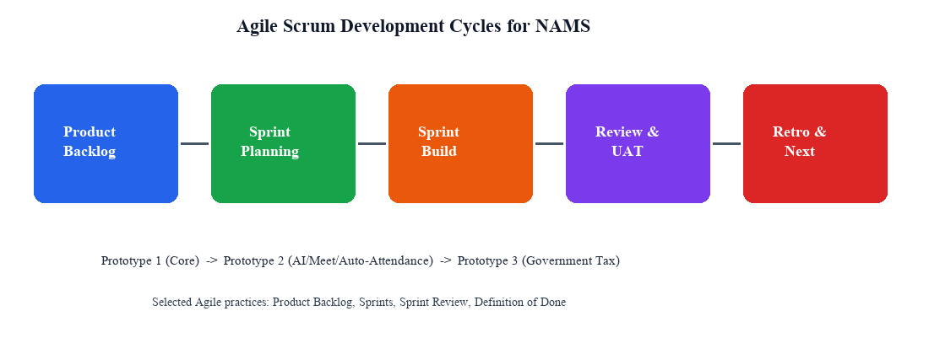
Figure 3. 1Agile Scrum cycle applied to NAMS prototype stages
After Figure 3.0, the narrative proceeds from process to product: Scrum organization, iteration planning, and the three reviewed prototypes that operationalize the backlog.

3.2.2 Scrum-Based Project Organization
Roles were adapted to the academic project setting. The Product Owner role was shared between the student team and Nokta Academy management for priority decisions. Developers implemented backend, web, and mobile slices. Testing combined automated unit checks with stakeholder UAT during sprint reviews (Schwaber et ai., 2020).
Work items were sliced vertically where possible (for example, student registration through API, UI, and permission checks in one increment) to avoid long integration delays. Financial algorithms received extra unit-test attention because calculation defects harm trust quickly (DeLone et al., 2003).
Documentation artifacts for the monograph use cases, sequence diagrams, architecture, ERD, and test tables were updated at the end of major increments so that the report remained synchronized with the running system.

3.2.3 Development Iterations
Iterations followed a staged capability model: (1) authentication, users, and academic masters; (2) attendance, exams, and results; (3) payments and payroll baseline; (4) communication and dashboards; (5) Prototype-2 enhancements; (6) Prototype-3 tax compliance. Each iteration produced a demonstrable increment for review.
This ordering matches dependency logic: payroll needs payments and teacher assignments; tax reports need stable finance records; parental attendance automation needs attendance policies and notification channels. Agile iteration did not remove dependencies; it exposed them earlier (Sommerville, 2016).
Regression checks after later iterations protected earlier increments. For example, adding AI question generation could not break manual exam scoring paths used by teachers who prefer paper assessments.

3.2.4 Prototype Development and User Review
Prototype development was organized in three reviewed stages. Prototype 1 delivered the integrated operational baseline. Prototype 2 added features demanded by 18 of 20 surveyed academies. Prototype 3 added quarterly and annual government tax reporting requested by Nokta Academy. Each stage was reviewed with stakeholders before the next backlog package was locked.

3.2.4.1 Prototype 1 Core Integrated Baseline
Prototype 1 implemented the minimum integrated platform required to replace fragmented spreadsheet and paper workflows: authentication and RBAC, student and teacher management, classes/subjects/timetable, manual attendance, manual examinations and results, fee collection, baseline payroll estimation, messaging/announcements, and role-based dashboards.
Explicitly excluded from Prototype 1 were: (a) AI-assisted examination question generation, (b) Google Meet / online class meeting-link workflows as a first-class attendance channel, and (c) automatic attendance marking for parental monitoring. These exclusions kept the first increment focused on data integrity and core CRUD reliability before automation complexity was introduced (Pressman et al., 2020).
Figure 3.1 shows the Prototype 1 administrative dashboard used during the first review. The screen emphasizes enrollment, manual attendance, fee status, and operational reports rather than AI or online-class automation.
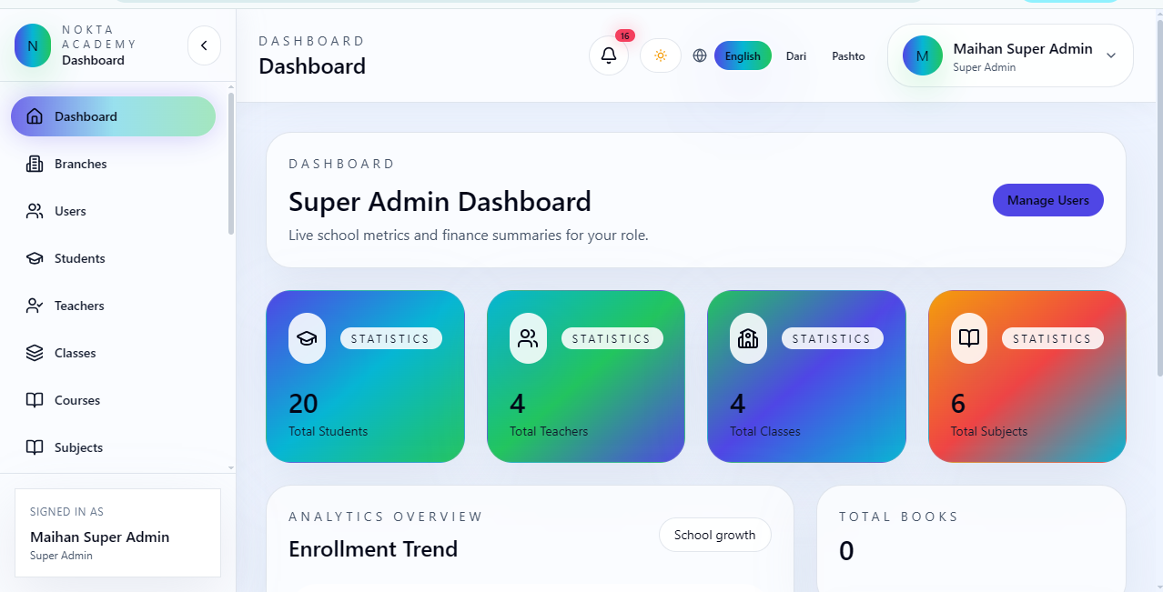
Reviewers used this dashboard to verify that key KPIs were reachable in one navigation hop, which supports perceived ease of use in technology acceptance models (Davis, 1989).
Figure 3. 2 Prototype 1 admin dashboard for core academy operations
The dashboard in Figure 3.1 confirmed that Prototype 1 already reduced tool-switching among admin staff. Remaining complaints concerned examination authoring speed and parent visibility exactly the gaps later addressed in Prototype 2.
Figure 3.2 presents the academic master-data screens of Prototype 1. Student records are linked to class, subject, teacher, and fee fields so that later payment and payroll calculations have stable references.
Without these linkages, financial modules would depend on manual re-entry and would recreate the fragmentation problem identified in Chapter 1 (Connolly et al., 2015).
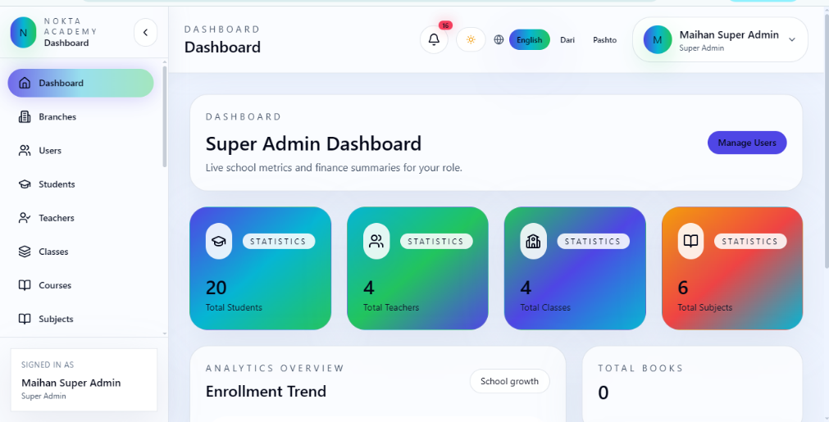
Figure 3. 3 Prototype 1 student, class, teacher, and timetable management screens
Stakeholder review of Figure 3.2 focused on validation rules (required fields, duplicate IDs, and assignment consistency). Fixes from that review entered the backlog before Prototype 2 work began.
Figure 3.3 documents the Prototype 1 attendance and examination path. Teachers mark attendance manually, and exams are created and scored without AI generation. Parents may view published results, but they do not receive automated online-attendance marks in this stage.
This design was intentional: automation was postponed until policy flags, notification channels, and survey demand were confirmed.
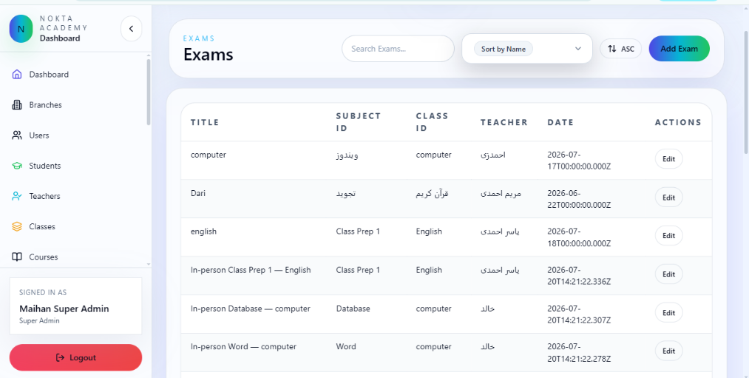
Figure 3. 4 Prototype 1 manual attendance and basic examination workflow
Figure 3.3 therefore represents a controlled baseline against which Prototype 2 enhancements can be compared in Chapter 4 results.
Figure 3.4 shows Prototype 1 finance capabilities: tuition collection, balances, expense recording, and baseline payroll estimation. Government quarterly/annual tax packages are not yet included; only basic tax estimation appears where needed for salary net pay.
Finance reviewers accepted this baseline for day-to-day fee operations but requested a later compliance package, which became Prototype 3.
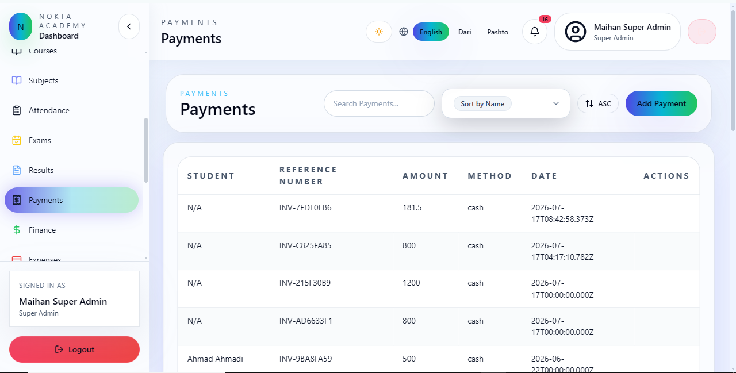
Figure 3. 5 Prototype 1 fee collection and baseline payroll view
Together, Figures 3.1 3.4 define the Prototype 1 contract: an integrated academy MIS without AI exam authoring, without online-meeting attendance automation, and without full government tax reporting.

3.2.4.2 Prototype 2 Survey-Driven Academic and Parent Enhancements
Prototype 2 was authorized only after questionnaire analysis. Of 20 academies that completed the instrument, 18 stated that they needed AI-supported examination question preparation, online class meeting support, and automatic attendance visibility for parents. Two newly opened academies did not provide a specific opinion because their teaching and parent-communication routines were not yet stable.
Based on that 18/20 demand signal, Prototype 2 added: (1) AI question generation for MCQ, true/false, and descriptive items with teacher review; (2) timetable online meeting links (Google Meet or equivalent URL) for remote/hybrid sessions; and (3) attendance-policy-driven automatic online attendance marking with parent notifications and parent portal reports.
These features were implemented behind permissions and configuration flags so that academies that were not ready could keep Prototype 1 behavior. Optional activation is consistent with Agile incremental adoption and reduces forced process change (Dikert et al., 2016).
Figure 3.5 illustrates the AI examination workspace introduced in Prototype 2. Teachers specify topic, difficulty, language, and question type; generated drafts are editable before publishing.
The design keeps humans in control: AI accelerates authoring, but academic responsibility remains with the teacher (Romero et al., 2020).
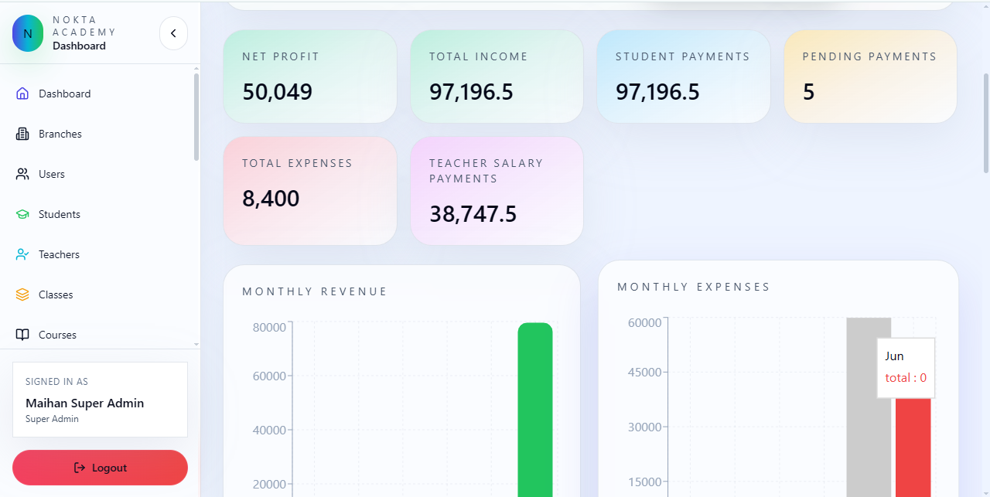
Figure 3. 6 Prototype 2 AI-assisted examination question generation
During review of Figure 3.5, teachers reported time savings in first-draft preparation, which aligns with the survey priority for faster exam setup.
Figure 3.6 shows how Prototype 2 connects timetable online links with attendance automation. When a session is configured for online delivery and auto-marking is enabled, the system can create online attendance records and notify linked parents.
Parents do not mark attendance themselves; they receive visibility and alerts. This matches the academy request for accountability without transferring control away from teachers/admin.
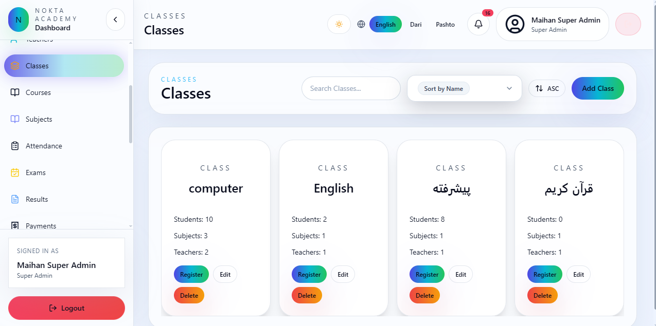
Figure 3. 7 Prototype 2 online class link and automatic parental attendance visibility
Figure 3.6 closes the communication gap identified in Chapter 1: parents previously relied on informal messaging to learn whether a child attended an online session.
Figure 3.7 summarizes the survey justification for Prototype 2. Eighteen academies requested the package; two newly started academies offered no specific opinion. The figure is retained in the methodology chapter because it is a process artifact as much as a result artifact.
Presenting the decision evidence here maintains requirements traceability from elicitation to implementation (International Organization for Standardization et al., 2018).
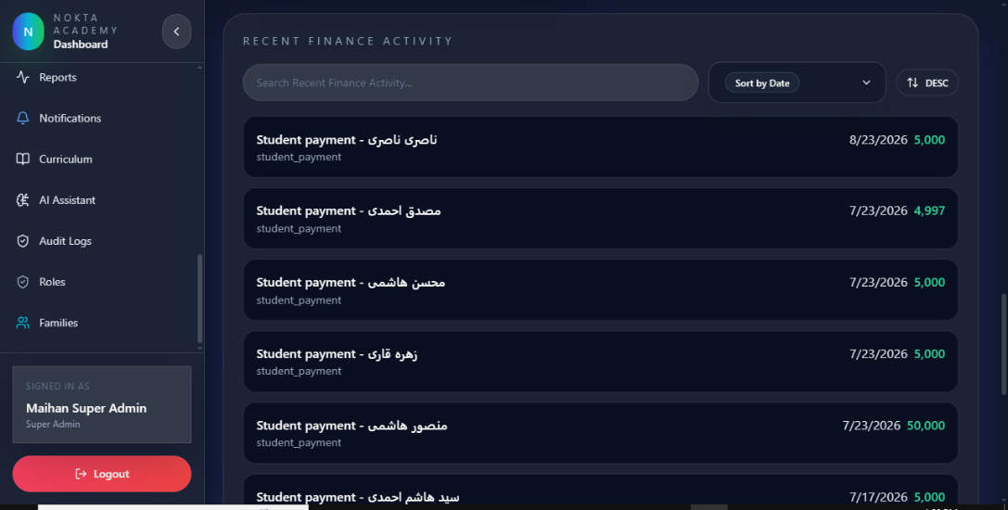
Figure 3. 8 Prototype 2 feature package justified by the 20-academy questionnaire
Chapter 4 later expands the same survey into fuller descriptive charts. Figure 3.7 is the decision snapshot used by the Product Owner to approve Sprint scope for Prototype 2.

3.2.4.3 Prototype 3 Government Tax Reporting (Quarterly and Annual)
Prototype 3 was driven by Nokta Academy’s own institutional request rather than by the multi-academy feature poll. After daily fee and payroll operations stabilized, academy management required structured support for government tax obligations on a quarterly and annual basis, including academy-level business receipt tax (BRT) treatment and employee salary tax summaries.
The implemented package includes Hijri-aware filters for month, quarter (Q1, Q4), and year; employee wage-tax brackets; academy tuition-based BRT calculation; annual packaging of quarterly totals; PDF/print export; and audit logging of report generation. Nonprofit education treatment for annual income tax is reflected according to the academy’s documented local compliance rules encoded in the finance services.
Prototype 3 therefore extends NAMS from an operational MIS into a compliance-supporting platform. This stage demonstrates why Agile delivery mattered: tax scope was not fully clear at project start, yet the modular finance architecture allowed addition without rewriting academic modules (Bass et al., 2012).
Figure 3.8 presents the Prototype 3 tax dashboard. Administrators and owners can open quarterly and annual views without exporting raw payment tables into external spreadsheets.
This directly responds to the sponsor’s compliance request and reduces manual reconciliation effort that previously risked calculation drift.
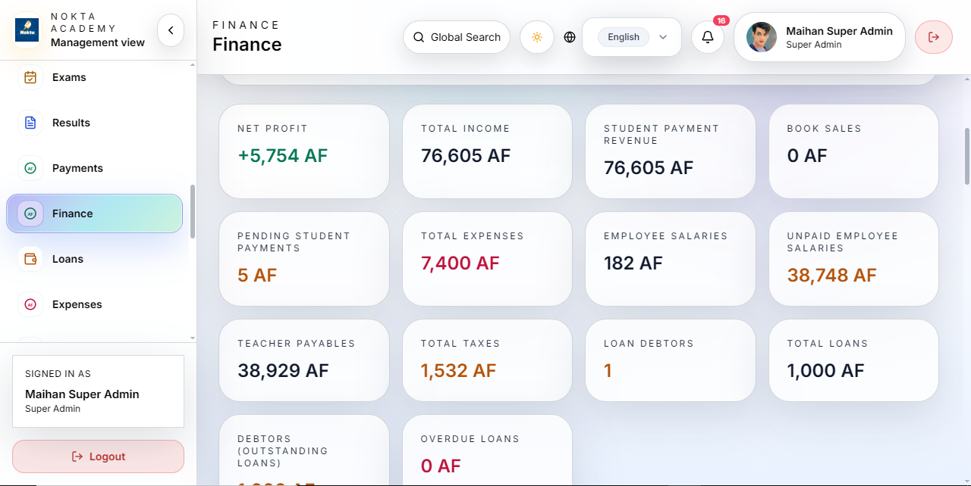
Figure 3. 9Prototype 3 government tax dashboard requested by Nokta Academy
Review comments on Figure 3.9 emphasized clear separation between employee salary tax and academy BRT so that users do not confuse the two obligations.
Figure 3.9 shows quarterly reporting controls. Users select Hijri year and quarter, then generate totals for tuition base, BRT, and related payroll withholdings.
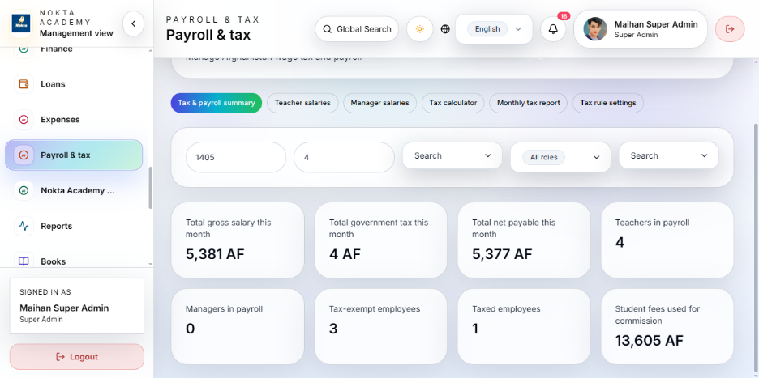
Quarterly cadence matches the academy’s declared filing rhythm and supports incremental verification before annual consolidation.
Figure 3. 10 Prototype 3 quarterly tax report filters and totals
The quarterly view in Figure 3.10 also aids branch comparison when more than one branch contributes tuition in the same period.
Figure 3.10 illustrates the annual package that consolidates four quarters into a year-to-date compliance set. Exports are printable and archivable for ownership review.
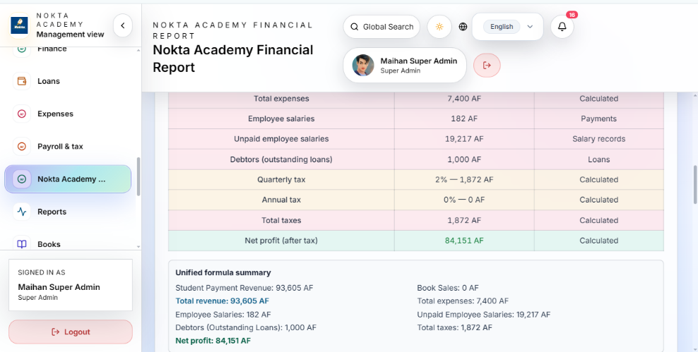
Annual packaging was a sponsor-critical outcome of Prototype 3 and is evaluated again in Chapters 4 and 5 as a practical contribution beyond generic LMS features.
Figure 3. 11 Prototype 3 annual tax package and export workspace
Figure 3.11 completes the prototype story: Prototype 1 stabilized operations, Prototype 2 answered multi-academy academic/parent demand, and Prototype 3 answered Nokta Academy’s government tax mandate.
Figure 3.11 connects salary records to tax services and finance entries. Gross, tax, and net values remain explainable for each teacher or staff member included in a period.
This transparency is essential for trust in information systems that affect livelihood and compliance simultaneously (DeLone et al., 2003).
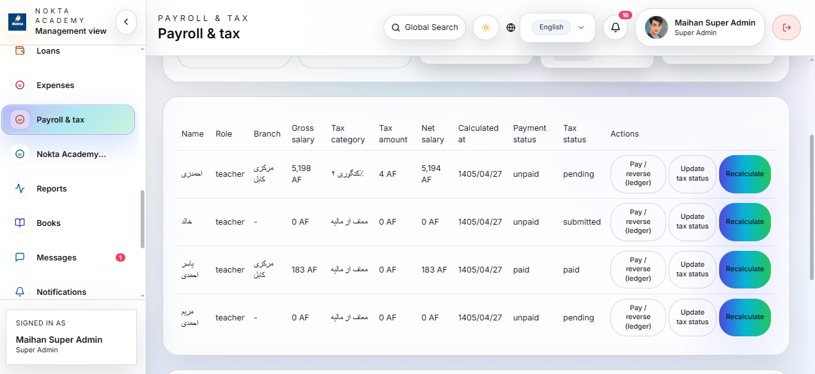
Figure 3. 12 Prototype 3 payroll–tax integration overview
With Figures 3.8 , 3.11 reviewed, the methodology transitions from prototype evidence to formal system design models in Section 3.3.

3.3 System Design
System design translates validated requirements into structural models: use cases, sequence diagrams, architecture, and database design. UML style artifacts communicate responsibilities among actors and components before further implementation detail is discussed (Bass et al., 2012).

3.3.1 Use Case Model
Figure 3.12 presents the NAMS use case model. Primary actors are Student, Parent, Teacher, Admin, Super Admin, and Owner. Shared use cases include managing students and teachers, recording attendance, managing exams (including AI-assisted authoring in Prototype 2), collecting fees, payroll and tax reporting, messaging, online class links, and dashboards.
The diagram is intentionally role-centric because authorization boundaries are part of the product, not an afterthought. Each actor sees only the use cases allowed by RBAC policy.
Compared with a generic LMS use case set, NAMS includes fee, payroll, tax, and parent attendance visibility as first-class academic-management concerns.
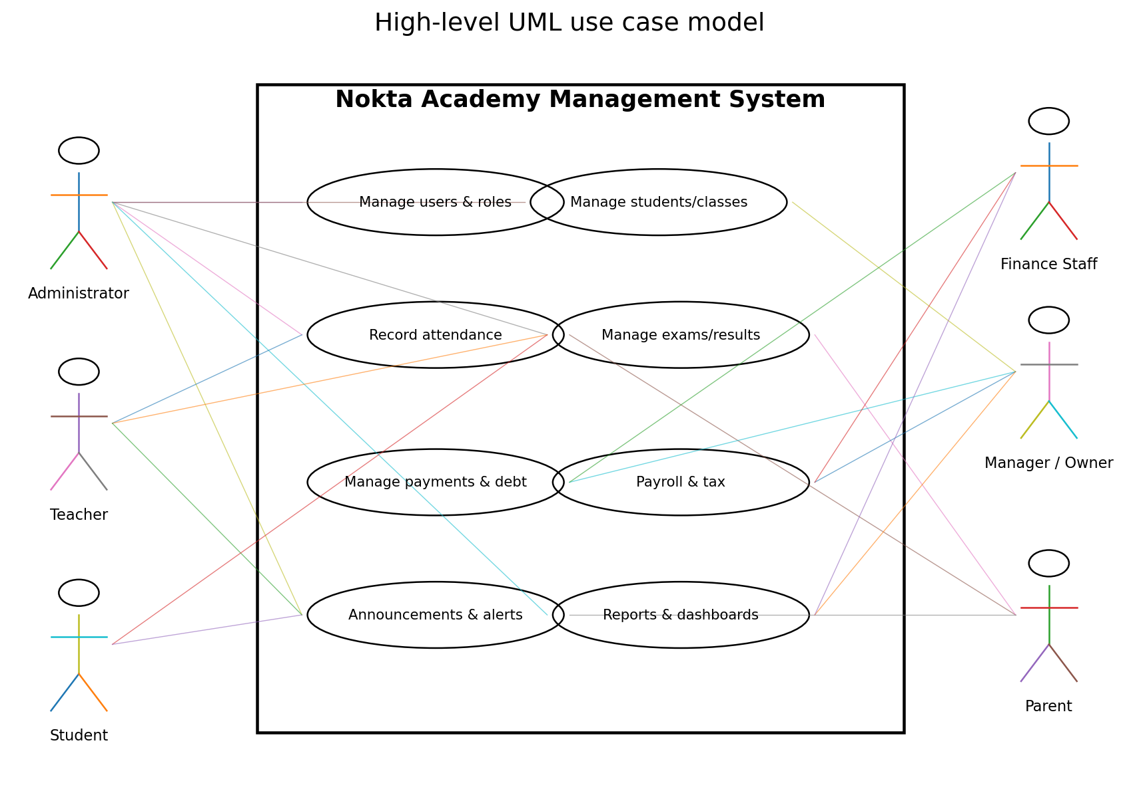
Figure 3. 13 Use case diagram for the Nokta Academy Management System
Figure 3.12 guides permission matrix design in the backend and protected routes in the web client. If a use case appears for Parent, corresponding API scopes must exist; otherwise the model would over-promise capability.
The next subsection details dynamic behavior for three critical flows using sequence diagrams.

3.3.2 Sequence Diagrams
Figure 3.13 models enrollment and fee payment. An administrator creates or updates a student, links class/subject/teacher data, and records payments that update balances and feed payroll bases where percentage salary rules apply.
The sequence clarifies that payment is not an isolated transaction; it emits financial side effects consumed by later payroll and tax services.
This design choice is central to NAMS’s claim of financial transparency relative to spreadsheet-based academies.
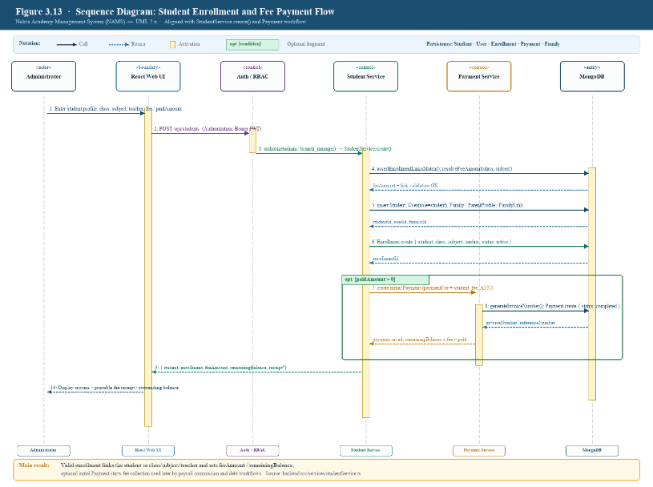
Figure 3. 14Sequence diagram for student enrollment and fee payment
Reading Figure 3.14 beside Prototype 1 screens shows that the enrollment–payment path was available before AI and tax packages, establishing the data spine of the system.
Figure 3.14 shows attendance marking and examination processing. In Prototype 1, marking is manual. In Prototype 2, online sessions may trigger automated online attendance records and parent notifications when policy allows.
Examination flow includes creating an exam, optionally generating AI questions, publishing, collecting results, and releasing grades to students and parents.
The sequence therefore spans both baseline and enhanced behaviors without requiring separate unrelated systems.
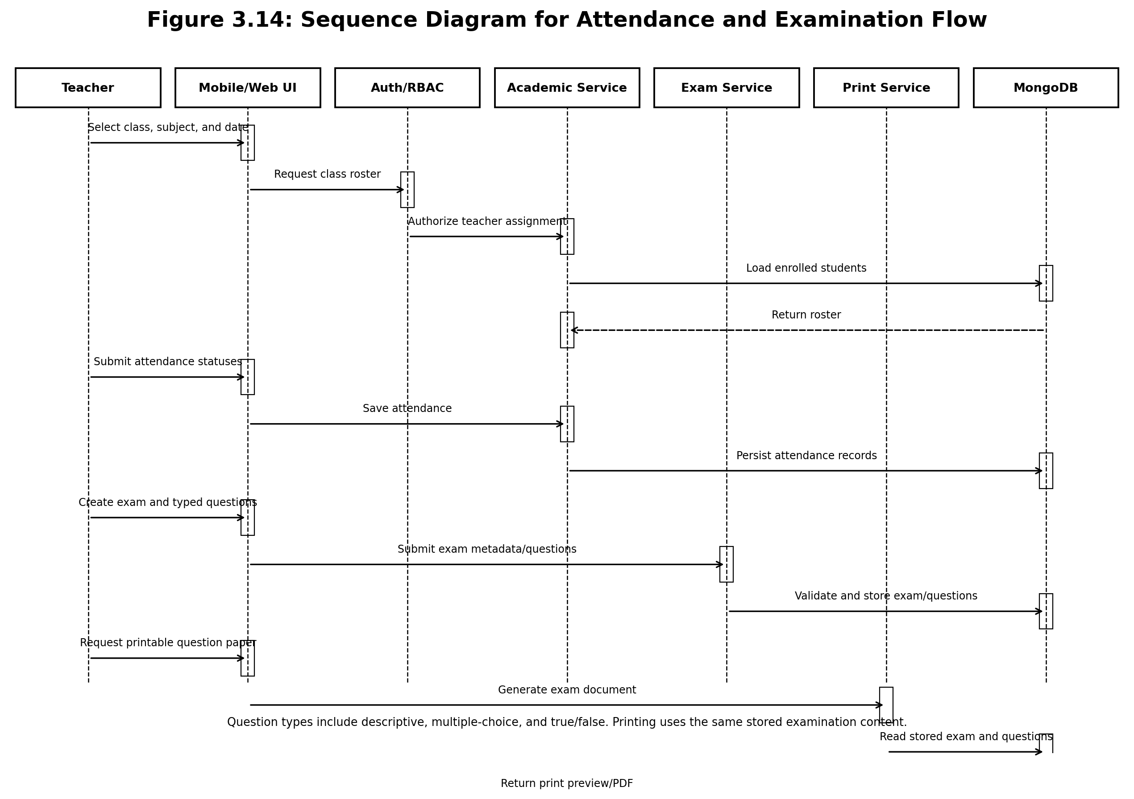
Figure 3. 15 Sequence diagram for attendance and examination processing

Figure 3.15 also supports testing design: unit tests cover scoring rules, while integration tests cover publish-and-notify paths.
Figure 3.15 describes payroll and tax reporting interactions introduced fully in Prototype 3. Salary records are computed from configured rules and payment bases; tax services apply employee brackets and academy BRT logic; reports are filtered by Hijri month, quarter, or year.
Owners and admins export printable summaries for compliance review, while audit logs retain who generated which package.
The sequence demonstrates that compliance reporting reuses operational data rather than asking staff to retype totals into external templates.
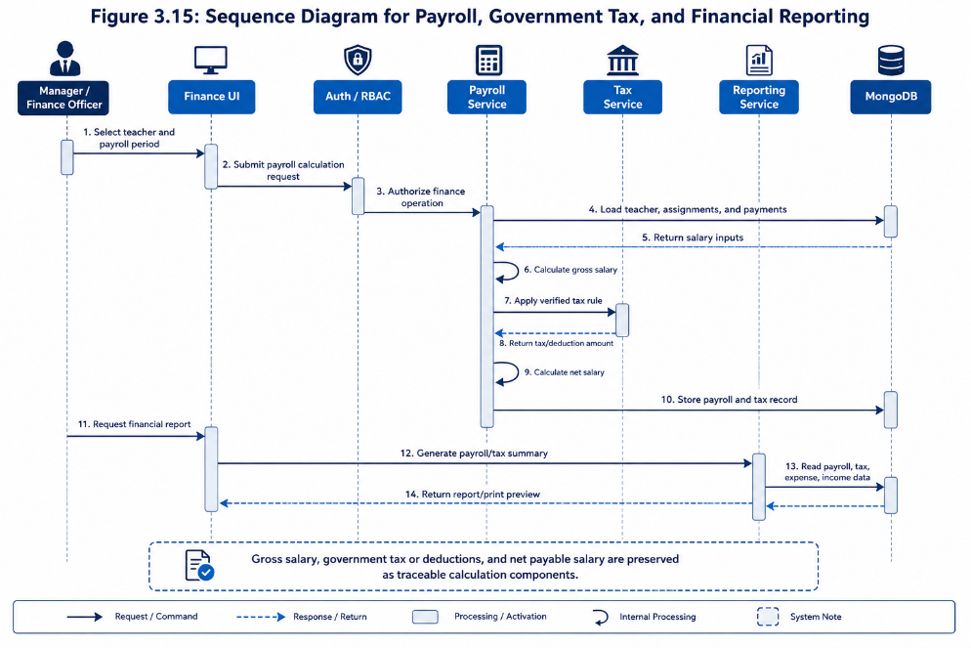
Figure 3. 16 Sequence diagram for payroll, tax, and financial reporting
Figures 3.13–3.16 collectively document the three most risk-sensitive business paths in NAMS: money in, academic evidence, and money/tax out.

3.3.3 Architectural Design
Figure 3.16 presents the NAMS architecture. Clients include the React web application, PWA access, and Flutter mobile paths. The Express/Node.js API layer hosts authentication, authorization, domain services, and scheduled jobs. MongoDB stores documents, while supporting services cover email/SMS notifications, AI providers, and report generation.
Layering isolates UI churn from business rules and persistence, improving maintainability (Bass et al., 2012).
Security cross-cuts the API through JWT validation, branch scoping, permission middleware, and audit logging.
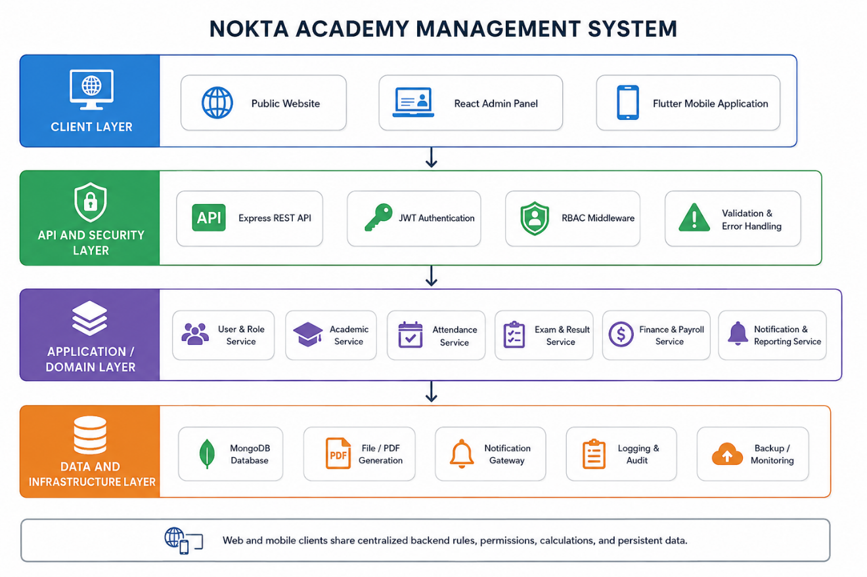
Figure 3.16 Layered architecture of NAMS (web, API, data, and supporting services)
Figure 3.16 explains how Prototype 2 jobs (auto attendance) and Prototype 3 tax services could be added as modules without redesigning the client stack.
Table 3.4 records stack choices that support the architecture in Figure 3.16. Selections favor rapid iteration for a small team while remaining familiar in contemporary full-stack practice (Sommerville, 2016).
AI providers are optional dependencies; Prototype 1 remains operable if AI keys are absent.
Table 3. 4 Technology Stack and Rationale for NAMS
Layer | Technology | Rationale
Web client | React 18, Vite, TypeScript, Tailwind | Responsive SPA with modular features
Mobile | Flutter / PWA | Student/teacher/parent access on phones
API | Node.js, Express, TypeScript | Non-blocking I/O and modular routes
Database | MongoDB, Mongoose | Flexible documents with ObjectId references
AuthZ/AuthN | JWT, bcrypt, RBAC permissions | Secure role-scoped access
Jobs | node-cron attendance/notification jobs | Automation for Prototype 2 policies
AI | OpenAI-compatible / Groq / Gemini providers | Optional exam authoring support
Reporting | PDF/print pipelines, dashboards | Operational and tax outputs

Stack rationale in Table 3.4 is revisited in Chapter 5 when comparing NAMS with LMS-centric platforms that lack native payroll/tax modules.

3.3.4 Database Design
Figure 3.17 provides an ER-style overview of core entities: users/roles, students, teachers, classes, subjects, enrollments, attendance, exams/results, payments, salary records, and messages. Although MongoDB is document-oriented, references preserve relational integrity for reporting (Chodorow, 2013).
The ER view helps justify why payment rows store student and contextual links used later by payroll and tax aggregations.
Soft-delete fields and timestamps support auditability without physically destroying history needed for quarterly reports.
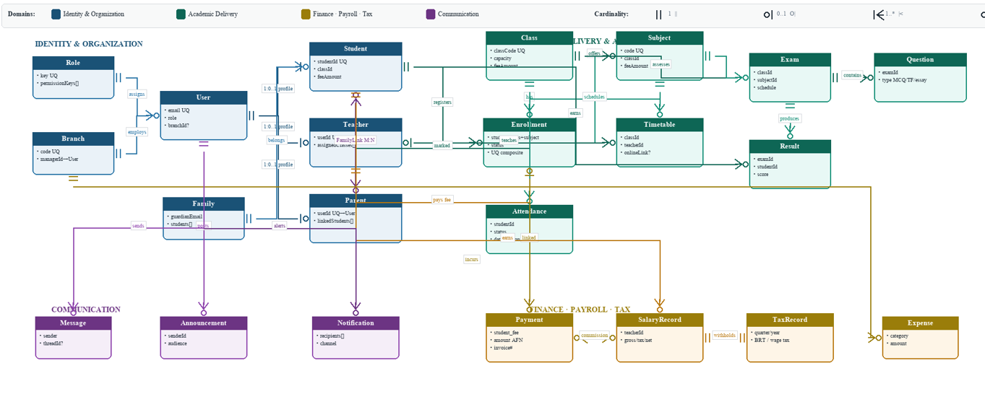
Figure 3. 17Entity-relationship overview of core NAMS collections
Figure 3.17 should be read with Figure 3.18, which shows a complementary schema view of document shapes used in implementation.
Figure 3.18 details key fields and relationships among operational collections. It is the schema companion to the ER overview and is useful for developers tracing service queries.
AttendancePolicy fields such as onlineAutoMarkEnabled appear here as configuration that enables Prototype 2 behavior without schema forks.
Tax and salary fields show how Prototype 3 reads operational collections rather than maintaining an unrelated parallel ledger.
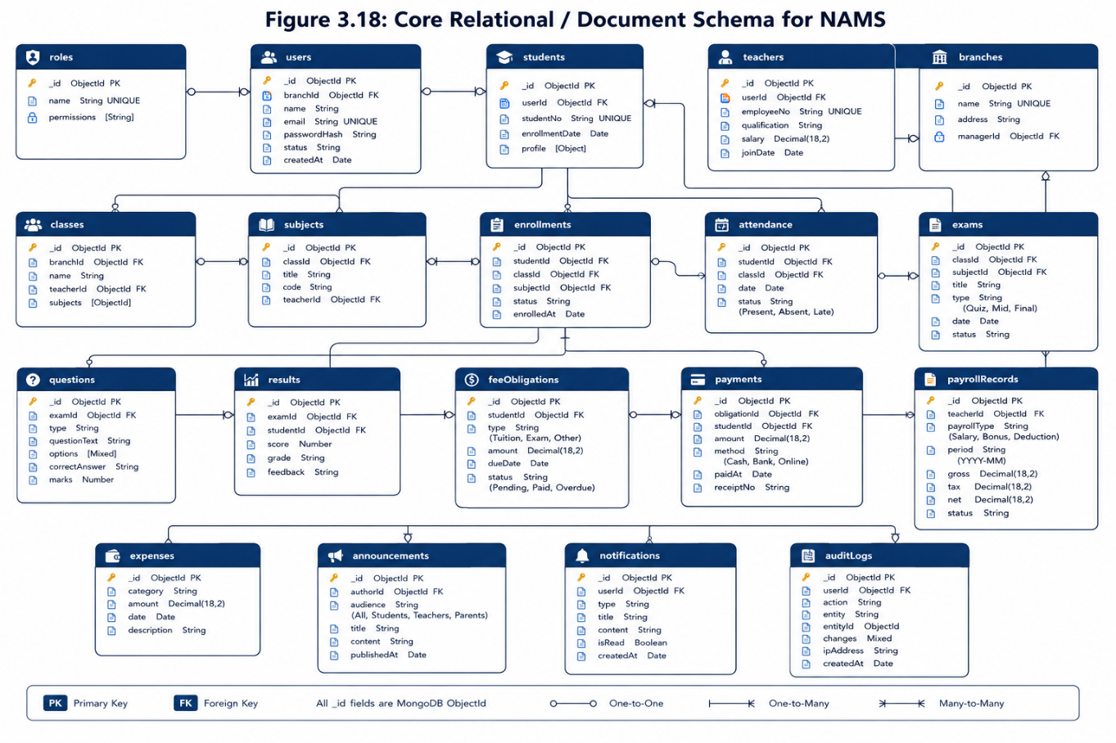
Figure 3.18 Core relational-document schema used by NAMS services
Figure 3. 18 With architecture and data design established, Section 3.4 summarizes how the design was implemented in engineering phases.

3.4 Implementation
Implementation followed the architecture and prototype plan. Backend modules were organized by domain routes and services; the web client used feature folders and shared API clients; mobile paths consumed the same REST API. Continuous integration lint/build checks reduced integration surprises as sprints advanced.

3.4.1 Development Environment
The development environment used Node.js 18+, MongoDB locally, React with Vite, TypeScript across stacks, Git for version control, and environment files for secrets (never committed). Optional services SMTP, SMS, Stripe, AI providers—could run in console/mock mode for campus demos.
Windows offline launcher scripts support LAN demonstration without public internet, which matters for academies with unstable connectivity (a constraint noted in Chapter 2).
Code quality gates included linting, unit tests for finance/tax calculations, and build verification for frontend and backend packages.

3.4.2 Implementation Phases
Phase A delivered identity, RBAC, students, teachers, classes, and subjects. Phase B delivered attendance and examinations. Phase C delivered payments and baseline payroll. Phase D delivered messaging, notifications, and dashboards (Prototype 1 complete). Phase E delivered AI exams, online links, and parental auto-attendance (Prototype 2). Phase F delivered quarterly/annual tax packages (Prototype 3).
Each phase ended with a review checklist mapped to FR/NFR IDs. Incomplete checklist items returned to the backlog rather than being silently skipped (Schwaber & Sutherland, 2020).
This phased evidence is later summarized in Chapter 4 as engineering results distinct from questionnaire results.

3.4.3 Key Modules Implemented
Key modules include authentication/session management, branch-aware masters, enrollment-linked students, attendance and attendance policies, exams/questions/results, AI generation endpoints, payments and finance entries, payroll and employee/academy tax services, messages/notifications, reports/printing, audit logs, and role dashboards. Enterprise extensions exist for transcripts, assignments, certificates, and security events where enabled.
Frontend resource configuration drives many CRUD screens, reducing duplication while still allowing specialized wizards for payments and exams. This pattern sped Prototype 1 delivery without freezing UX customization for high-traffic flows.
Background jobs implement Prototype 2 automation (online attendance auto-mark and related notifications) and are controlled by configuration so production behavior remains explicit.

3.4.4 Challenges and Solutions
Table 3.5 records the main engineering challenges. Most were organizational/requirements issues rather than unsolvable technical blockers another reason Agile suited this project (Dikert et al., 2016).
Tax clarity required sponsor workshops because legal interpretation cannot be guessed from generic LMS literature.
Table 3.5 Implementation Challenges and Solutions in NAMS
Challenge | Impact | Solution
Changing feature priorities after demos | Scope risk | Agile backlog + three prototype gates
Percentage payroll tied to payments | Calculation disputes | Deterministic services + unit tests
Multilingual RTL UI | Layout defects | Locale resources + RTL testing
Online attendance trust | Parent complaints | Policy flags + audit of auto marks
Tax rule clarity | Compliance risk | Sponsor workshops + Prototype 3 dedicated package
AI question quality | Teacher distrust | Editable drafts + human publish step

The solutions column in Table 3.5 feeds directly into the testing strategy: every major mitigation has a corresponding verification activity in Section 3.5.

3.5 Testing
Testing combined unit, integration, and user acceptance testing. Financial and tax functions received the strictest unit coverage because defects there undermine institutional trust. Integration tests exercised cross-module flows such as enroll pay_payroll and exam_result notify. UAT validated prototype goals with academy reviewers (Sommerville, 2016).

3.5.1 Unit Testing
Table 3.6 samples unit tests that protect Prototype 1-3 business rules. UT-04 and UT-05 explicitly lock the Prototype 1 versus Prototype 2 attendance behaviors.
UT-02 and UT-03 protect Prototype 3 compliance math from silent regression when other modules change.
Table 3.6 Sample Unit Test Cases for Core NAMS Calculations and Rules
Test ID | Area | Scenario | Expected Result
UT-01 | Payroll | Percentage salary on assigned student payments | Gross = base × percentage
UT-02 | Employee tax | Wage falls in progressive bracket | Tax matches bracket rule
UT-03 | BRT | Quarterly tuition aggregate | BRT = configured % of taxable tuition
UT-04 | Attendance policy | onlineAutoMarkEnabled = false | No auto online marks created
UT-05 | Attendance policy | onlineAutoMarkEnabled = true for online session | Auto mark + parent notify path
UT-06 | AI exam | Generate MCQ then edit before publish | Draft editable; publish uses final text
UT-07 | RBAC | Student token calls payroll report | Denied
UT-08 | Validation | Duplicate enrollment key | Rejected with clear error

Table 3.6 were executed during CI and before sprint reviews that claimed a prototype increment complete.

3.5.2 Integration Testing
Integration testing verified multi-module sequences: student registration to payment posting; manual attendance to report totals; exam publish to parent-visible results; online session to auto attendance notification; salary calculation to quarterly tax export. Failures often appeared at boundary assumptions (missing branchId, unpublished exam, disabled job flags).
API contract checks confirmed that frontend feature modules and backend routes agreed on payload shapes for payments, exams, and tax filters. This reduced UI-only “success” that hid backend rejects.
Integration evidence is summarized qualitatively in Chapter 4 engineering results rather than as raw CI logs, which are retained in the repository.

3.5.3 User Acceptance Testing
UAT was conducted at the end of each prototype gate. Prototype 1 UAT asked whether staff could run daily enrollment, attendance, exams, and fees without spreadsheets. Prototype 2 UAT asked whether AI drafting, online links, and parental auto-attendance were understandable and trustworthy. Prototype 3 UAT asked whether quarterly/annual tax outputs matched management expectations.
Feedback instruments combined task success observation with short satisfaction prompts inspired by usability evaluation practice (Nielsen, 1994). Formal large-sample SUS scoring was not claimed; instead, acceptance decisions were recorded per prototype gate.
UAT outcomes indicated acceptance of the Prototype 1 baseline, strong interest in Prototype 2 among academies that had requested those features, and sponsor acceptance of Prototype 3 tax packaging for Nokta Academy’s compliance workflow. Chapter 4 presents the supporting questionnaire figures.

CHAPTER 4: RESULTS

4.1 Questionnaire Results

4.1.1 Respondent Profile
Figure 4.1 shows who answered on behalf of each academy. Administrators and owners dominate, which is appropriate because they authorize tool adoption and finance workflows.
Teachers and branch managers contribute operational perspective on attendance and exams, while accountant responses emphasize fee and tax concerns.
Role diversity reduces the risk that requirements reflect only one department’s wishlist (Creswell, 2018).
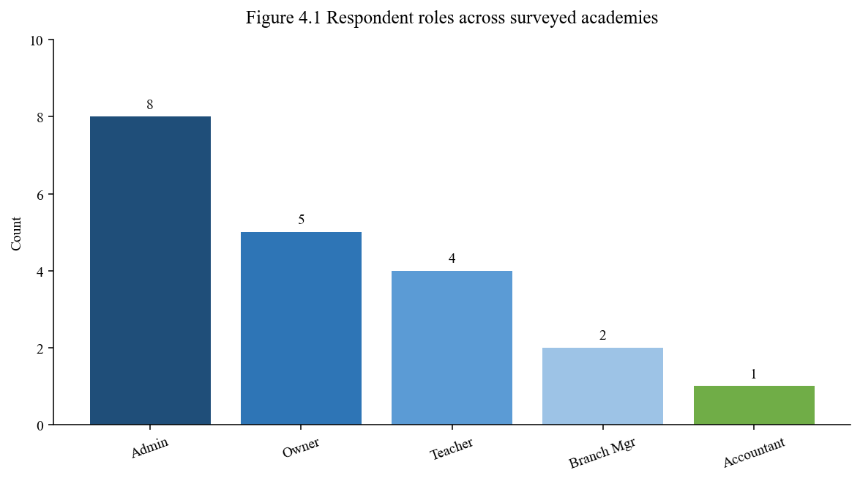
Figure 4.1 Respondent roles across the 20 surveyed academies
Figure 4.1 supports interpreting later priority scores as institutional rather than purely student-preference data.
Figure 4.2 separates academies operating more than one year (n=18) from newly started academies (n=2). This split is analytically important because the two new academies provided no specific opinion on Prototype 2 enhancements.
Mature academies had experienced spreadsheet pain points long enough to evaluate AI exams, online class links, and parental attendance automation concretely.
New academies were retained in the sample for honesty about uncertainty rather than forced opinions.
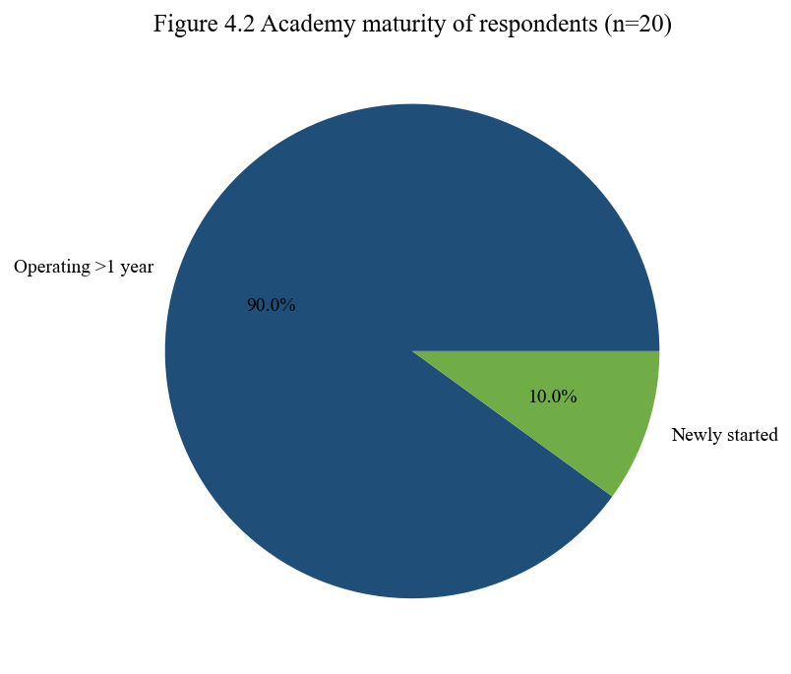
Figure 4.2 Operating maturity of participating academies
Figure 4.2 therefore explains why Prototype 2 authorization used an 18/20 demand rule rather than a unanimous rule.

4.1.2 Current Preparation and Access
Figure 4.3 reports current tools. Most academies still rely on paper/Excel or messaging apps, with only a minority using partial software. This empirical pattern confirms the problem statement’s claim of fragmentation.
Messaging-only coordination (for example, chat groups) can distribute announcements quickly but fails at durable fee balances, audit trails, and tax packaging.
The distribution justifies building an integrated MIS instead of a single-purpose exam app.
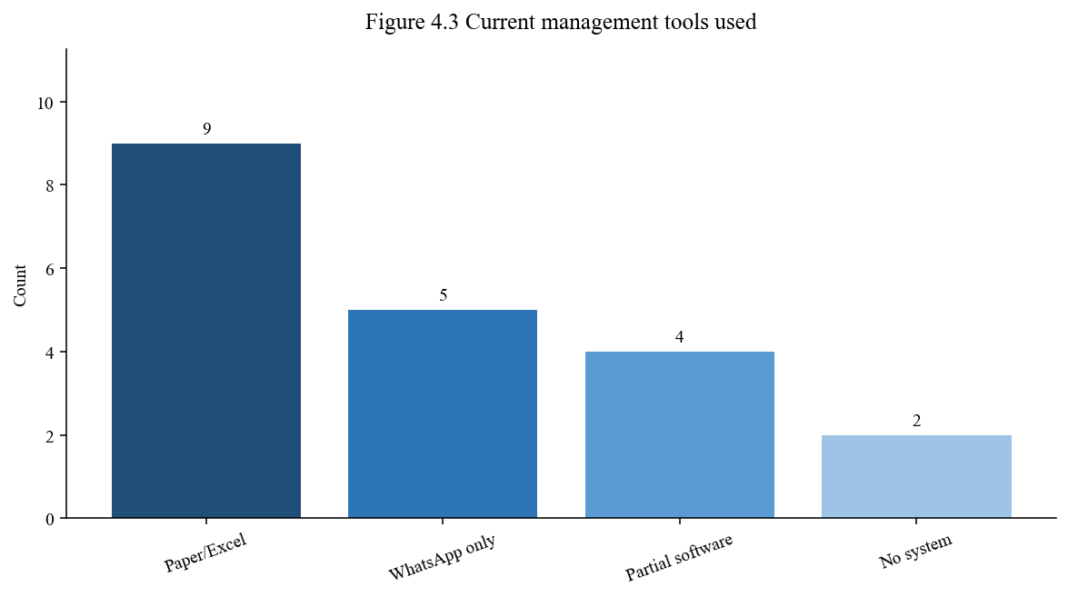
Figure 4.3 Current academic–administrative tools used by surveyed academies
Figure 4.3 also caution implementation: onboarding must import or replace Excel habits gradually, which again supports phased Agile delivery.

4.1.3 Feature Interest and Priorities
Figure 4.4 is the pivotal requirements result for Prototype 2. Eighteen academies stated that they need the AI examination, online meeting, and automatic parental attendance package. Two newly started academies expressed no specific opinion.
In percentage terms, 90% of the sample requested the package, providing clear Product Owner authority to schedule Prototype 2 after the baseline stabilized.
The figure is not a popularity contest alone; it is tied to interview notes that linked these features to teacher workload and parent trust.
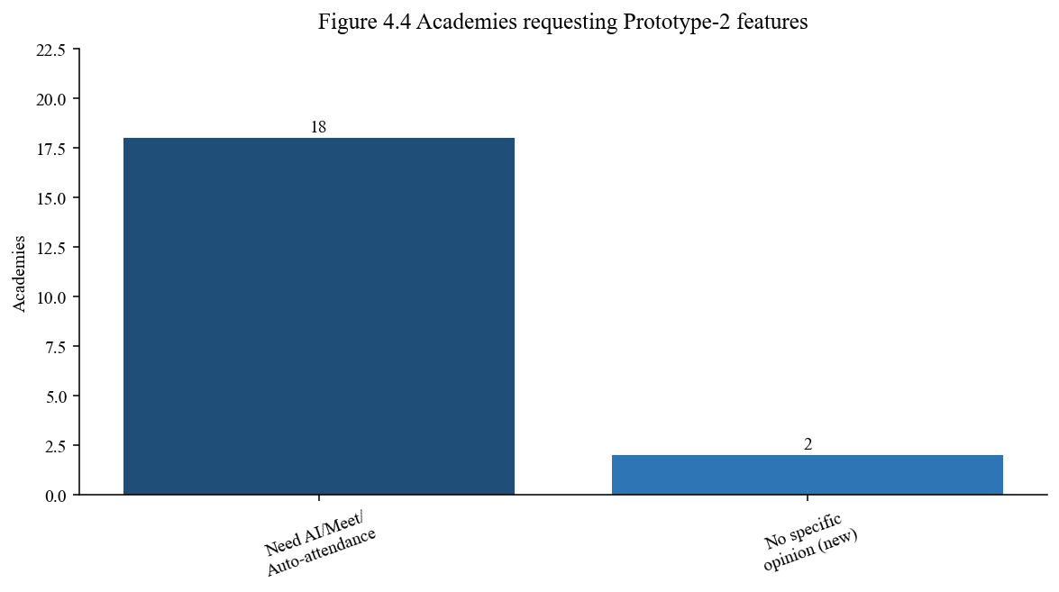
Figure 4.4 Academies requesting Prototype 2 feature package (AI exams, online meeting links, auto parent attendance)
Figure 4.4 should be read with Figure 4.5, which ranks a broader feature set by mean priority.
Figure 4.5 shows mean priority scores on a 1–5 scale. Fee/payroll and attendance lead, followed closely by exams/AI, parent portal capabilities, tax reports, and messaging.
High scores for fee/payroll validate Prototype 1’s finance spine. High scores for exams/AI and parent portal validate Prototype 2. Strong tax interest among respondents, combined with Nokta Academy’s direct request, validates Prototype 3.
The relatively close means indicate that academies want an integrated suite rather than a single silver-bullet module (McLean, 2003).
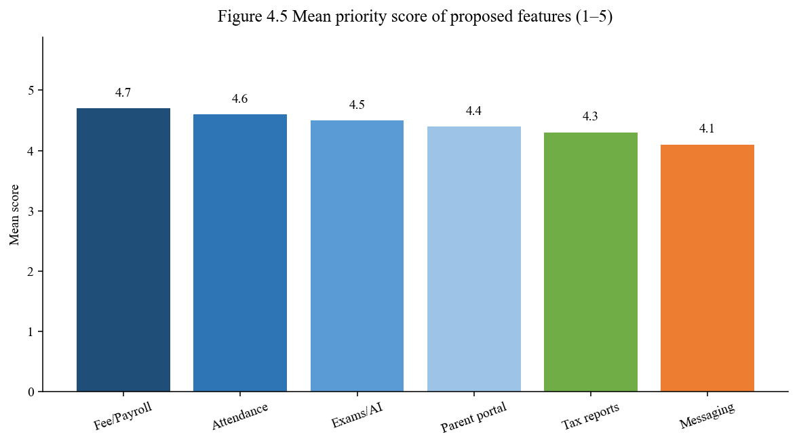
Figure 4.5 Mean priority scores of proposed NAMS feature groups
Figure 4.5 guided sprint ordering when calendar pressure forced sequencing choices among otherwise important items.

4.1.4 Perceived Impact
Figure 4.6 summarizes agreement with expected impact statements. Nearly all respondents agreed that NAMS would reduce manual work and improve transparency; most also expected faster reports, stronger parent trust, and better tax readiness.
Perceived usefulness is a central predictor of acceptance (Venkatesh et al., 2003). These counts therefore support adoption likelihood interpretations in Figure 4.7.
Tax readiness scoring high even before Prototype 3 coding shows latent demand that the sponsor request later made explicit.
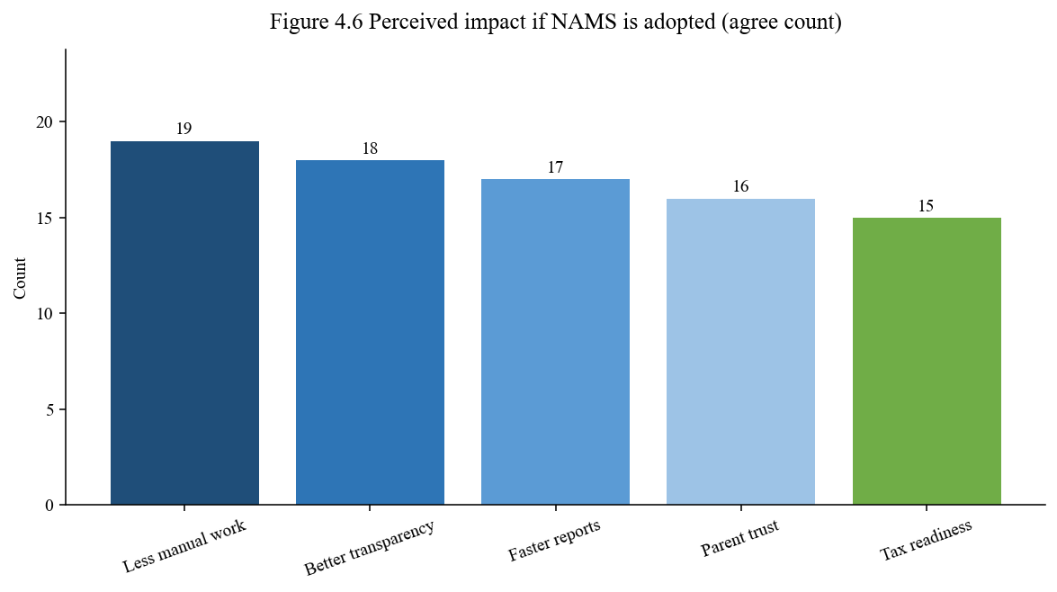
Figure 4.6 Perceived impact statements: number of academies agreeing
Figure 4.6 are expectations, not post-deployment longitudinal proof; Chapter 5 treats that distinction carefully.
Figure 4.7 shows adoption likelihood: 12 academies were very likely, 6 likely, and 2 neutral. No academy selected “unlikely” in this sample.
Neutrals correspond to the newly started academies that also withheld Prototype 2 opinions, reinforcing a maturity effect on technology commitment.
Overall acceptance is strong for a purposive sample and supports proceeding from prototype gates to broader pilot recommendations in Chapter 6.
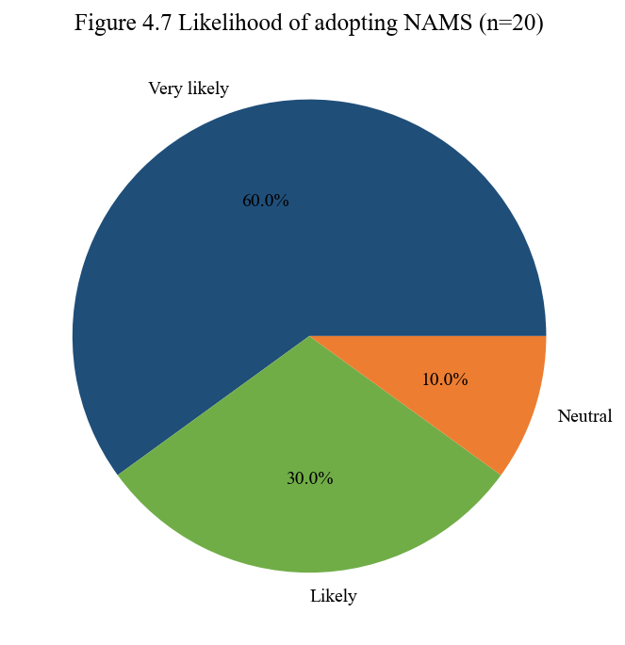
Figure 4.7 Likelihood of adopting NAMS among surveyed academies.
Figure 4.7 closes the questionnaire subsection and leads into prototype and engineering results.

4.1.5 Summary of Findings
Questionnaire findings show fragmented current tools, strong demand for integrated fee/attendance/exam capabilities, 18/20 demand for Prototype 2 enhancements, high expected impact, and high adoption likelihood. These findings answer the requirements questions that Chapter 3 framed and supply evidence for design trade-offs already implemented.
Engineering findings complementary to the survey are: Prototype 1 delivered a usable baseline; Prototype 2 features were implemented with configuration controls; Prototype 3 produced quarterly and annual tax outputs accepted in sponsor UAT; unit tests protected payroll/tax rules; and architecture diagrams/sequences remained aligned with the running monorepo modules.
Table 4.1 consolidates objective-oriented result statements for quick reference before discussion.
Table 4.1 is a results synthesis, not a new dataset. It exists to help readers transition into Chapter 5’s interpretive discussion without rereading every figure.
Each row points either to a prototype artifact or to survey evidence presented above.
Table 4.1 Summary Mapping of Result Evidence to Project Goals
Goal theme | Evidence | Prototype gate
Centralize records | CRUD modules + ERD/schema figures | P1
Improve attendance visibility | Manual marks (P1); auto online + parent alerts (P2) | P1–P2
Speed exam preparation | AI generation with teacher review | P2
Support online/hybrid class ops | Timetable online links + jobs | P2
Financial transparency | Payments–payroll linkage | P1
Government tax readiness | Quarterly/annual tax package | P3
Stakeholder acceptance | 18/20 feature demand; 18/20 likely/very likely adopt | Survey

The discussion chapter uses Table 4.1 as an index when relating findings to objectives and literature.

CHAPTER 5: DISCUSSION
This chapter interprets the results. It discusses main findings, relations to objectives and research questions, relations to literature and existing systems, practical implications for NAMS, and limitations following the Exit.pdf discussion pattern while remaining specific to academy management.

5.1 Main Findings
Three findings dominate. First, academies still operate with fragmented tools, so an integrated MIS addresses a real operational gap. Second, feature demand is broad but not uniform over time: core finance/academic modules were needed immediately, while AI exams, online meeting links, and parental auto-attendance were justified after 18/20 academies requested them. Third, compliance reporting (Prototype 3) emerged as a sponsor-critical capability that generic LMS platforms rarely treat as native (Saha, 2019).
These findings jointly support an iterative product strategy. A single big-bang release attempting AI, automation, and tax in the first demo would have delayed the baseline that staff needed most (Dikert et al., 2016).
Acceptance likelihood was high, but neutrality among new academies shows that digital readiness moderates adoption (Venkatesh et al., 2003).

5.2 Relation to Objectives and Research Questions
Chapter 1 objectives sought centralized information management, better communication, academic monitoring, operational efficiency, and analytics readiness. Prototype 1 advanced centralization and efficiency; Prototype 2 advanced communication/monitoring for online contexts and exam authoring; Prototype 3 advanced institutional reporting for tax compliance. Analytics readiness is partially achieved through structured data capture even where advanced ML models are future work (Aldowah et al., 2019).
Research questions about fragmentation, timely information, communication, analytics, and automation are therefore answered at the level of an engineered and reviewed system plus stakeholder evidence, not as a multi-year causal impact study. That scope matches a bachelor final-year project while still producing actionable knowledge (Hevner et al., 2004).
Table 5.1 provides an explicit answer matrix.
Table 5.1 compresses discussion claims into audit-friendly statements for defense and grading.
Each answer is bounded by the sample and prototype scope described in Section 5.5.
Table 5.1 Discussion Matrix Linking Research Questions to Evidence
Question theme | Answer from NAMS evidence
Fragmented records | Integrated student–class–fee–attendance–exam data model reduces multi-file reconciliation.
Timely integrated information | Dashboards and role portals expose current balances, attendance, and results.
Communication/coordination | Announcements/messages plus Prototype 2 parent attendance alerts shorten informal chasing.
Monitoring/analytics | Structured histories enable reports now and AI/analytics extensions later.
Automation efficiency | Fee/payroll linkage and Prototype 2/3 automations cut repetitive manual steps.

The matrix in Table 5.1 also shows why methodology choices (mixed methods + Agile prototypes) were not cosmetic: they produced the evidence types each answer requires.

5.3 Relation to Literature and Existing Systems
Relative to Moodle, Google Classroom, and Canvas, NAMS is less of a content LMS and more of an academy operations platform. Literature already notes that instructional platforms often need external tools for finance and institutional reporting (Costa et al., 2020). NAMS inverts that pattern by centering operations and attaching learning-support features where they help academies.
Information systems success theory helps interpret why tax and payroll accuracy matter: information quality and net benefits are damaged when financial figures are doubted (McLean, 2003). Technology acceptance theory helps interpret why Prototype 2 automation had to remain reviewable by teachers perceived control affects trust (Davis, 1989).
Learning analytics literature supports storing attendance and assessment consistently even before advanced models ship (Romero et al., 2020). NAMS follows that sequencing.

5.4 Practical Implications of NAMS
Practically, NAMS offers private academies a path from Excel/chat coordination to a role-aware system that can grow. Prototype gating reduces adoption shock: an academy may begin with Prototype 1 features and enable Prototype 2 flags when teachers and parents are ready.
For Nokta Academy specifically, Prototype 3 reduces dependency on ad-hoc tax spreadsheets and creates an auditable quarterly/annual trail. For other academies in the survey, the 18/20 demand signal suggests a transferable enhancement package around AI exams, online links, and parental attendance visibility.
Multilingual and offline-friendly deployment considerations remain practical differentiators in the local context discussed in Chapter 2.

5.5 Limitations of the Findings and System
Limitations include purposive sampling of 20 academies, self-reported expectations rather than longitudinal outcome measurement, and prototype UI figures that include engineered mock composites where live screenshots were insufficient for print clarity. AI question quality depends on external providers and teacher review discipline.
Government tax rules are implemented according to sponsor-provided operational interpretation for Nokta Academy; legal advice beyond that encoding is outside the software engineering scope. Multi-campus national integrations and biometric attendance were out of scope as stated in Chapter 1.
These limitations do not void the contribution; they bound claims appropriately for an applied bachelor project (Hevner et al., 2004).

CHAPTER 6: CONCLUSION AND FUTURE WORK

6.1 Summary of Work Done
This project designed and implemented the Nokta Academy Management System as an integrated web API mobile platform for private academy operations. Chapters 1, 2 established the problem and literature context. Chapter 3 documented mixed-methods requirements work and Agile Scrum delivery through three prototypes. Chapters 4 , 5 presented and interpreted survey and engineering results.
Prototype 1 delivered the operational baseline without AI exam generation, without online-meeting attendance automation, and without full government tax packaging. Prototype 2 added those academic/parent enhancements after 18 of 20 academies requested them. Prototype 3 added quarterly and annual government tax reporting at Nokta Academy’s request.
Design artifacts (use cases, sequences, architecture, ERD/schema) and tests were maintained to keep the monograph aligned with the running system.

6.2 Key Contributions
Contributions include: (1) an integrated academy MIS spanning academic and financial operations; (2) an evidence-based prototype strategy linking a 20-academy questionnaire to backlog decisions; (3) parental online-attendance visibility with policy controls; (4) AI-assisted exam authoring with human approval; and (5) a quarterly/annual tax reporting package grounded in operational data.
Methodologically, the project shows how Agile Scrum practices (backlog, sprints, reviews, definition of done) can be combined with formal requirements and UML-style design documentation suitable for academic assessment (Schwaber et al., 2020).
Empirically, the 18/20 feature-demand result provides a clear, citable decision record for why Prototype 2 existed as a separate gate rather than as hidden incomplete work.

6.3 Achievement of Objectives
Table 6.1 uses conservative status labels. “Partially achieved” for advanced analytics avoids over-claiming machine-learning interventions not delivered as production predictors (Peffers et al., 2007).
Tax reporting is marked achieved for the sponsor-defined package reviewed in Prototype 3 UAT.
Table 6.1 Objective Achievement Status for NAMS
Objective theme | Status | Evidence
Centralized information management | Achieved | Integrated modules + data model
Improved communication/coordination | Achieved (enhanced in P2) | Messages + parent attendance alerts
Academic monitoring & results access | Achieved | Exams/results portals
Operational efficiency (attendance/fees/exams) | Achieved | P1 baseline + automation in P2
Analytics/AI readiness | Partially achieved | Structured data + AI authoring; predictive ML future
Government tax reporting | Achieved (P3) | Quarterly/annual tax package UAT

Table 6.1 indicates that the project met its engineering objectives within the stated scope and limitations.

6.4 Future Enhancements
Future work should include longitudinal pilots measuring time saved and error reduction after deployment; deeper learning-analytics models for at-risk prediction; richer offline synchronization; expanded Flutter feature parity; stronger backup/recovery drills; and formal accessibility audits. Payment-gateway and biometric options may be reconsidered if academies fund those integrations.
On the compliance side, tax rule packs could become configurable per jurisdiction if NAMS expands beyond the current sponsor interpretation. On the AI side, item-quality scoring and curriculum alignment checks would improve teacher trust in generated questions.
Finally, a larger multi-city academy sample would strengthen generalizability beyond the purposive 20-academy questionnaire used here (Creswell et al., 2018).

REFERENCES
Al-Emran, M., Mezhuyev, V., & Kamaludin, A. (2018). Technology Acceptance Model in M-learning context: A systematic review. Computers & Education, 125, 389–412. https://doi.org/10.1016/j.compedu.2018.06.008
Al-Maroof, R. S., Salloum, S. A., Hassanien, A. E., & Shaalan, K. (2021). Fear from COVID-19 and technology adoption: The impact of Google Meet during Coronavirus pandemic. Interactive Learning Environments. Advance online publication. https://doi.org/10.1080/10494820.2020.1830121
Al-Rahmi, W. M., Yahaya, N., Alamri, M. M., Alyoussef, I. Y., Al-Rahmi, A. M., & Kamin, Y. B. (2021). Integrating innovation diffusion theory with technology acceptance model: Supporting students’ attitude towards using a massive open online courses (MOOCs) system. Interactive Learning Environments, 29(8), 1380–1392. https://doi.org/10.1080/10494820.2019.1629599
Aldowah, H., Al-Samarraie, H., & Fauzy, W. M. (2019). Educational data mining and learning analytics for 21st century higher education: A review and synthesis. Telematics and Informatics, 37, 13–49. https://doi.org/10.1016/j.tele.2019.01.007
American Psychological Association. (2020). Publication manual of the American Psychological Association (7th ed.). American Psychological Association. https://doi.org/10.1037/0000165-000
Basheer, S., AlLuhaidan, A. S., & Mathew, R. M. (2021). A secured smart automation system for computer labs in engineering colleges using the internet of things. Computer Applications in Engineering Education, 29(2), 339–349. https://doi.org/10.1002/cae.22223
Bass, L., Clements, P., & Kazman, R. (2012). Software architecture in practice (3rd ed.). Addison-Wesley.
Brooke, J. (1996). SUS: A quick and dirty usability scale. In P. W. Jordan, B. Thomas, B. A. Weerdmeester, & I. L. McClelland (Eds.), Usability evaluation in industry (pp. 189–194). Taylor & Francis.
Chodorow, K. (2013). MongoDB: The definitive guide (2nd ed.). O’Reilly Media.
Connolly, T. M., & Begg, C. E. (2015). Database systems: A practical approach to design, implementation, and management (6th ed.). Pearson.
Costa, C., Teixeira, L., & Alvelos, H. (2020). Exploring the usage of learning management systems in higher education: A systematic review. Education and Information Technologies. Advance online publication.
Creswell, J. W., & Creswell, J. D. (2018). Research design: Qualitative, quantitative, and mixed methods approaches (5th ed.). SAGE Publications.
Davis, F. D. (1989). Perceived usefulness, perceived ease of use, and user acceptance of information technology. MIS Quarterly, 13(3), 319–340. https://doi.org/10.2307/249008
DeLone, W. H., & McLean, E. R. (2003). The DeLone and McLean model of information systems success: A ten-year update. Journal of Management Information Systems, 19(4), 9–30. https://doi.org/10.1080/07421222.2003.11045748
Dikert, K., Paasivaara, M., & Lassenius, C. (2016). Challenges and success factors for large-scale agile transformations: A systematic literature review. Journal of Systems and Software, 119, 87–108. https://doi.org/10.1016/j.jss.2016.06.013
Fowler, M. (2004). UML distilled: A brief guide to the standard object modeling language (3rd ed.). Addison-Wesley.
Hevner, A. R., March, S. T., Park, J., & Ram, S. (2004). Design science in information systems research. MIS Quarterly, 28(1), 75–105.
Ifenthaler, D., & Yau, J. Y.-K. (2020). Utilising learning analytics to support study success in higher education: A systematic review. Educational Technology Research and Development, 68(4), 1961–1990. https://doi.org/10.1007/s11423-020-09788-z
International Organization for Standardization, & International Electrotechnical Commission. (2011). Systems and software engineering Systems and software Quality Requirements and Evaluation (SQuaRE) System and software quality models (ISO/IEC 25010:2011).
International Organization for Standardization, International Electrotechnical Commission, & Institute of Electrical and Electronics Engineers. (2018). Systems and software engineering Life cycle processes — Requirements engineering (ISO/IEC/IEEE 29148:2018).
Kraus, S., Jones, P., Kailer, N., Weinmann, A., Chaparro-Banegas, N., & Roig-Tierno, N. (2021). Digital transformation: An overview of the current state of the art of research. SAGE Open, 11(3), 1–19. https://doi.org/10.1177/21582440211047576
Likert, R. (1932). A technique for the measurement of attitudes. Archives of Psychology, 22(140), 1–55.
Miles, M. B., Huberman, A. M., & Saldaña, J. (2014). Qualitative data analysis: A methods sourcebook (3rd ed.). SAGE Publications.
Nielsen, J. (1994). Usability engineering. Morgan Kaufmann.
Peffers, K., Tuunanen, T., Rothenberger, M. A., & Chatterjee, S. (2007). A design science research methodology for information systems research. Journal of Management Information Systems, 24(3), 45–77. https://doi.org/10.2753/MIS0742-1222240302
Pressman, R. S., & Maxim, B. R. (2020). Software engineering: A practitioner’s approach (9th ed.). McGraw-Hill Education.
Rahman, M. M., & Saha, S. (2019). An integrated education management information system for private academic institutions. International Journal of Information Engineering and Electronic Business, 11(2), 1–10.
Romero, C., & Ventura, S. (2020). Educational data mining and learning analytics: An updated survey. WIREs Data Mining and Knowledge Discovery, 10(3), e1355. https://doi.org/10.1002/widm.1355
Schwaber, K., & Sutherland, J. (2020). The Scrum guide: The definitive guide to Scrum: The rules of the game.
Siemens, G. (2013). Learning analytics: The emergence of a discipline. American Behavioral Scientist, 57(10), 1380–1400. https://doi.org/10.1177/0002764213498851
Sommerville, I. (2016). Software engineering (10th ed.). Pearson.
Tilkov, S., & Vinoski, S. (2010). Node.js: Using JavaScript to build high-performance network programs. IEEE Internet Computing, 14(6), 80–83. https://doi.org/10.1109/MIC.2010.145
Traxler, J. (2018). Learning with mobiles in the digital age. Pedagogika, 68(3), 293–310.
Venkatesh, V., Morris, M. G., Davis, G. B., & Davis, F. D. (2003). User acceptance of information technology: Toward a unified view. MIS Quarterly, 27(3), 425–478. https://doi.org/10.2307/30036540
Venkatesh, V., Thong, J. Y. L., & Xu, X. (2012). Consumer acceptance and use of information technology: Extending the unified theory of acceptance and use of technology. MIS Quarterly, 36(1), 157–178. https://doi.org/10.2307/41410412

APPENDIX A: QUESTIONNAIRES

A.1 Requirements Elicitation Questionnaire
The questionnaire was administered to one primary respondent per academy (n=20). Items used categorical choices and five-point Likert-type ratings (Likert, 1932). The instrument is summarized below; full printed forms were used during data collection.
Section A - Academy profile: academy age, approximate student count, respondent role.
Section B - Current tools: paper/Excel, messaging apps, partial software, none.
Section C - Pain points: enrollment, attendance, exams, fees, parent communication, reporting, tax.
Section D - Feature usefulness and priority for core MIS modules (1–5).
Section E - Prototype 2 package: need for AI exam support, online class meeting links, and automatic parental attendance visibility (Yes / No specific opinion).
Section F - Perceived impact statements and adoption likelihood.
Scoring note: eighteen academies answered “Yes” to Section E; two newly started academies selected “No specific opinion.” These counts authorized Prototype 2 scope in Chapter 3.
APPENDIX B: SOURCE CODE REPOSITORY
The NAMS source code is maintained as a monorepo containing backend (Node.js/Express/TypeScript), web frontend (React/Vite), mobile/PWA assets, deployment configuration, ERD documentation, and monograph generation scripts. Local development uses MongoDB and environment-variable configuration described in the repository README.
Key paths include backend/src for API modules and jobs, frontend/src/features for UI domains, ERD/ for schema documentation, and scripts/ for report generation utilities used to produce this document.
Access credentials for demonstration accounts, if required by examiners, are provided separately through the department’s project submission channel and are not printed in the public monograph body.
APPENDIX C: RAW TEST DATA
Raw automated test outputs and CI logs are retained in the project repository. This appendix summarizes representative cases already presented in Table 3.6 and confirms that payroll, tax, RBAC, and attendance-policy tests were executed before prototype gate reviews.
Table C.1 is a compact raw-outcome digest for examiners. Detailed assertion messages remain in the repository test runner output.
A “Pass” status means the suite succeeded on the evaluated commit used for Prototype 3 UAT.
Table C.1 Representative Raw Test Outcome Summary
Suite | Focus | Outcome at Prototype-3 gate
Finance unit tests | Payroll percentage + tax brackets | Pass
Academy tax tests | Quarterly BRT aggregation | Pass
Attendance policy tests | Auto-mark on/off behavior | Pass
Auth/RBAC tests | Role denial on sensitive routes | Pass
Exam/AI smoke tests | Generate–edit–publish path | Pass

If department policy requires attaching full console logs, they can be exported from CI without altering the narrative chapters.
APPENDIX D: USER MANUAL
This abbreviated user manual describes common tasks for NAMS roles. It is intended for examiner orientation and academy onboarding, not as a substitute for in-app help text.

D.1 Administrator
1) Sign in with an admin account. 2) Create branches/classes/subjects as needed. 3) Register students and assign teachers. 4) Record fees and review dashboards. 5) For Prototype 3, open Payroll/Tax reports, select Hijri quarter or year, and export PDF.

D.2 Teacher
1) Open assigned classes. 2) Mark attendance for the session. 3) Create exams; optionally generate AI draft questions (Prototype 2), edit, and publish. 4) Enter or review results. 5) Check timetable online links for hybrid sessions.

D.3 Student
1) Sign in to view timetable, attendance summary, results, fee status, and announcements.

D.4 Parent
1) Sign in to the family/parent portal. 2) View linked children’s attendance and results. 3) In Prototype 2, receive notifications when online auto-attendance records are created for enabled sessions.

D.5 Owner / Super Admin
1) Review academy-level dashboards. 2) Manage roles/permissions as authorized. 3) Export quarterly/annual tax packages and archive them for compliance review.

