Paper Presentation on the topic: Rapid Advancements in AI BOON or BANE

By:

Mohammad Moulali (21030-CM-184)

&

Sandeep Kasturi (21030-CM-136)

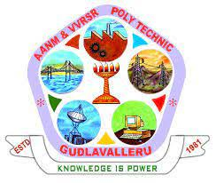

A.A.N.M &V.V.R.S.R POLYTECHNIC

Introduction:
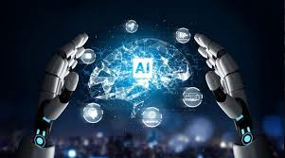
Artificial Intelligence (AI) refers to the simulation of human intelligence in machines that are programmed to think and act like humans. It involves the development of algorithms and computer programs that can perform tasks that typically require human intelligence such as visual perception, speech recognition, decision making, and language translation. AI has the potential to revolutionize many industries and has a wide range of applications, from virtual personal assistants to self-driving cars.
History of Artificial Intelligence
The timeline of the past seven decades of how AI evolved from its inception.
- 1956 – John McCarthy coined the term ‘artificial intelligence’ and had the first AI conference.
- 1969 – Shakey was the first general-purpose mobile robot built. It is now able to do things with a purpose vs. just a list of instructions.
- 1997 – Supercomputer ‘Deep Blue’ was designed, and it defeated the world champion chess player in a match. It was a massive milestone by IBM to create this large computer.
- 2002 – The first commercially successful robotic vacuum cleaner was created.
- 2005 – 2019 – Today, we have speech recognition, robotic process automation (RPA), a dancing robot, smart homes, and etc.
- 2020 – Baidu releases the Linear Fold AI algorithm to medical and scientific and medical and scientific and medical teams developing a vaccine during the early stages of the SARS-COV-2 (COVID- 19) pandemic. The algorithm can predict the RNA sequence of the virus in only 27 seconds, which is 120 times faster than other methods.
- Now present every one using AI applications for their work like assignment, projects and others.

BOON about AI:

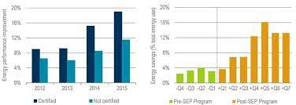

1. Increased Efficiency and Productivity
AI technology has the potential to significantly improve efficiency and productivity across various sectors. AI-powered machines can perform complex tasks faster and with higher precision than humans. For example, in the manufacturing industry, robots powered by AI can perform repetitive tasks in assembly lines 24/7 without any breaks or errors, leading to higher production rates and improved quality.

2. Enhanced Decision-Making

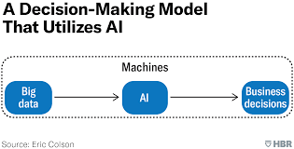

AI algorithms can process vast amounts of data and provide valuable insights, enabling better decision-making. For instance, in the healthcare sector, AI can analyze medical records, symptoms, and treatment options to assist doctors in diagnosing diseases accurately and recommending personalized treatment plans. This can lead to improved patient outcomes and more efficient healthcare delivery.

3. Automation of Mundane Tasks
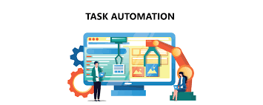
One of the significant benefits of AI is the automation of mundane and repetitive tasks, allowing humans to focus on more creative and complex activities. For instance, virtual assistants like Siri and Alexa can perform tasks such as setting reminders, making appointments, and answering questions, thereby freeing up human time and increasing productivity.
Recent advancements in AI have opened up exciting possibilities for the future. Some of the most significant advancements include:

Deep Learning:
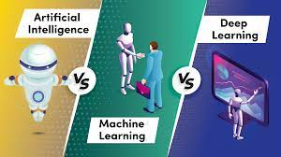
Deep learning is a subset of AI that involves training neural networks to learn from vast amounts of data. It has led to significant breakthroughs in image and speech recognition, natural language processing, and other areas.

2. Reinforcement Learning
Reinforcement learning is an AI technique that involves training an algorithm through a system of rewards and punishments. It is used to train machines to make decisions in complex and unpredictable environments, such as gaming and robotics.

3. Generative Models:

Generative models are AI systems that can create new content, such as images, music, or text. They work by learning the patterns and styles of existing data and generating new content based
on that learning. This technology has significant implications for the art, music, and entertainment industries.
Example: ChatGPT, SKY AI, Google Bard, Sincode.ai, Copy.ai etc.

BANE about AI:

1. Job Displacement
As AI systems gain more capabilities, there is a concern that it will lead to job displacement. Machines powered by AI can perform tasks traditionally done by humans, such as data entry, driving, and even customer service. This can result in unemployment and economic inequality without adequate measures in place to retrain and re-skill the workforce.

2. Ethical Considerations
Another concern associated with AI is related to ethical considerations. As AI algorithms become more advanced, there is a potential for bias and discrimination embedded in the decision-making processes. For example, in the criminal justice system, AI algorithms used for predicting recidivism rates have been found to be racially biased. It is crucial to ensure transparency and accountability in AI systems to avoid reinforcing existing biases and discrimination.

3. Security and Privacy Risks
With the rapid advancements of AI, there is an increase in security and privacy risks. AI systems are powered by massive datasets, and if these datasets are compromised, sensitive information can be misused. Additionally, AI-powered technologies like facial recognition raise concerns about invasion of privacy and potential misuse of personal data. Adequate regulations and safeguards must be in place to protect individuals' privacy and security.

4. Investment in Re-skilling and Retraining
To mitigate job displacement caused by AI, it is crucial to invest in re-skilling and retraining programs. Governments, employers, and academic institutions can coordinate to provide training opportunities and develop new skill sets required to work alongside AI systems. This will ensure that workers can remain relevant and continue to be employed even as machines become more advanced.

5. Ethical and Transparent AI
AI systems should be developed in an ethical and transparent manner. Fairness and non-discrimination should be embedded in the design and deployment of AI, and transparency must be ensured through explanations of how decisions are made. Algorithms should be audited regularly to detect and address any biases or errors and to provide clear explanations of how decisions were reached.

6. Regulations and Safeguards
To address security and privacy concerns, regulations and safeguards must be in place to protect sensitive data and prevent misuse. For example, data privacy laws such as GDPR require organizations to provide transparency and give users the right to access and delete their personal data. Additionally, ethical guidelines must be developed to guide the development and deployment of AI systems.

AI in Everyday Life:
AI has become an integral part of our everyday lives, with its influence extending across various sectors. Here are some examples of how AI is used in everyday life:

Virtual Assistants

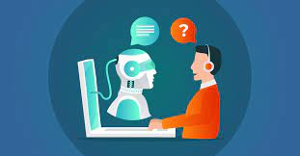

Virtual assistants like Siri, Alexa, and Google Assistant are AI-powered technologies that can perform tasks and answer questions based on voice commands. They can set reminders, provide weather updates, play music, and even control smart home devices. Virtual assistants make our lives more convenient and efficient by automating various tasks.
Example: Google Assistant, Alexa, Siri, ChatBots etc.

Recommendation Systems



AI-powered recommendation systems are used by e-commerce platforms, streaming services, and social media platforms to provide personalized recommendations to users. By analyzing user behavior and preferences, these systems suggest products, movies, shows, or posts tailored to individual tastes, enhancing the user experience
Example: Netflix etc.

Fraud Detection



AI algorithms are used in the financial sector for fraud detection and prevention. These algorithms analyze patterns and detect anomalies in financial transactions to identify potentially fraudulent activities. By automatically flagging suspicious transactions, AI helps protect individuals and organizations from financial fraud.
Example: Email spam detector.

4. Language Translation
AI-based language translation technologies have made it easier for people around the world to communicate and understand each other. These systems, such as Google Translate, use machine learning algorithms to translate text or speech from one language to another, facilitating global communication and breaking down language barriers.
Example: Google Translator etc.

5. Image Recognition
AI-powered image recognition technology is used in various applications, from facial recognition in security systems to object recognition in self-driving cars. Image recognition algorithms can identify and classify objects, people, and scenes within images or videos, leading to advancements in areas like surveillance, healthcare, and autonomous vehicles.
Example: Face Recognition, YOLO (You Only Look Once), OpenCV (Computer Vision) etc.

The Future of AI:
The future of AI holds tremendous potential for further advancements and integration into our lives. Here are some glimpses of what we can expect:

Healthcare Innovations



AI has the potential to revolutionize healthcare further. We can expect advancements like AI-powered diagnostics, personalized medicine, and the use of robotics in surgeries. AI algorithms will continue to analyze medical data to support doctors in making accurate diagnoses and treatment plans, ultimately improving patient outcomes.

2. Smart Cities
AI will play a central role in the development of smart cities. It will enable efficient traffic management, optimized resource allocation, and improved energy consumption. AI algorithms will analyze real-time data from various sources to make cities smarter, more sustainable, and more loveable.

Robotics and Automation
Robotic systems powered by AI will continue to advance, performing tasks that are dangerous, repetitive, or physically challenging for humans. We can expect increased automation in industries like manufacturing, agriculture, and logistics, leading to improved efficiency and reduced human labour requirements.

4. Ethical AI Development
As AI continues to proliferate, the focus on ethical AI development and deployment will grow. There will be increasing emphasis on transparency, fairness, and accountability in AI systems to ensure that they align with societal values and avoid reinforcing biases or discrimination.

Applications of AI:

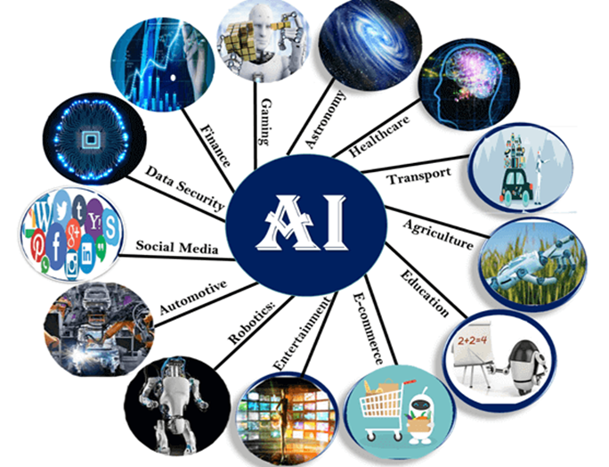

The applications of AI are vast and varied, and the technology has already made significant strides in enhancing various aspects of our lives. Here are some examples:

1. Healthcare
AI is transforming healthcare in several ways, from diagnosis to treatment and beyond. It can help doctors to diagnose diseases more accurately, provide personalized treatment, and even develop new drugs. For example, systems powered by AI can analyze medical records, symptoms, and treatment options to assist doctors in developing personalized treatments for patients.

2. Transportation
AI is being used to improve transportation in various ways. Self-driving cars powered by AI promise safer and more efficient transportation while reducing the need for human drivers. AI-powered traffic management systems can reduce congestion and improve traffic flow. Additionally, AI can help airlines to optimize their schedules and improve customer service.

3. Education
AI has the potential to transform education by personalizing the learning experience to individual student needs. AI-powered systems can adapt teaching methods and materials to cater to different learning styles and needs, making education more accessible and effective. For example, AI-powered tutoring systems can provide guidance and feedback to students based on their strengths and weaknesses.

Conclusion
The Future of AI is both exciting and uncertain. While it has the Potential to transform our world in positive ways, we must also be aware of the risks and challenges that come with rapid advancements. By working together to address these issues, We can create a future where AI benefits everyone.
Whether AI is BOON or BANE depends on how we choose to use it. If we use in responsibly, AI can be a powerful tool for solving problems and creating a better future.

