RAPID ADVANCEMENTS IN AI IS BOON OR BANE
Introduction
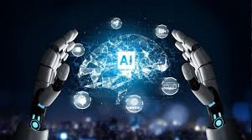
Artificial Intelligence (AI) refers to the simulation of human intelligence in machines that are programmed to think and act like humans. It involves the development of algorithms and computer programs that can perform tasks that typically require human intelligence such as visual perception, speech recognition, decision making, and language translation. AI has the potential to revolutionize many industries and has a wide range of applications, from virtual personal assistants to self-driving cars.
History of Artificial Intelligence
The tim0eline of the past six decades of how AI evolved from its inception.
- 1956 – John McCarthy coined the term ‘artificial intelligence’ and had the first AI conference.
- 1969 – Shakey was the first general-purpose mobile robot built. It is now able to do things with a purpose vs. just a list of instructions.
- 1997 – Supercomputer ‘Deep Blue’ was designed, and it defeated the world champion chess player in a match. It was a massive milestone by IBM to create this large computer.
- 2002 – The first commercially successful robotic vacuum cleaner was created.
- 2005 – 2019 – Today, we have speech recognition, robotic process automation (RPA), a dancing robot, smart homes, and etc …
- 2020 – Baidu releases the LinearFold AI algorithm to medical and scientific and medical and scientific and medical teams developing a vaccine during the early stages of the SARS-COV-2 (COVID- 19) pandemic. The algorithm can predict the RNA sequence of the virus in only 27 seconds, which is 120 times faster than other methods.
- Now present every one using AI applications for their work like assignment, projects and others.
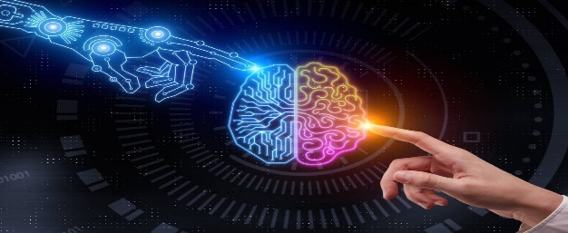
WHY AI IS BOON
- It reduces human error
- It never sleeps, so its available 24x7
- It never gets bored, so it easily handles repetitive tasks
- It’s very fast than humans


WHY AI IS BANE
- It’s costly to implement
- It can’t duplicate human creativity
- It will definitely replace some jobs,
leading to unemployment
- People can become overly reliant on it

- whether AI is a boon or a bane depends on how we choose to use it. If we use it responsibly, AI can be a powerful tool for solving problems and creating a better future.

APPLICATIONS OF AI
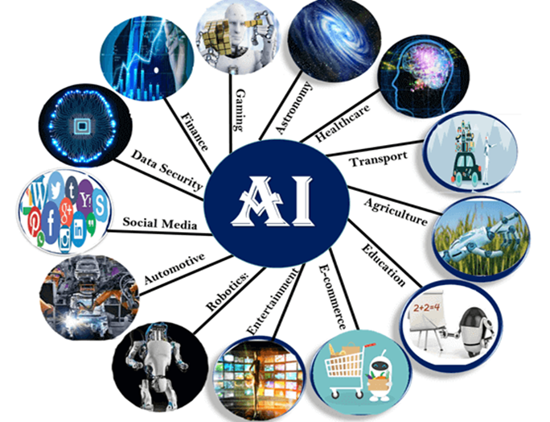
CONCLUSION
The future of AI is both exciting and uncertain. While it has the potential to transform our world in positive ways, we must also be aware of the risks and challenges that come with rapid advancements. By working together to address these issues, we can create a future where AI beneﬁts everyone.

