Prepared by: Mohammad Fahim Nazari

**Cloud-Base Architecture Design Implementation**

**Introduction**

The Architecture I have purposed to the Family Pro has been accepted and, in this report, I will showcase the implementation.

**Creating VPC**

For creating VPC we need to go to AWS console management and follow the steps the product of a VPC has been attached.

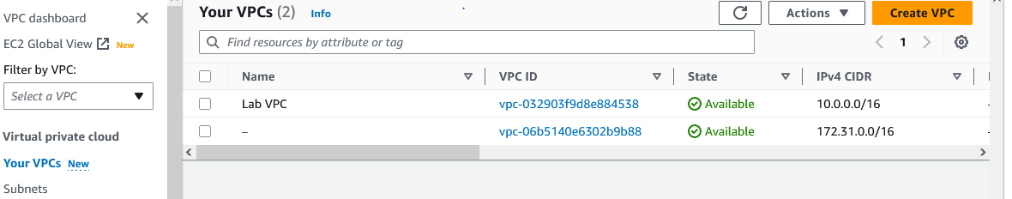

**Creating Subnet**

Once the VPC created, I created multiple subnets into different availability zone. Our subnet can be public and private, and the important part is to choose the right CIDR block for our subnet and the availability zone that our subnet resides.

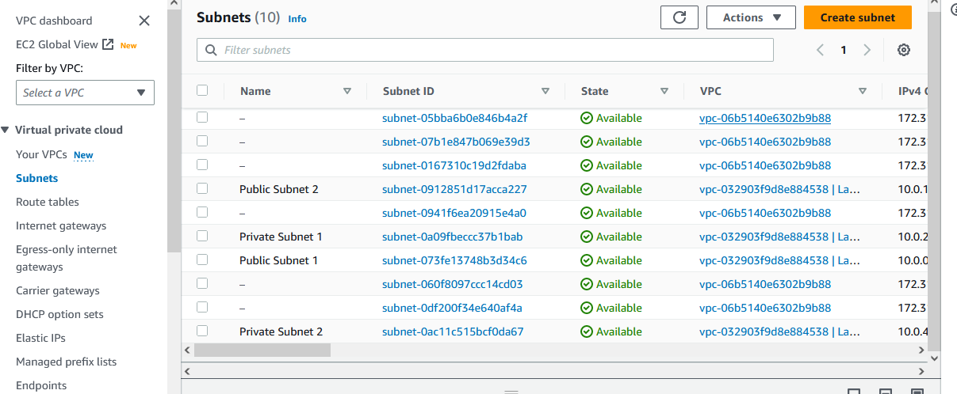

In the rout table we can see traffic one if in the VPC local and the second one is routed to internet gateway

ACL has allowed us to control and manage access to our AWS resources in the network level and it’s associated with VPC.

Security group is an option to get access to the database we are adding some inbound rules which specify traffic to have access to the database and outbound we allow all the traffic.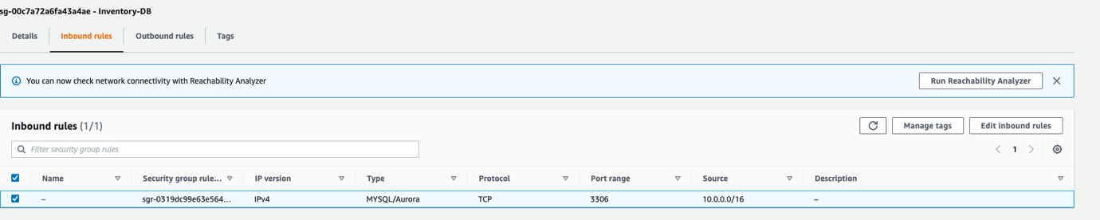

**Load Balancer**

To distribute the traffic between two servers in two availability zone we require load balancer.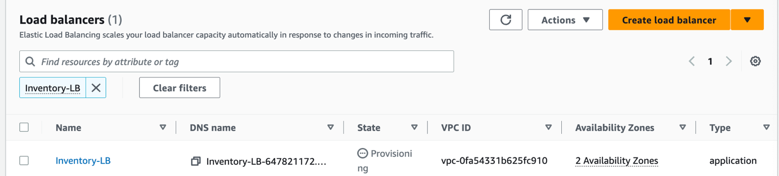

**Auto Scaling**

To adjust the capacity of our elastic compute instances we require autoscaling based on the demand of workloads. In the lab I was not authorized to create autoscaling.

**Conclusion**

Based on my design for the Facility Pro architecture in part1, I implemented the design in the lab the result shows that the system design effectively mirrors a high availability architecture. By creating two VPCs across two availability zones and employing load balancing and auto-scaling mechanisms, the solution showcases is fault tolerance and scalability.