Prepared by: Mohammad Fahim Nazari

**Serverless Architecture implementation of Facility Pro**

1. Creating a security group to control the inbound and outbound traffic.

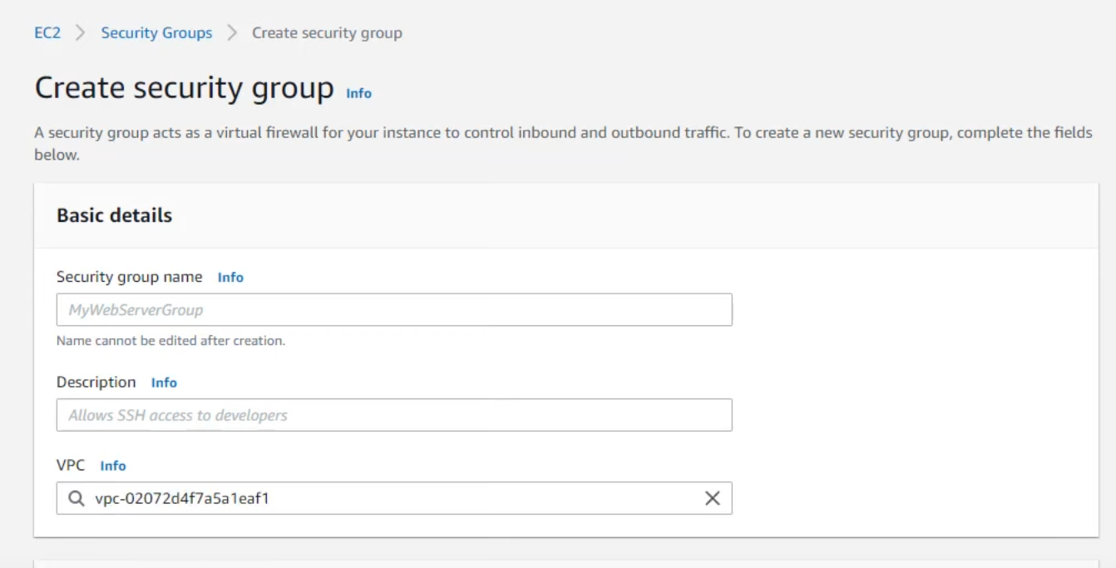

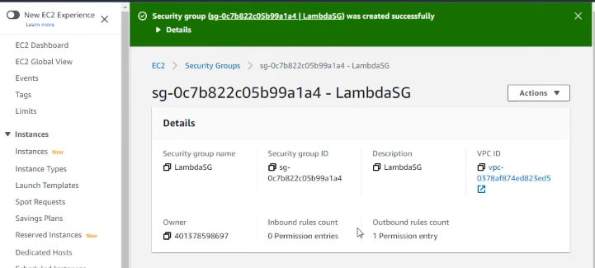

1. Modifying the inbound according to our needs

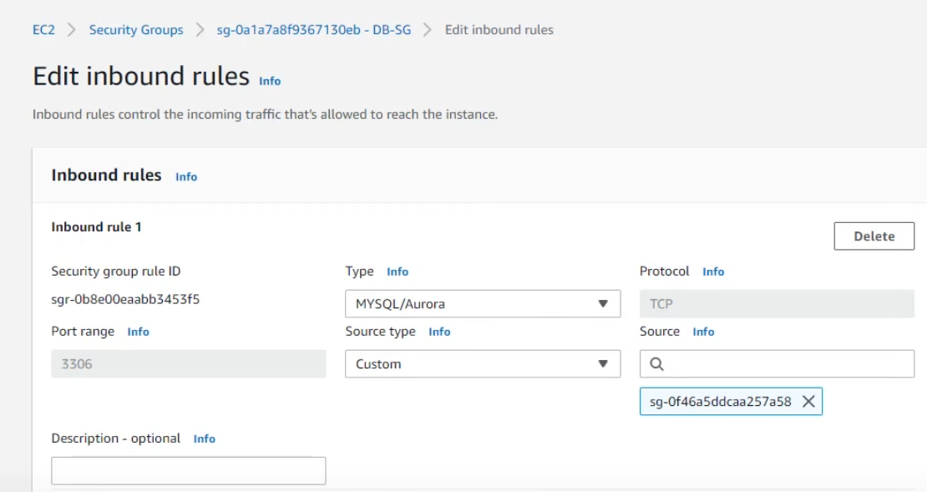

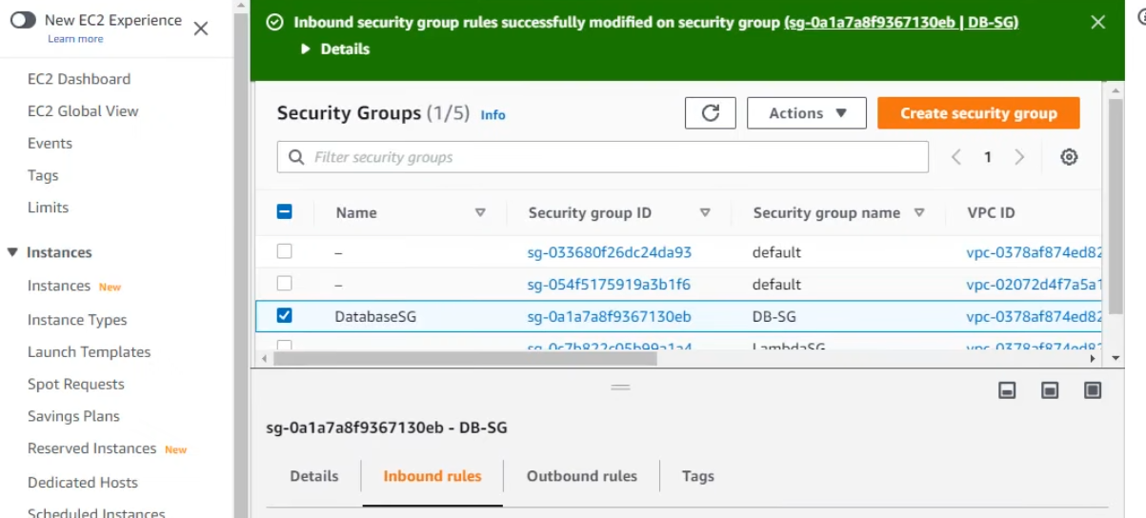

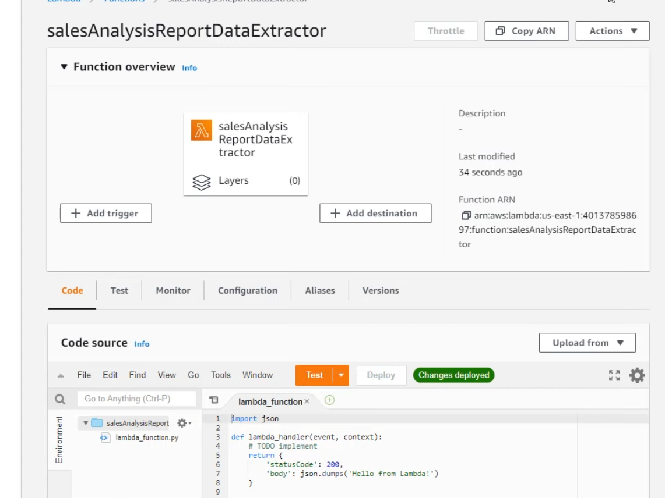

1. Creating simple notification service

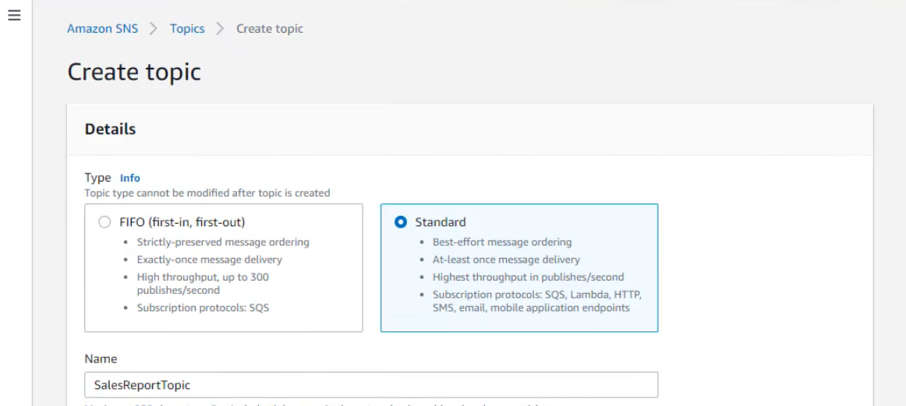

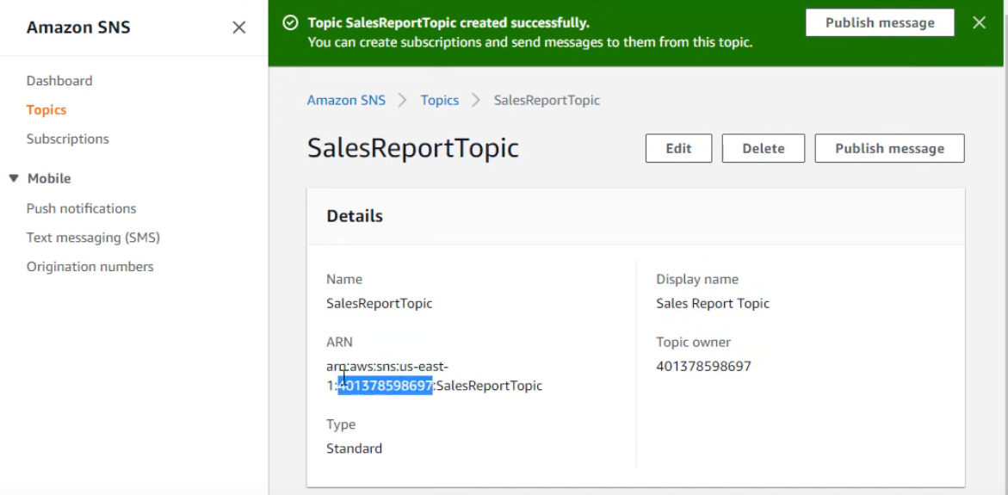

1. Creating a rule watch for certain events then routes them to AWS target you choose.

