CSC3320 System Level Programming

Lab Assignment 11 - Out of lab

Run the following examples through your Homework 4. Parts in this assignment correspond to

programs in Homework 4.

Part 1:

1. unsafepass

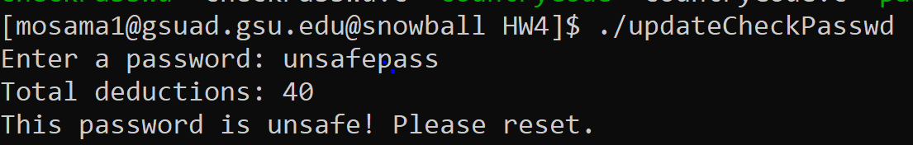

1. SafePaswd0192837465

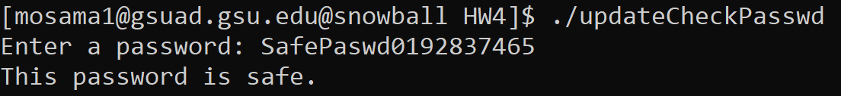

1. bbppddqq11223344

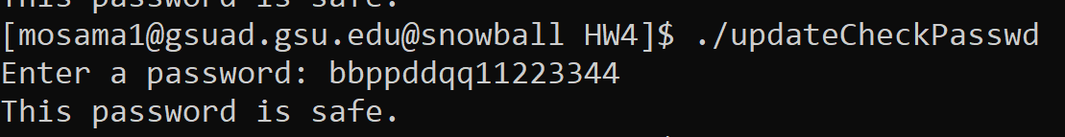

1. T20s9Q02lwmc2a

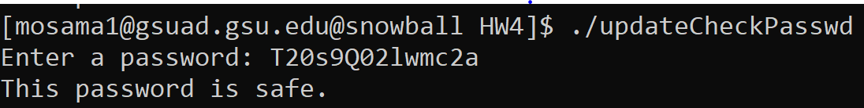

Part 2:

1. radar

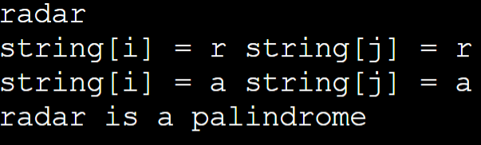

1. Gateman sees name, garageman sees name tag

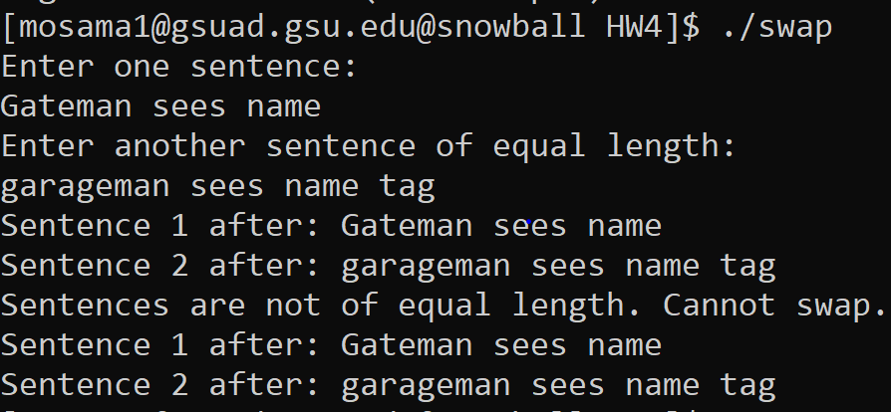

1. Some men interpret fine memos

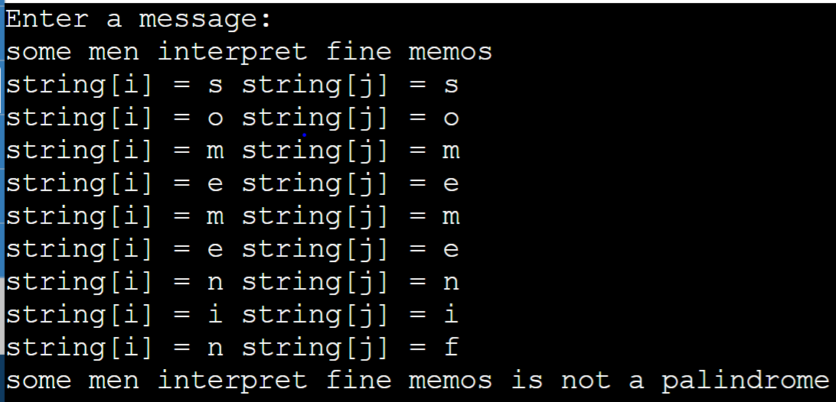

1. Do geese see God?

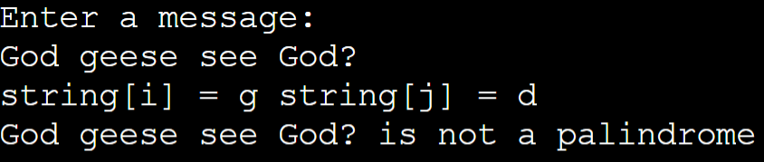

Part 3:

1. 47

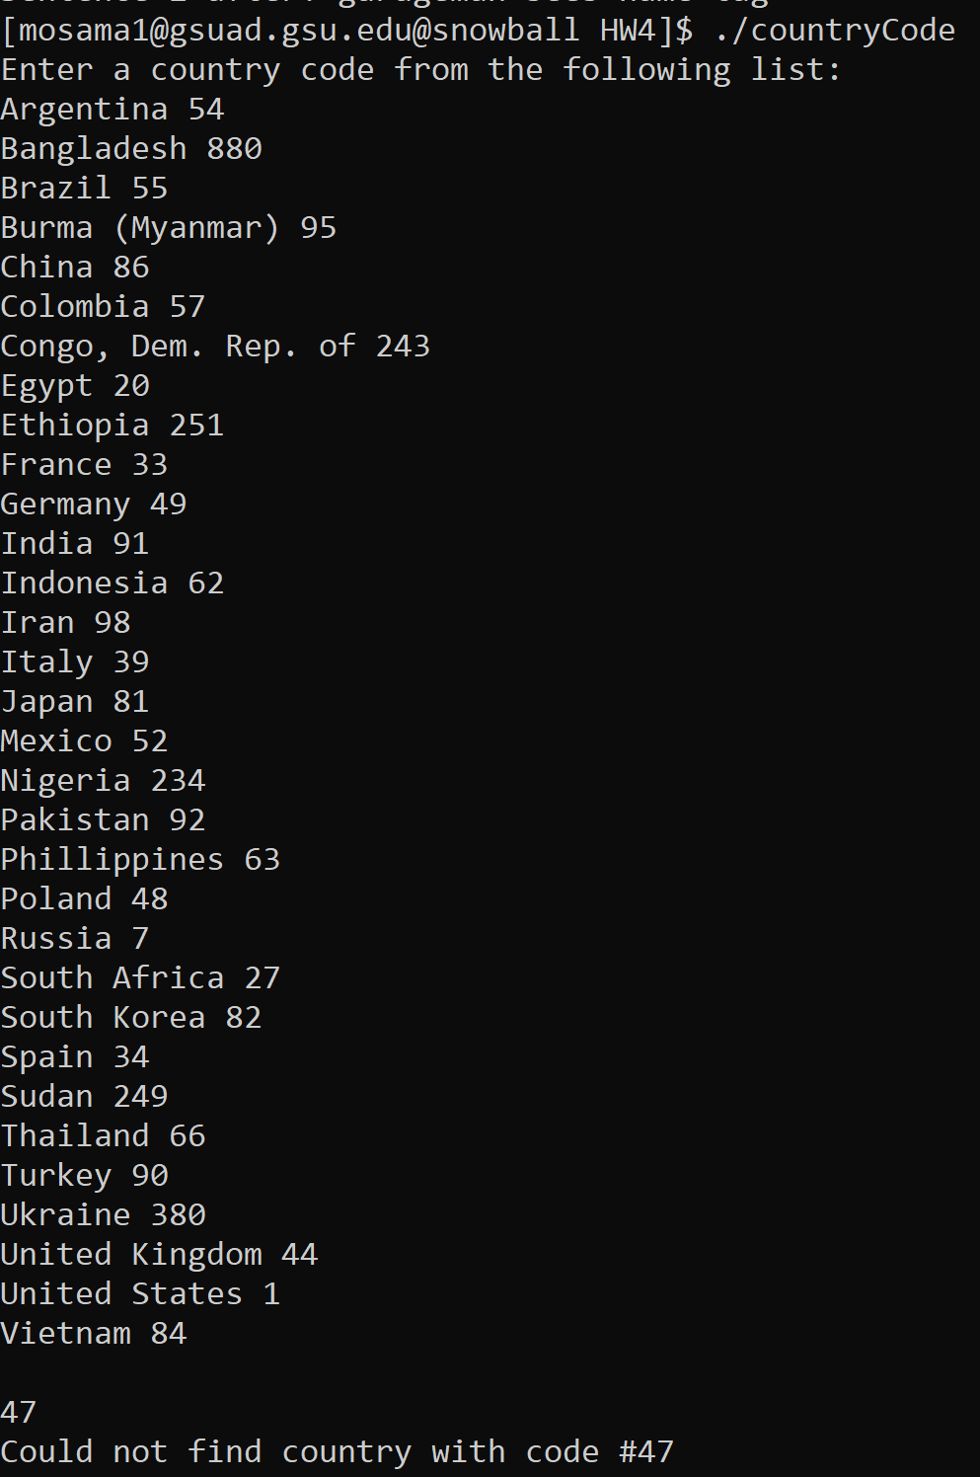

1. 354

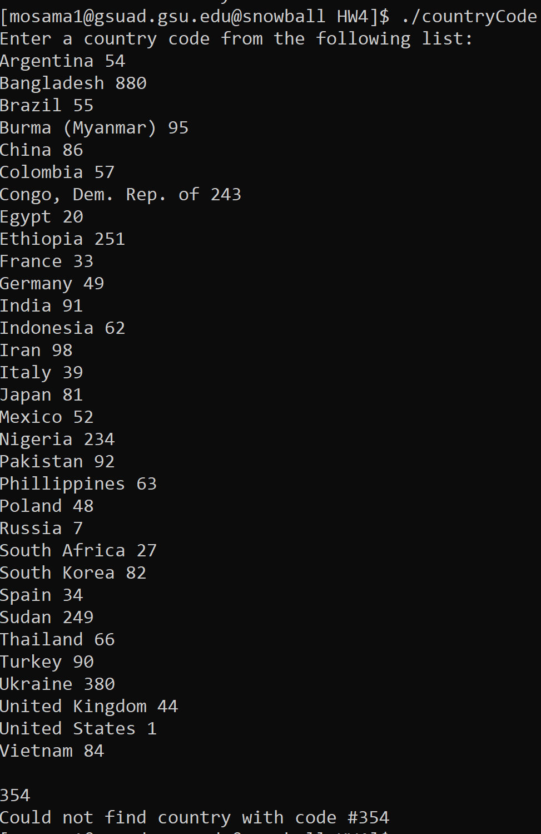

1. 420

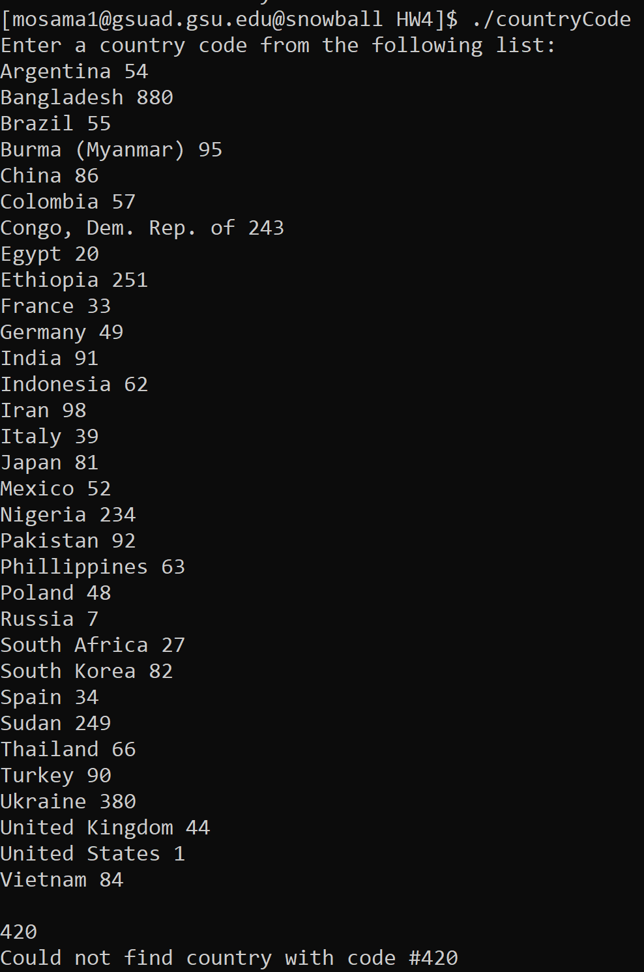

1. 372

