CSC3320 System Level Programming

Lab Assignment 4 - Part 2 (Out of lab)

Instructor: Bello Babatunde

Due at 11:59 pm on Wednesday, Sep. 22, 2021

Purpose: Practices on the grep, fgrep, egrep, sed , awk, and sort commands for text processing.

Note: Please follow the instructions below, and write a report by answering the questions and upload the report (named as Lab4_P2_FirstNameLastName.pdf or .doc) to the Google Classroom Out of Lab Assignment folder 

Please add the lab assignment NUMBER and your NAME at the top of your file sheet. The following table is from Wikipedia. It shows the eleven highest mountains in Georgia.

Brasstown Bald, (summit),4784,feet,Union County Rabun Bald, (summit),4696,feet,Rabun County 

Dick's Knob, (summit),4620,feet,Rabun County

Hightower Bald, (summit),4568,feet,Towns County

Wolfpen Ridge, (ridge high point),4561,feet,Towns and Union Counties

Blood Mountain, (summit),4458,feet,Union County Tray Mountain, (summit), 4430,feet,Towns County

Grassy Ridge, (ridge high point),4420,feet,Rabun County Slaughter Mountain, (summit),4338,feet,Union County Double Spring Knob, (summit),4280,feet,Rabun County

Coosa Bald, (summit),4280,feet,Union County

In above table, each line contains 5 fields separated by comma. Open your terminal and connect to snowball server. After that, go to directory Lab4 (cd ~/Lab4) and please download the file " mountainList.txt" by the following

command (internet access required):

cp /home/bbello1/Public/mountainList.txt mountainList.txt Be sure it succeeds using “ls” to see the file name “mountainList.txt” listed. 1) Use grep to print all lines where the mountains are at Towns or Union

County.

1

Sample Output

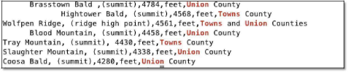2) Use wc and grep to count the number of mountains located at Rabun

County. Hint: please use

pipe | .

Sample Output

3) Finish task 2) by using only grep.

Hint: open the manual page of grep, and check -c option.

4) A. Type command sed ‘s/ridge high point/r.h.p./p’ mountainList.txt  and execute it. Then attach a screenshot of the output.

B.Type command sed -n ‘s/ridge high point/r.h.p./p’ mountainList.txt and  execute it. Then attach a screenshot of the output.

C. Open the manual page of sed and describe what does –n do in sed? D.Describe what does the sed command in (B) do?

5) Use sed to remove the leading spaces in "mountainList.txt" and print out the processed lines.

6) Finish task 5) and save the output to file "newList.txt".

7) Use sed to list the lines beginning with white spaces in "mountainList.txt".

Sample Output

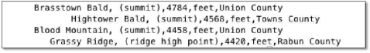

2

8) Use sed to delete the lines where the mountains are only at Union County

in "mountainList.txt".

Sample Output

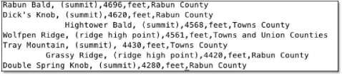9) Use sed to remove the middle three fields in each line of

"mountainList.txt". Hint: Think about the meaning of regex '[^,]'

sed -r 's/,([^,]*){3},/,/g' public/mountainList.txt

Sample Output

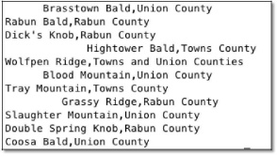

10) Use awk to finish task 9).

11) Use sed to insert a new line “Table: Eleven highest mountains in Georgia” at the beginning of "mountainList.txt".

12) Use sort to print out the sorted lines in alphabetical order according to the names of mountains.

13) Use sort to print out the sorted lines in descending order according to the height of mountains.

14) “When a pattern groups all or part of its content into a pair of parentheses, it captures that content and stores it temporarily in memory. You can reuse that content if you wish by using a back-reference, in the form:\1 or $1, where \1 or $1 reference the first captured group” (Refer to [1]). For example, the following command add a colon between Union and County sed -E ‘s/(Union)\s(County)/\1:\2/g’ mountainList.txt

Attach a screenshot of the output of the above sed command.

15) Now can you write a command to finish task 9) using sed with backreference?

Useful Links:

[1] Introducing Regular Expression - Capturing Groups and Backreferences https://www.safaribooksonline.com/library/view/introducingregular expressions/9781449338879/ch04.html

[2] Drew's grep tutorial http://www.uccs.edu/~ahitchco/grep/

[3] Grep and Regular Expressions!

http://ryanstutorials.net/linuxtutorial/grep.php [4] Web

Scraping with Regular Expressions

https://www.datascraping.co/doc/22/regular-expression