**Part A Questions:**

1. Attach a screenshot of the output in step 4?

Ans1) 

1. Describe what does the shell script **foo*.sh*** do?

Ans2) The foo.sh shell script is running a while loop. We initialize x=0 and keep the counter as i=1 then we start a while loop with the condition i<=3 then we do. It goes through the loop in the first iteration: s=1, x=1 in second iteration s=4, x=5 and in third iteration s=9, x=14. The i=4 and the while loop statement becomes false and we fall out of the loop then echo which means print the x value out. As for ./foo.sh it simply references the path to the script to call a script.

**Part B Question:**

1. Attach a screenshot of the output?

Ansb1)



**Part C Question:**

1. Attach a screenshot of the output?

**Part D Question:**

1. Then put the source code of foo.java in your answer sheet.

public class foo {

public static void main (String[] args) {

int x=0;

int i=0;

do

{

int s= i*i;

x=s+x;

i++;

}

while (i<=3);

System.out.print(x);

}

}



**Part E Questions:**

1. Attach a screenshot of the output in step 4?

1. Try Following command to complie and link hello.c again. And tell what new file is generated after this command? $cc -o hello hello.c

Ans2) hello is the new file created after using command $cc -o hello hello.c

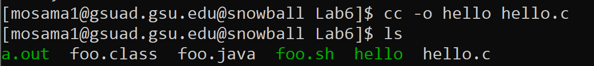

1. Try command below and attach screenshot of the output. $./hello

Ans3) 

1. Now write a C program named as myName.c based on hello.c . In this program, print out your first name and last name instead of “Hello,world”. For example, the output could be “My name is Yuan Long”

Execute your myName.c and attach screenshot of the output. Then write the source code of myName.c in your answer sheet and upload your file myName.c to classroom

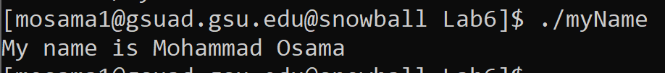

Attached myName.c and wrote the code below as well.

#include<stdio.h>

int main(void)

{

printf("My name is Mohammad Osama\n");

return 0;

}