**CSC3320 System Level Programming**

**Lab Assignment 6 - Part 1 - In-Lab**

**Purpose**: Learn how to correct a shell script and write more complicated shell scripts.

**Part 1:**

**Line #: Error: Correction:**

**Line 1: it doesn’t have the exclamation mark ! in the start of the $#/bin/bash so correction is to write it like this #!/bin/bash**

**Line 2: changed it from /* Check Error Script */ it was using how java has comment instead of # how unix have commands so fixed it by # Check Error Script**

**Line 12: changed it from grep '^[^a]*ce$' << END >> Result to grep '^[^a]*ce$'>> Result << END**

**Line 18: had -ENDHERE changed it to END**

**Line 24: had ls mail $1@student.gsu.edu < Result ls is used for listing all so we change that to just mail $1@student.gsu.edu < Result**

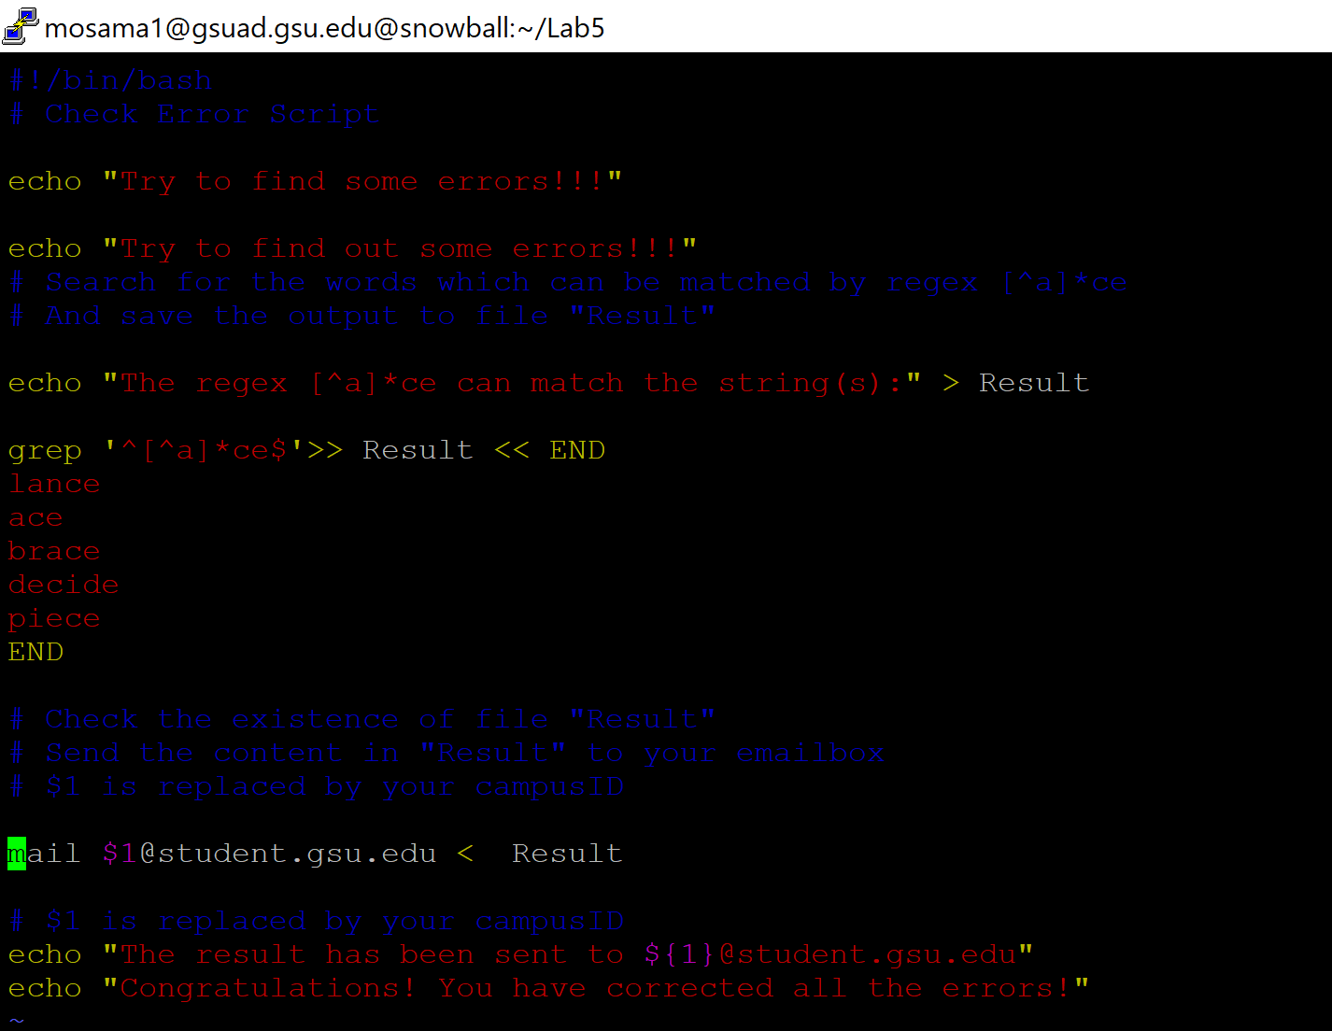

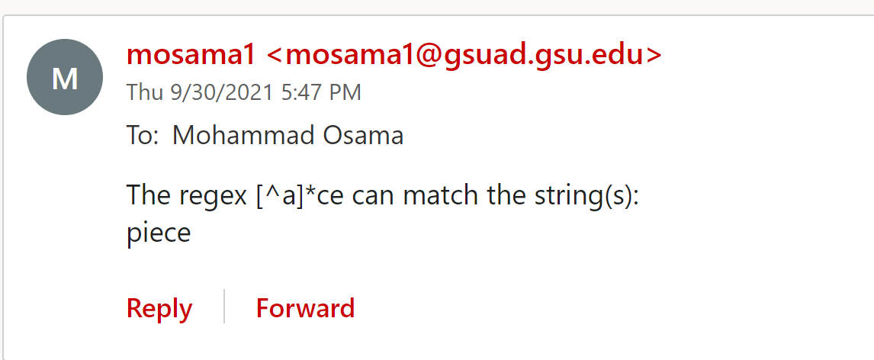

**Part 2:**

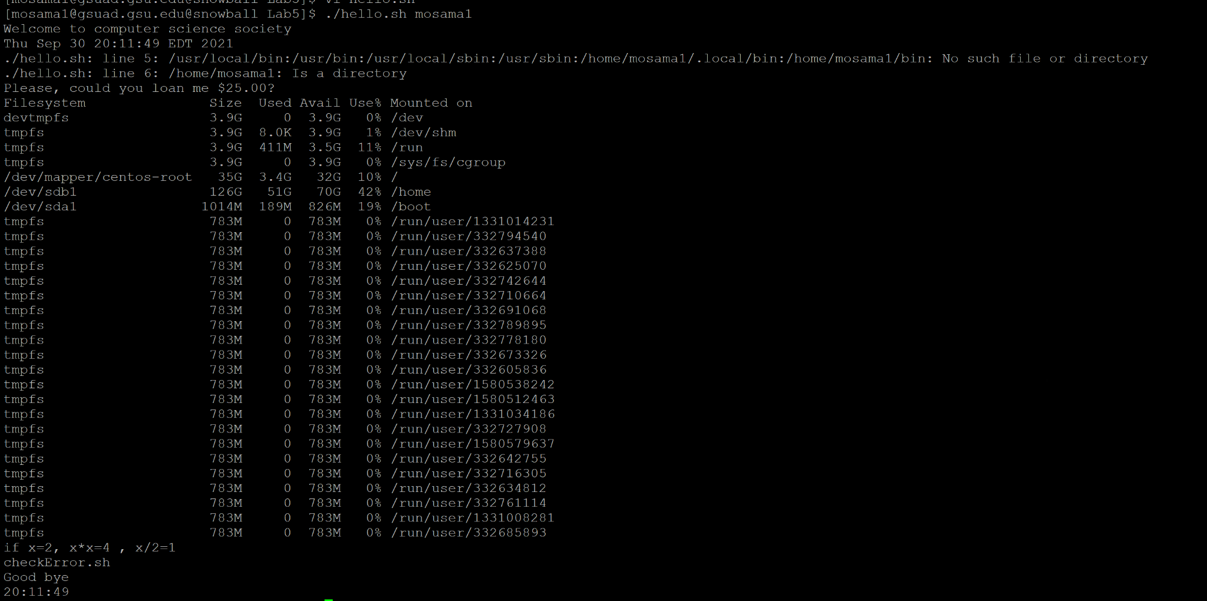

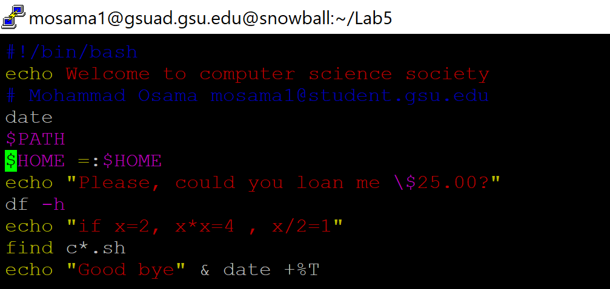

Uploaded the file hello.sh as well!