**CSC3320 System Level Programming**

**Lab Assignment 7 - Post-Lab**

Due at 11:59 pm on Friday, March 5, 2021

Purpose: Learn how to get input and print out formatted results using *scanf* and *printf* separately in C.

**Part 1:**

1) Write a C program named as ***getPhoneNumber.c*** that prompts the user to enter a telephone number in the form (999)999-9999 and then displays the number in the form 999-999-999:

Enter phone number [(999)999-9999]: (404)123-4567 You entered 404-123-4567

Question: Execute your **getPhoneNumber.c** and attach a screenshot of the output. Then write the source code of **getPhoneNumber*.c*** in your answer sheet and upload your file **getPhoneNumber***.****c*** to googleClassroom.

Output:

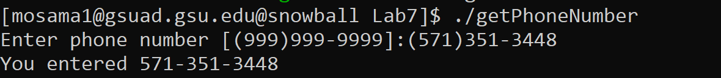

Code:

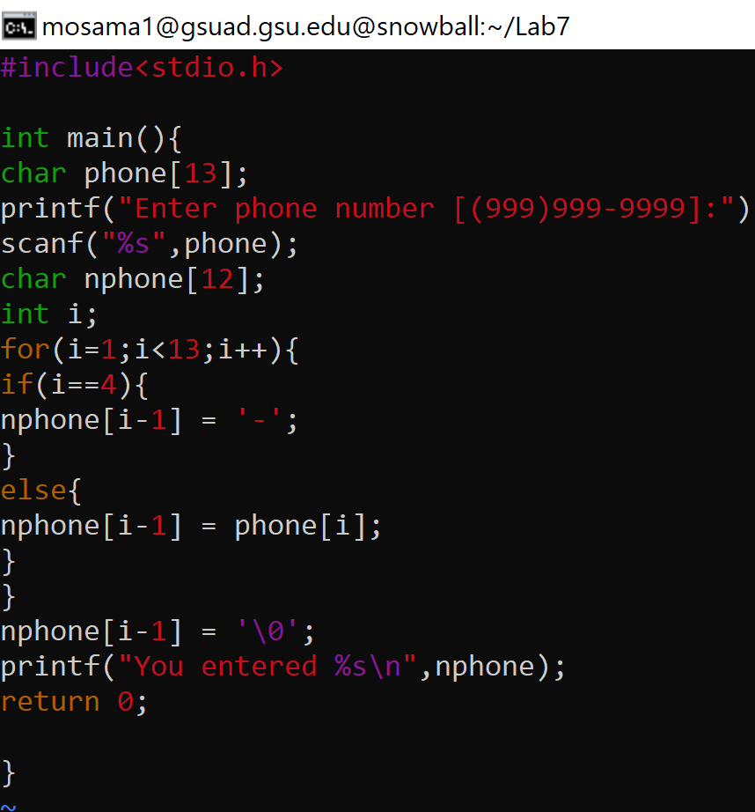

Code and the C file attached:

#include<stdio.h>

int main(){

char phone[13];

printf("Enter phone number [(999)999-9999]:");

scanf("%s",phone);

char input[12];

int i;

for(i=1;i<13;i++){

if(i==4){

input[i-1] = '-';

}

else{

input[i-1] = phone[i];

}

}

input[i-1] = '\0';

printf("You entered %s\n",input);

return 0;

}

2) Write a program named as ***calcPrice.***c that formats product information entered by the user and calculate the total amount of purchase.

Enter item number:583

Enter unit price:13.5

Enter quantity:2

Enter purchase date (mm/dd/yyyy):09/15/2016

Item Unit Price QTY Purchase Date Total Amount 583 $ 13.50 2 9/15/2016 $ 27.00

The item number, quantity and date should be left justified; the unit price and total amount should be right justified. Hint: Use tabs to line up the columns. Question: Execute your **calcPrice.c** and attach a screenshot of the output. Then write the

source code of **calcPrice.c** in your answer sheet and upload your file **calcPrice.c** to classroom.

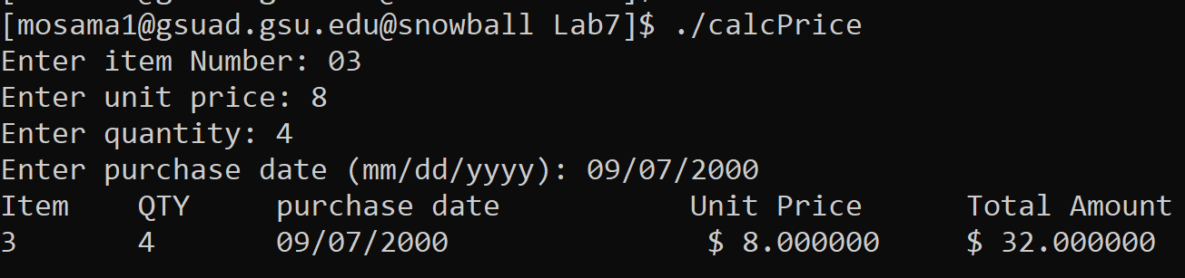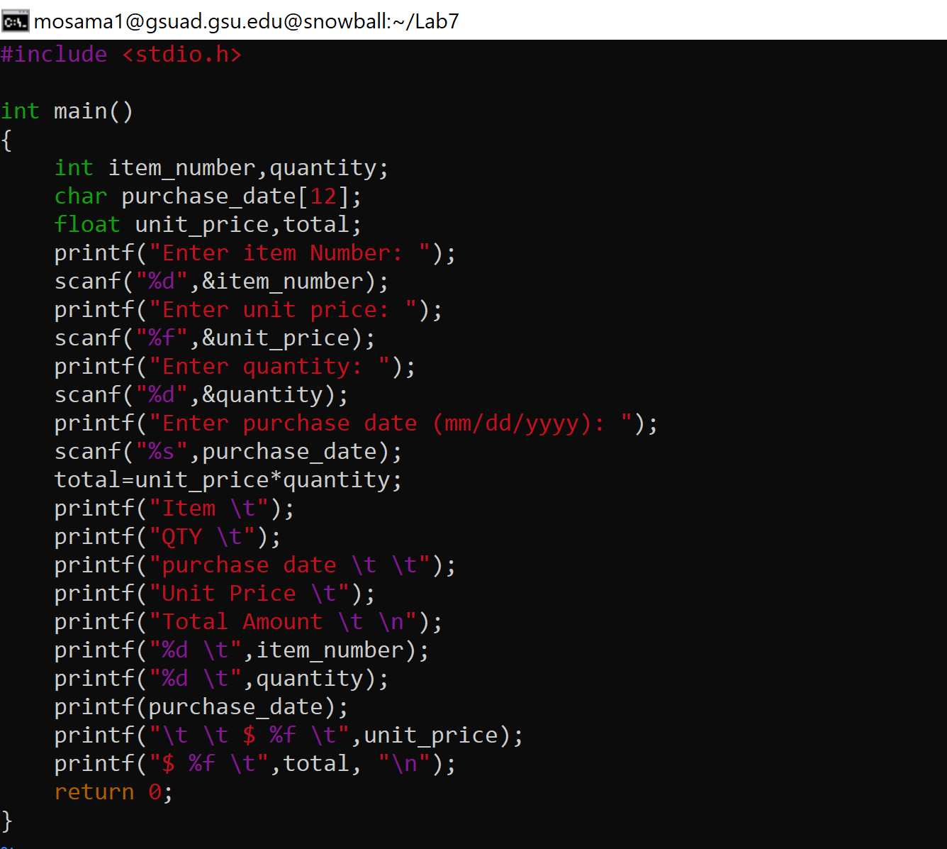

Code and the C file attached.

#include <stdio.h>

int main()

{

int item_number,quantity;

char purchase_date[12];

float unit_price,total;

printf("Enter item Number: ");

scanf("%d",&item_number);

printf("Enter unit price: ");

scanf("%f",&unit_price);

printf("Enter quantity: ");

scanf("%d",&quantity);

printf("Enter purchase date (mm/dd/yyyy): ");

scanf("%s",purchase_date);

total=unit_price*quantity;

printf("Item \t");

printf("QTY \t");

printf("purchase date \t \t");

printf("Unit Price \t");

printf("Total Amount \t \n");

printf("%d \t",item_number);

printf("%d \t",quantity);

printf(purchase_date);

printf("\t \t $ %f \t",unit_price);

printf("$ %f \t",total, "\n");

return 0;

}

**Part 2: (Optional)**

Note : This part is not for grading. But you will get some feedback. Can you write a shell script to finish the same task as in question 1) of Part 1?

1

***Submssion***:

• Please follow the instructions below step by step, and then write a report by answering the questions and upload the report (named as

Lab7_FirstNameLastName.pdf or Lab7_FirstNameLastName.doc) to Google Classroom, under the rubric Lab 7 Out-of-lab Assignment. • Upload files **getPhoneNumber.c** and **calcPrice.c** to the rubric named “Lab7” of the classroom. **Note: if you do not upload the C files you would get zero for this assignment**.

• Please add the lab assignment NUMBER and your NAME at the top of your file sheet.

2