4)Set a break point at the line of statement “while (num>0)”

Ans4) break 6 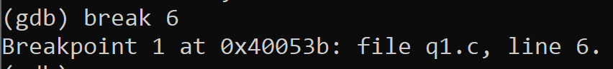

5) Run the program until the first break point

Ans5) r

Run the loop and fill the table below

|  |  |  |  |  |
| --- | --- | --- | --- | --- |
| Ans 6) | 1st iteration | 2nd iteration | 3rd iteration | 4th iteration |
| num | 112 | 11 | 1 | 0 |
| rev_num | 5 | 52 | 521 | 5211 |

8) what does the foo function do?

Ans 8) The foo function is reversing the given number

**Part 2**

First Error: changed \n to ‘\n’ – Line 11

Second Error: Space wasn’t initialized and assigned -Line 8

Third Error – Casted letter/words as they were into to float in order to support decimal numbers.

Assigned all value to 0.

Output displayed below:

