Part 1

1a) Run the C program, attach a screenshot of the output in the answer sheet.

Part 2

A) 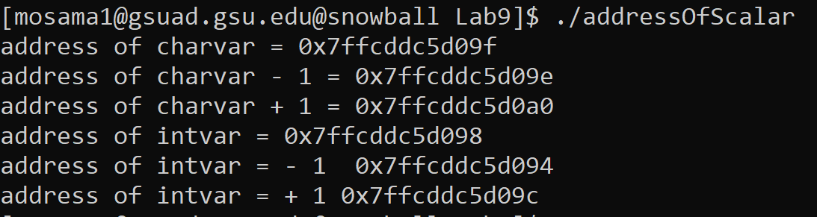

B)

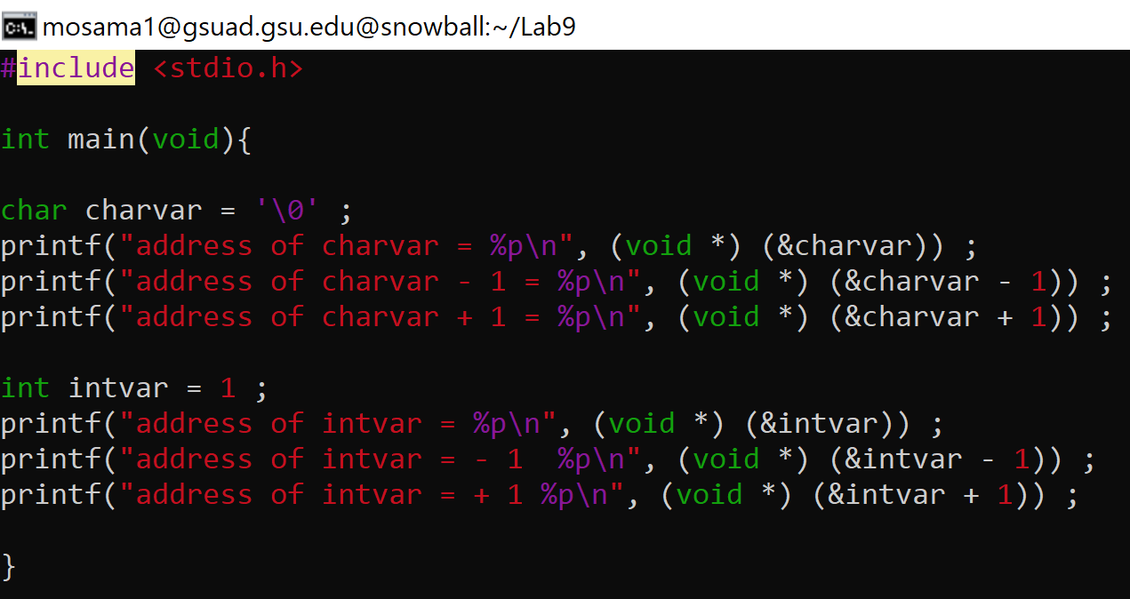

B) Source code:

#include<stdio.h>

int main(void) {

char charvar = '\0' ;

printf("address of charvar = %p\n", (void \*) (&charvar)) ;

printf("address of charvar - 1 = %p\n", (void \*) (&charvar - 1)) ;

printf("address of charvar + 1 = %p\n", (void \*) (&charvar + 1)) ;

int intvar = 1 ;

printf("address of intvar = %p\n", (void \*) (&intvar)) ;

printf("address of intvar = - 1 %p\n", (void \*) (&intvar - 1)) ;

printf("address of intvar = + 1 %p\n", (void \*) (&intvar + 1)) ;

}

C) Then explain why the address after intvar is incremented by 4 bytes instead of 1 byte.

Ans C) int is 4 bytes so to go to the next memory address or the after that is incremented 4 bytes instead of 1 byte.

Part 3

Ans A) Run the C program, attach a screenshot of the output in the answer sheet.

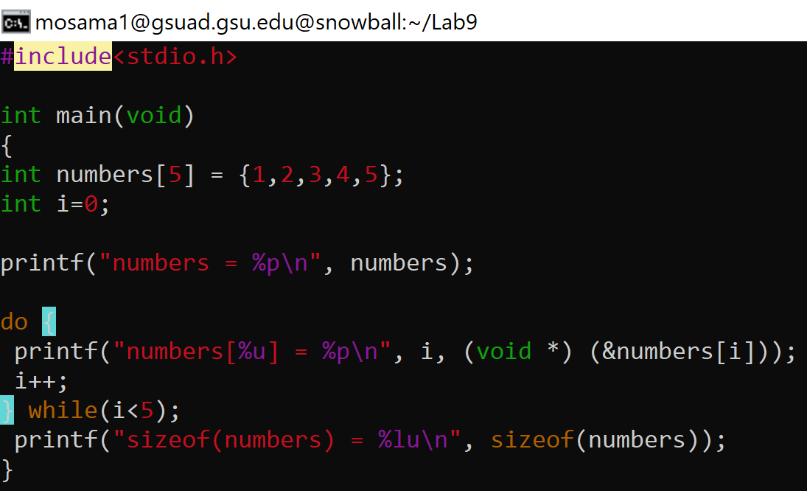

Ans B) Yes, they’re the same 0x7ffe71d84ae0

Ans C) printf(“sizeof(numbers) = %u\n”, sizeof(numbers));