Screenshot 1
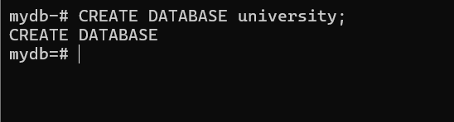

Screenshot 2
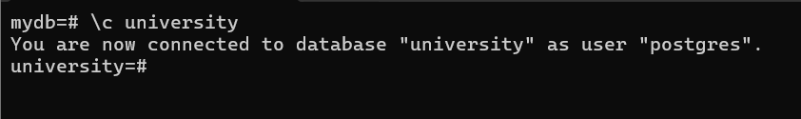

Screenshot 3
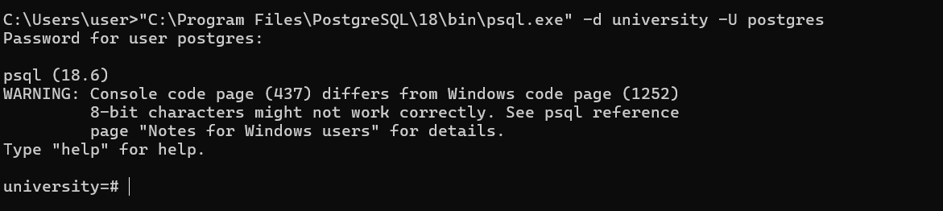

Screenshot 4
