Screenshot 1
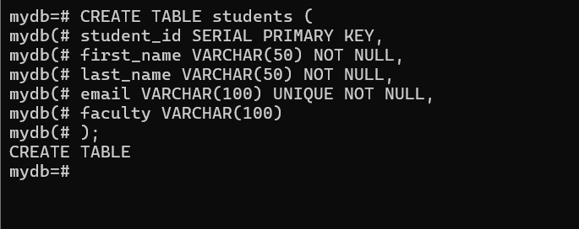

Screenshot 2
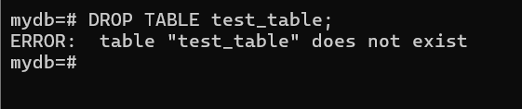

Screenshot 3
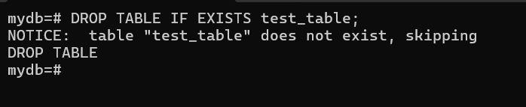

Screenshot 4
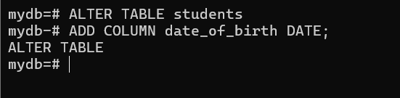

Screenshot 5
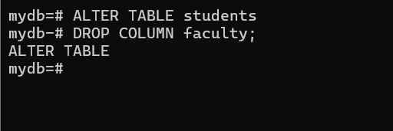

Screenshot 6
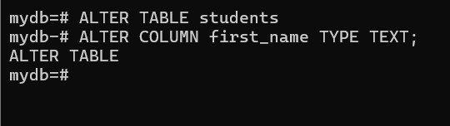

Screenshot 7
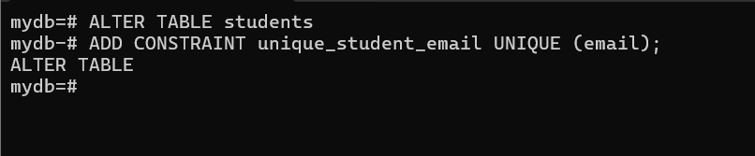

Screenshot 8
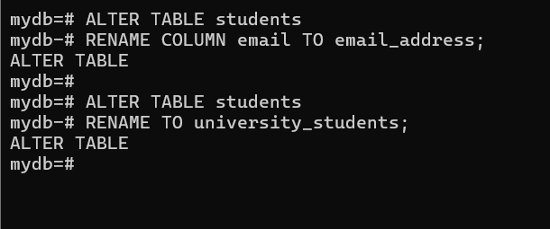

Screenshot 9
