Screenshot 1
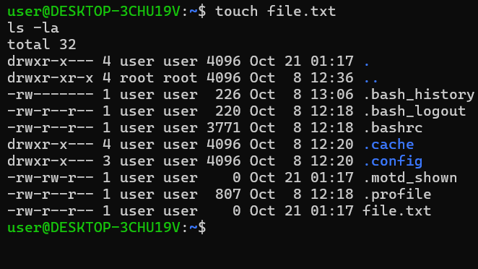
Screenshot 2
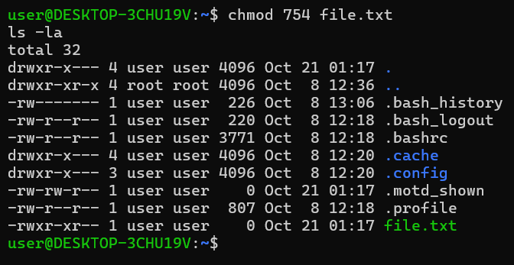
Screenshot 3
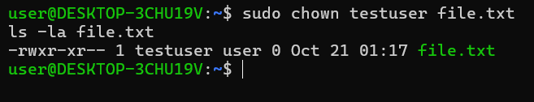
Screenshot 4
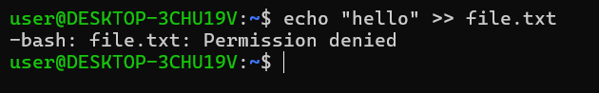
Screenshot 5
