Screenshot 1
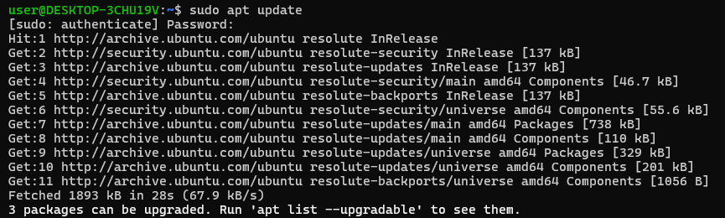
Screenshot 2
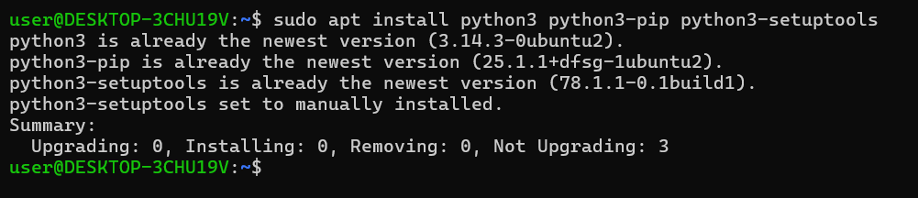
Screenshot 3
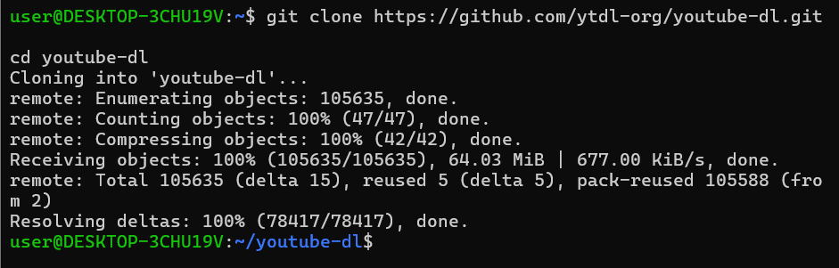
Screenshot 4
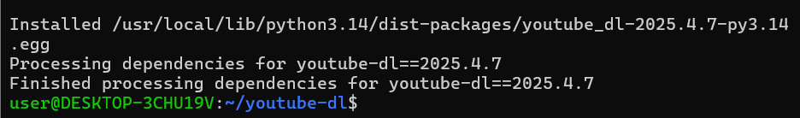
Screenshot 5
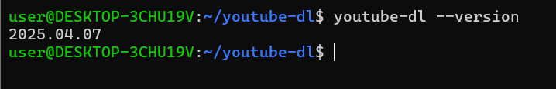
Screenshot 6
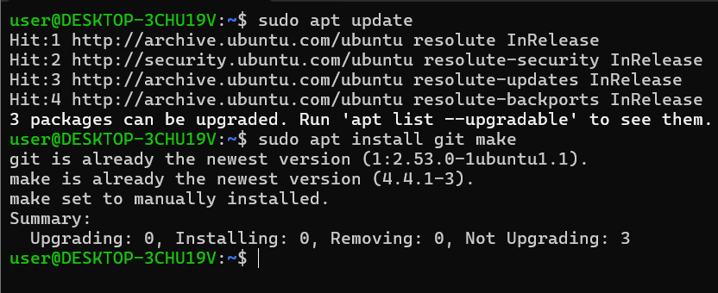
Screenshot 7
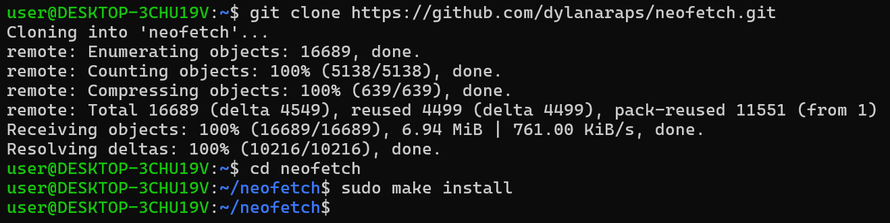
Screenshot 8
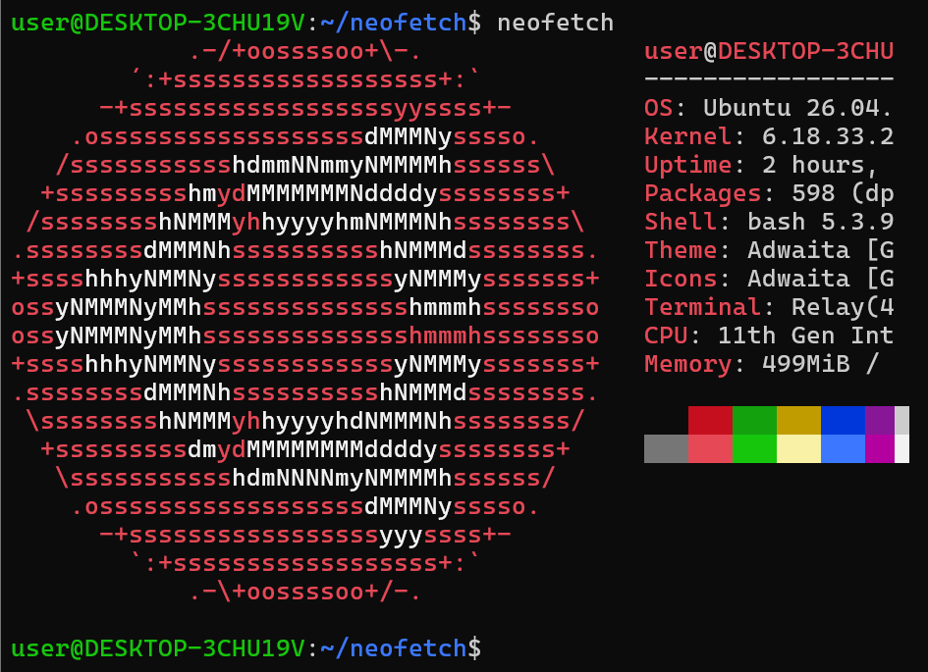
Screenshot 9
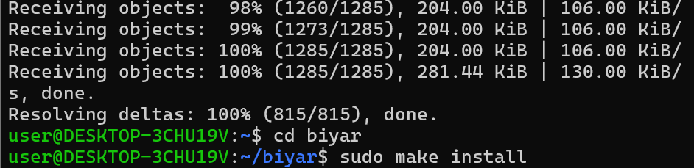
Screenshot 10
