Radiuma
A Shareable Executable Workflow Generator for Medical Image Analysis
Version 1.0.0

Developed by:
Quantitative Radiomolecular Imaging and Therapy (Qurit) lab & program
BC Cancer Research Institute
Vancouver, BC, Canada
Quantitative Radiomolecular Imaging & Therapy
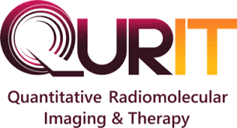
http://www.qurit.ca

In Collaboration with:
Technological Virtual Collaboration Company (TECVICO CORP.)
Vancouver, BC, Canada
TECVICO
Technological Virtual Collaboration
http://www.tecvico.com





