Heaven’s Light is Our Guide
Rajshahi University of Engineering and Technology
Department of Computer Science and Engineering

Lab Report

For the course
CSE 3206: Software Engineering Sessional

By  MD Rakibul Hasan Rifat  2103057 | To  Md. Sozib Hossain  Lecturer,  Dept. Of CSE, RUET

Contents
Project Title 3
Objectives 3
Theoretical Background 3
Python unittest Framework: 3
System Architecture 4
Module Hierarchy 4
Level 1: Basic Calculator (`calculator.py`) 4
Level 2: CT Calculator (`ct_calculator.py`) 4
Level 3: SGPA Calculator (`sgpa_calculator.py`) 5
Level 4: CGPA Calculator (`cgpa_calculator.py`) 5
Level 5: Performance Predictor (`predictor.py`) 6
Testing Methodology 6
Test Structure 6
Test Categories example: 6
Boundary Tests (Edge Cases) 6
Application Working: 7
Test Outputs 8
Project Structure 9
Conclusion 9


Scan Me i: Link to repository
(https://github.com/MohammadRakibulHasan04/Unit-Testing-CSE-3206)

Project Title
Unit Testing — Student Performance Predictor System.
Project Overview
This project implements a comprehensive Student Performance Predictor System that calculates CT (Class Test) averages, SGPA (Semester Grade Point Average), CGPA (Cumulative Grade Point Average), and provides academic performance predictions. The system demonstrates the implementation of unit testing principles using Python's `unittest` framework with a modular, dependency-based architecture.

Objectives
- Implement a five-level hierarchical module system with incremental dependencies
- Achieve comprehensive test coverage for all functional modules. Demonstrate best practices in unit testing, including test isolation and edge case handlingSWLC Methodology

Theoretical Background
Unit testing is a software testing methodology where individual units or components of software are tested in isolation to verify that each unit functions correctly according to its specification.
The project follows TDD principles where tests are written to validate:
- Expected Behavior: Normal operating conditions with valid inputs
- Edge Cases: Boundary conditions (zero, empty lists, exact thresholds)
- Error Handling: Invalid inputs and exception scenarios

Python unittest Framework:
The `unittest` module provides:
- TestCase class: Base class for creating test cases
- Assertions: Methods like `assertEqual()`, `assertRaises()`, `assertTrue()`
- Test Discovery: Automatic test detection and execution
- Test Fixtures: Setup and teardown methods for test preparation

System Architecture

Module Hierarchy
Level 1: calculator.py (Base Module)
↓
Level 2: ct_calculator.py
↓
Level 3: sgpa_calculator.py
↓
Level 4: cgpa_calculator.py
↓
Level 5: predictor.py (Complete System)

Level 1: Basic Calculator (`calculator.py`)
Purpose: Foundation module providing arithmetic operations
Functions:
- `add(a, b)` - Addition of two numbers
- `subtract(a, b)` - Subtraction operation
- `multiply(a, b)` - Multiplication operation
- `divide(a, b)` - Division with zero-check validation
- `average(numbers)` - Calculate mean of a list
- `add_all(numbers)` - Sum all numbers in a list
Dependencies: None

Level 2: CT Calculator (`ct_calculator.py`)
Purpose: Calculate best 3 out of 4 CT marks (university grading policy)

Functions:
- `sort_marks(marks)` - Sort in descending order
- `get_best_n(marks, n)` - Extract top n marks
- `calculate_ct_average(ct_marks)` - Average of best 3 CTs
- `validate_ct_marks(marks)` - Ensure marks in 0-20 range
Dependencies: `calculator.py`

Level 3: SGPA Calculator (`sgpa_calculator.py`)
Purpose: Calculate semester GPA from course grades
Functions:
- `marks_to_grade(marks)` - Convert numerical marks to letter grades
- `grade_to_points(grade)` - Map letter grades to grade points (4.0 scale)
- `calculate_course_marks(ct_marks, attendance, final_exam)` - Total course marks
- `calculate_sgpa(courses)` - Weighted GPA for a semester
Dependencies: `calculator.py`, `ct_calculator.py`

Level 4: CGPA Calculator (`cgpa_calculator.py`)
Purpose: Calculate cumulative GPA across semesters
Functions:
- `calculate_cgpa(semesters)` - Weighted CGPA calculation
- `get_total_credits(semesters)` - Sum of completed credits
- `is_on_track(cgpa, min_cgpa)` - Check academic standing
- `calculate_required_sgpa(...)` - Predict required performance
Dependencies: `calculator.py`, `sgpa_calculator.py`

Level 5: Performance Predictor (`predictor.py`)
Purpose: Generate predictions and recommendations
Functions:
- `get_academic_standing(cgpa)` - Determine academic classification
- `predict_graduation_cgpa(...)` - Project final CGPA
- `get_improvement_tips(cgpa, target_cgpa)` - Personalized recommendations
- `generate_report(semesters, target_cgpa)` - Comprehensive performance report
Dependencies: All previous modules

Testing Methodology

Test Structure
Each module has a corresponding test file with multiple test classes:
src/
├── calculator.py → test_calculator.py (7 test classes)
├── ct_calculator.py → test_ct_calculator.py (4 test classes)
├── sgpa_calculator.py → test_sgpa_calculator.py (4 test classes)
├── cgpa_calculator.py → test_cgpa_calculator.py (5 test classes)
└── predictor.py → test_predictor.py (5 test classes)

Total Test Classes: 25
Coverage Strategy: Each function has dedicated test class with multiple test methods

Test Categories example:

Boundary Tests (Edge Cases)
Tests at operational limits:
def test_grade_boundary(self):
self.assertEqual(marks_to_grade(80), 'A+')
self.assertEqual(marks_to_grade(79), 'A')

Integration Tests
Tests validating module interactions:
def test_course_marks_normal(self):
ct_marks = [18, 16, 15, 14] Calls ct_calculator
attendance = 8
final_exam = 55
result = calculate_course_marks(ct_marks, attendance, final_exam)
self.assertAlmostEqual(result, 79.33, places=2)

Application Working:
The application uses mock data in `main.py` to demonstrate the testing, no user input is taken in this case. The main application `main.py` includes a demonstration CLI that shows all modules working together:
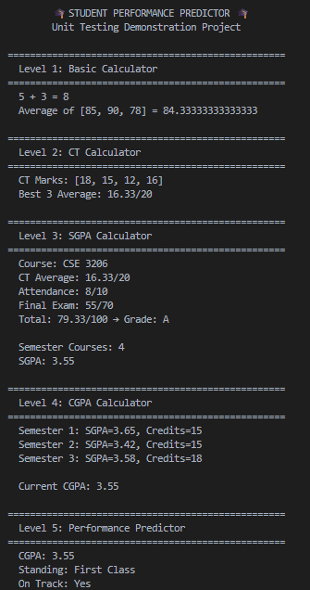
Figure 1: Main application CLI output

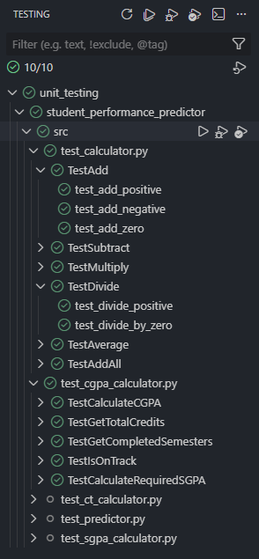
Test Outputs
Figure 2: Test Interface (GUI in VS Code)
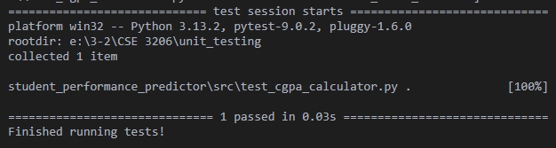
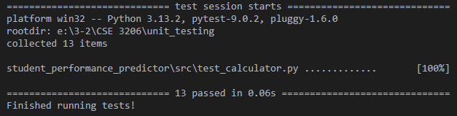
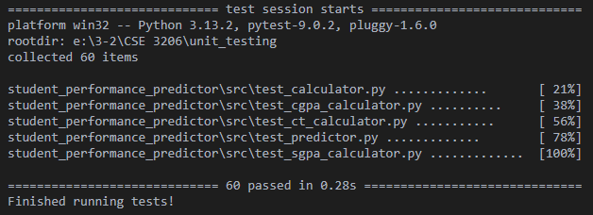
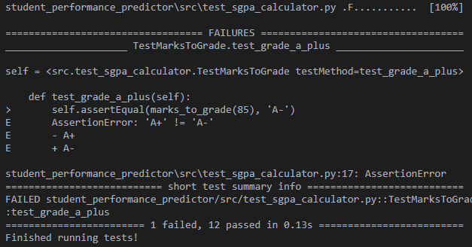
Figure 3: Testing a module
Figure 4: Testing a file
Figure 5: Running all tests
Figure 6: Tests detect error and shows the error details

Project Structure
student_performance_predictor/
├── src/
│ ├── __init__.py
│ ├── conftest.py Test configuration
│ ├── calculator.py Level 1: Base arithmetic
│ ├── test_calculator.py 16 tests
│ ├── ct_calculator.py Level 2: CT calculations
│ ├── test_ct_calculator.py 9 tests
│ ├── sgpa_calculator.py Level 3: Semester GPA
│ ├── test_sgpa_calculator.py 10 tests
│ ├── cgpa_calculator.py Level 4: Cumulative GPA
│ ├── test_cgpa_calculator.py 10 tests
│ ├── predictor.py Level 5: Predictions
│ ├── test_predictor.py 12 tests
│ └── main.py CLI demonstration

Conclusion
- Successfully implemented a 5-level hierarchical system with 57 unit tests.
- Achieved 100% test pass rate across all modules
- Demonstrated comprehensive testing strategies including positive, negative, and boundary tests

