# Component

#initials:

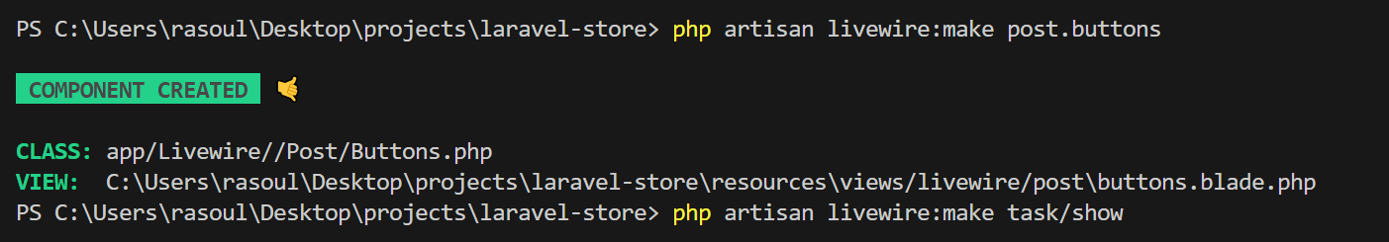



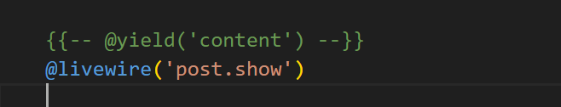

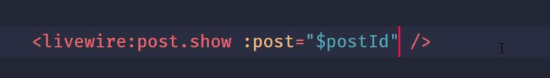

Mount function is like cunstructor and will run before render. As yellow line will be send automaticly to view we can fill it in mount, and we can don’t use mount and fill title directly in @livewire.

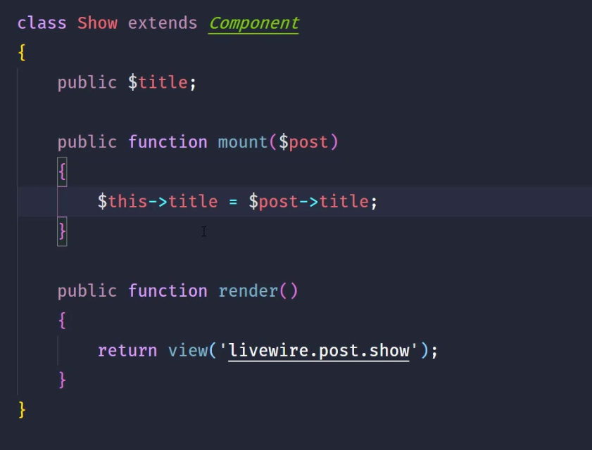



#Full page component

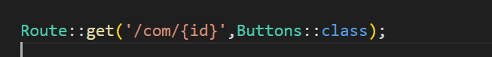

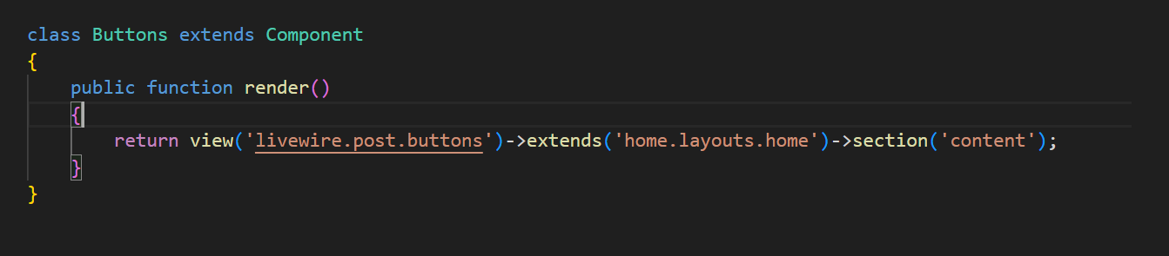

#nested components: each component return a blade and obviuosly we call a lot of components in it

# Property

#binding:

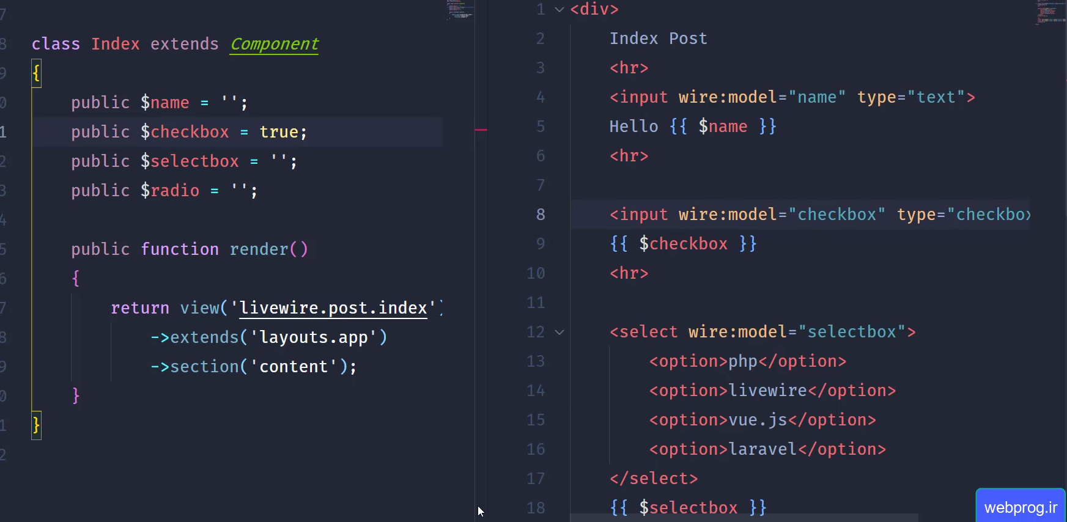



Note-1-green underlined: it use for all kind of inputs, its like sayin by any changes(like keyup event ) connect to my model(component class that renderd me) and change the existence variable by my name, it is a replace for name attribure ,so that mean if we have set similar green uderlined to get it as array, and do the same for radios

## modifiers:

Cunsider bindig instrunction, by modiphiers are for hanling an decrease request sendiing for changes that we must use it.

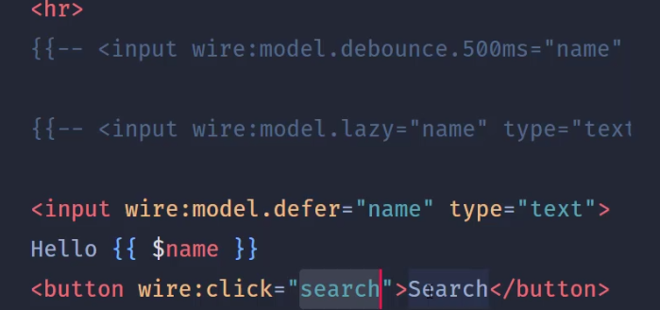

###debounce: we set a custom delay time

### lazy: on fouces out we can use it

###defer : needs a live wire action to send request

##computed property

Tip: we can use it for cash request to database, its not oly for database it cash every hing needed till the parrametest change, as long as postId is 1 it willget post from cash.

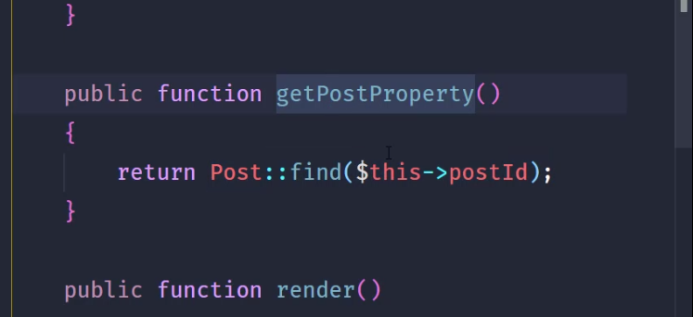

# Action

#action and event:

##click event

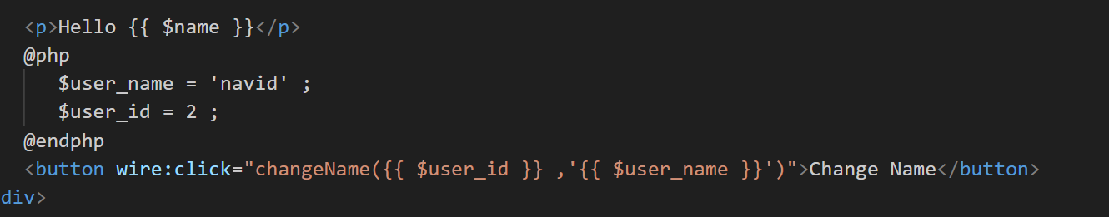

Rendered view

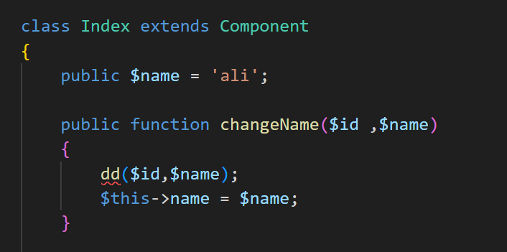

## submit event:

Note:we use prevent modifier to perevent submiting of form by button

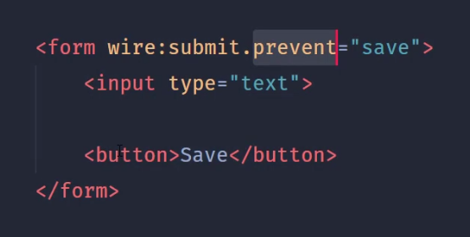

#emit: to do some thing in another component class,its like event and lisiner

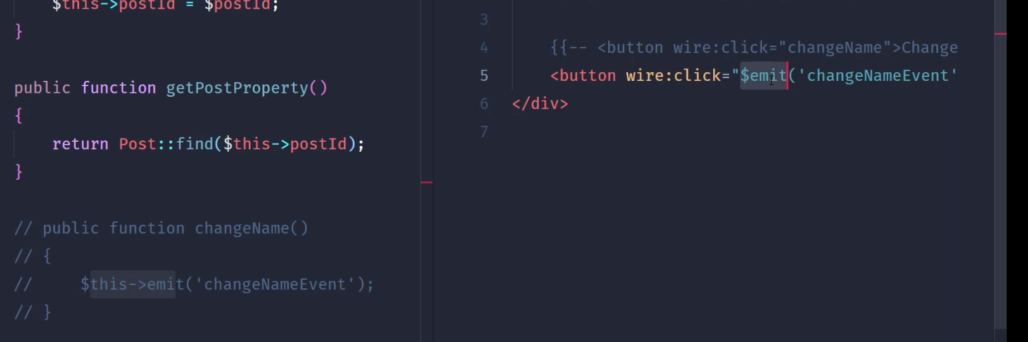



After this do bellow:

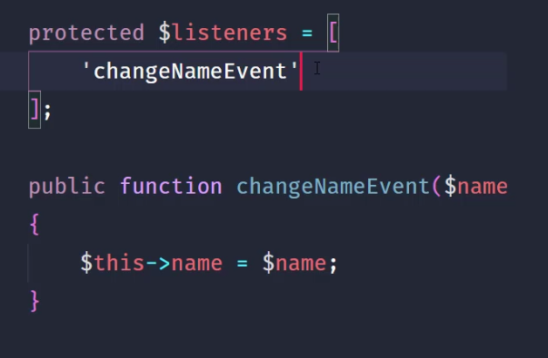

##More option:

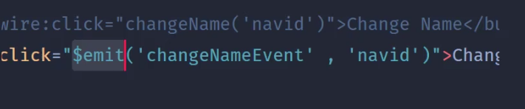

Evnet, parameters

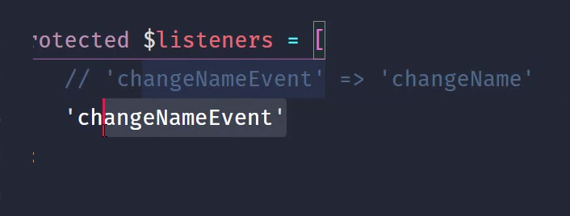

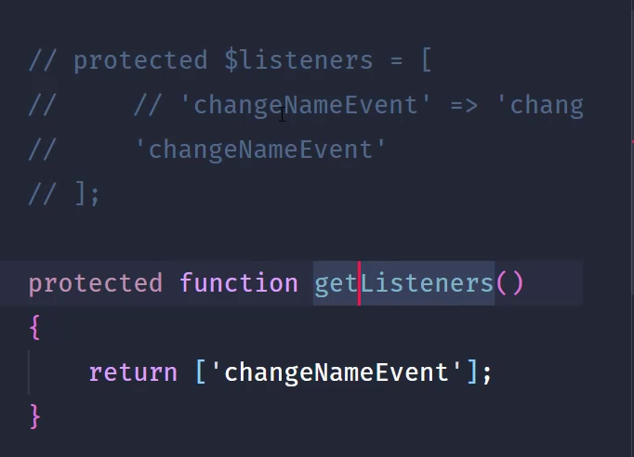

# Usefull stuff

## Documentation:

#properties:

## pull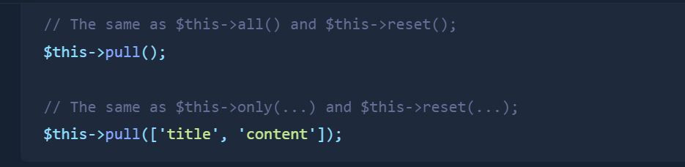

## Interesting

# send parameter to component:

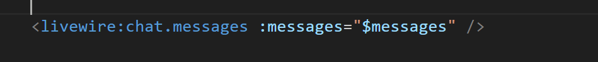



# My spa preceed:

1-using wire:navigate

2-use lazy because of placeholder method