# Initials:

#add vite to an exisit project:

1)



2)

We need this to tell npm(package.json is the file that npm read it) to run dev command for vite to start.

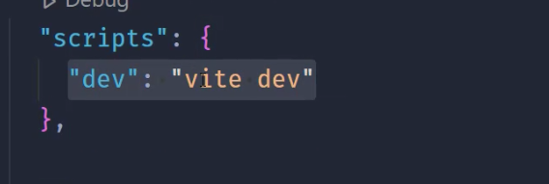

Package.json

3) optinal

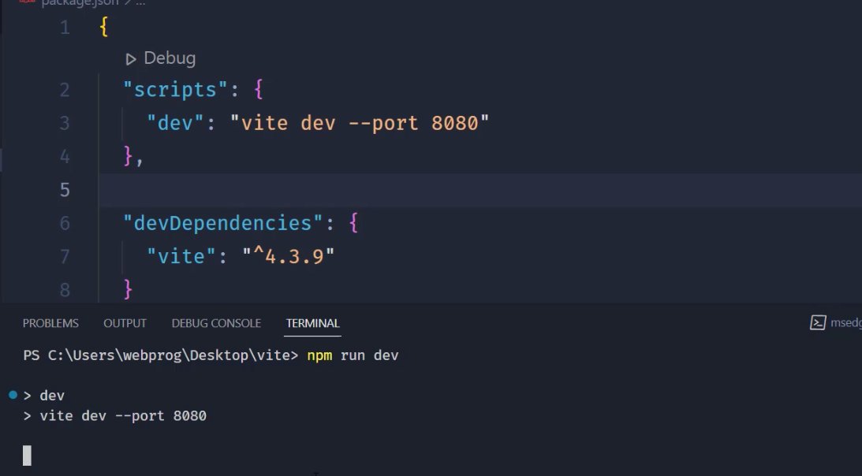



# create a project with vite:

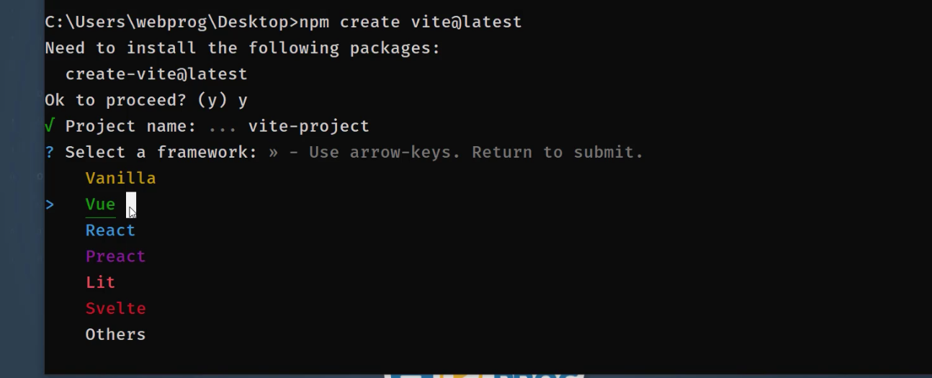

## add css and libraries directly in js file

**# import css in js file:**

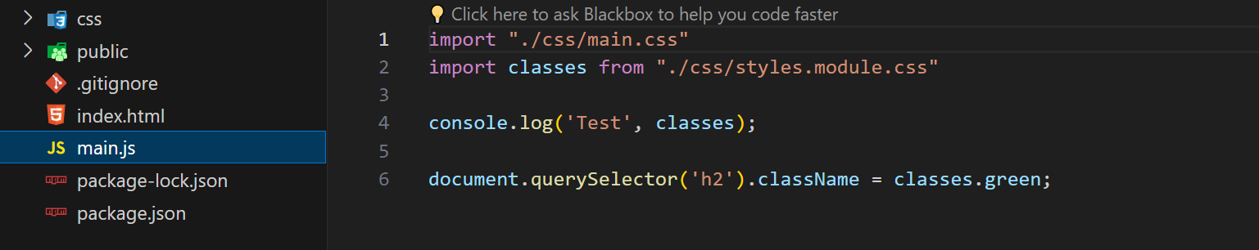



Main.js

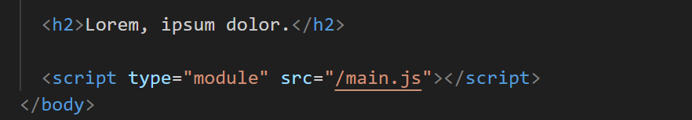

Index.html

## tip: we can import our css in a main css file and then import main in js file

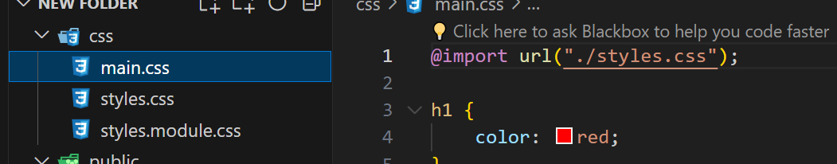



# add libraries(hear bootstrap)

After npm instal bootstrap -->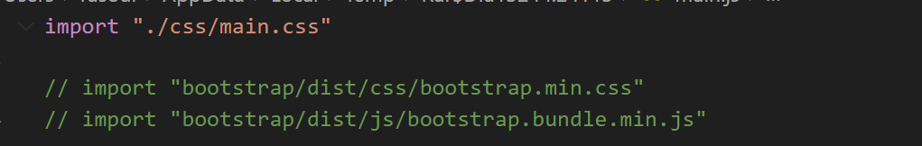



##tip: I rather to import css file 

#how to load img, backgrounf ,font :

Vite is ready for thid kinda stuf and only thing that we need for that is to address this file from public directory.

##font:

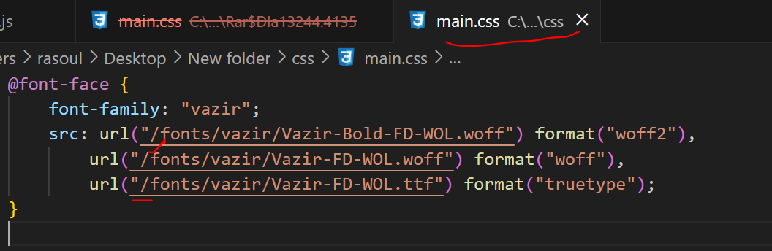

##background: 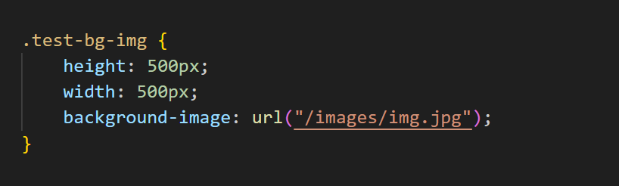



## even img tag: 



Note: slash in all types mean start addressing in public directory

## Vite in laravel :

#css : with import

Js: for using classes refrenced in app.js we should put the type of script tag mogdle

# # Interesting:

#npm unistal 