# Initials

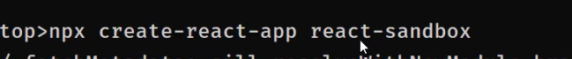

#logic of relative address in javascript:

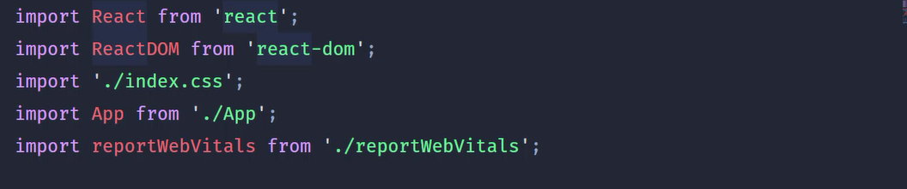

Without <<.>> it means from node_modules with <./> it means currrent directory

# react compnent types to write:

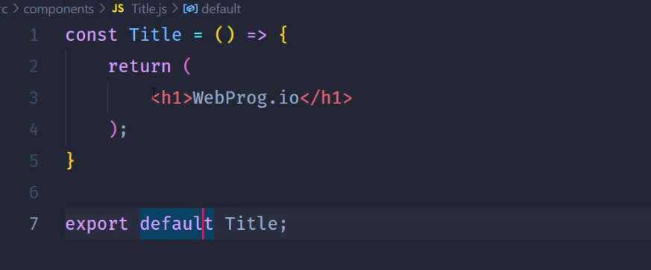

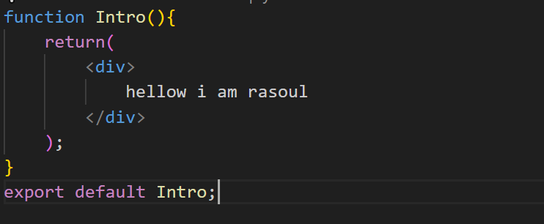

Tip: after export we can import.

# jsx

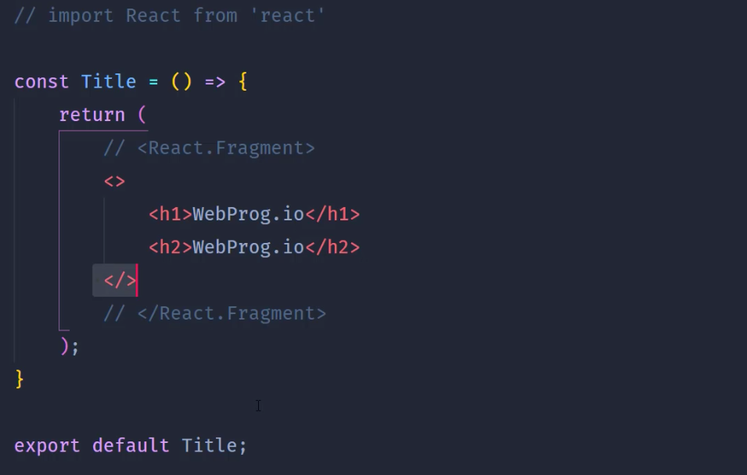



With fragment we can have to element aside eachother



# inline css and variables in component:

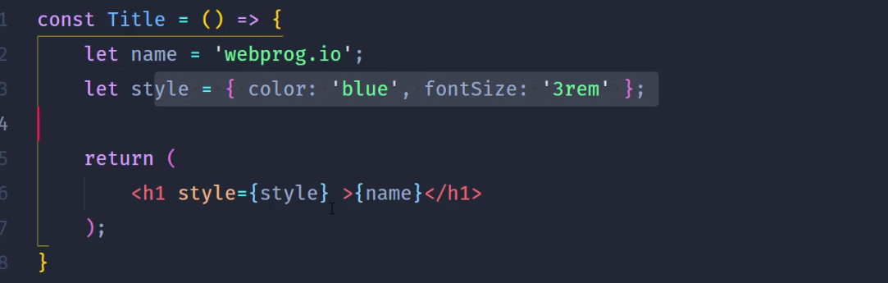



#events in react

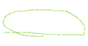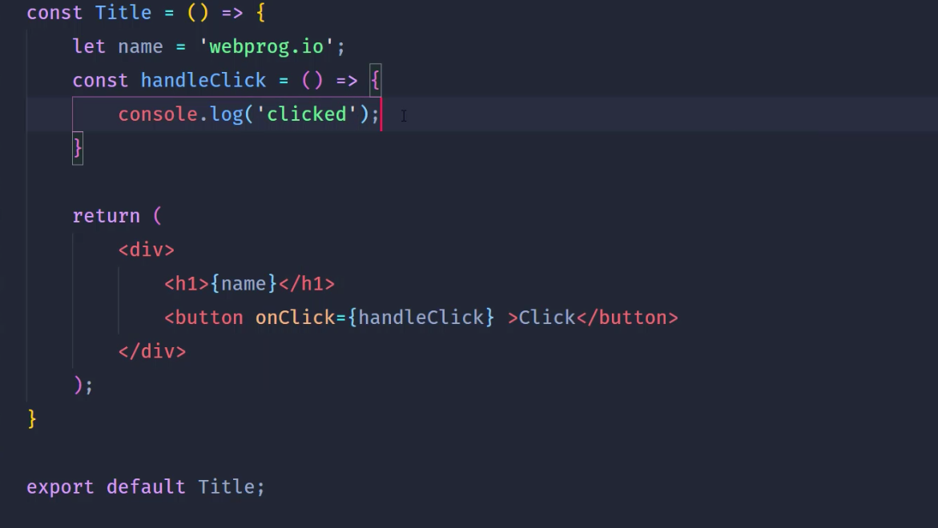



## with parameter:

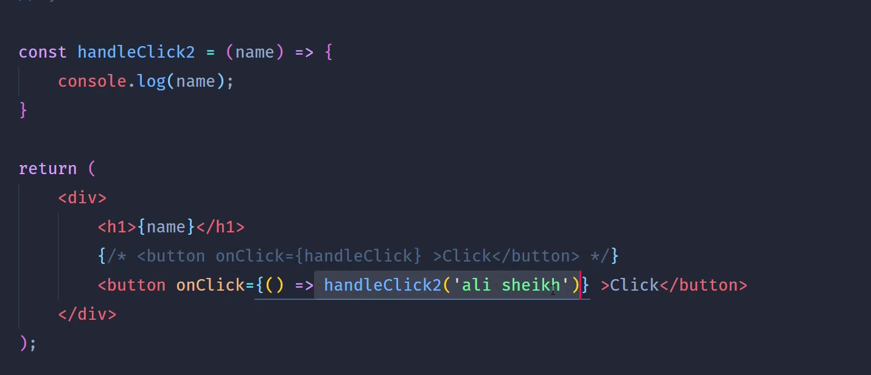



## get element : 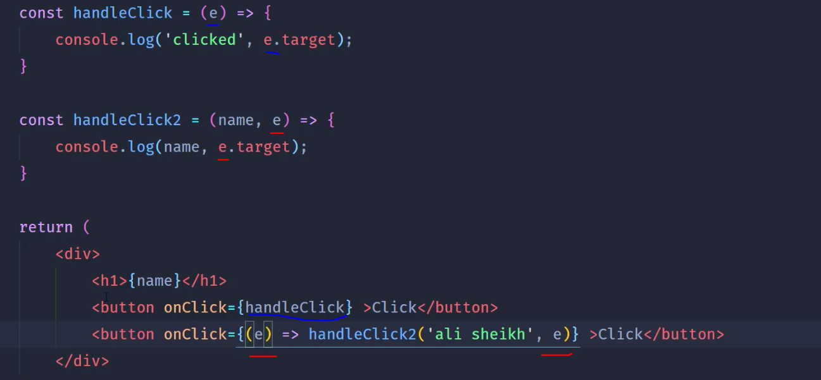

# props (sending paramenters to a childe componenst) 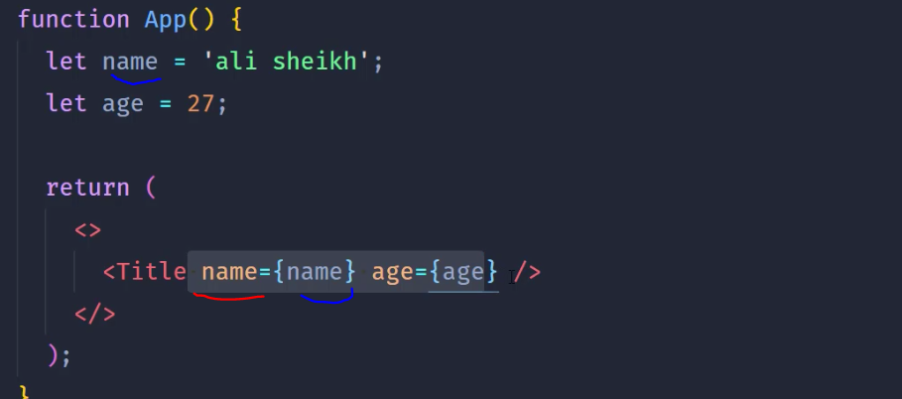



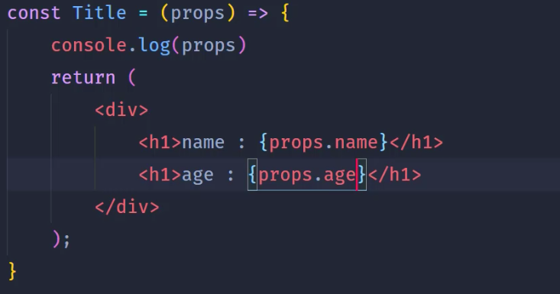

Props is an object



# Hook

#usestate

With this after every time that we use setCount(the way calling(under-lined) is something in javascript) it will rerender the component after every set command.

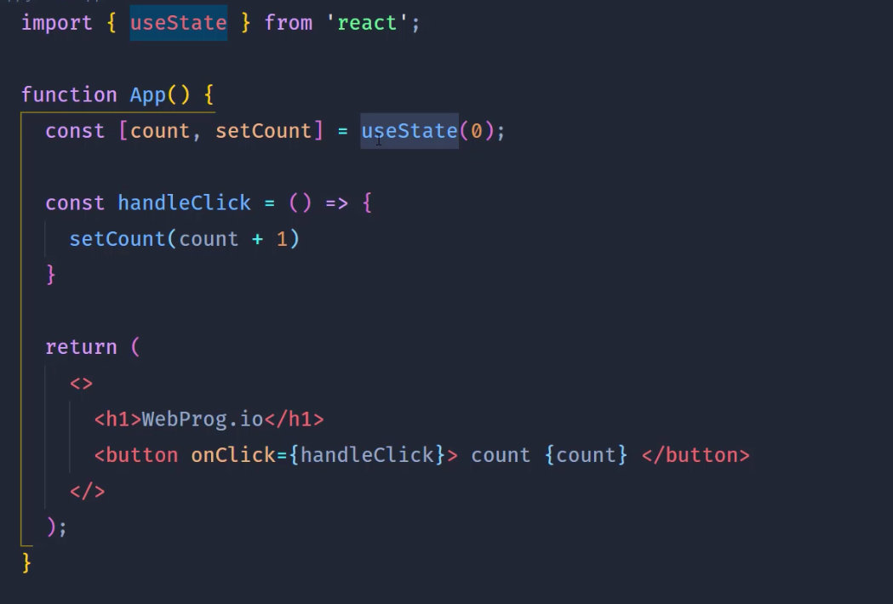

getter

setter

