# Initials:

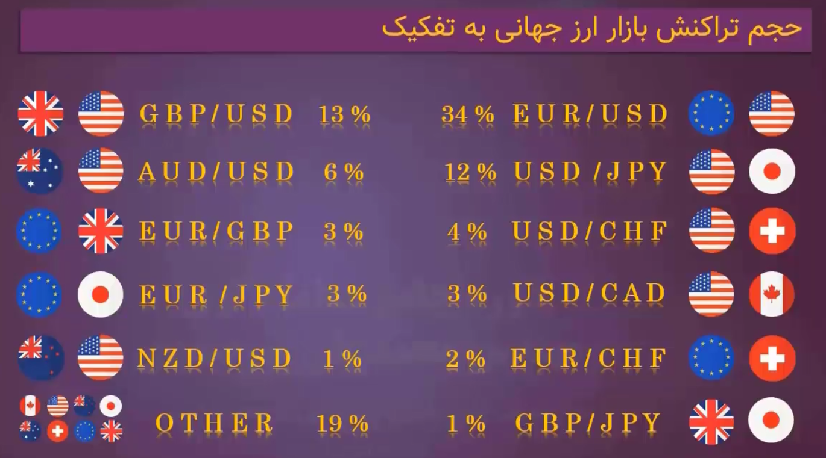

Tip- we are not supose to trade all pairs we gonna studdy most of them and finly pic 2 or 3 for trade.

Tip1-donts espect larg profits tha rasanble target is 20% profit per weak. Alwayes alwaayes my target in profits should be atleast weakly I mean for example I should expect 10% profit for my weaks. Do not forget this ,it’s for mind path.

Tip2- our thouth should be allwayes on the floor(lowest number)

Tip3-we only must risk 2% of total assets per a trade.

Tip4- most of tardes of pursamadi is by market sell and buy

Tip5- trade like a sniper not a machin guner.

Tip6- ignoring Tip 3 cause over trading.

# Accounting:

1 lot = 100/000$

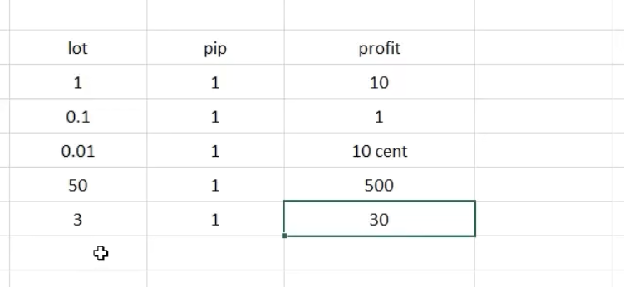

changes

Position volume

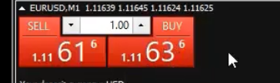

In pairs: forth number is pip

In gold: first desimal number



# Tooles:

Market24hclock.ir -> market overlap time

## Metatrader 4

# custom chart

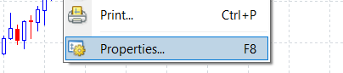

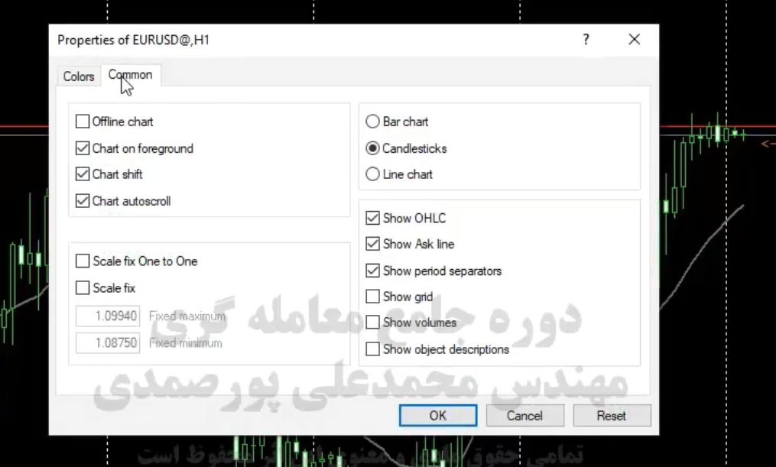

After that we customized we save templete:

# Tips

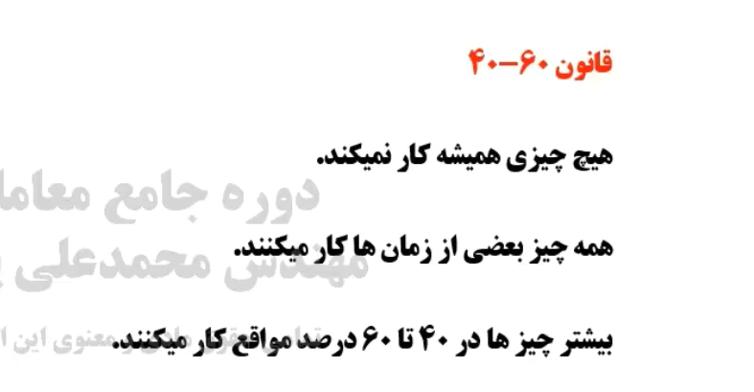tip-7: day that you traded with mobile you will be punish.

# Price action

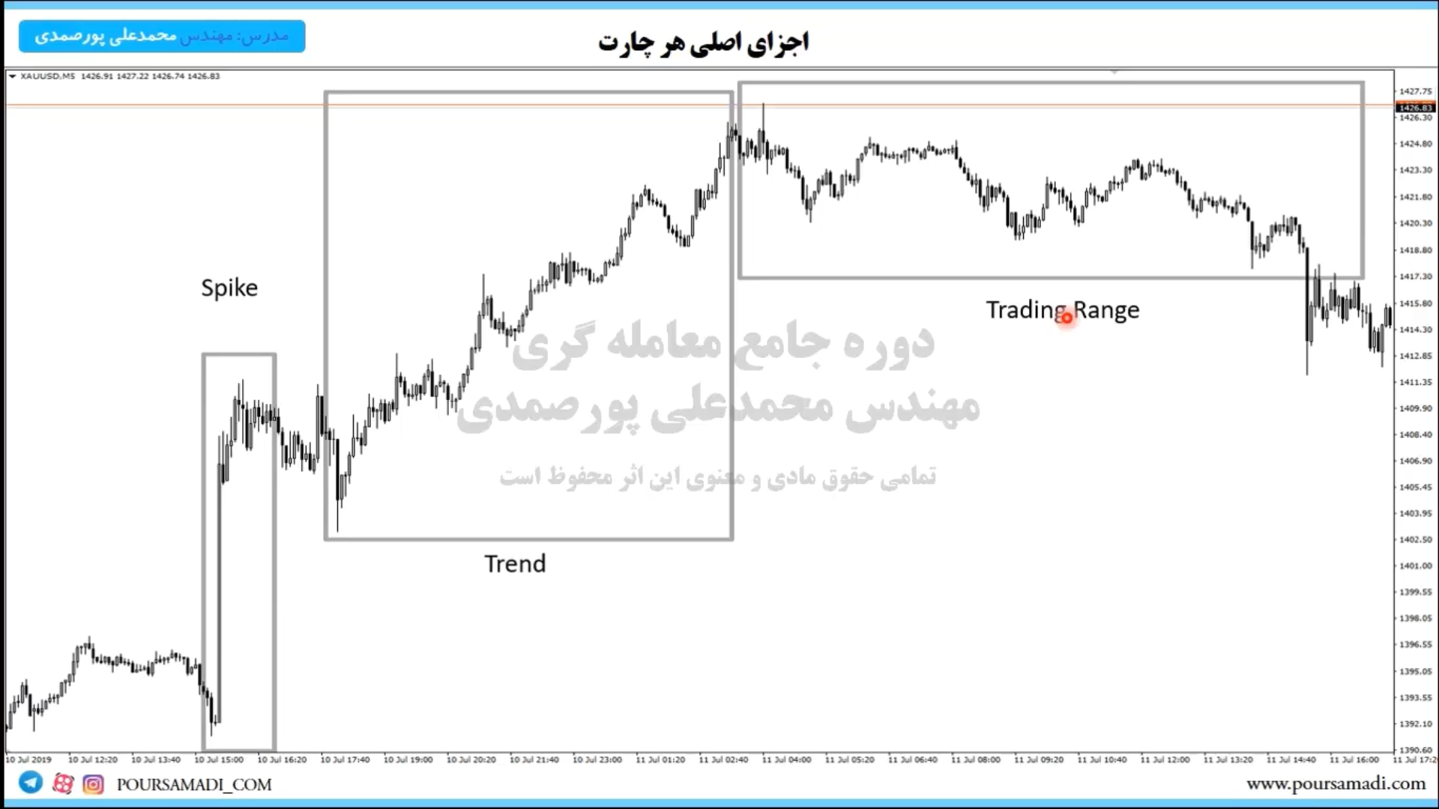

#candle stick

Pin bar: 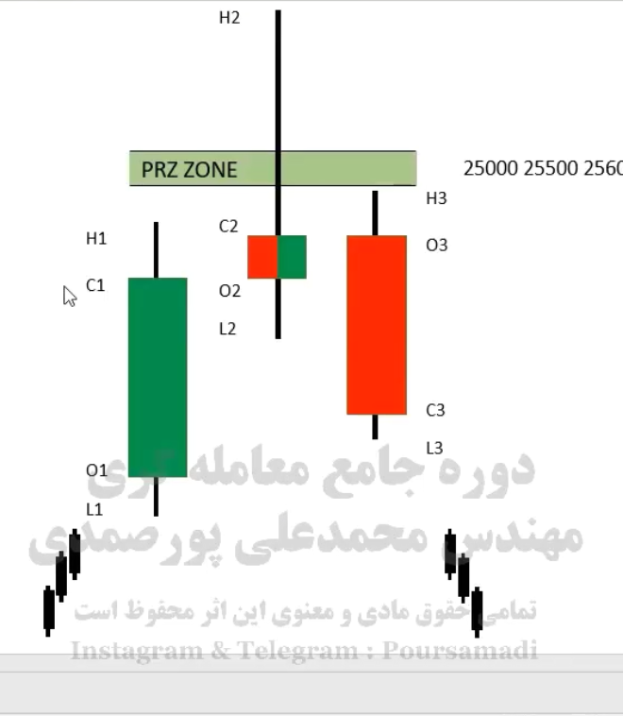

**## Tip alwayes ignore pinbar that signal againest trend.**