

نویسنده : محمد رضیئی

شماره دانشجویی : 9431704

پروژه پایانی دیتابیس

بهار 98

## Github

## <https://github.com/MohammadRaziei/DB2019/tree/master/Workspace/Project>

## دیاگرام :

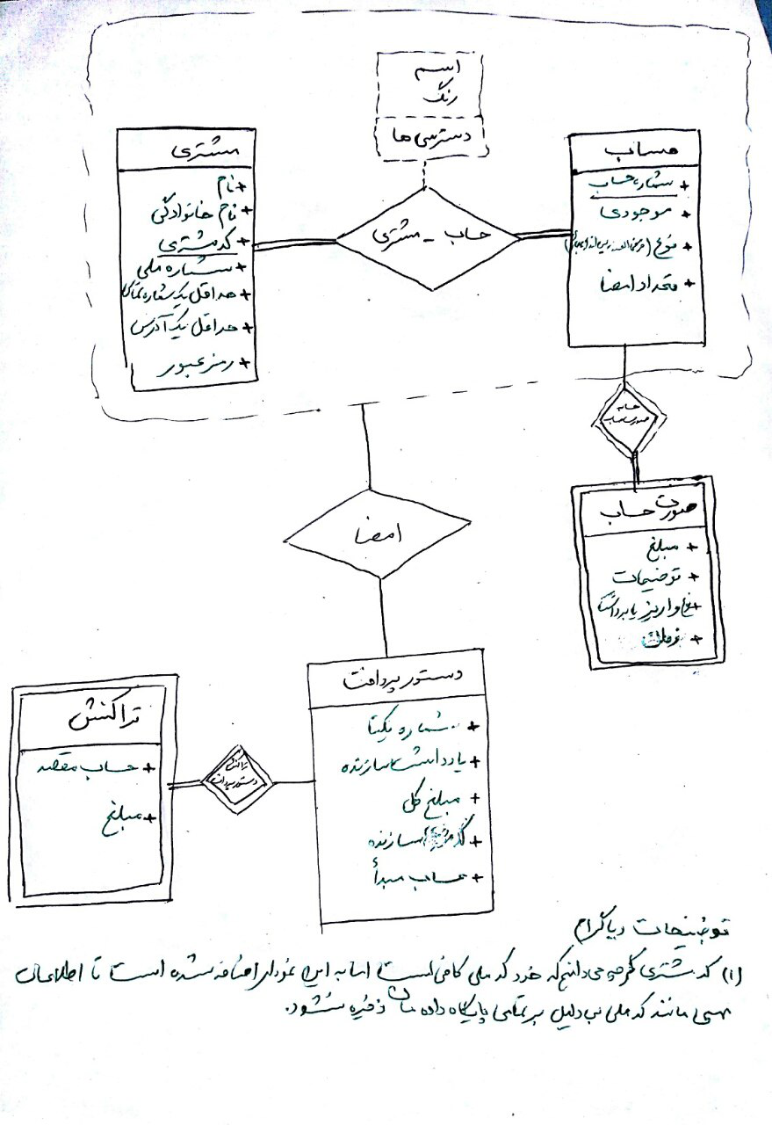

جداول نهایی :

*-- Customer :*

**CREATE** **TABLE** Customer (

CID **int**,

NationalCode **int** **Unique**,

LastName **varchar**(127),

FirstName **varchar**(127),

Hash_Password **varchar**(63),

**CONSTRAINT** PK_C **PRIMARY** **KEY** (CID)

);

**CREATE** **TABLE** Customer_Address(

CID **int**,

Address **varchar**(255) **NOT** **NULL**,

**CONSTRAINT** PK_CAd **PRIMARY** **KEY** (CID),

**CONSTRAINT** FK_CAd **FOREIGN** **KEY** (CID) **REFERENCES** Customer(CID)

);

**CREATE** **TABLE** Customer_Phone(

CID **int**,

Phone **varchar**(12) **NOT** **NULL**,

**CONSTRAINT** PK_CP **PRIMARY** **KEY** (CID),

**CONSTRAINT** FK_CP **FOREIGN** **KEY** (CID) **REFERENCES** Customer(CID)

);

*-- Account :*

**CREATE** **TABLE** Account(

AID **int**,

Cash **int** **DEFAULT**(0),

AType **varchar**(15),

Nsign **int**,

**CONSTRAINT** PK_A_ID **PRIMARY** **KEY** (AID),

**CONSTRAINT** CHK_A_type **CHECK**(AType **in** ('currnet','charity','saving'))

);

**CREATE** **TABLE** Account_soratHesab(

AID **int**,

STime **timestamp**,

Descriptions **varchar**(257),

amount **int**,

Stype **varchar**(15) **NOT** **NULL**,

**CONSTRAINT** PK_AS **PRIMARY** **KEY** (AID,STime),

**CONSTRAINT** FK_AS_ID **FOREIGN** **KEY** (AID) **REFERENCES** Account(AID),

**CONSTRAINT** CHK_AS_type **CHECK**(Stype **in**('receive','send'))

);

**CREATE** **TABLE** DastorPardakht(

PNumber **int**,

CNote **varchar**(255),

CID **int**,

Origin_AID **int** **Not** **Null**,

State **numeric**(1,0) **DEFAULT**(0),

**CONSTRAINT** PK_D **PRIMARY** **KEY** (PNumber),

**CONSTRAINT** FK_D_CID **FOREIGN** **KEY** (CID) **REFERENCES** Customer(CID),

**CONSTRAINT** FK_D_Origin_AID **FOREIGN** **KEY** (Origin_AID) **REFERENCES** Account(AID),

**CONSTRAINT** CHK_AS_type **CHECK**(State **in** (0,1))

);

*-- Transactions*

**CREATE** **TABLE** Transactions(

TID **int** **NOT** **NULL** **AUTO_INCREMENT**,

PNumber **int**,

Dest_AID **int**,

amount **int**,

**CONSTRAINT** PK_T **PRIMARY** **KEY** (TID),

**CONSTRAINT** FK_T_PNumber **FOREIGN** **KEY** (PNumber) **REFERENCES** DastorPardakht(PNumber),

**CONSTRAINT** FK_T_Dest_AID **FOREIGN** **KEY** (Dest_AID) **REFERENCES** Account(AID)

);

*-- Customer_Account*

**CREATE** **TABLE** Customer_Account(

AID **int**,

CID **int**,

Name **varchar**(127),

Color **varchar**(31),

**CONSTRAINT** PK_CA **PRIMARY** **KEY** (CID,AID),

**CONSTRAINT** FK_CA_CID **FOREIGN** **KEY** (CID) **REFERENCES** Customer(CID),

**CONSTRAINT** FK_CA_AID **FOREIGN** **KEY** (AID) **REFERENCES** Account(AID)

);

**CREATE** **TABLE** Customer_Account_Access(

AID **int**,

CID **int**,

Access **varchar**(7),

**CONSTRAINT** PK_CAA **PRIMARY** **KEY** (CID,AID,Access),

**CONSTRAINT** FK_CAA_CID **FOREIGN** **KEY** (CID) **REFERENCES** Customer(CID),

**CONSTRAINT** FK_CAA_AID **FOREIGN** **KEY** (AID) **REFERENCES** Account(AID),

**CONSTRAINT** CHK_CAA_Access **CHECK**(Access **in** ('pay','visit','sign'))

);

*-- Customer_sign*

**CREATE** **TABLE** Customer_sign(

CID **int**,

PNumber **int**,

**CONSTRAINT** PK_CS **PRIMARY** **KEY** (CID,PNumber),

**CONSTRAINT** FK_CS_CID **FOREIGN** **KEY** (CID) **REFERENCES** Customer(CID),

**CONSTRAINT** FK_CS_PNumber **FOREIGN** **KEY** (PNumber) **REFERENCES** DastorPardakht(PNumber)

);

*-- Customer_sign_deleted*

**CREATE** **TABLE** Customer_sign_deleted(

CID **int**,

PNumber **int**,

**CONSTRAINT** PK_CSD **PRIMARY** **KEY** (CID,PNumber),

**CONSTRAINT** FK_CSD_CID **FOREIGN** **KEY** (CID) **REFERENCES** Customer(CID),

**CONSTRAINT** FK_CSD_PNumber **FOREIGN** **KEY** (PNumber) **REFERENCES** DastorPardakht(PNumber)

);

عملیات ها :

*-- Q1*

**insert** **into** Customer **values**( 101, 0019773722, 'Mohammad', 'Raziei', **SHA1**('password'));

**insert** **into** Customer **values**( 102, 0022621121, 'Ali', 'Raziei', **SHA1**('PASS541054'));

**insert** **into** Customer **values**( 103, 00195785104, 'Simon', 'Jakson', **SHA1**('PASS54'));

*-- Q2*

**insert** **into** Account(AID, cash, AType, NSign) **values**(11, 1200, 'currnet', 2);

**insert** **into** Account(AID, cash, AType, NSign) **values**(12, 3300, 'charity', 3);

**insert** **into** Account(AID, cash, AType, NSign) **values**(13, 1049, 'saving', 2);

*-- Q3*

*-- (AID, CID, ACCESS)*

**insert** **into** Customer_Account **values**(11, 101, 'MR','blue');

**insert** **into** Customer_Account_Access **values**(11, 101, 'sign');

**insert** **into** Customer_Account_Access **values**(11, 102, 'pay');

**insert** **into** Customer_Account **values**(12, 102, 'AR', 'blue');

**insert** **into** Customer_Account_Access **values**(12, 102, 'sign');

**insert** **into** Customer_Account_Access **values**(12, 103, 'visit');

**insert** **into** Customer_Account **values**(13, 101, 'SJ', 'red');

**insert** **into** Customer_Account_Access **values**(13, 101, 'visit');

**insert** **into** Customer_Account_Access **values**(13, 103, 'pay');

**delete** **from** Customer_Account_Access

**where** (AID, CID, Access) = (13, 103, 'pay');

**update** Customer_Account_Access

**set** Access = 'pay'

**where** (AID, CID) = (13, 101);

*-- Q4*

**insert** **into** DastorPardakht(PNumber, CNote, CID, Origin_AID)

**values**(6062, 'this is some notes : 6062', 101, 11);

*-- Q5*

**update** DastorPardakht

**set** Origin_AID = 12

**where** PNumber = 6062;

**delete** **from** DastorPardakht

**where** PNumber = 6062;

*-- Q10*

**insert** **into** DastorPardakht(PNumber, CNote, CID, Origin_AID)

**values**(6062, 'this is some notes 6062', 101, 11);

**insert** **into** Customer_sign **values**(103, 6062); *-- impossible (CID=103 , AID=11)*

**insert** **into** Customer_sign **values**(101, 6062); *-- possible*

**delete** **from** Customer_sign

**where** (CID, PNumber) = (101, 6062);

**insert** **into** Customer_sign_deleted **values**(101, 6062);

*-- Q7*

**insert** **into** Transactions(PNumber, Dest_AID, amount) **values**(6062, 12, 300);

**insert** **into** Transactions(PNumber, Dest_AID, amount) **values**(6062, 13, 450);

**delete** **from** Transactions

**where** (PNumber, Dest_AID) = (6062, 13);

**update** Transactions

**set** amount = 333

**where** (PNumber, Dest_AID) = (6062, 12);

*-- Q8*

**insert** **into** Customer_Account_Access **values**(11, 102, 'sign');

**insert** **into** Customer_Account_Access **values**(11, 103, 'sign');

**update** DastorPardakht **set** state = 1 **where** PNumber = 6062; *-- impossible 1 < 2*

**insert** **into** Customer_sign **values**(102, 6062);

**update** DastorPardakht **set** state = 1 **where** PNumber = 6062; *-- possible 2 => 2*

*-- Q9*

*/\**

*This operation is fully automatic using triggers.*

*\*/*

**insert** **into** Account_soratHesab(STime, amount, AID, Descriptions, SType)

**values** (**current_timestamp**(), 11500, 11, 'exp1', 'receive');

**insert** **into** Account_soratHesab(STime, amount, AID, Descriptions, SType)

**values** (**current_timestamp**(), 24600, 12, 'exp2', 'send');

فانکشن ها و ویو ها:

*-- VIEWs :*

**CREATE** **VIEW** customers_have_sign **as**

**select** **distinct** CID

**from** Customer_sign;

**create** **view** Amaade_Padakht_list **as**

**select** AID, Nsign, **count**(*) **as** signs

**from** Customer_Account_Access **natural** **join** (

**select** Nsign, AID

**from** (DastorPardakht **as** P) **inner** **join** (Account **as** A)

**on** A.AID = P.Origin_AID

)

**where** Access = 'sign'

**group** **by** AID, Nsign

**having** Nsign <= signs;

**CREATE** **VIEW** Payment **as**

**select** PNumber, CID, Origin_AID, State, **sum**(amount) **as** total,CNote

**From** Transactions **natural** **join** DastorPardakht

*-- PROCEDUREs*

delimiter $$

**CREATE** **PROCEDURE** transactions_list(accountNumber **int**)

**begin**

**SELECT** *

**FROM** Transactions **natural** **JOIN** DastorPardakht

**WHERE** Dest_AID = accountNumber **and** state = 0;

**end** $$

DELIMITER ;

delimiter $$

**CREATE** **PROCEDURE** deleted_signs_list(customerNo **int**)

**begin**

**select** *

**from** Customer_sign_deleted

**where** CID = customerNo;

**end** $$

DELIMITER ;

delimiter $$

**CREATE** **PROCEDURE** sharing_accounts(customerNo1 **int**, customerNo2 **int**)

**begin**

**select** C1 **as** CNumber **from** (

**select** **distinct** CID **as** C1

**from** Customer_Account_Access

**where** CID = customerNo1

) **inner** **join** (

**select** **distinct** CID **as** C2

**from** Customer_Account_Access

**where** CID = customerNo2

)

**where** C1 = C2;

**end** $$

DELIMITER ;

delimiter $$

**CREATE** **PROCEDURE** payment_ability_by_User(UID **int**)

**begin**

**select** PNumber, CNote, CID, Origin_AID, total, state

**from** Customer_Account_Access **inner** **join** Payment

**on** AID = Origin_AID

**where** Access = 'sign' **and** CID = UID;

**end** $$

DELIMITER ;

delimiter $$

**CREATE** **PROCEDURE** payments_list_by_user(UID **int**)

**begin**

**select** **distinct** PNumber

**from** Payment **natural** **join** Transactions

**where** CID = UID

**not** **in**(

**select** paymentNumber

**from** Payment **inner** **join** Customer_Account_Access

**on** Origin_AID = AID

**where** Access = 'sign' **and** CID = UID);

**end** $$

DELIMITER ;

delimiter $$

**CREATE** **PROCEDURE** transactions_list_by_user(User_AID **int**, User_amount **float**)

**begin**

**select** *

**from** Transactions **natural** **join** Payment

**where** state = 1 **and** Dest_AID = User_AID **and** amount > User_amount;

**end** $$

DELIMITER ;

*-- HashBytes ( 'MD5', Hash_Password )*

کوئری:

*-- Q1*

**select** * **from** customers_can_sign;

*-- Q2*

**select** AID

**from** Account **natural** **join**(

**select** **count**(*) **as** signs, AID

**from** Custumer_Account_Access

**where** Access ='sign'

**group** **by** AID

)

**where** signs > Nsign;

*-- Q3*

**select** * **from** Amaade_Padakht_list;

*-- Q4*

**call** transactions_list(3);

*-- Q5*

**call** deleted_signs_list(2);

*-- Q6*

**call** sharing_accounts(1, 2);

*-- Q7*

**call** payment_ability_by_User(2);

*-- Q8*

**call** payments_list_by_user(1);

*-- Q9*

**call** transactions_list_by_user(3, 150);

پایان