# Document for PMgen V.20181212

Qing Wang (Vincent), Pedro A. Valdes-Sosa

2018.12.12 CNEURO, Cuba.

## Abstract

This is a matlab code for generating a specific sparse precision matrix (PM), the corresponding covariance matrix (Cov), and the Gaussian samples from the PM. If there is any problems related to this code, please kindly contact Qing Wang ([vincent.qing@neuroinformatics-collaboratory.org](mailto:vincent.qing@neuroinformatics-collaboratory.org)), and we are happy to get your feedback and will give response as soon as possible.

## Usage

[PM, COV, Data, nz] = PMgen(p, density, D, n, C, SHOW);

p is the number of variables, density is about twice the density of PM user expected (not precise), D is the diagonal for T, n is number of samples, n=0 does not generate sample, C=1 generate complex PM, COV, and Data, or generate real values for them, SHOW=1 will give a figure like below, which shows the PM, COV, and PM*COV for confirmation. nz is the precise sparsity for COV and PM.

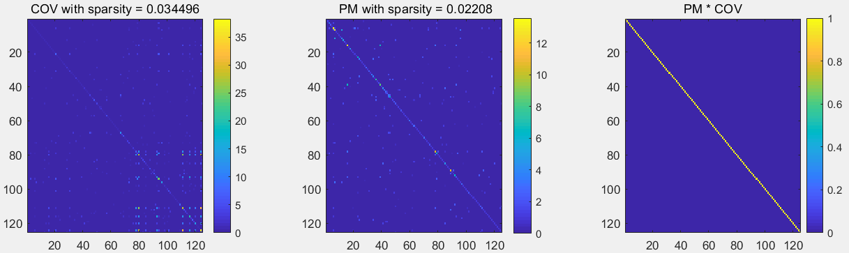

## Theory

The theory behind this code is the regression interpretation of PM with Cholesky decomposition, and it is detailed in Pourahmadi‘ book chapter 1.6[1]. According to the equation 1.18 in [1], we can further calculate covariance of the residuals of the variables ,which turns out to be the diagonal of PM, if we divide each row of PM by the corresponding element of the diagonal of PM, we obtain matrix T, which has been described in equation 1.19 in book [1], with T, we can simply calculate its inverse and use them to generate the PM and Cov for both real and complex values (see equation 1.20 in [1]). We can generate sample data (standard normal distribution N(0,1) ) with PM generated by calculating: $S=T^{-1}∙D^{-\frac{1}{2}}∙M$, M is a random normal distribution matrix, S is the sample generated.

## Reference

[1] Pourahmadi, M. (2013). High-dimensional covariance estimation: with high-dimensional data (Vol. 882). John Wiley & Sons.

## Appendix Code

% Generate the complex normal distribution with structured covariance and

% precisioin matrix.

% Reference: Pourahmadi, M. (2013). High-dimensional covariance estimation:

% with high-dimensional data (Vol. 882). John Wiley & Sons.

% by Vincent,Pedro @ 2018.12.12

function [PM, COV, Data, nz]=PMgen(p, density, D, n, C, SHOW)

% input: p: number of variables;

% density: sparsity of the precision matrix (PM), p*p*density nz entries;

% Diag: the eigen value of the covariance matrix(COV);

% n: number of data points generated;

% C: complex flag;

% SHOW: show the figure of PM and COV.

% output: PM: population PM;

% COV: population COV;

% Data: p*n data matrix from population with COV and PM.

% nz: number of non-zero elements.

randn('state',1); % fix rand generator

if D~=[] % controling D, default identity.

DMat = diag(D);

DMatInv = diag(1./D);

DMatInvSqrt = diag(1./sqrt(D));

else

DMat = diag(ones(p,1));

DMatInv = DMat;

DMatInvSqrt = DMat;

end

% create sparse triagular matrix with about half spartisty.

Tr = tril(sprandn(p, p, density));

% for complex and real case

if C

Ti = sprandn(Tr);

T = Tr +1i*Ti;

else

T=Tr;

end

T = spdiags(ones(p,1),0,T); % change the diagnals with ones

Tinv = inv(T);

% Obtain the Precision Matrix and Covariance Matrix

PM =T'*DMatInv*T;

COV=Tinv*DMatInv*Tinv';

disp('Sparsity for Cov and PM are: ')

% precise sparsity

nz = [nnz(COV)/(p*p) nnz(PM)/(p*p)]

% display the results

if SHOW

figure

subplot(131)

imagesc(abs(full(COV)))

colorbar

title(['COV with sparsity = ' num2str(nz(1))])

subplot(132)

imagesc(abs(full(PM)))

colorbar

title([' PM with sparsity = ' num2str(nz(2))])

subplot(133)

imagesc(abs(full(PM*COV)))

colorbar

caxis([0 1])

title('PM * COV')

% Generate Gaussian data from PM

if n~=0

if C

Data = Tinv*DMatInvSqrt*(randn(p,n)+1i*randn(p,n));

else

Data = Tinv*DMatInvSqrt*randn(p,n);

end

end

end