In the Name of God

**Convex Optimization Course**

Mohammadreza Arani

810100511

*University of Tehran*

*13/May/2022*

# Problem:

Consider a vector time series xt ∈ Rn, t = 1, 2, . . . . We want to ft a model of the form xt ∼N (0, atΣ), where Σ ∈ Sn ++ is given, and $a_{t}$ > 0. (We assume xt and xs are independent for t ̸= s.)  
Roughly speaking, the covariance matrix of xt scales up and down with time; at is scale factor at  
time t.  
We are given the base covariance matrix Σ, and a sample sequence x1, . . . , xT . We are to fnd the  
scale factor time series $a_{t}$, t = 1, . . . , TWe will ft the scale factor times series by minimizing the negative log likelihood, plus a term that  
regularizes the variation in a(t), $λ{\sum_{t=1 to T-1}{(log\left(a_{t+1}\right)-log⁡(a_{t}))}}^{2}$ 
  
,

where λ > 0 is a given hyper-parameter. (Note that log at+1 - log at can be interpreted as the  
fractional change in the scaling parameter from t to t + 1.)

**a)** Show how to solve this ftting problem using convex or quasiconvex optimization. Fully justify  
any changes of variables, or relaxations, that your method uses.  
**b)** Carry out your method on the data given in covar series data.⋆, for the three hyper parameter  
values λ = 0.01, λ = 1, λ = 100. (This gives three diﬀerent estimates of the scale factor time  
series.) Plot these three estimates versus t.  
**C)** Validation. The data covar series data.∗ contains another time series y1, . . . , yT from the same  
source. Evaluate the negative log likelihood of your three models obtained in part (b) on this  
validation data set. Which of the three hyper-parameter values achieves the smallest negative  
log-likelihood?

# Solution:

We are asked to provide the likelihood function, considering given constraints and the objective function mixed with regularization term we have:

## Part (a):

Gaussian Distribution PDF $→$

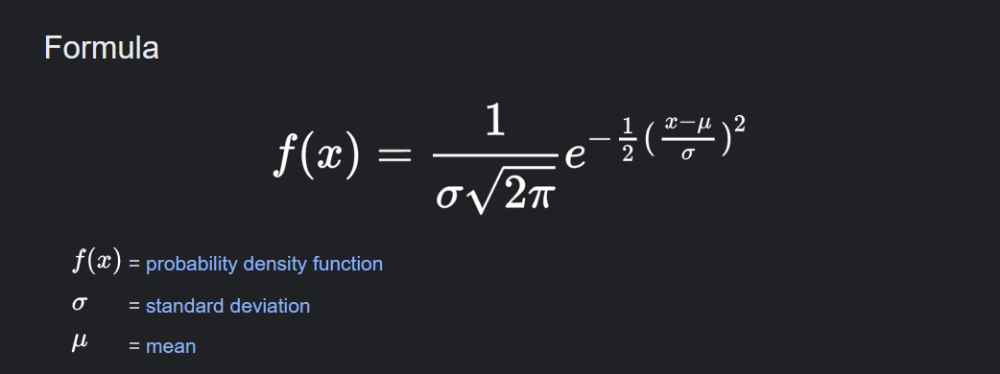

Turning scalar form into vectorized form:

$$f\left(x\right)=1/({\left(2π\right)}^{\frac{n}{2}}|a_{t}∑|)*exp⁡( -\frac{1}{2}*x_{t}^{T}*\frac{1}{(a_{t}\sum{)}} x_{t})$$

We are told, xt and xs for t~=s are independent! =>

The joint pdf distribution will be the product of each single pdf:

$$f\left(x1,…x_{T} knwoing:a_{1},…,a_{T}\right)= \prod_{t=1}^{T}{f(x_{t}|a_{t})}$$

* We consider the log-likelihood due to ease of calculations!

$$\log\left(f\left(x1,…x_{T} knwoing:a_{1},…,a_{T}\right)\right)=\log\left( \prod_{t=1}^{T}{f\left(x_{t} | a_{t}\right)}\right)$$

$$=\sum_{t=1}^{T}{log⁡(f(x_{t}|a_{t}))}=\sum_{t=1}^{T}{log⁡(1/({\left(2π\right)}^{\frac{n}{2}}|a_{t}∑|)*exp⁡( -\frac{1}{2}*x_{t}^{T}*\frac{1}{(a_{t}\sum{)}} x_{t}))}= \sum_{t=1}^{T}{-\frac{n}{2}*log\left(\frac{1}{2π}\right)-log⁡(|a_{t}∑|)-\frac{1}{2}*x_{t}^{T}*\frac{1}{(a_{t}\sum{)}}*x_{t}}$$

With sum simplifications we derive the equation below:

$$log-likelihood= -[\frac{1}{2}x_{t}^{T}\frac{1}{(a_{t}\sum{)}}x_{t}+log⁡(a_{t}) ]$$

* Objective function with regularization Term:

Cost function = J = $\left[\frac{1}{2}x_{t}^{T}\frac{1}{(a_{t}\sum{)}}x_{t}+\log\left(a_{t}\right)\right]+λ\sum_{t}{{\left(\log\left(a_{t+1}\right)-\log\left(a_{t}\right)\right)}^{2}}$

Min J

s.t. $a_{t}≥0$ for t =1,…,T

$$λ>0$$

Before going to matlab, to solve the problem using CVX, we need to perform a change of variable:

$$s_{t}=\log\left(a_{t}\right);c_{t}=\frac{1}{2}x_{t}^{T}(\sum^{-1}{)}x_{t}$$

$$a_{t}=e^{s_{t}}$$

$$J=∑\left(s_{t}\right)+c_{t}.\exp\left(-s_{t}\right)+λ\sum_{t=1→T-1}{{\left(s_{t+1}-s_{t}\right)}^{2}}$$

Converting J into Vectorized form will yield:

For: $$s=[s_{1};s_{2};…;s_{T}]$$

&

P as the differentiation matrix is like a Toeplitz matrix:

$$J=1^{T}\left(s+ c.\exp\left(-s\right)\right)+λs^{T}Ps$$

* Summation of convex elements is convex.
* Quadratic form is also convex considering P being PSD.

## Part (b):

Loading data in matlab:

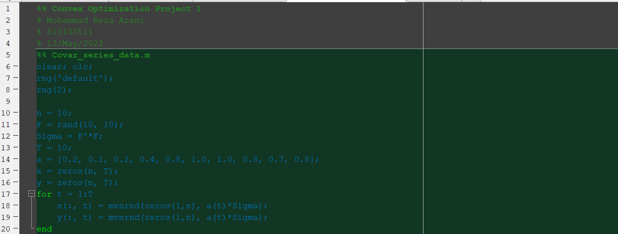

Figure

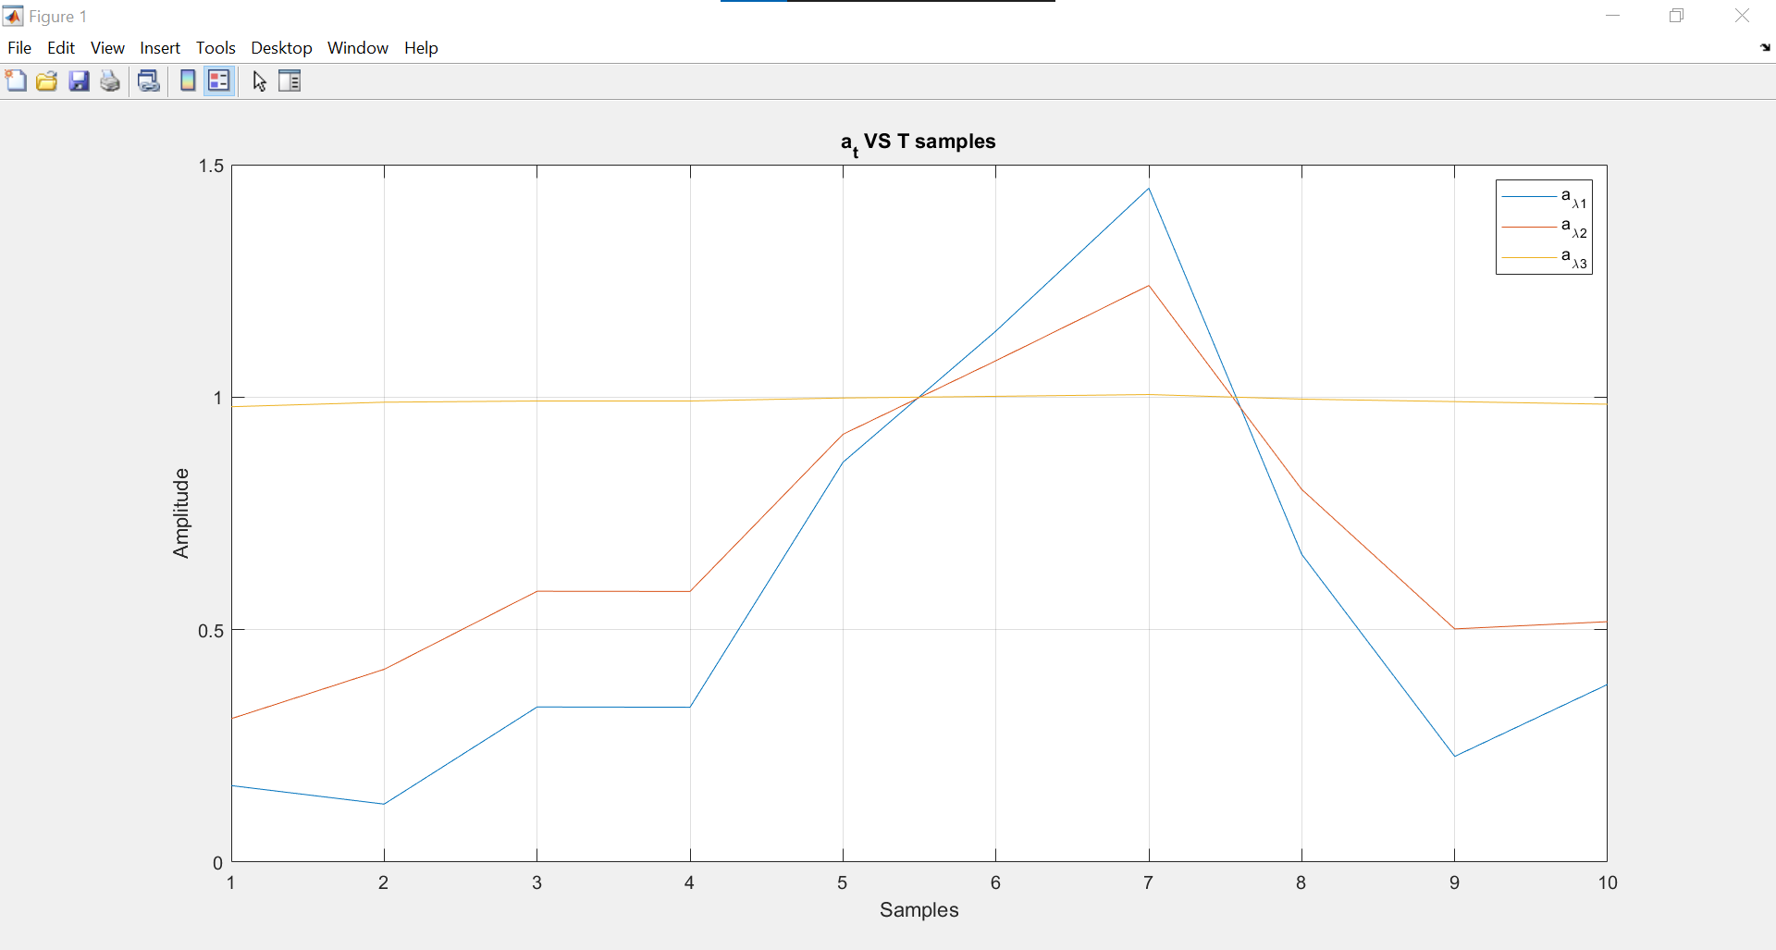

Figure

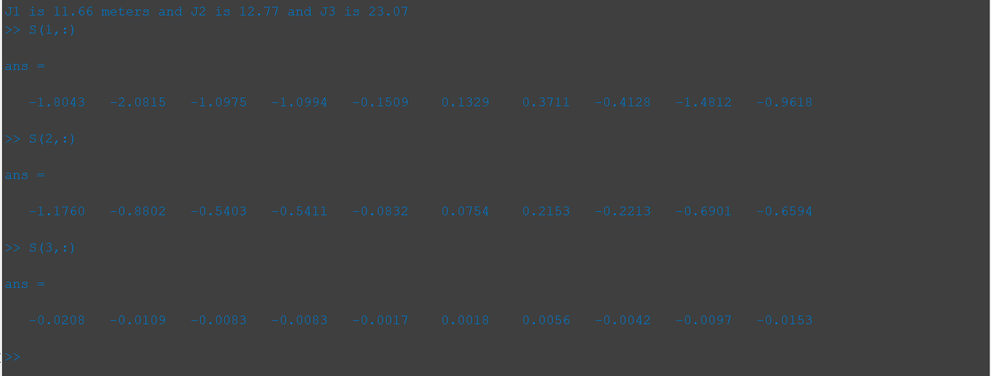

Figure

## Part (c):

Done in Matlab