به نام خدا

Section3. JavaScript Basics - Variables and Statements

**INTRODUCTION**

In this section you are going to learn the very basic of JavaScript. Every programming language has its own syntax and some core building blocks of code. That's exactly what we are going to cover in this section.

**LESSON 1: VARIABLES AND STRINGS**

In this lesson you are going to learn what is a variable and the first data type which is string.

With the help of "let" you can define a variable.

"let" is a JavaScript preserved word.

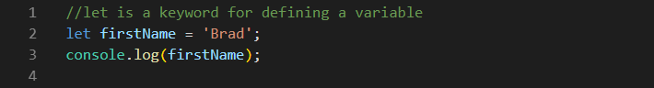

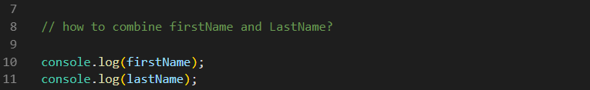

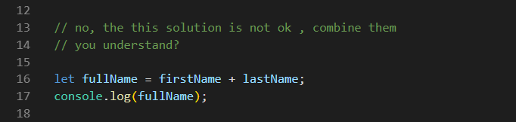

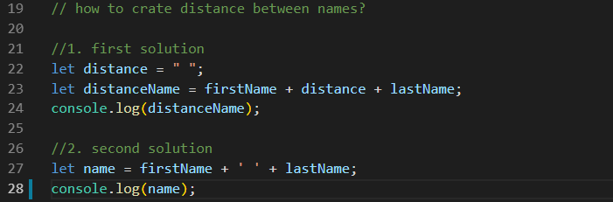

Project (1):

1. Define 3 variables: city, country and location;

2. Save the name of your city in variable city;

3. Save the name of your country in variable country;

5. Location variable concatenate city and country;

4. Print something like this: "Tehran, Iran";

**LESSON 2: Numbers**

In this lesson you are going to learn about numbers and some basic math operations;

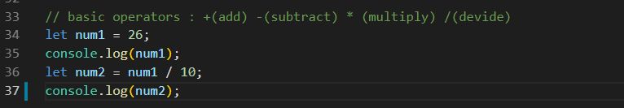

Project (2):

We have the score of a student from 20. Calculate the score of this student from 100. (test example : 10 from 20 is 50%)

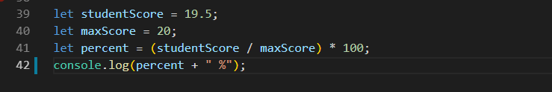

**LESSON 3: More on variables**

1. You can't define a variable more than once.

2. Never start a variable with numbers (0 - 9).

3. Never use any symbols in your variable declaration except for $ and _

4. Never use JavaScript key words for you declaration. (E.g. let is a preserved JavaScript key word.)

3. You can start variable declaration with $ or _ (underscore.)

Project (3):

Write a program that take a number in Fahrenheit and print out the value in Celsius and Kelvin.

// Fahrenheit to Celsius Formula: Celsius = (Fahrenheit - 32) * 5 / 9

// Fahrenheit to Kelvin Formula: Kelvin = (Fahrenheit + 459.67) * 5 / 9

**LESSON 4: More on variables**

1. You can't define a variable mor