**Web2 Design Document**

Mohammad Reza - i378474

Abdullah - i409411

Mattia - i427065

Application description

Our application is a course management system which helps to monitor and organize courses within the institution.

Dashboard

The dashboard contains a navigation bar on the left and three sections each one views recently added or updated (course/role/user). At the bottom of each section the details of the selected item are displayed.

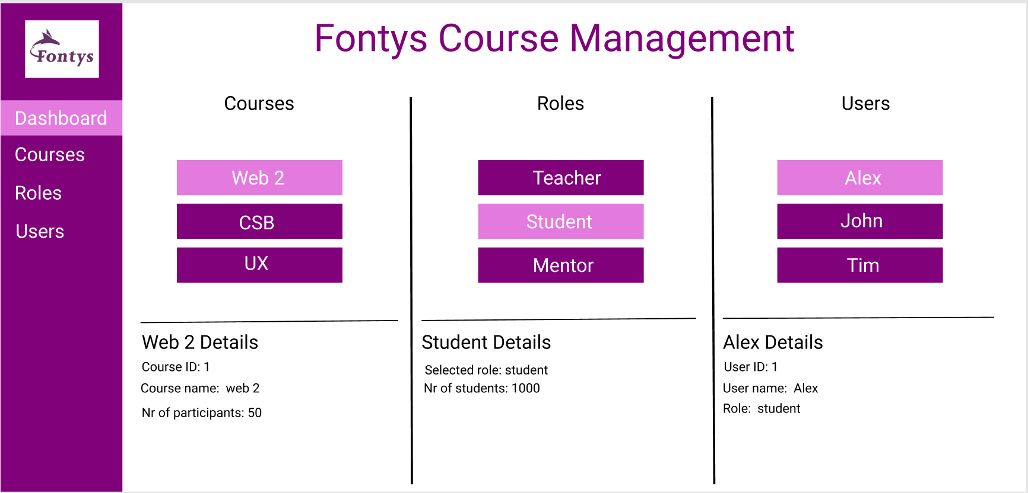

Courses

This panel provides a list of available courses, by selecting a course correspondent course info will be displayed in the lower right corner enabling the user to edit or delete course information or adding a new course in the upper right corner.

The same applies for roles and users panels.

