

**ENCS3330, DIGITAL INTEGRATED CIRCUITS.**

**Assignment #2**

**Student: Mohammad Salem – 1200651.**

**Section 2.**

**Dr: Khader Mohammad**

**Date: 14/1/2024.**

**Assignment #2**

**N-Latch**

1. **Schematic view**

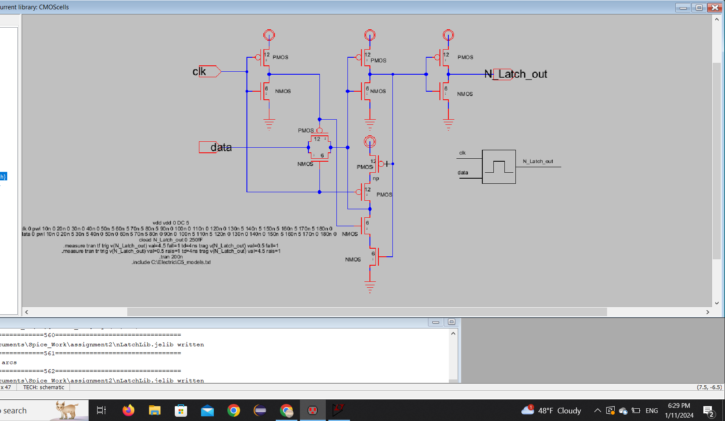

**2.Icon view**

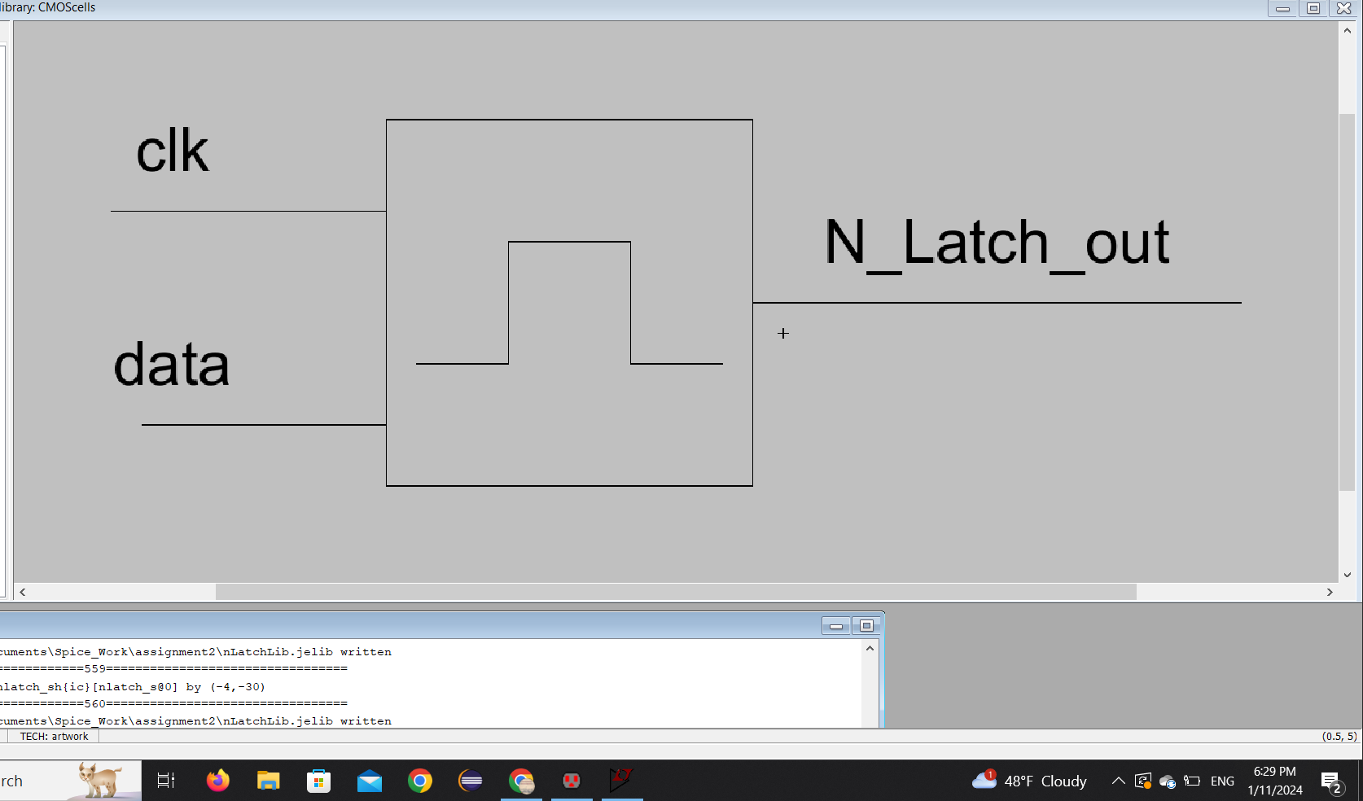

**3.Code view**

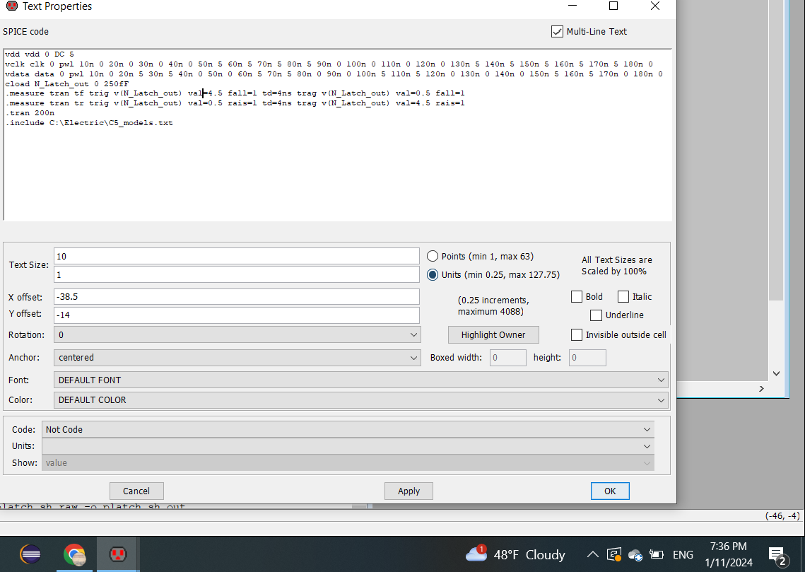

**4.Delay to out and clk to out as appears in the following figure.**

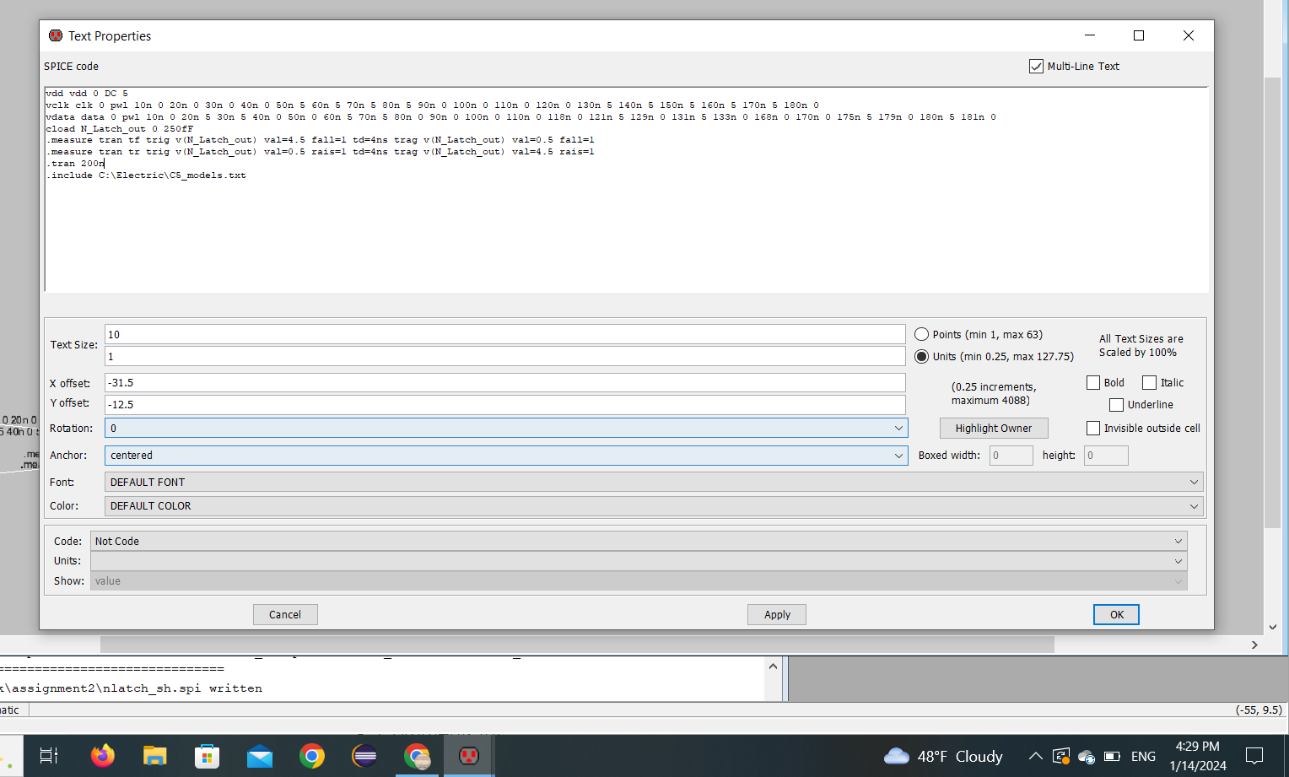

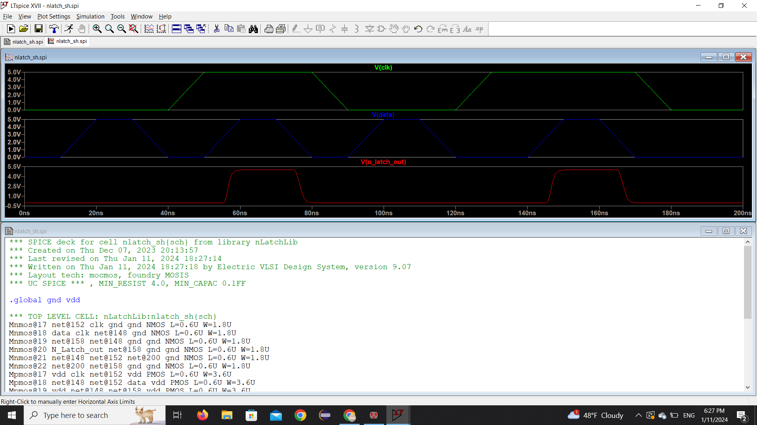

**5.Layout**

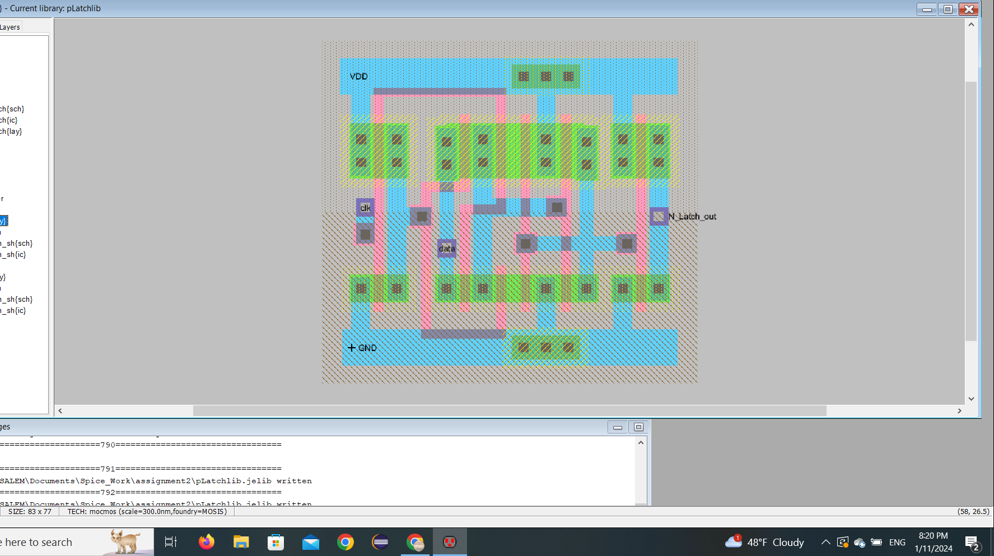

**Cases when simulation failed when missing setup/Hold windo**



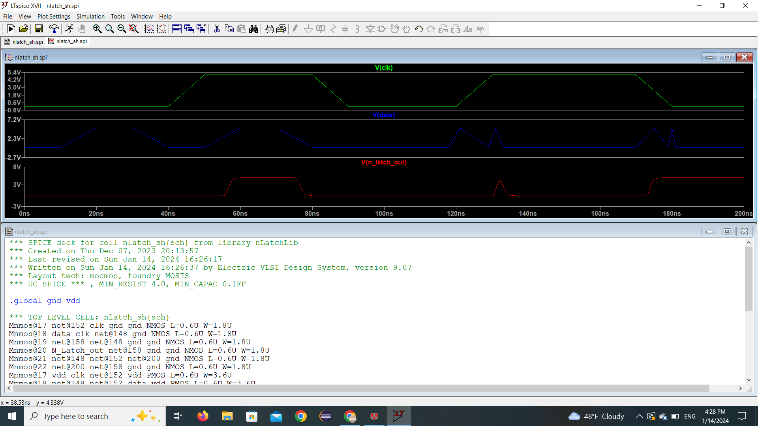

**P-Latch**

1. **Schematic view**

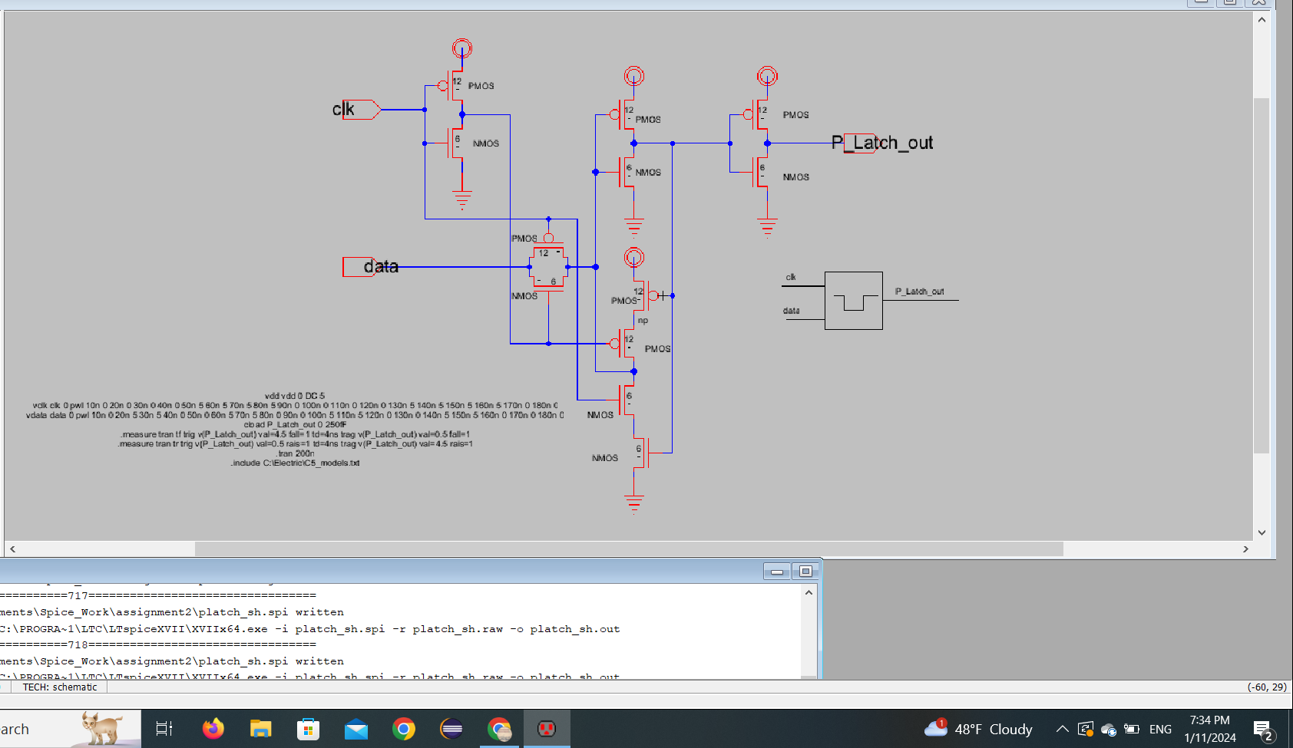

**2.Icon View**

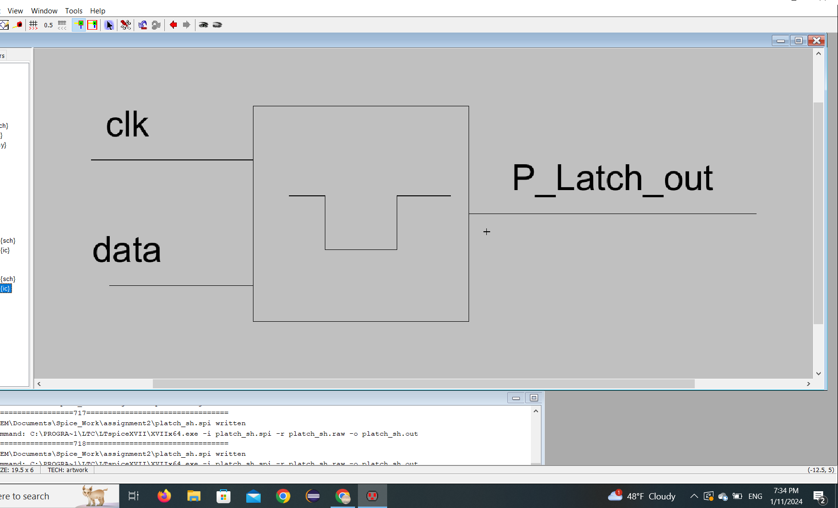

**3.Layout view**

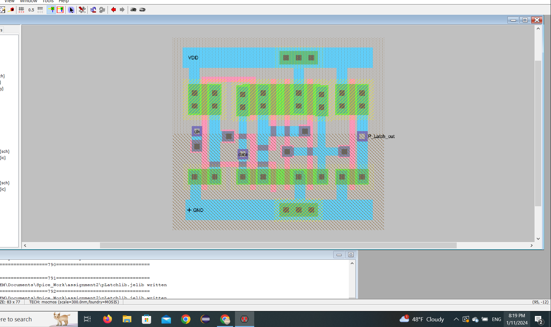

**4.Delay to out and clk to out as appears in the following figure.**

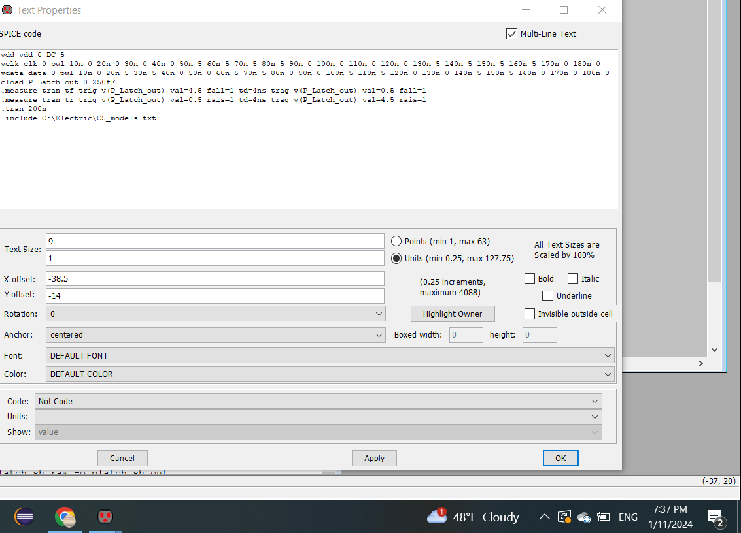

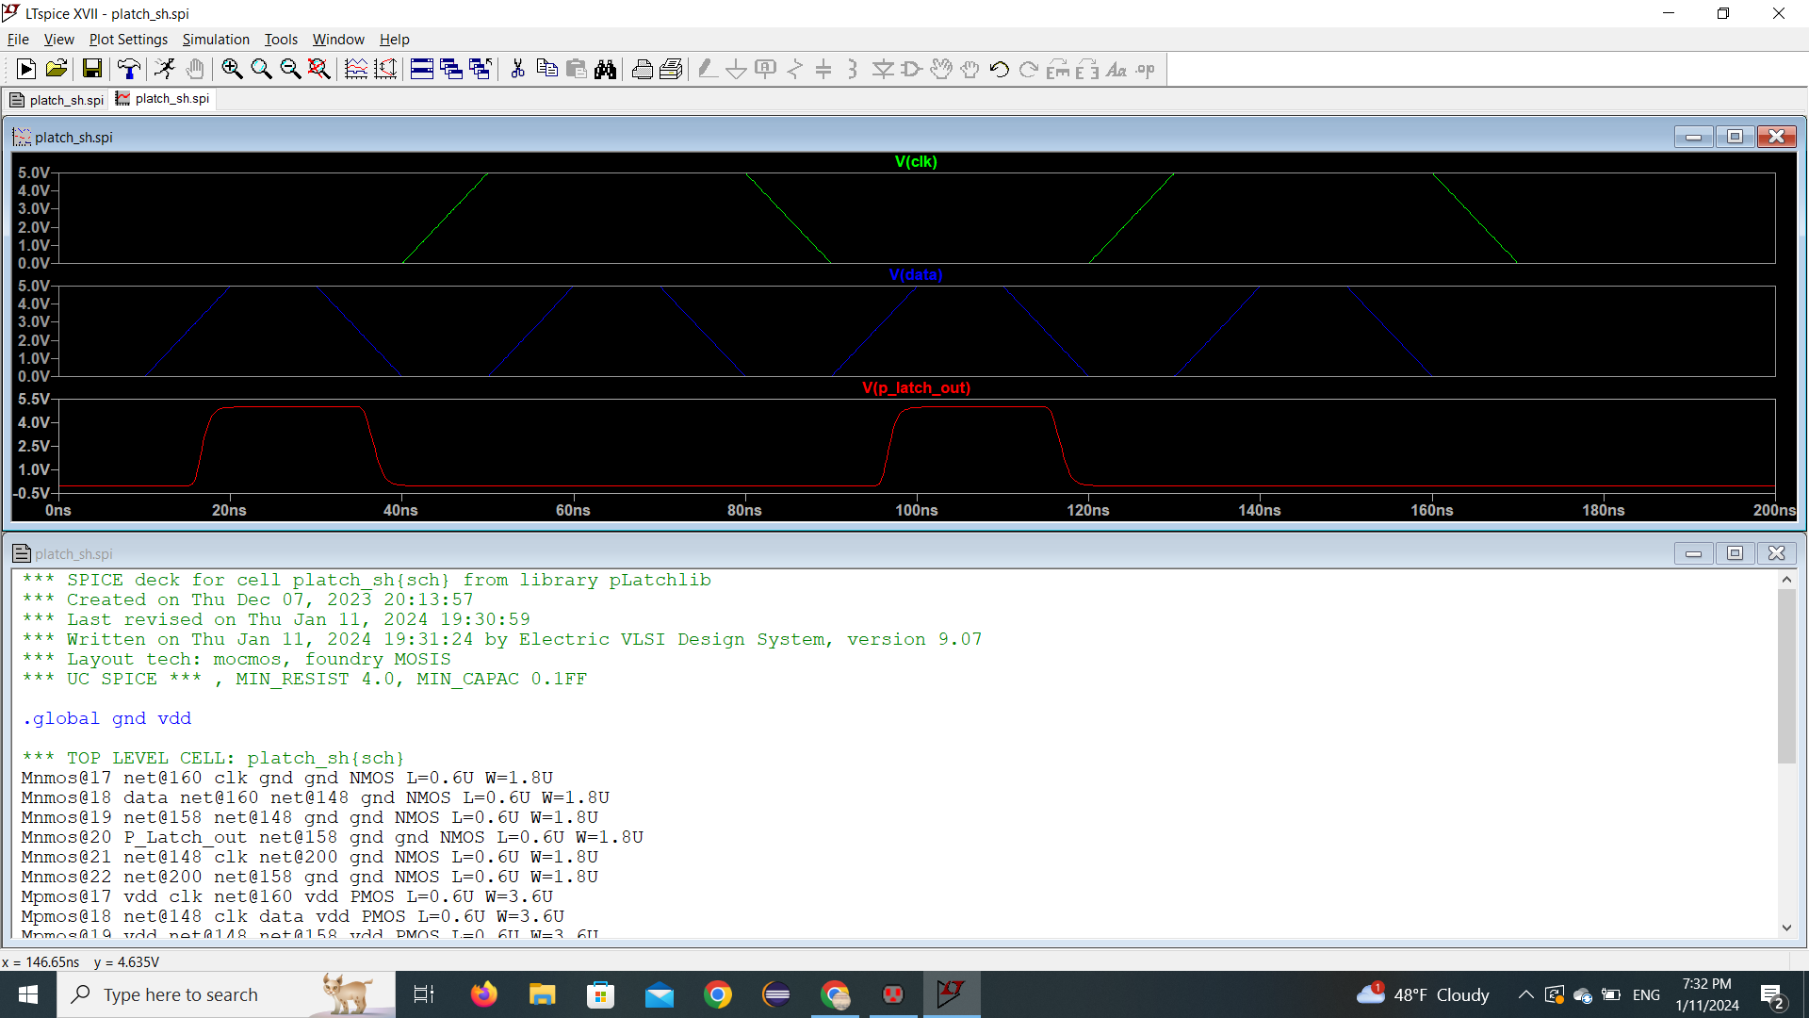

**Rising Edge_FlipFlop**

1. **Schematic view**

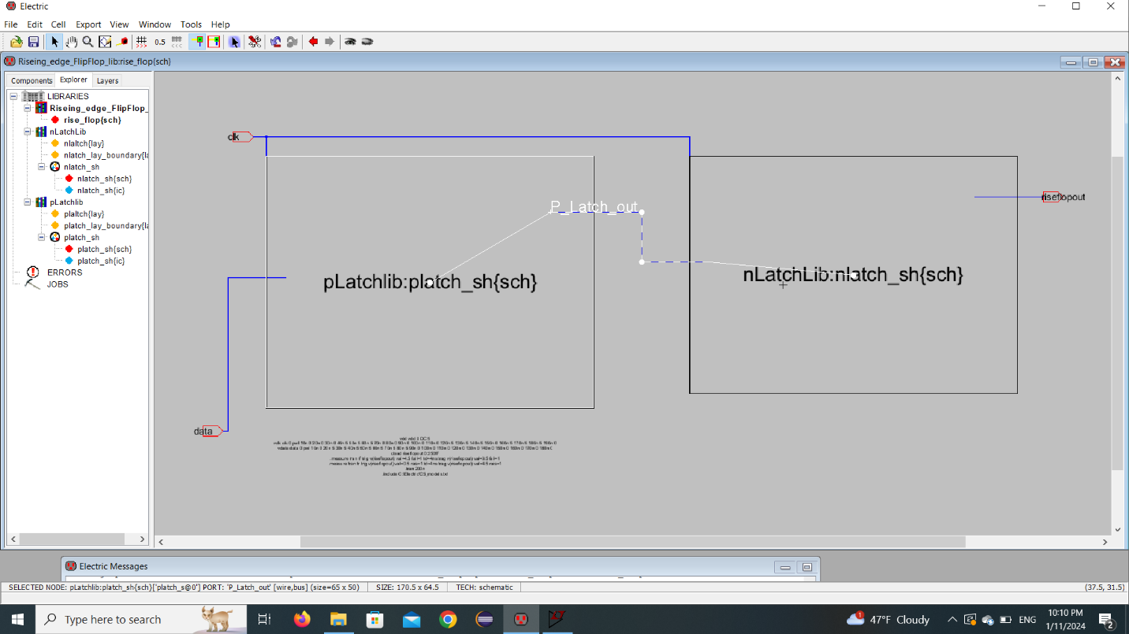

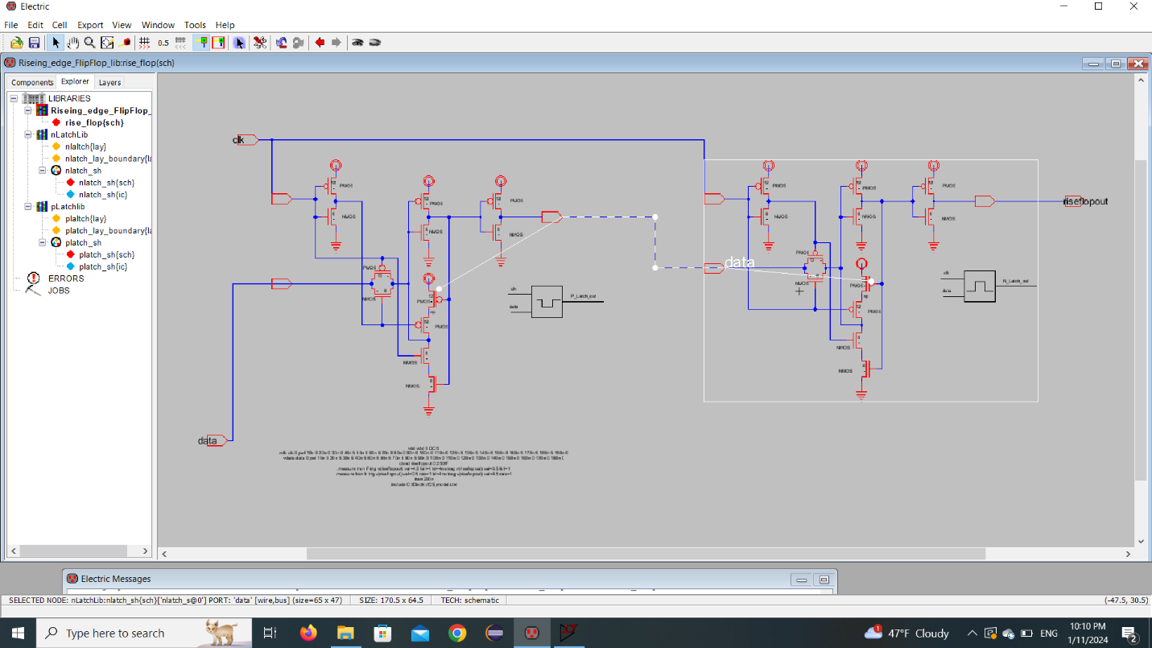

**2.Layout**

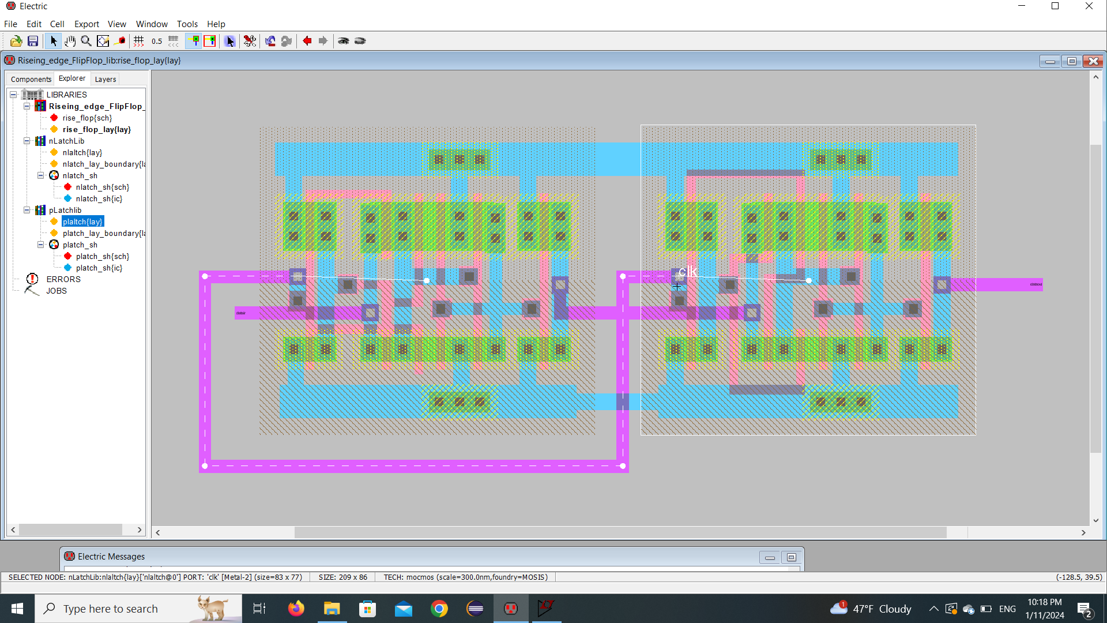

**3.Delay to out and clk to out as appears in the following figure.**

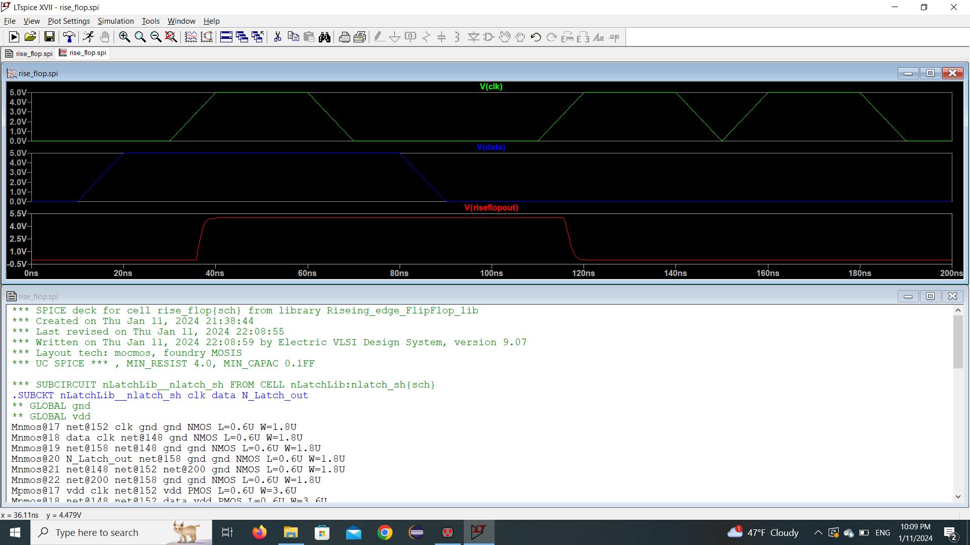

**Falling Edge Flip Flop**

1. **Schematic view**

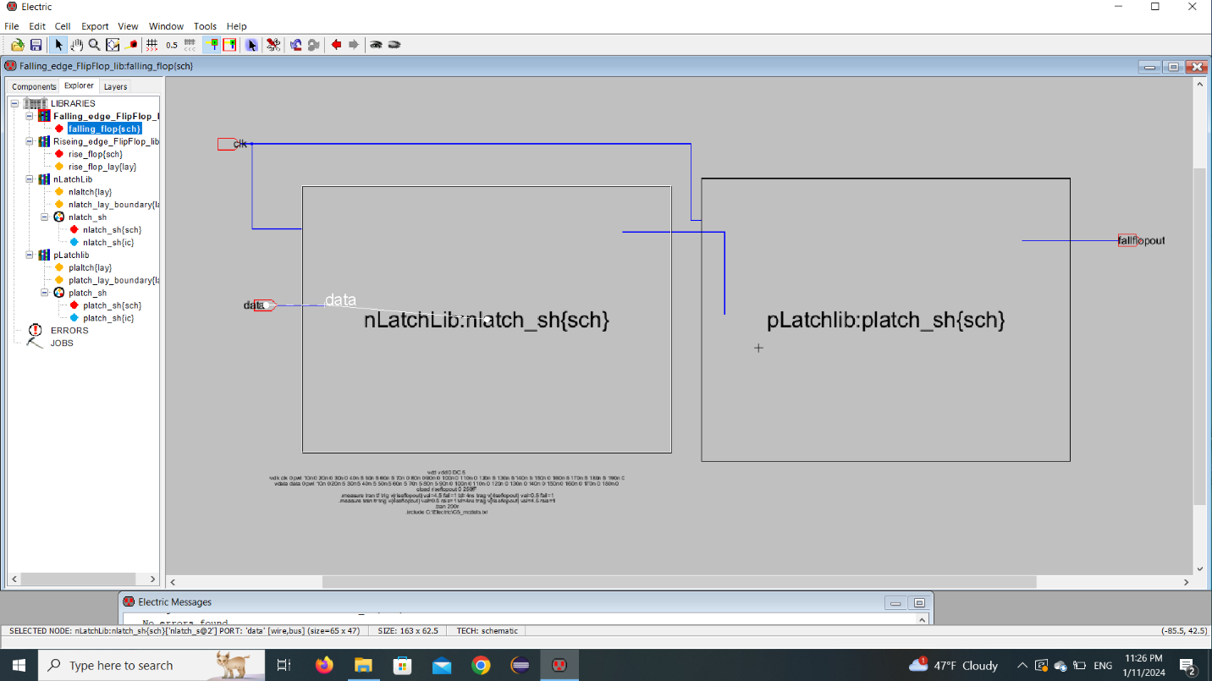

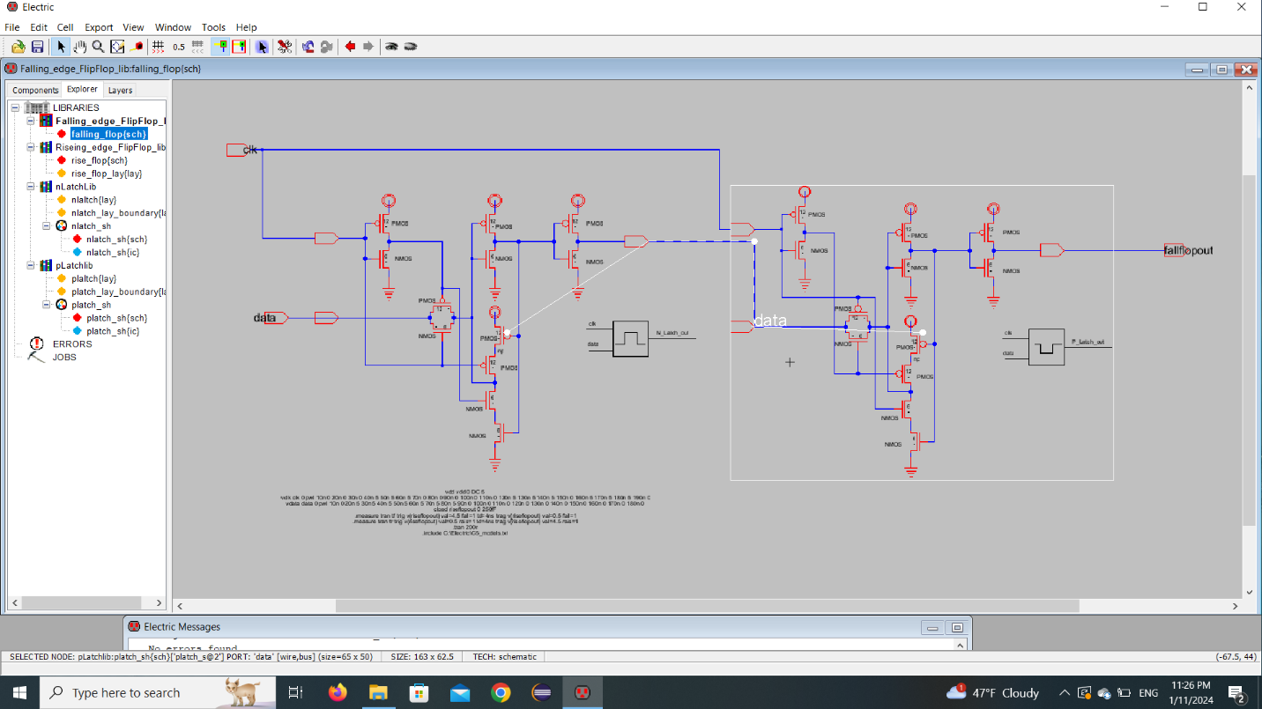

**2.Layout**

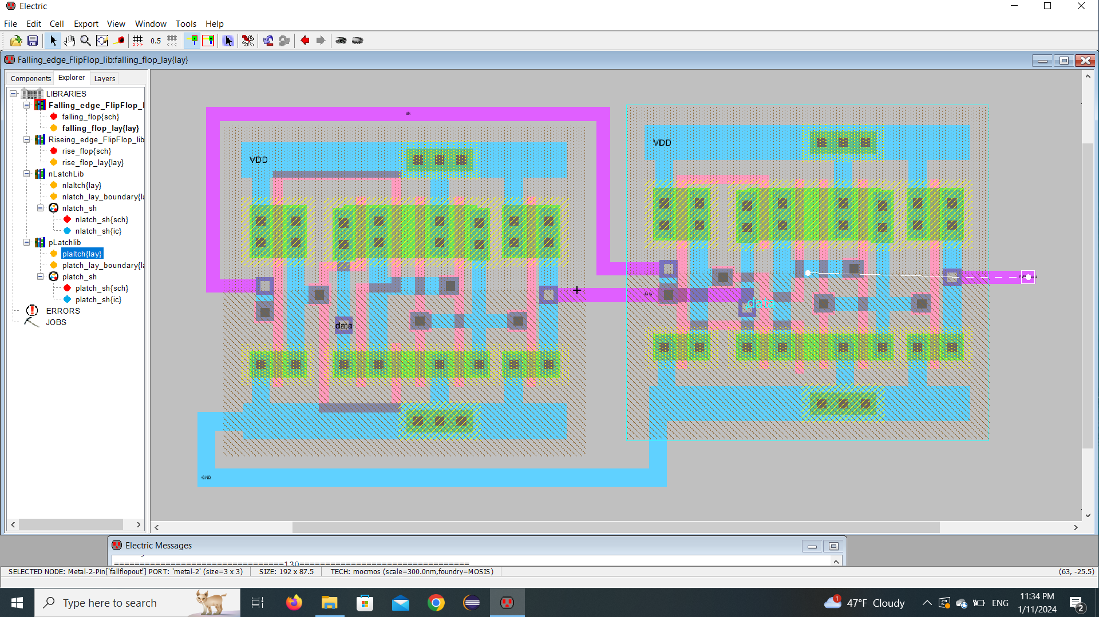

**3.Delay to out and clk to out as appears in the following figure.**

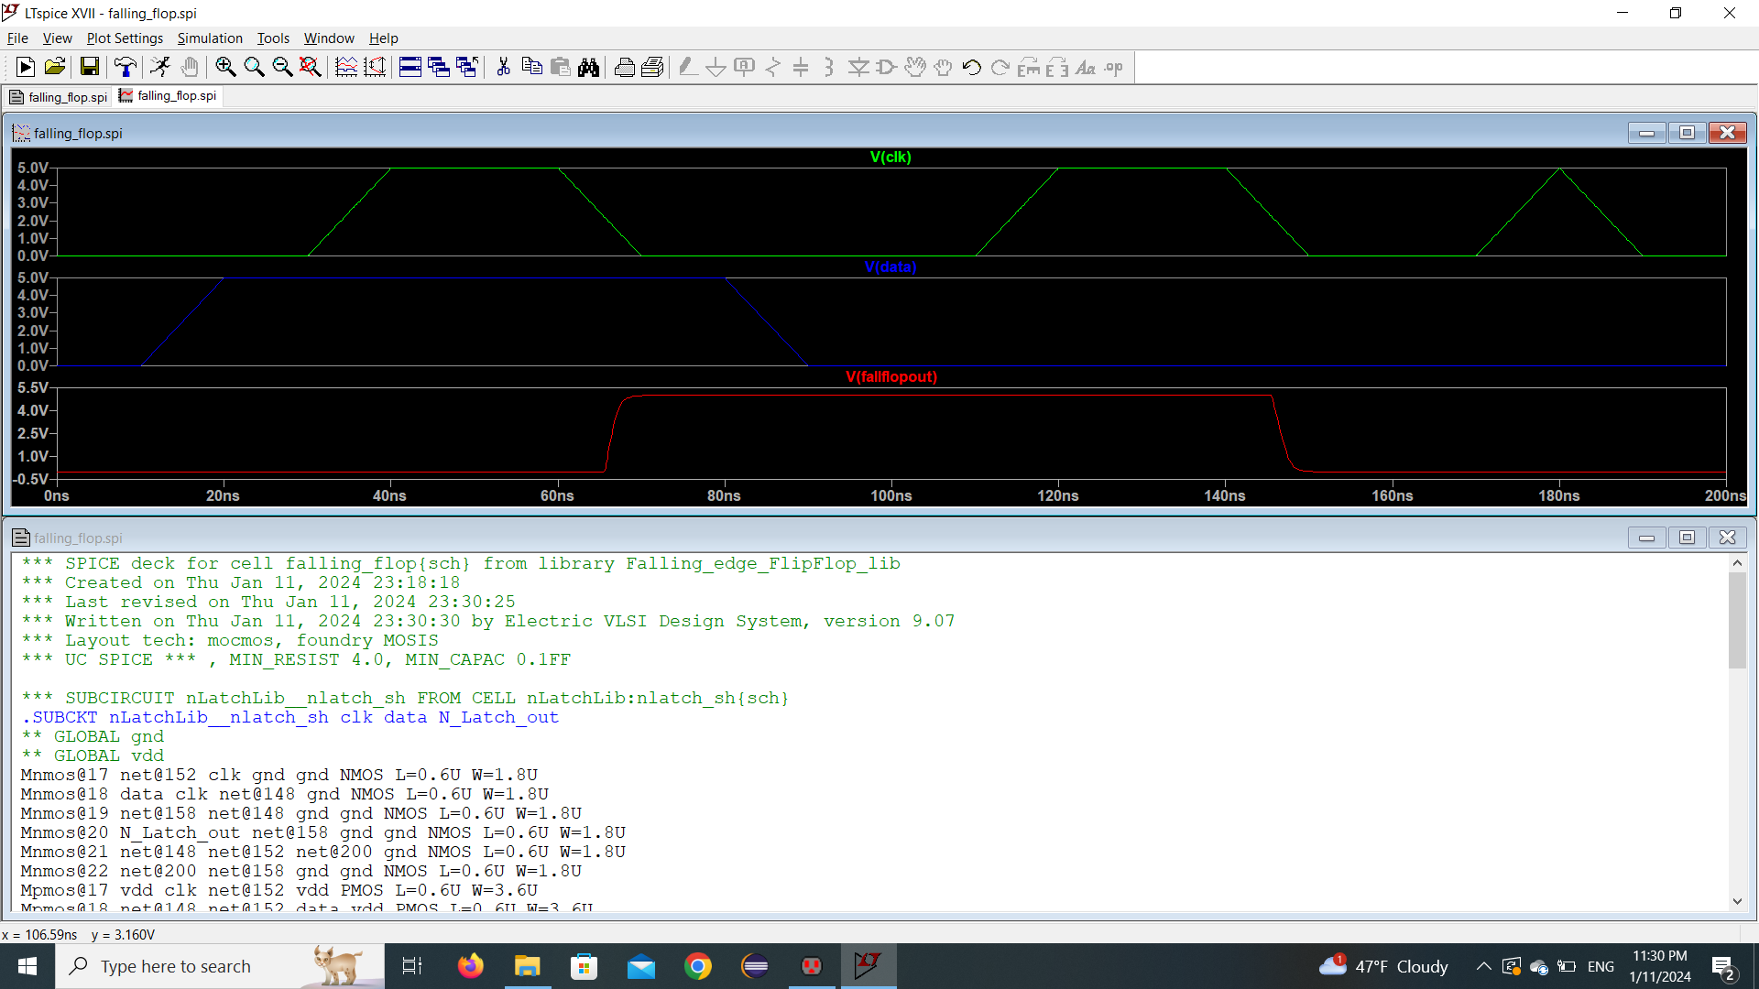

**4.Cases when simulation failed when missing setup/Hold windo**

