

**Faculty of Engineering and Technology**

**Electrical and Computer Engineering Department**

**COMPUTER DESIGN LABORATORY**

**(ENCS4110)**

**Experiment No. 10: ADC– Measure Analog Voltage Signal with TM4C123**

**Report 3**

Prepared by:

**Student’s Name**: Mohammad Salem **Student’s Id**: 1200651

**Partner Names and numbers:**

Mahmoud Khatib 1200275Ismail Tarteer 1211243

**Instructor: Dr**. Abualseoud Hanani

**Assistant: Eng**. Tareq Zidan

**Section**: 1 **Date**: 29/5/2024

# Abstract

In this experiment, we will learn how to use the analog to digital module (ADC) of TM4C123GH6PM Microcontroller using TM4C123G Tiva C Launchpad.

Also, we will learn to configure ADC modules and sample sequencer of TM4C123 using configuration registers. We will measure analog voltage by using one of the analog input pins of TM4C123GH6PM microcontroller, and discuss both polling and interrupt-based approach.

# Table of Contents

Contents

Abstract i

Table of Contents ii

List of figures iii

Theory 1

1. TM4C123 Microcontroller ADC Introduction 1

**2. ADC Resolution** 2

**3. Sample Sequencers** 2

**4. TM4C123G ADC Configuration and Initialization steps** 3

**4.1. Enable Clock to ADC** 3

**4.2. Configure PORT as an Analog Pin** 4

**4.3. Sample Sequencer Configuration** 4

**4.4. Activate ADC SS** 4

**4.5. Sampling Option** 5

**4.6 Analog Channel Selection** 5

**4.7 ADC Sampling Rate Setting** 5

**4.8. Schematic Diagram** 6

**5. Enable TM4C123G ADC Interrupt** 6

**6. Enable TM4C123 ADC Interrupt Mask** 7

Procedure 8

**Example 1** 8

**LabWork1** 9

**LabWork2** 10

Conclusion 11

References 12

Appendix 13

**Example1:** 13

**Lab Work1:** 14

**LabWork2:** 17

# List of figures

Figure 1:TM4C123 ADC microcontroller 1

Figure 2:ADC input 1

Figure 3:Samples Numbers and FIFO depth 2

Figure 4:ADC module 3

Figure 5:potentiometer 6

Figure 6:ADC Code TM4C123G 8

Figure 7: LabWork1 9

# Theory

## TM4C123 Microcontroller ADC Introduction

It has two identical successive Approximation Register (SAR) architecture-based ADC modules such as ADC0 and ADC1 which share 12 analog input channels.[1]

Each ADC input channel supports 12-bit conversion resolution. Furthermore, it has a built-in temperature sensor and a programmable sequencer to sample multiple input analog sources. The following table shows the GPIO pins which are used for alternate functions with analog input channels.



Figure :TM4C123 ADC microcontroller

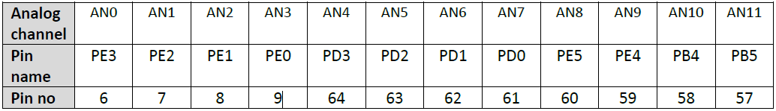

Figure :ADC input

## **2. ADC Resolution**

12-bit resolution means the ADC converts the analog values between 0 to 3.3 volts into discrete digital values in the range of 0 to (2^12) – 1 or 0 to 4095. That means, if digital value is 0, the analog input to ADC channel is zero and if digital value is 4095, the analog input to ADC channel is 3.3 volts. This formula is used to calculate the minimum analog voltage ADC can measure: [2]

Resolution = 3.3 volts / 4095 = 0.8mV

Here 0.8mV means the discrete digital value after conversion shows the 0.8 millivolts. For example, if the digital value measured by ADC is 2048, we can calculate analog voltage by multiplying digital value with 0.8 millivolts.

Analog voltage = 2048 x 0.8 = 1.65V

So, the maximum voltage ADC can measure directly is 3.3 volts and the minimum is zero volts.

## **3. Sample Sequencers**

TM4C123 microcontroller has two ADC modules that are ADC0 and ADC1. Each analog to digital converter has a separate sample sequencer (SS0, SS1, SS2 and SS3) which can sample different input channels. All these sequencers offer different numbers of samples that they can capture and the length of FIFO.[3]



Figure :Samples Numbers and FIFO depth

## **4. TM4C123G ADC Configuration and Initialization steps**

### **4.1. Enable Clock to ADC**

we enable the clock to ADC module and to the GPIO pin which is used as an analog input. RCGCADC register is used to enable the clock to ADC0 and ADC1 modules. Bit0 of RCGCADC enables ADC0 and bit1 of RCGCADC register enables ADC1. Setting the corresponding bit enables and clearing disables the clock to the corresponding analog to digital converter.[4]



Figure :ADC module

RCGCGPIO register is used to enable clock to the related GPIO port pin which will be used to measure analog input. For example, we are using analog channel zero or AN0. AN0 takes analog signals from the PE3 pin of PORTE. Setting the 5th bit of RCGCGPIO register enables the clock to PORTE of TM4C123 microcontroller.

### **4.2. Configure PORT as an Analog Pin**

To configure the analog channel corresponding GPIO pin as an analog pin. To enable alternate function of PE3 pin as an analog input, three registers are used.

* **AFSEL**: This register selects alternate functions of each GPIO pin. Because each pin is multiplexed with different peripherals. This line enables the alternate function of PORTE pin 3 or PE3.

GPIOE->AFSEL |= (1<<3);

* **DEN:** This register enables or disables the digital functionality of the corresponding GPIO port. This line disables the digital functionality of PE3 pin.

GPIOE->DEN &= ~ (1<<3);

* **AMSEL**: This register is used to enable analog function of GPIO pins. We are using PE3 pin for AN0.Therefore, we must enable PE3 analog function by setting the 3rd bit of AMSEL register.

GPIOE->AMSEL |= (1<<3);

### **4.3. Sample Sequencer Configuration**

the sample sequencer is part of ADC modules of TM4C123 microcontroller. It is used to get ADC samples and stores the conversion results in FIFO.

### **4.4. Activate ADC SS**

ADCACTSS (active sample sequencer) register is used to enable or disable sample sequences SS0, SS1, SS2 and SS3. For example, we will be using SS3 in this experiment. Setting ASEN3 bit of ADCACTSS register enables the SS3 and clearing it disables the SS3. Before configuring ADC channel, we must disable the sample sequencer by clearing bit3 like this:

ADC0->ACTSS &= ~ (1<<3);

### **4.5. Sampling Option**

ADCEMUX register selects the trigger option to start sampling of an input signal for each sample sequencer. Trigger event sources are processor, PWM, analog comparators, external interrupts, and software. The default trigger option is by software. This line selects a software event as a start conversion trigger.

ADC0->EMUX &= ~0xF000;

### **4.6 Analog Channel Selection**

TM4C123G microcontroller provides 12 analog channels. ADC-SSMUXn registers ( where n=0, 1,2,3 ) select analog channels for sample sequencers. For example, if we want to use SS3 and analog channel A0, this line will select AN0 analog channel for sample sequencer 3 or SS3.

ADC0->SSMUX3 = 0;

### **4.7 ADC Sampling Rate Setting**

ADCPC register is used to set the sampling rate of ADC. The Analog to digital converter module of the TM4C123G microcontroller supports a sampling rate from 125 KSPS to 1 MSPS. First four bits of the ADCPC register are used to set the sampling rate. This line sets the sampling rate to 250ksps

ADC0->PC = 0x3;

After ADC initialization and configuration, set the SS3 bit of ADCPSSI register to start ADC conversion for sample sequencer 3.

ADC0->PSSI |= (1<<3);

If you are using ADC1 or other sample sequencers, select the corresponding bit of ADCPSSI register.

ADCRIS register provides raw interrupt signal for each sample sequencer on sample conversion completion. INR3 bit of ADCRIS register raw interrupt status of SS3. If you are using a polling method to get ADC value, you can keep polling this bit and read the data whenever the INR3 bit becomes one.

ADCSSFIFO0,ADC-SSFIFO1, ADC-SSFIFO2 and ADC-SSFIFO3 registers contain the conversion result of ADC sample sequencers for SS0, SS1, SS2 and SS3 respectively. 12 least significant bits of these registers store conversion results.

### **4.8. Schematic Diagram**

We are using Analog channel zero or AN0 which takes input from PE3 pin. PE3 is a pin number three of PORTE of TM4C123 microcontroller.

In this schematic diagram, we are using a variable resistor to provide variable voltage input signal to AN0. Connect the middle terminal of a potentiometer with PE3/AN0 and other two terminals with 3.3 volts and ground terminal respectively



Figure :potentiometer

## **5. Enable TM4C123G ADC Interrupt**

We used a polling method to measure analog signal value with TM4C123 microcontroller ADC. However, the polling method is not an efficient method and it’s a wastage of microcontroller processing time and resources. Instead of using a polling method where we keep polling for ADC conversion to complete using bit3 of ADCRIS register, we can use the ADC interrupt handler function to read the ADC conversion value.

As we have seen in the previous example, we keep polling for ADC conversion to complete using this line:

while((ADC0->RIS & 8);

TM4C123 microcontroller keeps executing this loop and will not perform any useful function until ADC conversion is not completed. Hence, to avoid this wastage of microcontroller processing time, we can enable ADC data reception using ADC0 handler function.

## **6. Enable TM4C123 ADC Interrupt Mask**

In order to enable ADC0 interrupt, ADC Interrupt Mask (ADCIM) is used. Setting bit3 of the ADCIM register enables the SS3 Interrupt Mask.

As you know that in ARM Cortex-M4 microcontroller, NVIC or nested vectored interrupt controller manages all interrupts. TM4C123 microcontroller supports 78 peripheral interrupts which are also known as IRQs. Before using each peripheral interrupt handler, we should enable each peripheral interrupt request to each NVIC using NVIC interrupt control register. The interrupt number of ADC0SS3_IRQn is 17. This line enables ADC0 sequencer 3 interrupt in NVIC.

NVIC->ISER[0] |= 0x00010001; /* enable IRQ17 for ADC0SS3*/

# Procedure

## **Example 1**

This ADC code of TM4C123GH6PM microcontroller reads analog input from AN0 pin and based on digital value turns on or turns off the onboard green LED of TM4C123G Tiva C launchpad. If measured digital value is less than 2048 LED will remain off. If ADC digital value is greater than or equal to 2048, LED turns on.

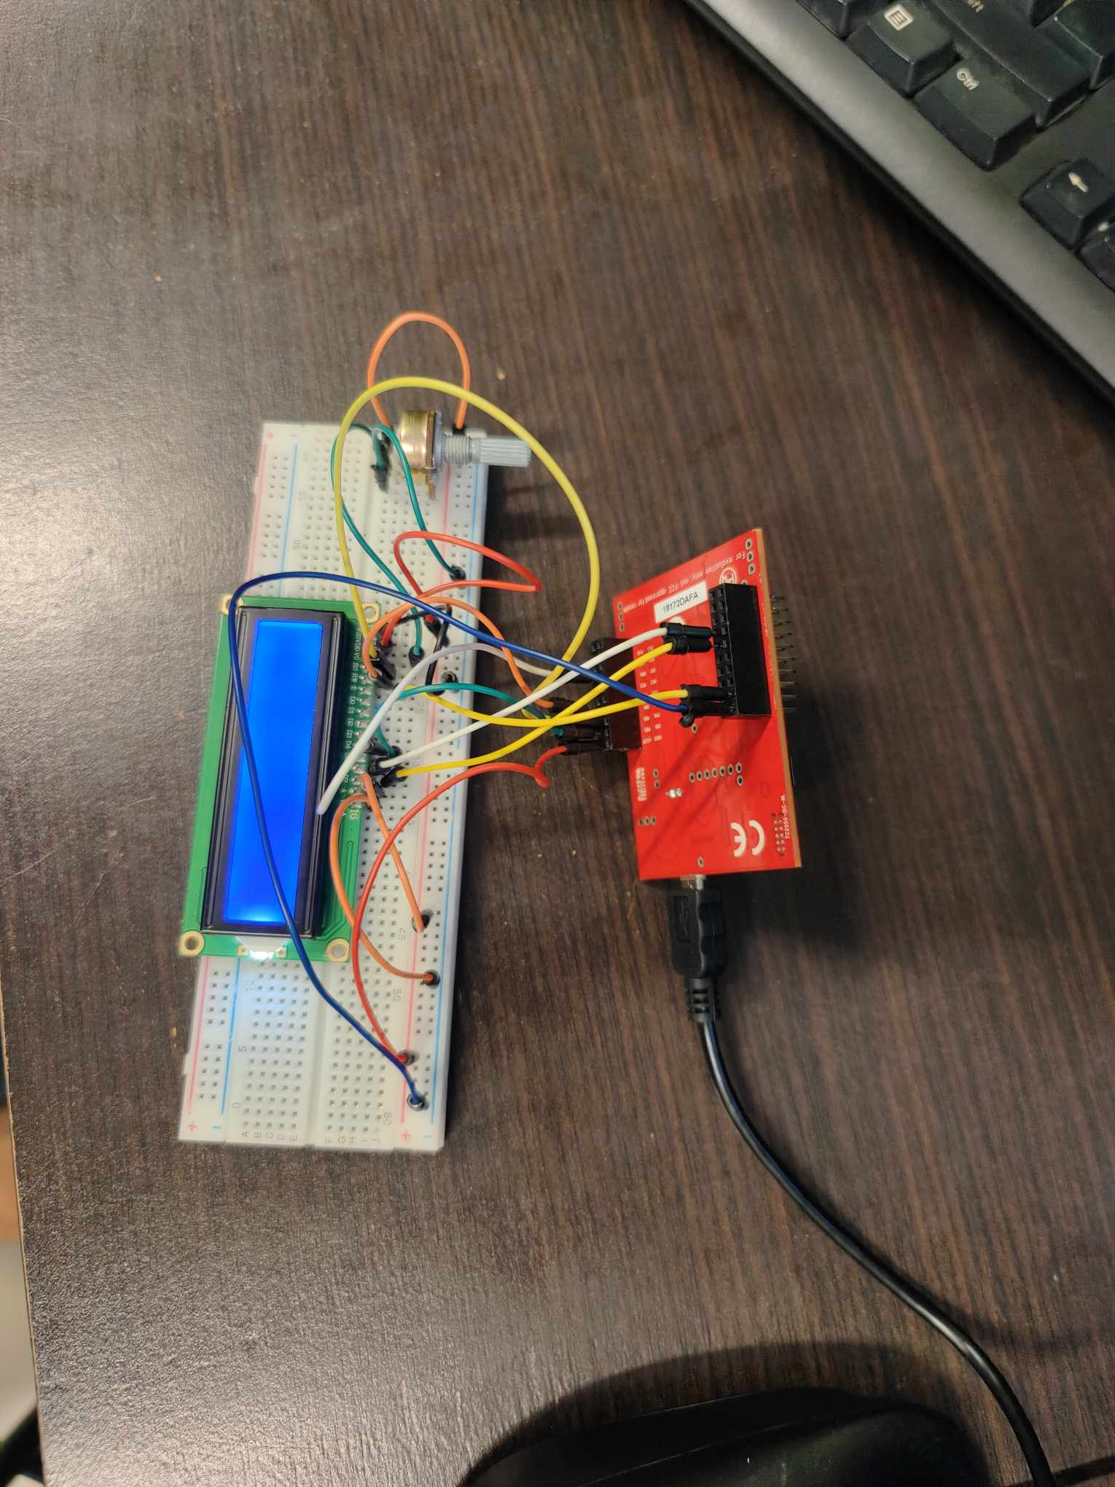

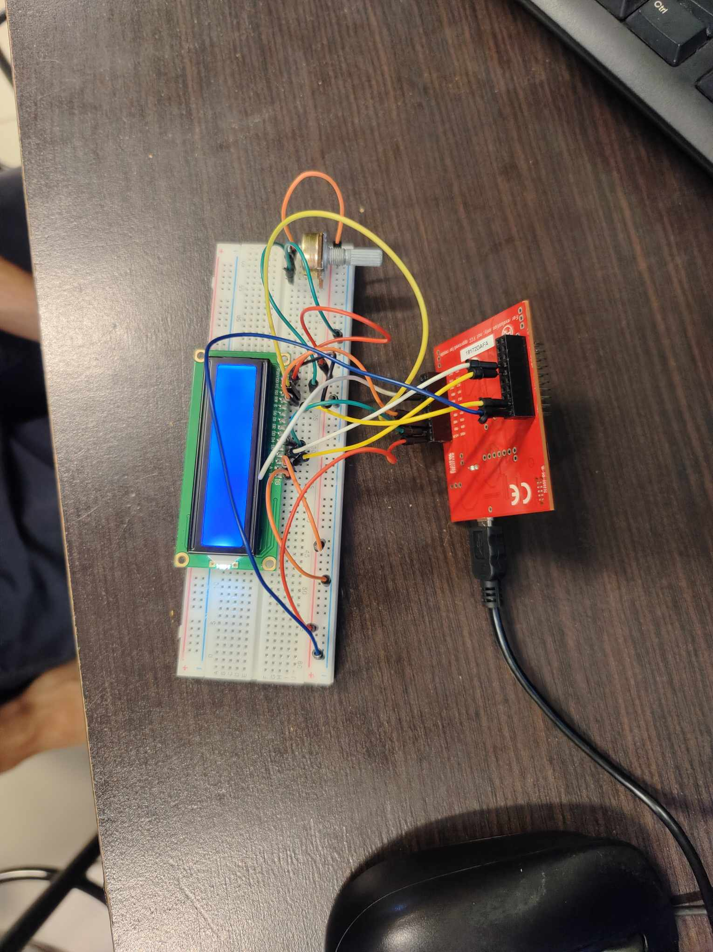

Figure :ADC Code TM4C123G

## **LabWork1**

We used the interrupt method so that RED led is on only when the value is greater than 1000. The GREEN led is on only when the value is below 1000.

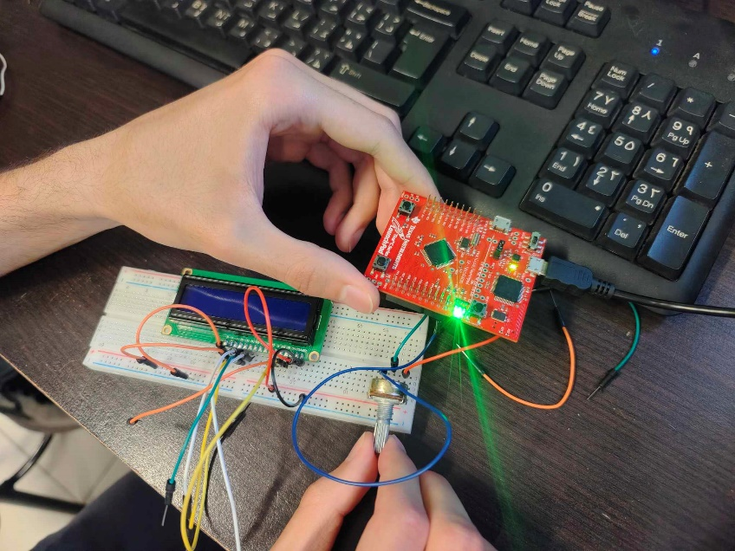

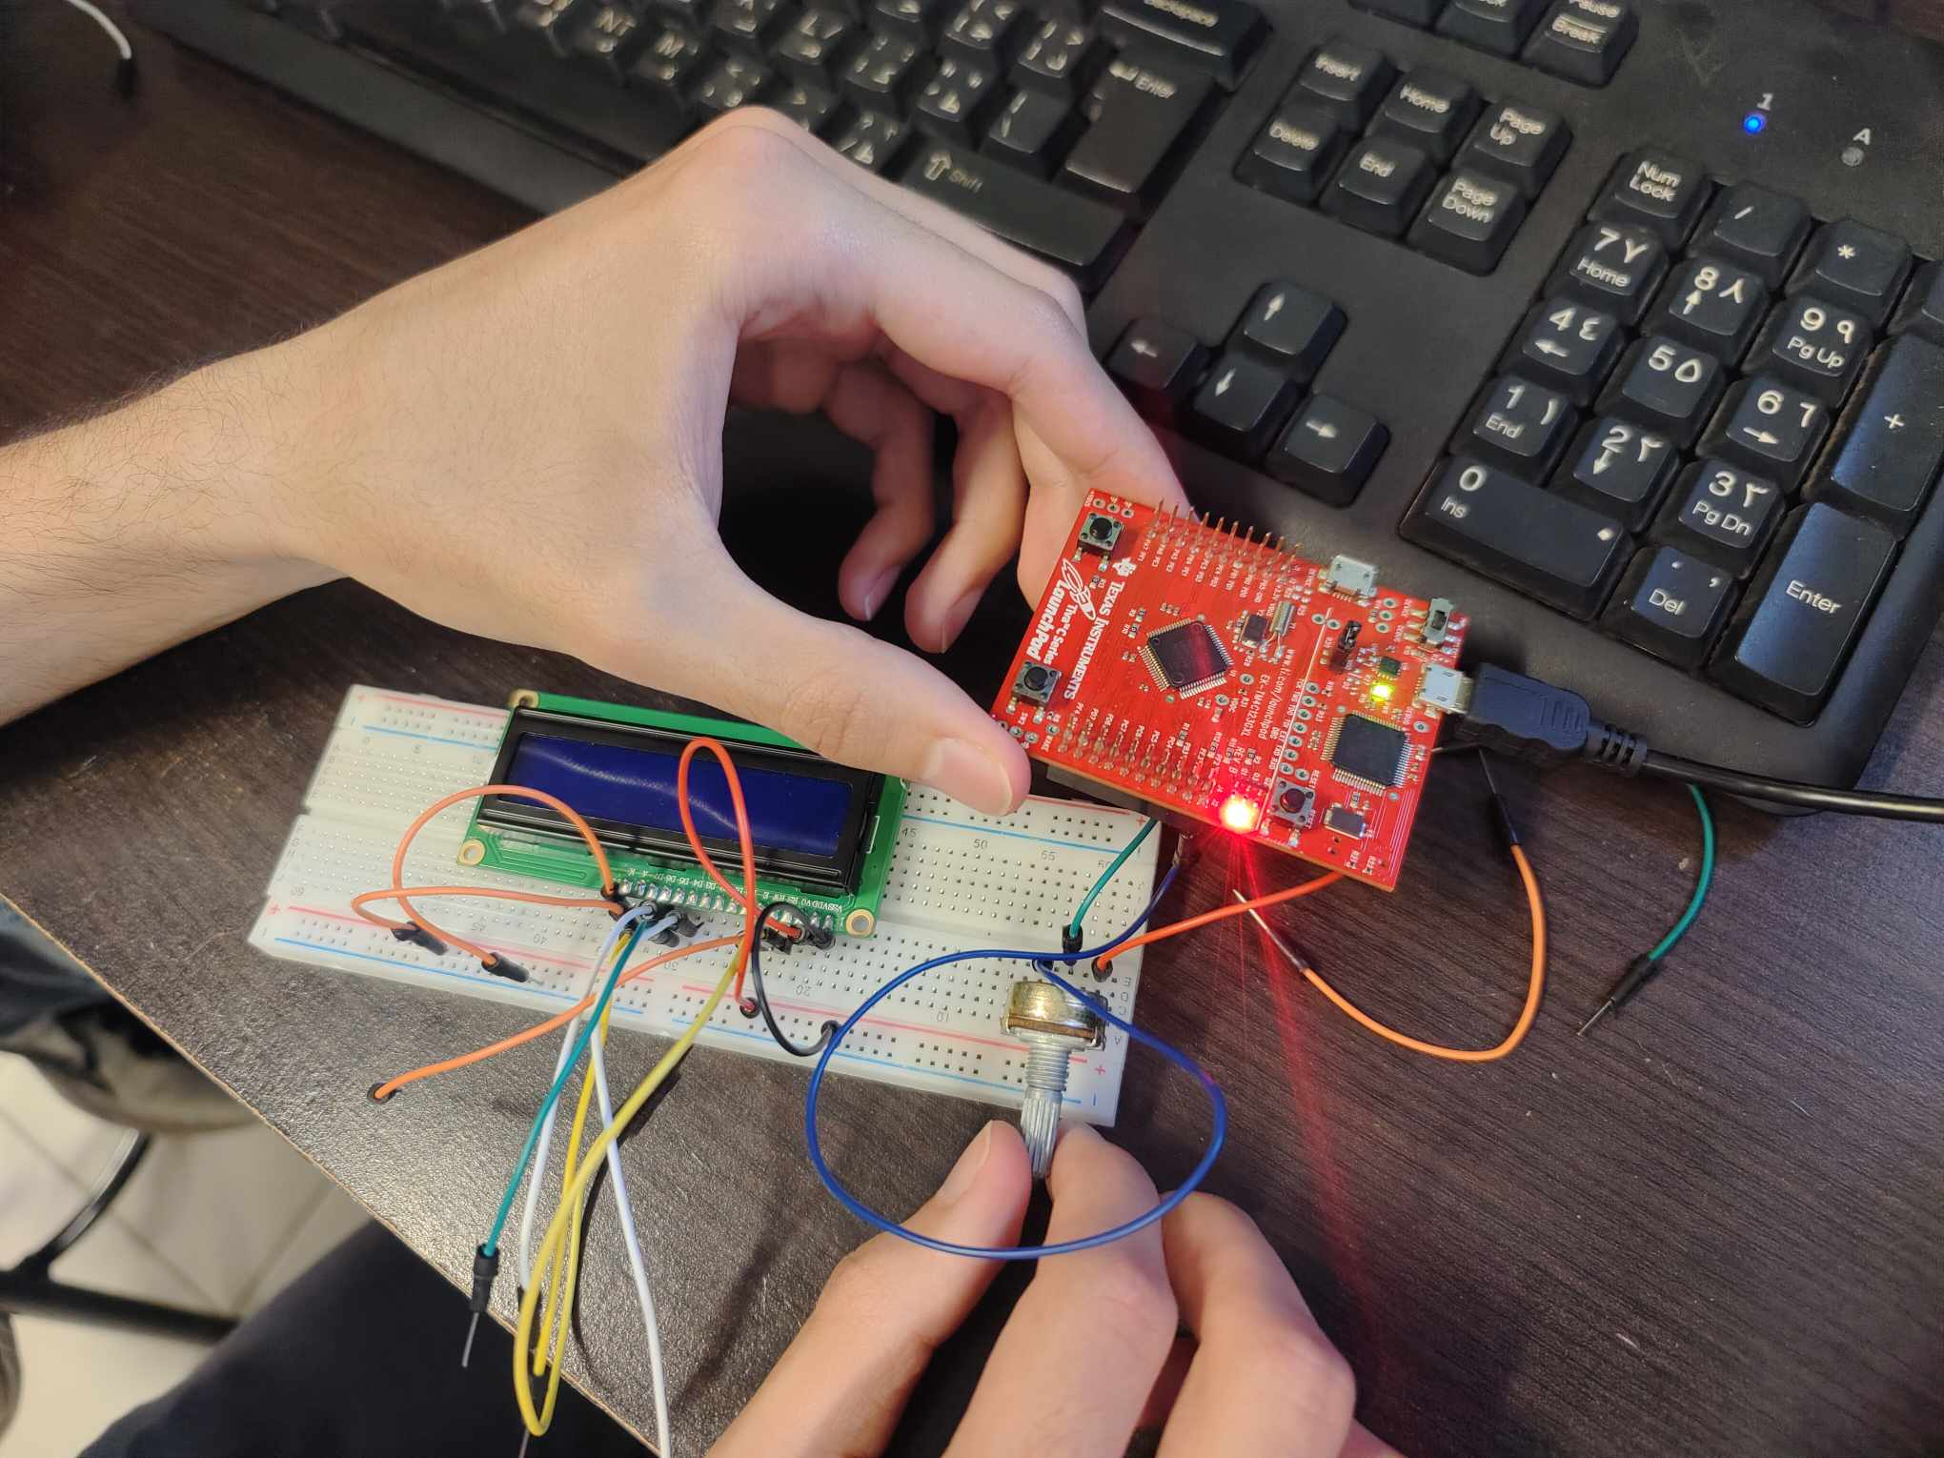

Figure : LabWork1

## **LabWork2**

Using ADC with interrupt, the input value and the voltage value are both not displayed on the LCD, because it is do not work in ENCS4110 lab.

The input value and the voltage not appear.

# Conclusion

Through this experiment, I have gained knowledge about the usage of analog-to-digital (ADC) of the TM4C123G Tiva C Launchpad. Also, we learned how to setup the ADC modules and sampler’s sequencer of TM4C123G. Most importantly, we learned both polling and interrupt-based approach to use TM4C123 MCU ADC.

# References

[1]: <https://microcontrollerslab.com/adc-tm4c123g-tiva-c-launchpad-measure-analog-voltage-signal/>

[2]:<https://spectruminstrumentation.com/support/knowledgebase/hardware_features/ADC_and_Resolution.php>

[3]: <https://e2e.ti.com/support/microcontrollers/arm-based-microcontrollers-group/arm-based-microcontrollers/f/arm-based-microcontrollers-forum/508089/tm4c123-launchpad-periodic-adc-sampling>

[4]: Lab Manual

# Appendix

## **Example1:**

//Mohammad Salem 1200651

/* TM4C123G Tiva C Series ADC Example */

/* This Program controls the onboard green LED based on discrete digital value of ADC */

/* If AN0 channel value is less 2048 digital value than LED turns off and otherwise remain on */

#include "TM4C123GH6PM.h"

#include <stdio.h>

//Functions Declaration

volatile unsigned int adc_value;

void ADC0SS3_Handler(void){

adc_value = ADC0->SSFIFO3; /* read adc coversion result from SS3 FIFO*/

ADC0->ISC = 8; /* clear coversion clear flag bit*/

ADC0->PSSI |= (1<<3); /* Enable SS3 conversion or start sampling data from AN0 */

}

int main(void)

{

volatile float voltage;

/* Enable Clock to ADC0 and GPIO pins*/

SYSCTL->RCGCGPIO |= (1<<4); /* Enable Clock to GPIOE or PE3/AN0 */

SYSCTL->RCGCADC |= (1<<0); /* AD0 clock enable*/

/* initialize PE3 for AIN0 input */

GPIOE->AFSEL |= (1<<3); /* enable alternate function */

GPIOE->DEN &= ~(1<<3); /* disable digital function */

GPIOE->AMSEL |= (1<<3); /* enable analog function */

/* initialize sample sequencer3 */

ADC0->ACTSS &= ~(1<<3); /* disable SS3 during configuration */

ADC0->EMUX &= ~0xF000; /* software trigger conversion */

ADC0->SSMUX3 = 0; /* get input from channel 0 */

ADC0->SSCTL3 |= (1<<1)|(1<<2); /* take one sample at a time, set flag at 1st sample */

ADC0->ACTSS |= (1<<3); /* enable ADC0 sequencer 3 */

/*Iniitialize PF3 as a digital output pin */

SYSCTL->RCGCGPIO |= 0x20; // turn on bus clock for GPIOF

GPIOF->DIR |= 0x08; //set GREEN pin as a digital output pin

GPIOF->DEN |= 0x08; // Enable PF3 pin as a digital pin

while(1)

{

ADC0->PSSI |= (1<<3); /* Enable SS3 conversion or start sampling data from AN0 */

while((ADC0->RIS & 8) == 0) ; /* Wait untill sample conversion completed*/

adc_value = ADC0->SSFIFO3; /* read adc coversion result from SS3 FIFO*/

ADC0->ISC = 8; /* clear coversion clear flag bit*/

/* convert digital value back into voltage */

voltage = (adc_value * 0.0008);

if(adc_value >= 2048)

GPIOF->DATA = 0x08; /* turn on green LED*/

else if(adc_value < 2048)

GPIOF->DATA = 0x00; /* turn off green LED*/

}

}

## **Lab Work1:**

//Mohammad Salem 1200651

#include "TM4C123GH6PM.h"

#include <stdio.h>

//Functions Declaration

volatile unsigned int adc_value;

void ADC0SS3_Handler(void){

adc_value = ADC0->SSFIFO3; /* read adc coversion result from SS3 FIFO*/

ADC0->ISC = 8; /* clear coversion clear flag bit*/

ADC0->PSSI |= (1<<3); /* Enable SS3 conversion or start sampling data from AN0 */

}

int main(void)

{

volatile float voltage;

/* Enable Clock to ADC0 and GPIO pins*/

SYSCTL->RCGCGPIO |= (1<<4); /* Enable Clock to GPIOE or PE3/AN0 */

SYSCTL->RCGCADC |= (1<<0); /* AD0 clock enable*/

/* initialize PE3 for AIN0 input */

GPIOE->AFSEL |= (1<<3); /* enable alternate function */

GPIOE->DEN &= ~(1<<3); /* disable digital function */

GPIOE->AMSEL |= (1<<3); /* enable analog function */

/* initialize sample sequencer3 */

ADC0->ACTSS &= ~(1<<3); /* disable SS3 during configuration */

ADC0->EMUX &= ~0xF000; /* software trigger conversion */

ADC0->SSMUX3 = 0; /* get input from channel 0 */

ADC0->SSCTL3 |= (1<<1)|(1<<2); /* take one sample at a time, set flag at 1st sample */

ADC0->ACTSS |= (1<<3); /* enable ADC0 sequencer 3 */

/*Iniitialize PF3 as a digital output pin */

SYSCTL->RCGCGPIO |= 0x20; // turn on bus clock for GPIOF

GPIOF->DIR |= 0x08 | 0x02; //set GREEN pin as a digital output pin

GPIOF->DEN |= 0x08 | 0x02; // Enable PF3 pin as a digital pin

while(1)

{

ADC0->PSSI |= (1<<3); /* Enable SS3 conversion or start sampling data from AN0 */

while((ADC0->RIS & 8) == 0) ; /* Wait untill sample conversion completed*/

adc_value = ADC0->SSFIFO3; /* read adc coversion result from SS3 FIFO*/

ADC0->ISC = 8; /* clear coversion clear flag bit*/

/* convert digital value back into voltage */

voltage = (adc_value * 0.0008);

if(adc_value >= 1000)

GPIOF->DATA = 0x02; /* turn on red LED*/

else if(adc_value < 1000)

GPIOF->DATA = 0x08; /* turn off green LED*/

}

}

## **LabWork2:**

//Mohammad Salem 1200651

#include "TM4C123.h" // Device header

#define LCD GPIOB //LCD port with Tiva C

#define RS 0x01 //RS -> PB0 (0x01)

#define RW 0x02 //RW -> PB1 (0x02)

#define EN 0x04 //EN -> PB2 (0x04)

//Functions Declaration

void delayUs(int); //Delay in Micro Seconds

void delayMs(int); //Delay in Milli Seconds

void LCD4bits_Init(void); //Initialization of LCD Dispaly

void LCD_Write4bits(unsigned char, unsigned char); //Write data as (4 bits) on LCD

void LCD_WriteString(char*); //Write a string on LCD

void LCD4bits_Cmd(unsigned char); //Write command

void LCD4bits_Data(unsigned char); //Write a character

void delayUs(int); //Delay in Micro Seconds

volatile unsigned int adc_value;

void ADC0SS3_Handler(void){

adc_value = ADC0->SSFIFO3; /* read adc coversion result from SS3 FIFO*/

ADC0->ISC = 8; /* clear coversion clear flag bit*/

ADC0->PSSI |= (1<<3); /* Enable SS3 conversion or start sampling data from AN0 */

}

int main(void)

{

char* str = "Tiva C starting"; //Write any string you want to display on LCD

char s[20];

volatile float voltage;

char D[20];

volatile float input;

LCD4bits_Init(); //Initialization of LCD

LCD4bits_Cmd(0x01); //Clear the display

LCD4bits_Cmd(0x80); //Force the cursor to beginning of 1st line

delayMs(500); //delay 500ms for LCD (MCU is faster than LCD)

LCD_WriteString(s); //Write the string on LCD

delayMs(500); //Delay 500 ms to let the LCD diplays the data

LCD4bits_Cmd(0xC0); //Force the cursor to beginning of 2

delayMs(500); //delay 500ms for LCD (MCU is faster than LCD)

LCD_WriteString(D); //Write the string on LCD

delayMs(500); //Delay 500 ms to let the LCD diplays the data

/* Enable Clock to ADC0 and GPIO pins*/

SYSCTL->RCGCGPIO |= (1<<4); /* Enable Clock to GPIOE or PE3/AN0 */

SYSCTL->RCGCADC |= (1<<0); /* AD0 clock enable*/

/* initialize PE3 for AIN0 input */

GPIOE->AFSEL |= (1<<3); /* enable alternate function */

GPIOE->DEN &= ~(1<<3); /* disable digital function */

GPIOE->AMSEL |= (1<<3); /* enable analog function */

/* initialize sample sequencer3 */

ADC0->ACTSS &= ~(1<<3); /* disable SS3 during configuration */

ADC0->EMUX &= ~0xF000; /* software trigger conversion */

ADC0->SSMUX3 = 0; /* get input from channel 0 */

ADC0->SSCTL3 |= (1<<1)|(1<<2); /* take one sample at a time, set flag at 1st sample */

ADC0->ACTSS |= (1<<3); /* enable ADC0 sequencer 3 */

/*Iniitialize PF3 as a digital output pin */

SYSCTL->RCGCGPIO |= 0x20; // turn on bus clock for GPIOF

GPIOF->DIR |= 0x08; //set GREEN pin as a digital output pin

GPIOF->DEN |= 0x08; // Enable PF3 pin as a digital pin

/* Enable ADC Interrupt */

ADC0->IM |= (1<<3); /* Unmask ADC0 sequence 3 interrupt*/

NVIC->ISER[0] |= 0x00020000; /* enable IRQ17 for ADC0SS3*/

ADC0->ACTSS |= (1<<3); /* enable ADC0 sequencer 3 */

ADC0->PSSI |= (1<<3); /* Enable SS3 conversion or start sampling data from AN0 */

while(1)

{

/*control Green PF3->LED */

/* convert digital value back into voltage */

voltage = (adc_value * 0.0008);

sprintf(s, "Voltage = %.2f", voltage);

//LCD4bits_Cmd(0x01); //Clear the display

LCD4bits_Cmd(0x80); //Force the cursor to beginning of 1st line

delayMs(500); //delay 500ms for LCD (MCU is faster than LCD)

LCD_WriteString(s); //Write the string on LCD

delayMs(500); //Delay 500 ms to let the LCD diplays the data

sprintf(s, "input = %d", adc_value);

//LCD4bits_Cmd(0x01); //Clear the display

LCD4bits_Cmd(0xc0); //Force the cursor to beginning of 1st line

delayMs(500); //delay 500ms for LCD (MCU is faster than LCD)

LCD_WriteString(s); //Write the string on LCD

delayMs(500); //Delay 500 ms to let the LCD diplays the data

if(adc_value >= 2048)

GPIOF->DATA = 0x08; /* turn on green LED*/

else if(adc_value < 2048)

GPIOF->DATA = 0x00; /* turn off green LED*/

}

}

void LCD4bits_Init(void)

{

SYSCTL->RCGCGPIO |= 0x02; //enable clock for PORTB

delayMs(10); //delay 10 ms for enable the clock of PORTB

LCD->DIR = 0xFF; //let PORTB as output pins

LCD->DEN = 0xFF; //enable PORTB digital IO pins

LCD4bits_Cmd(0x28); //2 lines and 5x7 character (4-bit data, D4 to D7)

LCD4bits_Cmd(0x06); //Automatic Increment cursor (shift cursor to right)

LCD4bits_Cmd(0x01); //Clear display screen

LCD4bits_Cmd(0x0F); //Display on, cursor blinking

}

void LCD_Write4bits(unsigned char data, unsigned char control)

{

data &= 0xF0; //clear lower nibble for control

control &= 0x0F; //clear upper nibble for data

LCD->DATA = data | control; //Include RS value (command or data ) with data

LCD->DATA = data | control | EN; //pulse EN

delayUs(0); //delay for pulsing EN

LCD->DATA = data | control; //Turn off the pulse EN

LCD->DATA = 0; //Clear the Data

}

void LCD_WriteString(char * str)

{

volatile int i = 0; //volatile is important

while(*(str+i) != '\0') //until the end of the string

{

LCD4bits_Data(*(str+i)); //Write each character of string

i++; //increment for next character

}

}

void LCD4bits_Cmd(unsigned char command)

{

LCD_Write4bits(command & 0xF0 , 0); //upper nibble first

LCD_Write4bits(command << 4 , 0); //then lower nibble

if(command < 4)

delayMs(2); //commands 1 and 2 need up to 1.64ms

else

delayUs(40); //all others 40 us

}

void LCD4bits_Data(unsigned char data)

{

LCD_Write4bits(data & 0xF0 , RS); //upper nibble first

LCD_Write4bits(data << 4 , RS); //then lower nibble

delayUs(40); //delay for LCD (MCU is faster than LCD)

}

void delayMs(int n)

{

volatile int i,j; //volatile is important for variables incremented in code

for(i=0;i<n;i++)

for(j=0;j<3180;j++) //delay for 1 msec

{}

}

void delayUs(int n)

{

volatile int i,j; //volatile is important for variables incremented in code

for(i=0;i<n;i++)

for(j=0;j<3;j++) //delay for 1 micro second

{}

}