Help Document

Of

Eskadenia Payment Plugin

*for*

**nopCommerce – 4.10**

***by***

**QBS Team**



1. Upload plugin
2. Install plugin
3. Plugin Configuration
4. Pay Payment
5. **Upload plugin**

For install **Eskadenia Payment Plugin,** you need to upload plugin zip file from admin side.

For upload plugin follow below steps

1. Go to Your Store
2. Login with Admin credentials
3. Go **to Plugin List** via

* Side bar (Left hand side)
* Configuration
* Local Plugins

On this page you can see list of all plugins.

If you have plugin "**Eskadenia Payment Plugin**” already in this list than you not need to upload plugin.

If plugin is not exist list then you need to upload plugin from admin area.

In plugin list page, there is button for **Upload Plugins or Theme at** top right side**.**

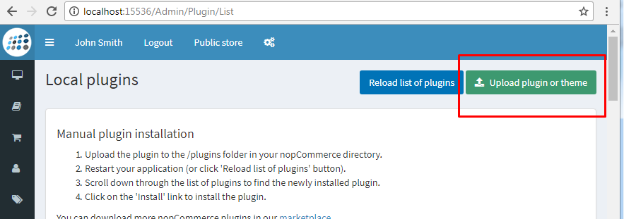

Click on this button and it’ll open popup with file brows for upload file.

On popup you can see instruction of plugin zip folder and manual update.

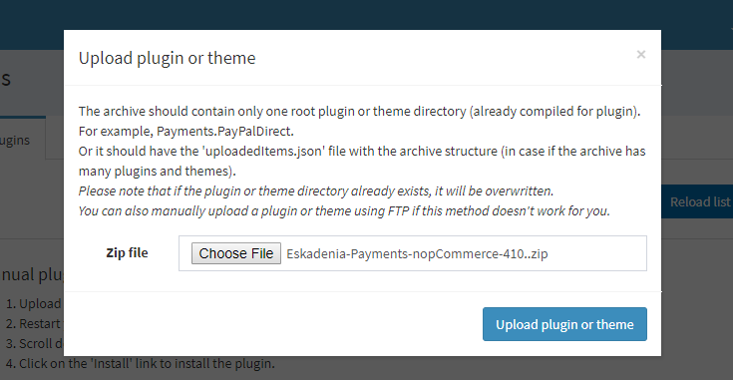

Now select **plugin zip** file and click on Upload plugin or theme button.

Once you click on it’ll upload plugin and you can find plugin "**Eskadenia Payment**” in plugin list.

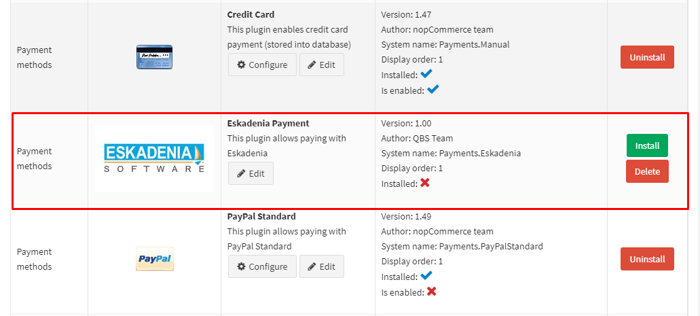

Now you can click on install button for install plugin**.**

1. **Install plugin**

For install plugin, just click on install button and plugin will install within few moment.

Once installation done, configuration button will available next to plugin description.

Click on configure button for configure plugin.

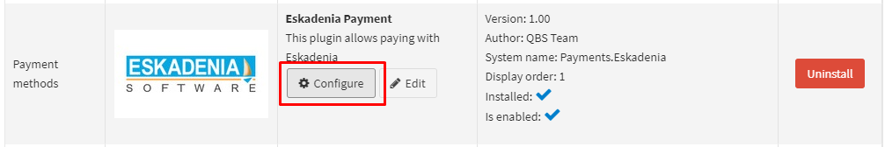

You can also go to configuration page from payment method list.

1. **Plugin Configuration**

For go to configuration page click on Configure button under the plugin details in plugin list page.

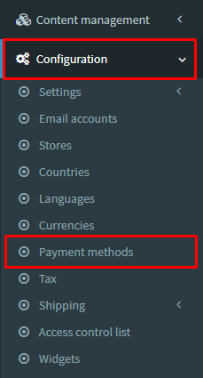

Or you can go configure page from payment

Method list page.

Go to Admin panel

* Side bar (Left hand side)
* Configuration
* Payment Methods

**Enable Payment Plugin:**

Click on edit button of Eskadenia Payment and check **Is Active** option then click on update button.

**Enable Payment Plugin:**

For configuration, click on configure button of Eskadenia Payment option.

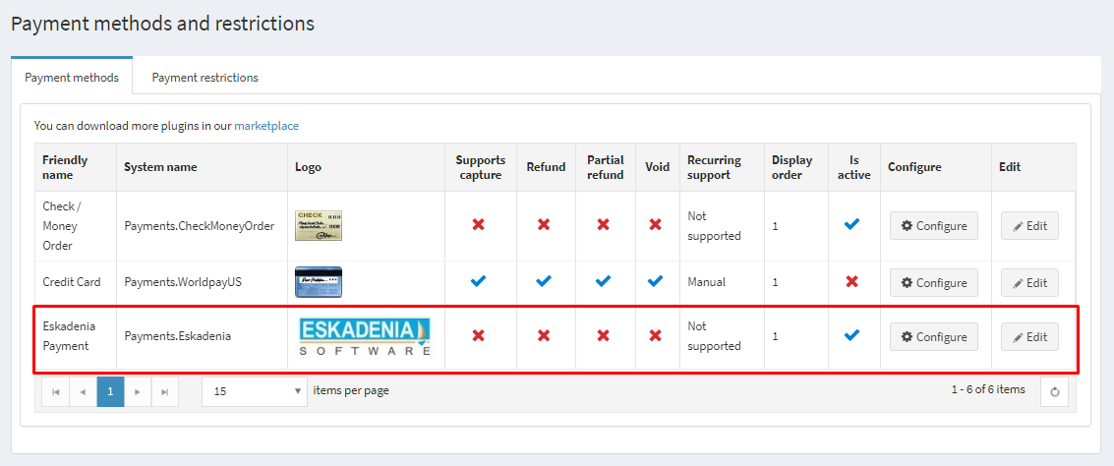

1. **Configuration page**

Here is image for how configuration page is look.

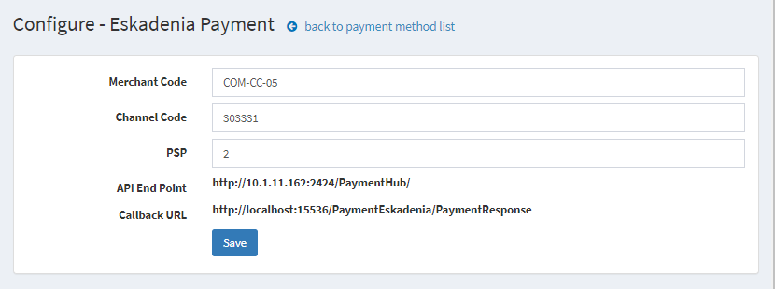

**Here are**

* **Merchant Code:** Merchant code which will provide by Eskadenia
* **Channel Code:** Channel code which will provide by Eskadenia
* **PSP:** PSP code which will provide by Eskadenia
* **API End Point:** API endpoint which provide by Eskadenia. This endpoint admin can change from Advance setting (Admin > Configuration > Settings > All Settings via key: eskadeniapaymentsettings.apiendpoint). API end point should till ‘PaymentHub/’.
* **Callback URL:** Callback URL of payment response. This will be configured under plugin. Callback URL will be <http://yourstore.com/PaymentEskadenia/PaymentResponse>.

Payment gateway wills send response on this URL.

1. **Payment Workflow**

User can make payment via once Eskadenia payment option enable.

For make payment via Eskadenia, user have select Eskadenia payment option from checkout process.

**Note**: *This payment gateway is* ***support only Jordanian dollar (JOD),*** *so if customer’s current currency is not JOD then Eskadenia payment option will not display on payment method list.*

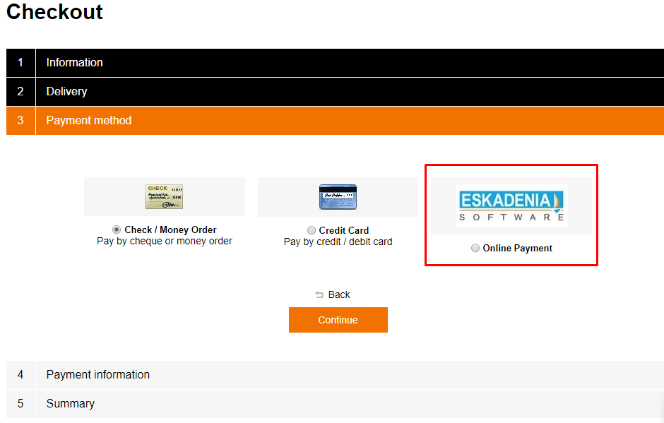

Select Eskadenia payment option and click on continue button.

On click of continue button, system will say ***“This will redirect to you on Eskadenia payment page.”***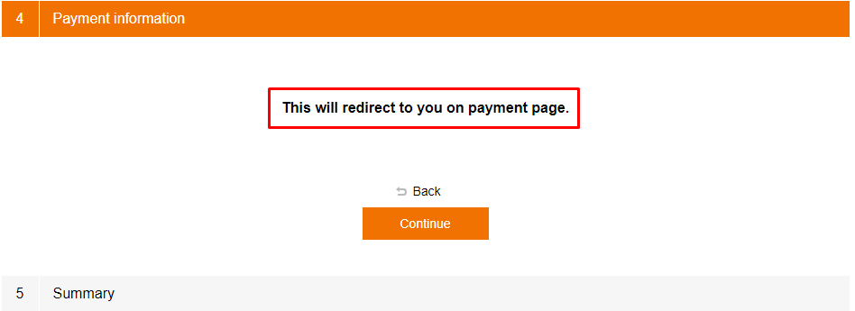

Now click on continue and then confirm order button. This will redirect to payment page.

Before go to payment page, system will validate cart.

For validate cart, system will send request to Eskadenia server with detail and it will send response.

Request parameter:

<http://10.1.11.162:2424/PaymentHub/PayPrep?merchantCode=COM-CC-05&channelCode=303331&serviceType=validateCheckout&merchantTrxNo=9999123&payAmount=66&currencyCode=JOD>

Here

* [**http://10.1.11.162:2424/PaymentHub/PayPrep**](http://10.1.11.162:2424/PaymentHub/PayPrep)**:** End point
* **MerchantCode:** Merchant code
* **ChannelCode**: Merchant Channel code
* **ServiceType**: API name for validate cart (this is fix)
* **MerchantTrxNo:** Merchant transaction number which will be unique. Here we use Order id for track order
* **PayAmount**: Order total amount which need to pay
* **CurrencyCode:** Currency code JOD

**Response of this request something like**

merchantTrxNo=1111--;--trxStatus=OPC-00130--;--payAmount=66

**Here**

* **MerchantTrxNo:** Merchant transaction number which will be unique. Here we use Order id for track order
* **trxStatus**: Status code of request
* **PayAmount**: Order total amount which need to pay

Status Codes (same for all request)

|  |  |
| --- | --- |
| Status Code | Description |
| OPC-00000 | **Request served successfully** |
| OPC-00130 | **Fail. Merchant Code Does Not Exist** |
| OPC-00131 | **Fail. Currency Code Does Not Exist** |
| OPC-00132 | **Fail. Transaction Not Found with MerchantTrxNo** |

If validateCheckout API get success response (OPC-00000) then system redirect user to payment portal page.

Payment request url:

<http://10.1.11.162:2424/PaymentHub/PayPrep?merchantCode=COM-CC-05&channelCode=303331&serviceType=proceedCheckout&custEmail=rajupaladiya1392@mail.com&custNum=Raju&merchantTrxNo=9999123&payAmount=66&currencyCode=JOD&PSP=2&callBackUrl=http://localhost:15536/PaymentEskadenia/PaymentResponse>

Here

* [**http://10.1.11.162:2424/PaymentHub/PayPrep**](http://10.1.11.162:2424/PaymentHub/PayPrep)**:** End point
* **MerchantCode:** Merchant code
* **ChannelCode**: Merchant Channel code
* **CustEmail**: Customer email address, if have billing/shipping email address then passing billing/shipping email address otherwise pass customer’s email address
* **CustNum**: Customer name (First Name + Last Name)
* **ServiceType**: API name for validate cart (this is fix)
* **MerchantTrxNo:** Merchant transaction number which will be unique. Here we use Order id for track order
* **PayAmount**: Order total amount which need to pay
* **CurrencyCode:** Currency code JOD
* **PSP:** PSP value which is provide by Eskadenia
* **CallbackURL**: Call back url for get response from payment gateway.

User will get payment form here where he/she can enter card detail and make payment.

System will send payment response on callback URL once he/she submit card detail for procced payment.

Response will be like:

<http://localhost:15536/PaymentEskadenia/PaymentResponse/?merchantTrxNo=9999123&patTrxStatus=OPC-00000&payTrxNo=OES-20190929114619173&payAmount=66.0&payTrxDate=29-09-2019&secureHash=$2a$10$qasKb28TEfmc1mQyPK2JhuYojdfyyYK78R5K8egyESDQCJvBgVBPa>

Here

* **SecureHash:** This will be generated using BCrypt algorithm by hashing the response arams values using a provided Secret Token.
* **PayTrxDate:** The date of the successful payment transaction

Rest of same as previous.

If payment status code is OPC-00000 then system will call for check payment status.

For this need to make post request on below endpoint with parameter

**End Point:** http://10.1.11.162:2424/PaymentHub/rest/Communicator/PayCheck

**Request Body:**

{

"merchantCode": "COM-CC-88",

"channelCode": "303331",

"merchantTrxNo": "999333"

}

**Success Response**

{

"merchantTrxNo": "9999123",

"payTrxStatus": "OPC-00000",

"description": "General Success",

"payTrxNo": "OES-20190929114619173",

"payAmount": "66.0",

"payTrxDate": "29-09-2019"

}

**Fail Response**

{

"payTrxStatus": "OPC-00132",

"description": "No Payment transaction found at the Payment Gateway"

}

***If response is success then order payment status will update with pending to paid and order status update to Processing mode.***

***If response is fail then payment status and order status will not update.***

Response of every API calls are stored in order note, so admin can check it from order edit page under admin area.