**Design of Thiophene-based 2D Metal-free Photocatalyst Driven by Non-adiabatic Dynamics Simulations**

**Fulu Zheng1, Yamei Liu2, Mingchao Wang2, Thomas Frauenheim1**

*1 Construcor University, Campus Ring 1, Bremen 28759, Germany*

*2 Center for Advancing Electronics Dresden (cfaed) and Faculty of Chemistry and Food Chemistry, Technische Universität Dresden, Mommsenstrasse 4, Dresden 01062, Germany*

*Email:* [*fzheng@constructor.university;*](mailto:fzheng@constructor.university;)[*flzheng525@gmail.com*](mailto:flzheng525@gmail.com)

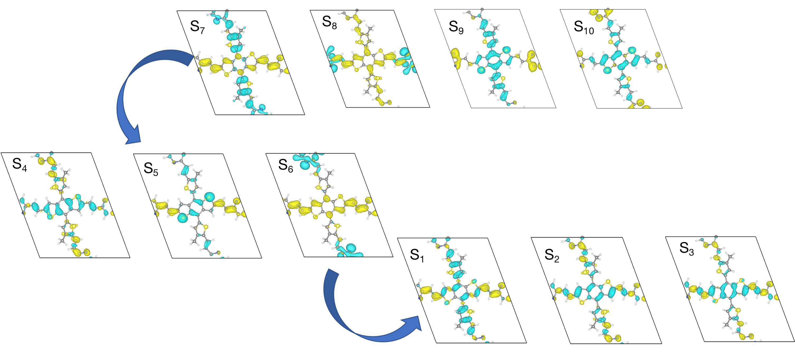 

Mimicking natural photosynthesis holds significant potential for addressing global challenges such as climate change and energy scarcity. Artificial photosynthetic systems, particularly those focusing on CO₂ reduction, are emerging as promising solutions. Among various approaches, 2D metal-free photocatalysts have garnered substantial attention due to their unique properties, such as large surface area, tunable electronic structure, and cost-effectiveness. In this work, we explore the design and synthesis of thiophene-based 2D metal-free photocatalysts aimed at achieving high-performance CO₂ reduction. Leveraging insights from advanced non-adiabatic dynamics simulations, we have developed a series of photocatalysts optimized at the molecular level for enhanced catalytic efficiency. These simulations provide a deep understanding of the excited state dynamics and charge transfer mechanisms, crucial for improving the photocatalytic activity. This study not only demonstrates the feasibility of using 2D metal-free materials in artificial photosynthesis but also highlights the critical role of non-adiabatic dynamics simulations in guiding the development of next-generation photocatalytic systems.



*This study has received funding from the European Union’s Horizon 2020 research and innovation programme under grant agreement No 899205.*