**Non-adiabatic Molcular Dynamics of Silver Clusters using Semiempirical Methods**

Kevin Walsh

*Department of Chemistry, Brandeis University, Waltham, MA*

Email: [kevinwalsh@brandeis.edu](mailto:kevinwalsh@brandeis.edu)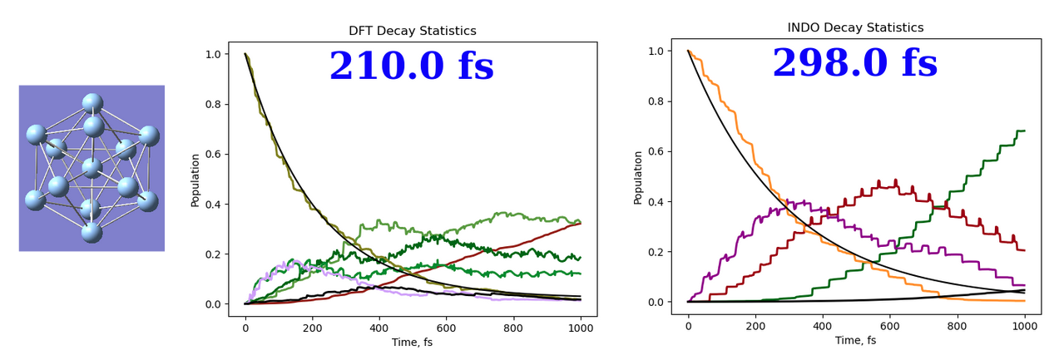

Silver nanoclusters have shown great promise in fields related to light harvesting due to their ability to support plasmons, which strongly absorb light and localize its electric field on the nanoscale. The emergence of plasmonic behavior in these systems is still poorly understood, so the accurate modeling of such systems is critical to increasing their applicability. We have created an interface between the MOPAC and Libra software packages to run non-adiabatic molecular dynamics (NAMD) simulations using the semiempirical INDO/S hamiltonian. INDO/S reduces the computational cost of running molecular simulations by replacing expensive integrals with parameters that are assigned based on experimental results or previous calculations. Combining this semiempirical approach with Libra allows us to cheaply model excited states in the configuration interaction (CI) basis. We have previously parameterized INDO/S for Ag and now perform NAMD on an icosahedral Ag135+ nanocluster. The resulting non-adiabatic couplings (NACs) and decay timescales are reasonably accurate and can be computed orders of magnitude faster than DFT.