**Excitons in Hematite Fe2O3: Short-time Dynamics**

**from TD-DFT and non-Adiabatic Dynamics Theories**

Lili Rassouli

Department of Chemical and Biological Engineering, University at Buffalo, Buffalo NY 14260

Email: [lilirass@buffalo.edu](mailto:lilirass@buffalo.edu)

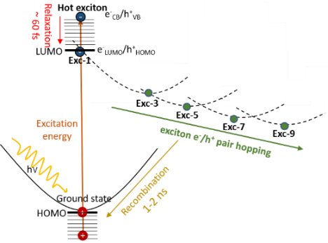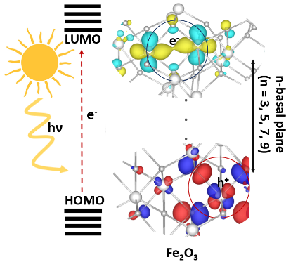

In this presentation, I'll take you through the fascinating world of exciton dynamics in hematite, using Nonadiabatic Molecular Dynamics (NA-MD) simulations in Libra.

First, I'll introduce you to my system: hematite (Fe2O3), a photoactive semiconductor oxide that's a strong candidate for photoelectrochemical cells (PECs). We'll explore the unique structure of excitons in hematite and how they resemble a pair of polarons (an electron polaron and a hole polaron) with associated lattice distortions. You'll see how, over longer timescales, these electron-hole pairs hop across the material, moving from a state where they are three basal planes apart (Exc-3) to states where they are separated by 5, 7, 9, and more planes. This process illustrates the fascinating journey of charge separation within hematite.

Next, I'll dive into the technical details of how Libra, particularly the Decoherence-Corrected Trajectory Surface Hopping approaches in NA-MD simulations, have been pivotal in my research. These methods have allowed me to determine recovery times of approximately 1.1 to 1.8 nanoseconds and excited states relaxation times of around 60 to 70 femtoseconds. Remarkably, these findings align well with experimentally derived lifetimes.

Join me as we explore how advanced simulation techniques are unlocking new understandings of photoexcitation dynamics in hematite, paving the way for future innovations in photoactive materials.