**Investigating the Excited State Properties of Photoactive TiO2 Nanoclusters using Non-Adiabatic Molecular Dynamics**

M. Recio-Poo

*Departament de Ciència de Materials i Química Física & Institut de Química Teòrica i Computacional (IQTCUB), Universitat de Barcelona, c/Martí i Franquès 1-11, 08028 Barcelona, Spain;*

*E-mail: miguelrecio@ub.edu*

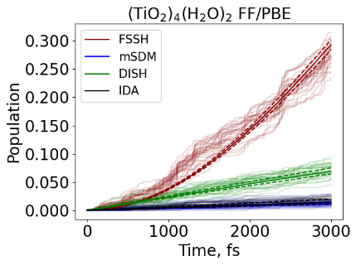

Titania (TiO2) has gained considerable attention over the last few decades in the field of photocatalysis due to its unique electronic and optical properties. [1,2] As a wide-bandgap semiconductor, titania can absorb ultraviolet (UV) light and generate electron-hole pairs that can be used for redox reactions at its surface. However, TiO2 has two significant drawbacks for applications using sunlight: 1) a relatively large bandgap (i.e., 3.2 eV for the anatase bulk phase) implying that its activation requires UV-light, and 2) a rapid recombination of electron-hole pairs that facilitates catalyst deactivation, rendering redox reactions unfeasible. Here, I employ nonadiabatic molecular dynamics (NA-MD)[3,4] using Libra computational code capabilities in order to investigate the dynamics of the excited states of various small bare and hydrated titania systems. In this way, I assess the suitability of using: i) either classical or *ab initio* MD to obtain the initial nuclear trajectories, ii) single-particle or TD-DFT states for computing the nonadiabatic couplings (NACs), and iii) explore a variety of trajectory surface hopping methods for running NA-MD simulations aimed at predicting the lifetime of the electronic states of interest. This detailed study not only shed light on the effect of size and water coverage on the dynamics of various excited states of the selected TiO2 models, but also constitutes an initial methodological assessment of NA-MD dynamics recipes for further use in larger and more realistic titania nanostructures.

*References*

[1] M. A. Fox, M. T. Dulayme, *Chem. Rev.*, **93(1)**, 341-357 (1993)

[2] A. Fujishima, X. Zhang, D. A. Tryk, *Surf. Sci. Rep.*, **63(12)**, 515-582 (2008)

[4] B. Smith, M. Shakiba, A. V. Akimov. *J. Chem. Theory Comput.*, **17,** 678-693 (2021)

[5] B. Smith, A. V. Akimov, *J. Phys. Chem. Lett.*, **11**, 1456-1465 (2020)