**Nonadiabatic molecular dynamics simulations with Libra**

Mohammad Shakiba

Department of Chemistry, University at Buffalo, The State University of New York, Buffalo, NY 14260-3000

Email: [mshakiba@buffalo.edu](mailto:mshakiba@buffalo.edu)

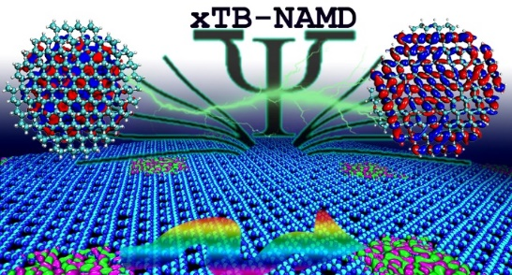

Nonadiabatic molecular dynamics (NA-MD) simulations provide valuable atomistic insights into the photoexcitation dynamics in solar energy materials. Such simulations have been utilized in the photoexcited dynamics of different materials with applications in solar cells, light-emitting diodes, photocatalysis, etc. However, modeling such simulations for structures with sizes close to those observed in experimental studies are computationally expensive and the simulations are limited to small- and medium-sized structures with few hundreds of atoms.

In this presentation, I will show how the advanced techniques, that are implemented in Libra, can be used to perform such calculations for nanoscale systems. In the first part, I will highlight our most recent work on NA-MD simulations using the xTB framework implemented in the open-source Libra code. I will first talk about the implementation details and then, I will show the applicability of this approach for describing hot-electron relaxation dynamics in large silicon quantum dots. I will also talk about how electron-hole recombination dynamics depends on the charge carrier concentration by performing NA-MD in carbon nitride monolayers with up to 5600 atoms (14.2 nm x 12.3 nm).

In the second part, I will show a conceptually different ML strategy, devised in our group, for constructing the Kohn-Sham (KS) Hamiltonian matrix in a desired level of theory for nanoscale systems. I will first show our observation that the KS Hamiltonian obtained from a converged charge density is relatively a smooth map of the KS Hamiltonian obtained from a cheap non-self-consistent atomic density guess. I will show that this model is conceptually simpler that other ML models, requires smaller number of training datapoints, learns fast, speeds up the calculations by several orders of magnitude with a good accuracy compared to conventional calculations, and is scalable and applicable to different nanoscale materials, such as fullerene and silicon quantum dots, even with minimalistic ML techniques. Finally, I will show when it is applied to NA-MD simulations of hot-carrier relaxation dynamics, the corresponding timescales are within the error margin of the conventional calculations.