**Nonadiabatic molecular dynamics with subsystem density functional theory: application to crystalline pentacene**

Qingxin Zhang

*Department of Chemistry, University at Buffalo, The State University of New York, Buffalo, NY 14260, United States*

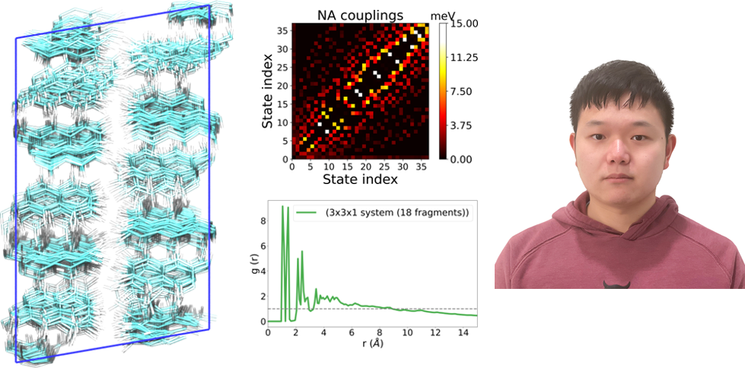

I will present the development and assessment of the nonadiabatic molecular dynamics approach with the electronic structure calculations based on the linearly scaling subsystem density functional method. The strategy is implemented in an open-source eQE/Libra software designed for nonadiabatic dynamics simulations in extended systems. As proof of the applicability of this method to large condensed-matter systems, we examine the dynamics of nonradiative relaxation of excess excitation energy in pentacene crystals with the simulation supercells containing more than 600 atoms. Furthermore, increased structural disorder observed in larger supercell models induces larger nonadiabatic couplings of electronic states and accelerates the relaxation dynamics of excited states. We conduct a comparative analysis of several quantum-classical trajectory surface hopping schemes, including two new methods proposed in this work (revised decoherence-induced surface hopping and instantaneous decoherence at frustrated hops). Finally, I will conclude different test schemes based on relaxation times and show customized subsystem situations.