**Nonadiabatic Dynamics in Metal Halide Perovskites**

Wei Li

*School of Chemistry and Materials Science, Hunan Agricultural University, Changsha 410128, PR China*

E-mail: [weili@hunau.edu.cn](mailto:weili@hunau.edu.cn)

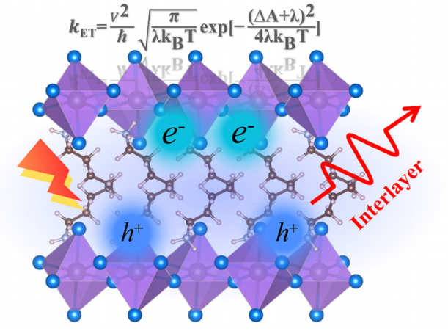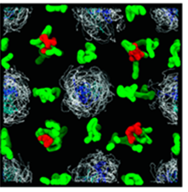 

Non-adiabatic molecular dynamics (NA-MD) simulation is a popular method that have reached great success.[1] In this talk, I will introduce our recent works in the NA-MD simulations of metal halide perovskites. First, we implemented a versatile projection-operator diabatization approach for calculation of electronic coupling integrals in two-dimensional organic-inorganic hybrid lead halide perovskites,[2] with a specific focus on the interlayer charge transfer rate. Second, we introduced the classical path approximation for simplified version of constrained density functional theory to simulate interlayer charge transfer in 2D perovskites in the time-domain.[3] Third, we incorporated the spin-orbital coupling effect in NA-MD simulation by introducing two-component spinor wave functions,[4] revealing that the nonradiative dynamics in hybrid perovskite materials can be greatly accelerated by spin-orbital coupling. Fourth, we explored the applicability and validity of Hamiltonian repetition NA-MD simulation using two-states model Hamiltonians, demonstrating how this approach can extend NA-MD timescale in realistic systems.[5] The last, we discussed how NA-MD simulations can serve as a powerful tool for unraveling the unusual defect, temperature, and pressure properties observed in hybrid perovskites,[6,7,8] offering valuable insights to guide future experiments.

***Keywords：Nonadiabatic molecular dynamics***, ***Perovskite solar cells****,* ***Charge transfer***

**References**

[1]Li W.; Prezhdo O. V.; et al. *Nanoscale*, **2021**, *13*, 10239.

[2] Li W.; Prezhdo O. V.; Beljonne D. et al. *J. Chem. Theory Comput.*, **2023**, *19*, 9403.

[3] Li W.; Prezhdo O. V.; et al. *to be submitted.*

[4] Li W.; Prezhdo O. V.; Akimov A. V.; et al. *ACS Energy Lett.* **2018**, *3*, 2159

[5] Li W.; Akimov A. V. *J. Phys. Chem. Lett.*, **2022**, *13*, 9688.

[6] Li W.; Prezhdo O. V.; et al. *J. Am. Chem. Soc.*, **2018**, *140*, 15753.

[7] Li W.; Prezhdo O. V., Zhang H.-X, et al. *ACS Energy Lett.*, **2017**, *2*, 1270.

[8] Li W.; Prezhdo O. V. *Chem. Mater*. **2020**, *32*, 4707.