**PERSONAL BLOG ON CLOUD STATIC WEB APPS**

**PHASE 4 Development Part**

**Project : Personal Blog**

**Team member : Mohammad Sharik**

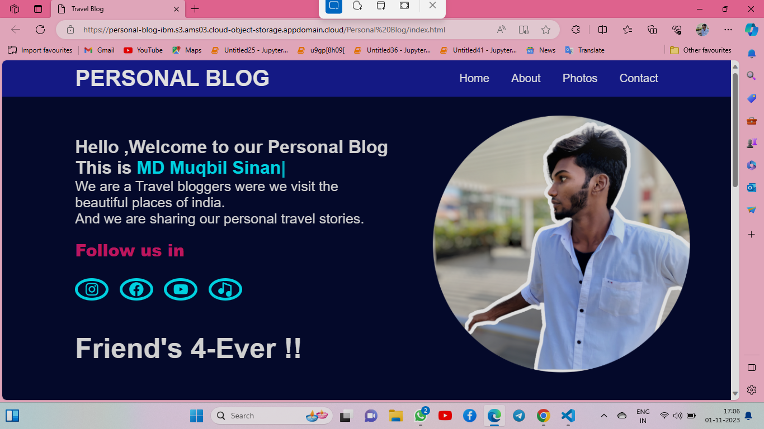

**Introduction**

Welcome to "My Personal blog," Hello ,Welcome to our Personal Blog .We are a Travel bloggers were we visit the beautiful places of india.And we are sharing our personal travel stories.The cloud has become the beating heart of the digital era, a catalyst for change that influences every facet of our lives. As we navigate the ever-evolving landscapes of technology, this blog aims to serve as your compass and guide through the intricate pathways of the digital skies.

**Here I am Developed a website for my Blog**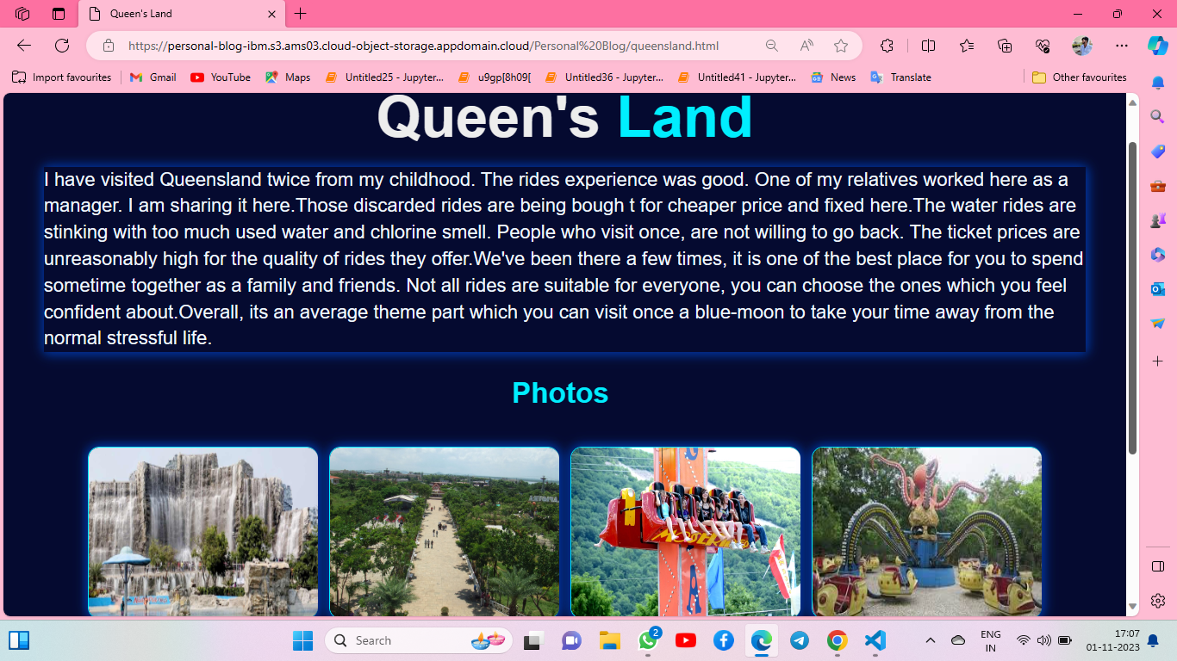

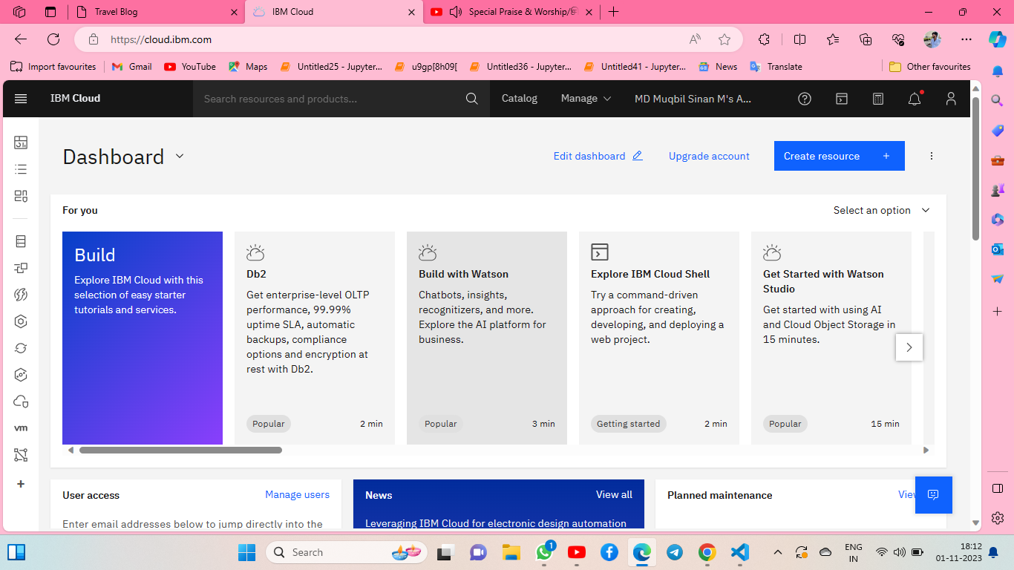

<!DOCTYPE html>

<html lang="en">

<head>

<meta charset="UTF-8">

<meta name="viewport" content="width=device-width, initial-scale=1.0">

<title>Travel Blog</title>

<link rel="stylesheet" href="style.css">

<link href='https://unpkg.com/boxicons@2.1.4/css/boxicons.min.css' rel='stylesheet'>

<script src="https://unpkg.com/typed.js@2.0.16/dist/typed.umd.js"></script>

</head>

<body>

<header class="header">

<a href="index.html" class="logo">PERSONAL BLOG</a>

<nav class="navbar">

<a href="index.html" style="--i:1" class="active">Home</a>

<a href="about.html" style="--i:4">About</a>

<a href="photos.html" style="--i:2">Photos</a>

<a href="contact.html" style="--i:5">Contact</a>

</nav>

</header>

<section class="home">

<div class="home-content">

<h3>Hello ,Welcome to our Personal Blog</h3>

<h3>This is <span class="text"></span></h3>

<p>We are a Travel bloggers were we visit the <br> beautiful places of india.

<br>And we are sharing our personal travel stories. </p>

<div class="home-scl">

<div class="so-Me">Follow us in </div>

<a href="https://www.instagram.com/enoch__j/" style="--i:1"><i class='bx bxl-instagram' ></i></a>

<a href="https://www.facebook.com/enocsenoch.enoch.1" style="--i:1"><i class='bx bxl-facebook-circle' ></i></a>

<a href="https://www.youtube.com/channel/UCWuSX7Dy4ITHu301nzTsDRw" style="--i:1"><i class='bx bxl-youtube'></i></a>

<a href="https://open.spotify.com/" style="--i:1"><i class='bx bxs-music' ></i></a>

</div>

<h1 style="font-size: 50px;padding-top: 30px;transition:background 0.5s transform 0.5s;

animation: slideLeft 1s ease forwards;

animation-delay: calc(.2s * var(--i));" >Friend's 4-Ever !!</h1>

</div>

</section>

<section>

<div class="services" id="services">

<div class="container">

<h1 class="sub-title">Our <span>Travel Blogs</span></h1>

<div class="services-list">

<div>

<i class='bx bxs-radiation' style='color:#69e6dc' ></i>

<i class='bx bxs-radiation' style='color:#69e6dc' ></i>

<h2>THEME PARK</h2>

<p> I have visited Queensland twice from my childhood. The rides experience was good. One of my relatives worked here as a manager. I am sharing it here.Those discarded rides are being bought for cheaper price and fixed here.The water rides are stinking with too much used water and chlorine smell. People who visit once, are not willing to go back. The ticket prices are unreasonably high for the quality of rides they offer.We've been there a few times, it is one of the best place for you to spend sometime together as a family and friends. Not all rides are suitable for everyone, you can choose the ones which you feel confident about.Overall, its an average theme part which you can visit once a blue-moon to take your time away from the normal stressful life.

</p>

<a href="queensland.html" class="read">learn More</a>

</div>

<div>

<i class='bx bx-water' style='color:#7ceae5'></i>

<i class='bx bx-water' style='color:#7ceae5'></i>

<h2>MARINA BEACH</h2>

<p> The beach is known for its vibrant and bustling atmosphere. It is a hub of activity with numerous food stalls, vendors selling toys and souvenirs, and horse and camel rides for children. For lovers of local cuisine like murukku as well as sundal comprising rice and legumes plus an assortment of ice cream flavours, Marina Beach holds inexorable allure. Weekends and holidays present prime time for families, acquaintances and good couples to come for beach sports, picnics or even engage in kite-flying accompanied by other fascinating pursuits found here.The fact that Marina Beach boasts various events spread across the calendar year plus the added attractions including cultural performances, food stalls and thrilling available at its beachside.

</p>

<a href="marina.html" class="read">learn More</a>

</div>

<div>

<i class='bx bxs-tree' style='color:#69e6dc' ></i>

<i class='bx bxs-tree' style='color:#69e6dc' ></i>

<h2>Hill Station</h2>

<p>Thirupparapu waterfalls is the most attractive and most tourist visited places in Kanyakumari Tourism. This beautiful cascading waterfalls in Kanyakumari located 70 kms from Kanyakumari local sightseeing Places on the way to Trivandrum. Height of Thirparappu waterfalls in Kanyakumari is 300 ft., even then the height of the waterfalls is not too high, but the view and fun in this waterfalls in on its peak. The Tamilnadu Tourism department has maintain the falls very well. The wateerfalls in divided with steel rods as 2 sections, one for Men and other one is for women. There is also a small park maintained by the authority where kids can enjoy their time. Kodayar's water falls in this waterfalls before falling here it crosses a river bed in that boating service is also available.</p>

<a href="hill.html" class="read">learn More</a>

</div>

</div>

</div>

</div>

</section>

<script src="main.js"></script>

<div class="sub-title">

<h3>Visit us !

<br>For More Updates

</h3>

</div>

</body>

</html>