**Java florist web**

|  |  |  |
| --- | --- | --- |
| Supervisor : | Sir Zaman. | |
| Batch : | 2209E01. | |
| Group : | Java florist web. | |
| Serial No. | Enrollment No. | Student Name. |
| 1. | 1413906 | Abdullah. |
| 2. | 1418307 | Hassan A. |
| 3. | 1413950 | Shahmeer. |
| 4. | 1413931 | Shayan. |
| 5. | 1422408 | Ubaid. |

**Acknowledgement**

*The first, we would like to express my special thanks of gratitude to my teacher Sir Zaman who helped a lot in finalizing this project within the limited time frame, valuable counseling and assistance for the accomplishment of this project.*

*Secondly, we would also like to thanks the e-project team at Aptech Head Office, who gave as the opportunity to do this interesting and wonderful project about Ice-cream Parlor*

*Thirdly, we also thank the e-project team for giving this task to us. Following are the benefits of this Project:*

* *Re-enforcement of skills happens in the experimental learning process.*
* *A mentor, ensuring that we do not get drifted, constantly guide us.*
* *It gives us a lot of confidence to face an interview as we have worked on a project. We can explain virtually everything on the subject we have learnt.*

*Problems Definition*

Java Florist, a florist service provider, aims to develop a comprehensive website to facilitate the communication of wishes through sending flower bouquets on special occasions. The key objectives and challenges in this endeavor are outlined as follows:

1. **Online Presence Establishment:** Java Florist seeks to establish a strong online presence to expand its reach and accessibility beyond physical stores, catering to customers who prefer the convenience of online shopping.
2. **Customer Engagement:** The website must engage customers effectively by providing a user-friendly interface, showcasing a wide range of professionally designed flower arrangements suitable for various occasions such as birthdays, weddings, new babies, thank you gestures, Father's Day, Mother's Day, etc.
3. **Product Showcase:** The website should feature a diverse catalog of flower arrangements with high-quality images, detailed descriptions, and options for customization to meet individual preferences and requirements.
4. **Delivery Logistics:** Java Florist aims to offer reliable and efficient delivery services, including same-day delivery in Mumbai and surrounding areas, as well as nationwide delivery through a network of trusted florists. Coordinating logistics for timely and secure delivery is a critical aspect of the website's functionality.
5. **E-commerce Integration:** Implementing a secure and seamless e-commerce platform is essential for facilitating online transactions, including order placement, payment processing, and order tracking.
6. **Customer Support:** Providing exceptional customer support is vital for addressing inquiries, resolving issues, and ensuring a positive shopping experience. This may involve incorporating features such as live chat support, email communication, and an extensive FAQ section.
7. **Marketing and Promotion:** Developing effective marketing strategies to attract and retain customers, such as promotional offers, discounts, loyalty programs, and targeted advertising campaigns across various digital channels.
8. **Scalability and Maintenance:** Building a scalable website architecture capable of handling increasing traffic and transaction volumes over time, while also ensuring regular maintenance and updates to keep the platform secure and up-to-date.

By addressing these key objectives and challenges, Java Florist aims to create a user-centric and feature-rich website that enhances the experience of sending flower bouquets for special occasions, thereby strengthening its brand presence and driving business growth.

Top of Form

***Task Sheet***

|  |  |  |  |  |  |  |
| --- | --- | --- | --- | --- | --- | --- |
| Project Ref.No:  Ep/Advertisement  Portal Management  System /01 | | Project  Title | Date Of preparation Of Activity Plan | | | |
| No. | ***Task*** | **J**  **A**  **V**  **A**  **F**  **L**  **O**  **R**  **I**  **S**  **T**  **W**  **E**  **B** | ***Actual***  ***Start Date*** | ***Actual Days*** | ***Team-Mate***  ***Name*** | ***Status*** |
| 01. | ***Flower details*** | 28  -  F  E  B  -  2  0  2  4 | 3  0  -  D  A  Y  S  - | Ubaid |  |
| 02. | ***About page***  ***Home page*** | Shayan  ,  Shahmeer |  |
| 03. | ***Gallery page*** | Abdullah  Shahmeer |  |
| 04. | ***Front end***  ***Template*** | Shayan |  |
| 05. | ***Login/ Register page*** | Abdullah |  |
| 06. | ***Documentation*** | Abdullah  Ubaid  Hassan A |  |

***Flow chart***

REGISTRATION FLOWCHART

Input Fields Of

Registration Form

Start

Yes No No Yes No Yes

Accept information

Display

Alert message

Alert message

Alert message

Validate email address for duplication

Check if it contains @

Check if it contain empty spaces

Stop

LOGIN FLOWCHART No Yes

Display-Information not correct

Validate Username and Password

Open Movie Page

Stop

Accept Information

Insert Username and Password

Start

**user guide**

TABLE OF CONTANT

1. *Introduction*
2. *Getting Started*
   * *2.1. Creating an Account*
   * *2.2. Logging In*
   * *2.3. Resetting Your Password*
3. *Browsing Flowers*
   * *3.1. Finding Best Boque’s*
4. *Booking Boque’s*
   * *4.1. Selecting a Boque*
   * *4.2. Choosing Occasion*
5. *Troubleshooting*
   * *7.1. Common Issues*
   * *7.2. Contacting Customer Support*
6. *Privacy and Security*
   * *8.1. Protecting Your Account*
   * *8.2. Data Privacy*
7. *Conclusion*

**Developers guide**

TABLE OF CONTENT

1. Introduction
2. System Architecture
   * 2.1. High-Level Overview
   * 2.2. Frontend
   * 2.3. Backend
   * 2.4. Database
3. Technology Stack
   * 3.1. Frontend Technologies
   * 3.2. Backend Technologies
   * 3.3. Database Technologies
4. Development Environment Setup
   * 4.1. Prerequisites
   * 4.2. Setting Up the Development Environment
5. Directory Structure
6. Coding Standards and Best Practices
7. System Features
   * 7.1. User Registration and Authentication
   * 7.2. Finding Boque
   * 7.3. Boque Booking
   * 7.4. Payment Processing
   * 7.5. User Profiles and Preferences
   * 7.7. Merchandise Sales
   * 7.8. Contests and Prizes
8. API Documentation
   * 8.1. API Endpoints
   * 8.2. Request and Response Formats
9. Security
   * 9.1. Authentication and Authorization
   * 9.2. Data Encryption
   * 9.3. Handling Security Vulnerabilities
10. Testing
    * 10.1. Unit Testing
    * 10.2. Integration Testing
    * 10.3. User Acceptance Testing
11. Deployment
    * 11.1. Deployment Process
    * 11.2. Server Configuration
    * 11.3. Continuous Integration/Continuous Deployment (CI/CD)
12. Scaling and Performance Optimization
    * 12.1. Horizontal and Vertical Scaling
    * 12.2. Caching Strategies
    * 12.3. Load Testing
13. Logging and Monitoring
    * 13.1. Logging Practices
    * 13.2. Monitoring Tools
14. Maintenance and Support
    * 14.1. Bug Tracking and Issue Management
    * 14.2. Version Control
    * 14.3. Patching and Updates
15. Troubleshooting
    * 15.1. Common Issues and Solutions
16. Future Development Roadmap
17. Conclusion

**Screen shots**

1. NAVBAR



1. Gallery Page



1. ABOUT US

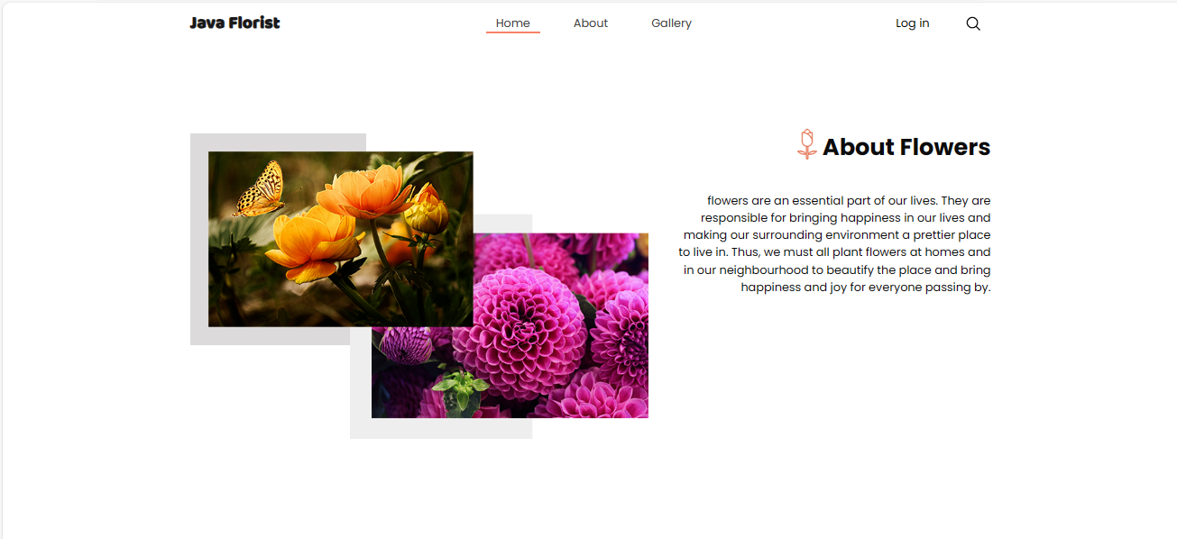

1. FOOTER

