Image Processing Lab 1

Mohammad Sorkhian

This lab has two main parts, Transformation and Histogram Equalization.

**Transformation**

In this section, the following steps have been done:

**1-6.** I studied the provided codes and wrote them in the Matlab.

**7.** I created the outputs of two required rotation, 90 and -25 degrees.

**8.** We can see that the presented algorithm in 1-6, causes some black dots after rotation. For solving this problem, I changed the rotation procedure which has been presented along with this document, and all code lines have been commented in detail

**9.** Reason for black dots in the rotated image: When we transform an image in a continuous space, we can find correspondent value for each dot in the transformed picture from the original one. In the discrete space, the mapping has to be from Z to Z or N to N. But, when we transform pixels of the original image, we end up with some spatial values that are not in Z or N and, in these cases, we have to correct it with rounding to the nearest neighbor. Thus, some pixels in the rotated image would not be covered by mapped pixels from the original image. As a result, we see these uncovered pixels with their initial value, zero in our picture in this lab.

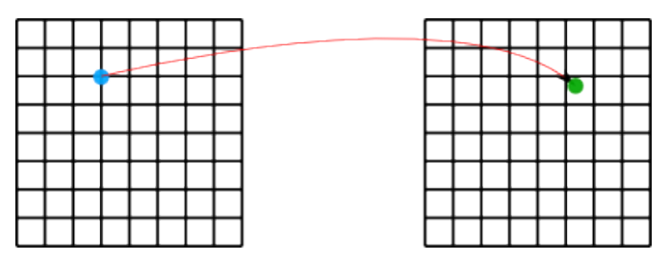

[sci.utah.edu/~acoste/uou/Image/project3/ArthurCOSTE_Project3.pdf](http://www.sci.utah.edu/~acoste/uou/Image/project3/ArthurCOSTE_Project3.pdf)

**10.** In this step, five mentioned transformations have been done and uploaded along with this document.

**Histogram Equalization**

**1-6.** I have studied and implemented presented codes in Matlab.

**7.** In the uploaded files, there are two graphs for Histogram Distribution, before and after Equalization. It can be seen that the intensity distribution in the Histogram graph is not uniform. Equalized histogram graph is sensitive to pixels distribution over the intensity range. If we have a more even-distributed intensity, we would have a more even-equalized histogram. But in this untouched histogram graph, we can see that a higher portion of pixels has been cumulated in the upper range of the intensity range. Furthermore, as we are working with digital images, our histograms are based on discrete values. As a result of this, most of the time, we should round our calculated values to the nearest digits, and this also decreases the integrity and uniformity of the equalized histogram.

**Performance evaluation**

Both manual and automatic (built-in) transformation have been applied to an arbitrary picture. After measuring their execution speed, we saw that the built-in function has much better performance, 4s compared to 15s.