**Task1.**

Create GCP account (Free account): **Created**

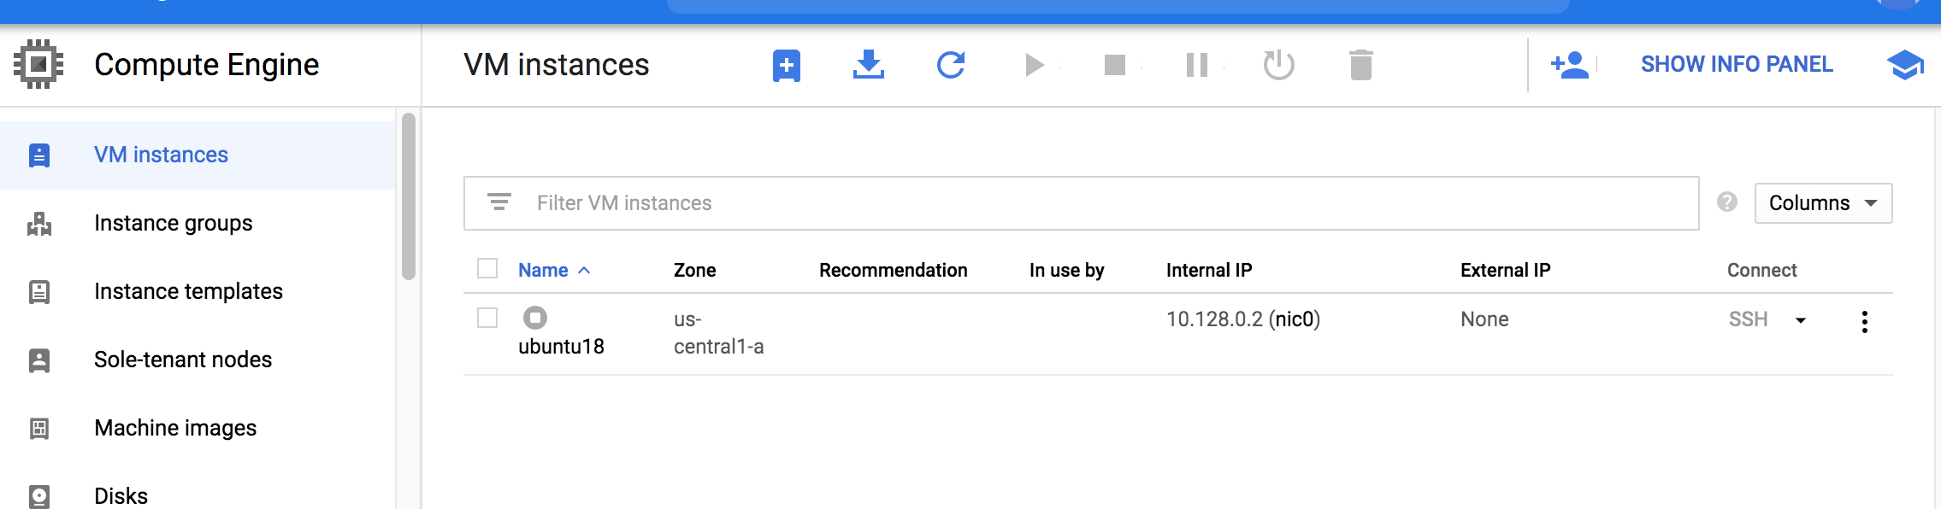

Create Ubuntu instance, install putty, and connect Ubuntu with the putty: **Created**

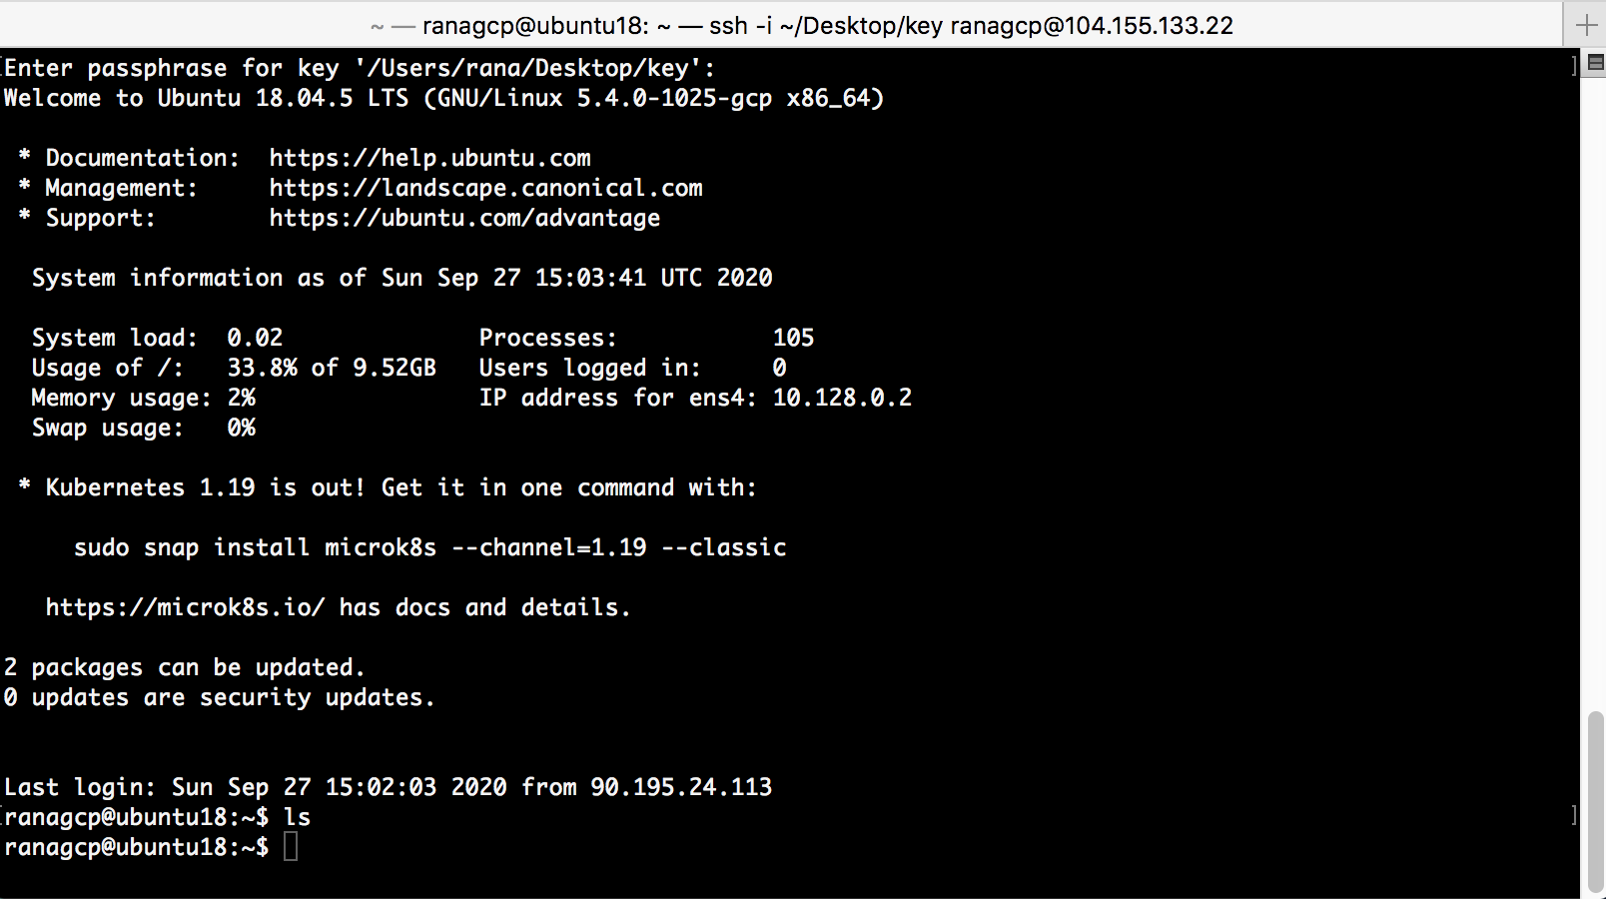

**Task2.**

Make sure that Hadoop is installed and all the daemons are running without any issues: **Succeeded**

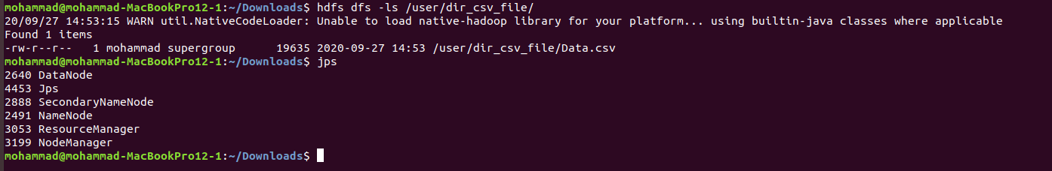

**Task3.**

Any 15 HDFS commands: **Listed**

1. **hdfs dfs -ls /**
2. **hdfs dfs -ls -d /hadoop**
3. **hdfs dfs -ls -R /hadoop**
4. **hdfs dfs -ls /hadoop/bank\***
5. **hdfs dfs -cat /hadoop/test**
6. **hdfs dfs -appendToFile /home/ubuntu/test1 /hadoop/text2**

Appends the content of a local file test1 to a hdfs file test2.

1. **hdfs dfs -appendToFile /home/ubuntu/test1 /hadoop/text2**

Appends the content of a local file test1 to a hdfs file test2.

1. **hdfs dfs -put /home/ubuntu/sample /hadoop**

**or hdfs dfs –moveFromLocal /home/ubuntu/sample /hadoop**

Copies the file from local file system to HDFS.

1. **hdfs dfs -put -f /home/ubuntu/sample /hadoop**

Copies the file from local file system to HDFS, and in case the local already exits in the given destination path, using -f option with put command will overwrite it.

1. **hdfs dfs -put -l /home/ubuntu/sample /hadoop**

Copies the file from local file system to HDFS. Allow DataNode to lazily persist the file to disk. Forces replication factor = 1.

1. **hdfs dfs -put -p /home/ubuntu/sample /hadoop**

Copies the file from local file system to HDFS. Passing -p preserves access and modification times, ownership and the mode.

1. **hdfs dfs -get /newfile /home/ubuntu/**

Copies the file from HDFS to local file system.

1. **hdfs dfs -get -p /newfile /home/ubuntu/**

Copies the file from HDFS to local file system. Passing -p preserves access and modification times, ownership and the mode.

1. **hdfs dfs -get /hadoop/*.txt /home/ubuntu/**

Copies all the files matching the pattern from local file system to HDFS.

1. **hdfs dfs -chmod -R 777 /new-dir**

Change the permission of the directory

1. **hdfs dfs -chown -R admin:hadoop /new-dir**

change the owner and group (admin-owner, hadoop –group)

1. **hdfs dfs -help**
2. **hdfs dfs –du –s –h /dir**

shows disc usage for the directory

1. **hdfs fsck /**

health of hadoop file system

**Task4.**

Copy text and csv files to hdfs: **Succeesd.**

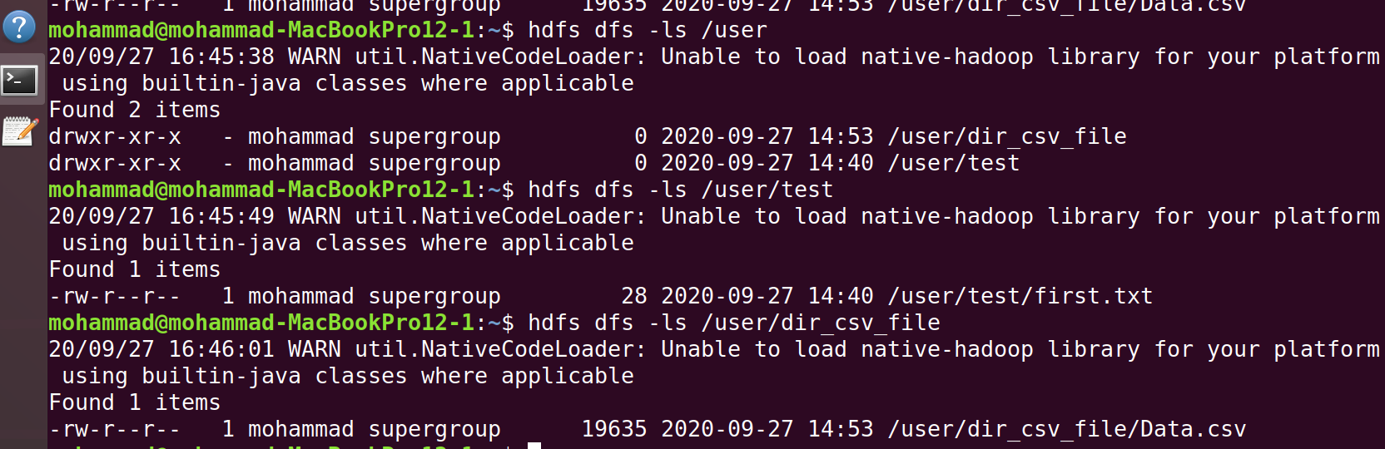



**Task5.**

Connect to Namenode server url(localhost:50070). Just take a screenshot. **(Succeeded)**



