APTECH VISION

**Participants Name:** Mohammad Taha & Rayyan Ali

**Website Name:** ZAP MART

**Project Type:** Electronic Ecommerce Website

**Project:** Static Website

**Batch Code:** 2110F1

Search icon

Currency dropdown

Static Ecommerce Website

Change

Country

Language dropdown

Header

Cart

User account

Green light Indicates that you are login your account

Wish list

Logo

Default

Page

Contact page

Products

Dropdown

Website

Intro Page

Logo

Figure 01

Figure 03

Figure 02

After clicking this search icon search bar is displayed and location, language, and currency will be hidden as shown in fig 03



If you create an account so you will enjoy a 50% discount on you first order

Discount Banner

Footer



Most recommended products links

Main page links

Contact links

Social links

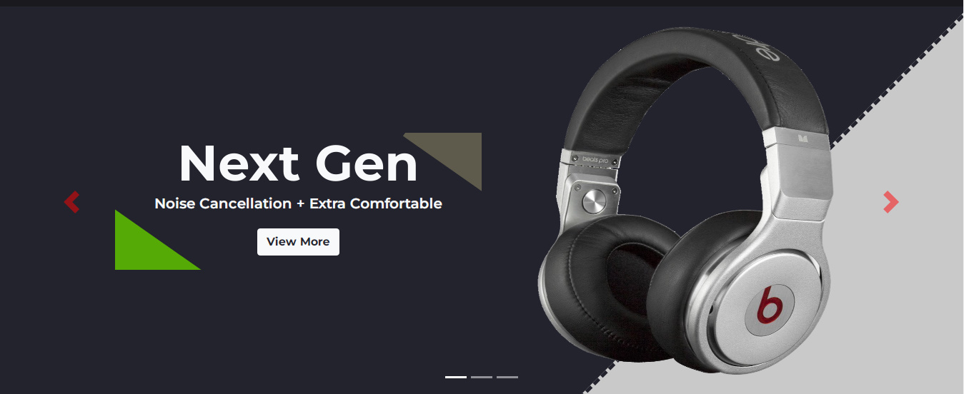

Slider

Header

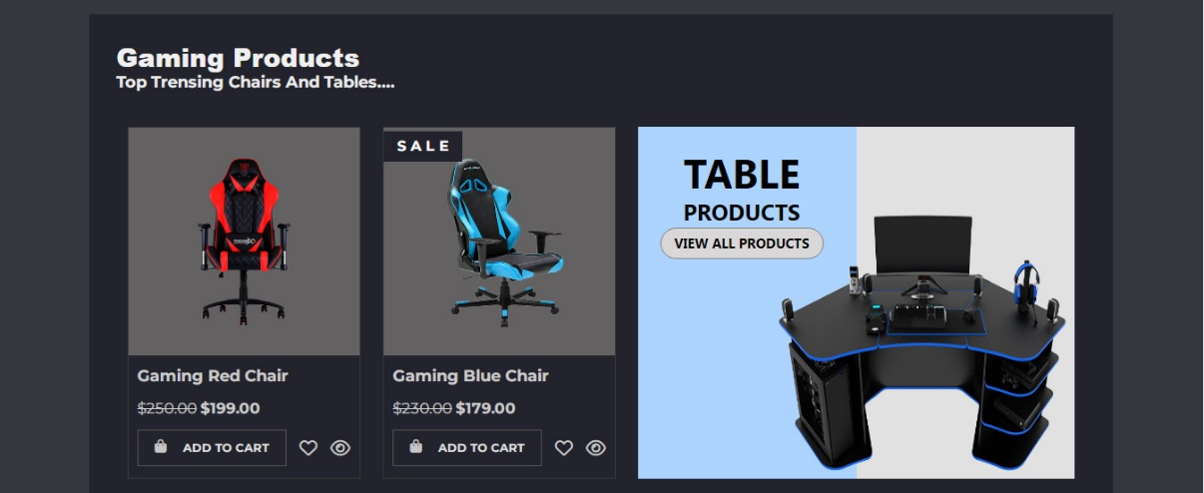

HOME PAGE



Trending products

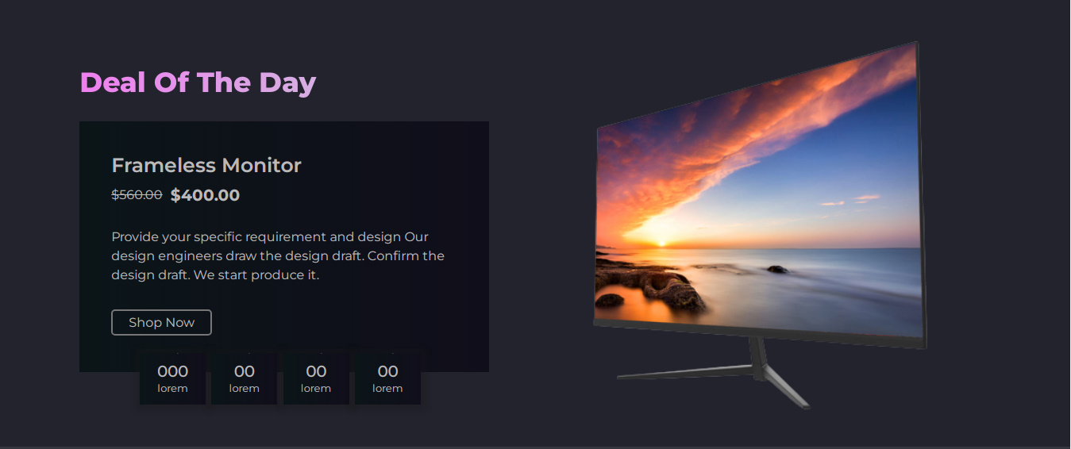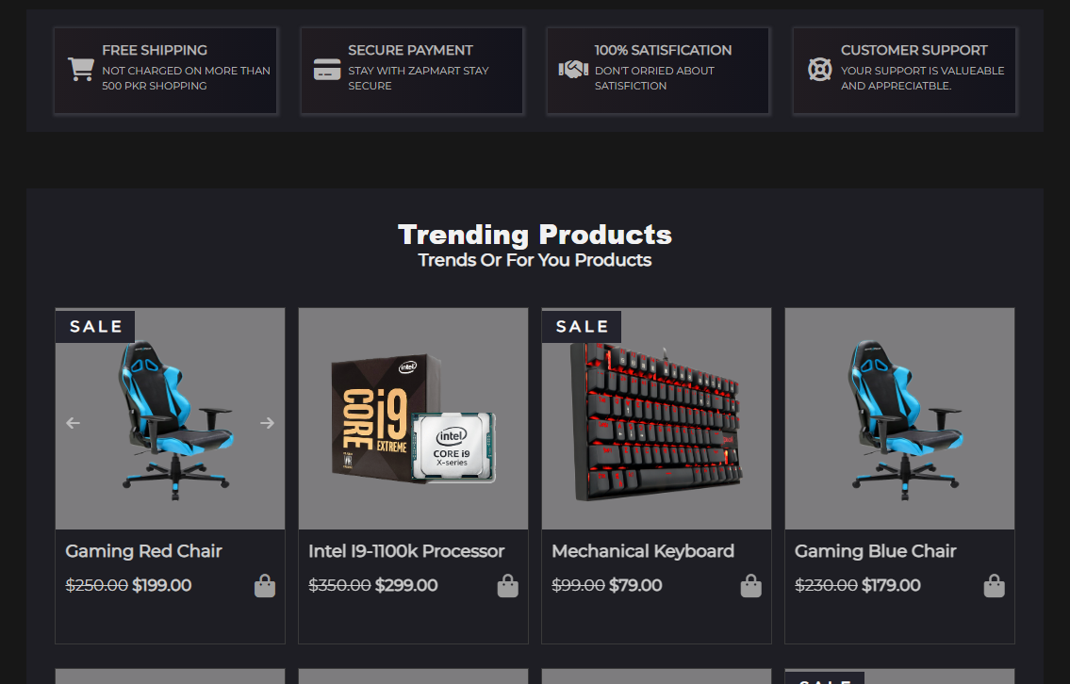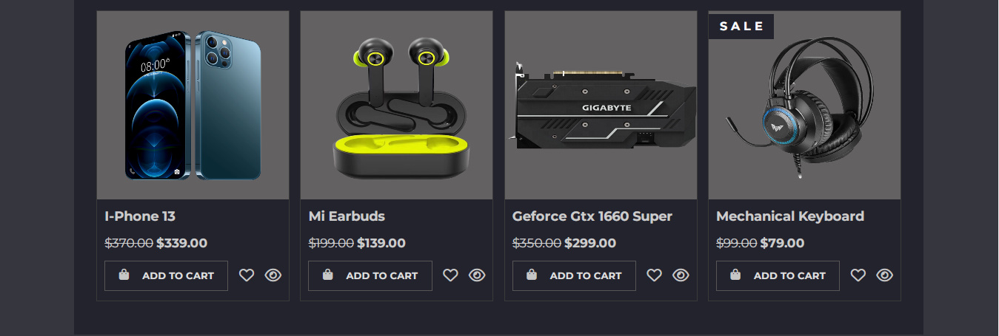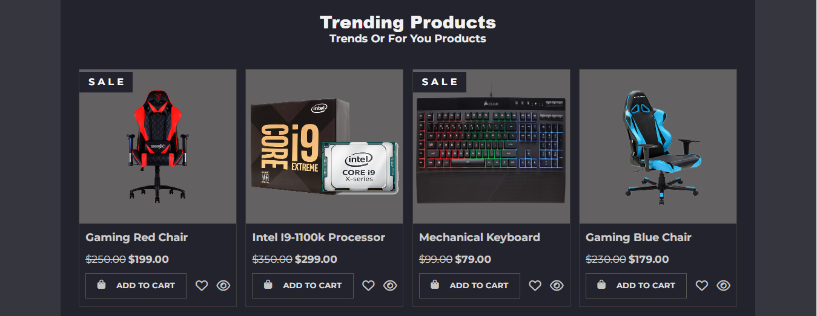

Deal Of The Day

Promotions Cards

Trend Items

Discount Banner with Footer





Slider

Header

ABOUT US PAGE

Content

Then we will write a content to describe about the website



Discount banner with footer

Discount banner with footer



Header

Products



Pagination

Long search bar

Relevant products you search

Search items



Discount banner with footer

Header

Contact us page

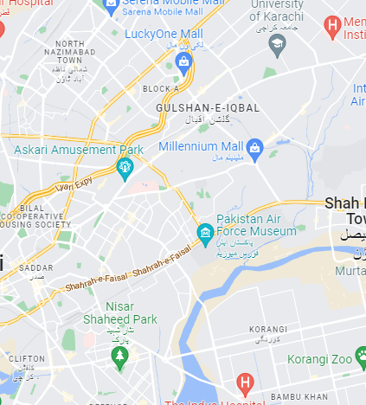

Submit

Message

Email

Name

FORM

MAP



Discount banner with footer

THANK YOU