Afterimage User Manual
Prerequisites
- Ensure Anaconda is installed and Python 3.11 is available.
- NVIDIA CUDA capable GPU with at least 12GB of VRAM

Create Environment
conda create -n afterimage_env python=3.11 -y
conda activate afterimage_env
1. Clone Repository
git clone https://github.com/MohammadTaha24/Afterimage.git
cd Afterimage
2. Install PyTorch
Install the latest PyTorch based on your system:
https://pytorch.org/get-started/locally/
As of April 2026 for Nvidia GPUs:
pip3 install torch torchvision --index-url https://download.pytorch.org/whl/cu130
3. Install Dependencies
pip install -r requirements.txt
4. Install Unsloth
pip install unsloth unsloth_zoo
5. Install PyTorch (This is not a mistype)
After the installation of different packages, Pytorch defaults to CPU as the device, hence we have to re-install the latest PyTorch based on your system:
https://pytorch.org/get-started/locally/
As of April 2026 for Nvidia GPUs:
pip3 install torch torchvision --index-url https://download.pytorch.org/whl/cu130
6. Hugging Face Authentication
To be able to get the token need, create/log-in to a hugging face account. Settings -> Access tokens -> create new token -> select the below options and scroll down to -> create token -> copy token and after entering the command
hf auth login
enter the token from the website when asked
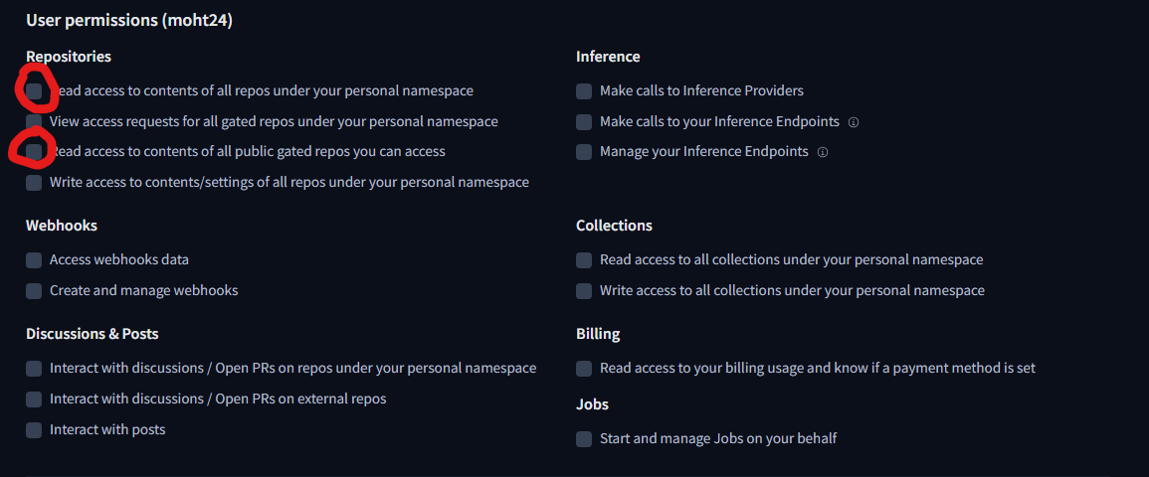
7. Download Model Assets
python download_model_assets.py --clear-qwen3-target
8. Run Backend
Open a NEW Anaconda Prompt:
cd Afterimage
conda activate afterimage_env
uvicorn backend.main:app --host 127.0.0.1 --port 9000
9. Run Frontend
Open ANOTHER Anaconda Prompt:
cd Afterimage
conda activate afterimage_env
streamlit run frontend\app.py

Notes:
Base model unsloth/Qwen3-VL-8B-Instruct-unsloth-bnb-4bit is auto-downloaded on first run.
NVIDIA CUDA capable GPU is required for proper performance.
Stable internet connection is required.

