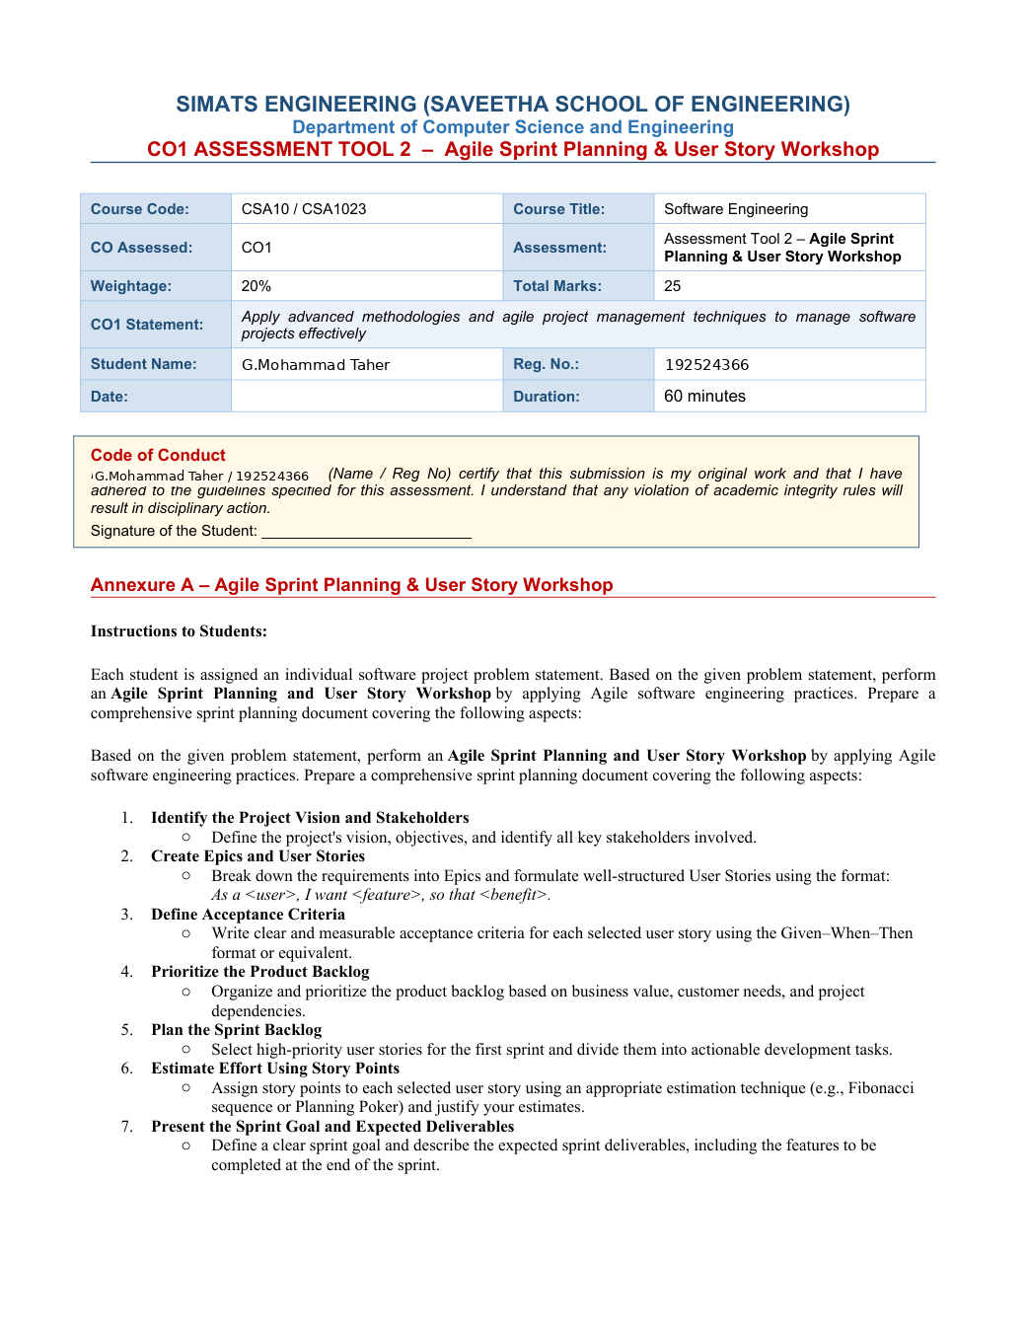

Annexure A – Agile Sprint Planning & User Story Workshop
Problem Statement: API Abuse Detection and Self-Healing Microservices Platform
Instructions to Students: Based on the given problem statement, perform an Agile Sprint Planning and User Story Workshop by applying Agile software engineering practices. Prepare a comprehensive sprint planning document covering the following aspects:
1. Identify the Project Vision and Stakeholders
Define the project’s vision, objectives, and identify all key stakeholders involved.
2. Create Epics and User Stories
Break down the requirements into Epics and formulate well-structured User Stories using: As a <user>, I want <feature>, so that <benefit>.
3. Define Acceptance Criteria
Write clear and measurable acceptance criteria for each selected user story using Given–When–Then or equivalent.
4. Prioritize the Product Backlog
Organize and prioritize the product backlog based on business value, customer needs, and project dependencies.
5. Plan the Sprint Backlog
Select high-priority user stories for the first sprint and divide them into actionable development tasks.
6. Estimate Effort Using Story Points
Assign story points using an appropriate estimation technique such as Fibonacci sequence or Planning Poker and justify estimates.
7. Present the Sprint Goal and Expected Deliverables
Define a clear sprint goal and describe expected sprint deliverables, including features to be completed at the end of the sprint.

1. Project Vision and Objectives
Project Vision
The vision of the API Abuse Detection and Self-Healing Microservices Platform is to protect API-driven applications from abnormal traffic, abusive requests, and cascading service failures. The platform will monitor API activity continuously, detect suspicious patterns early, apply protective policies, and recover unhealthy services automatically.
Project Objectives
• Monitor API requests and service health in real time.
• Detect abnormal and abusive API usage.
• Apply rate limiting and access-control policies.
• Detect cascading failures among microservices.
• Restart or isolate unhealthy components automatically.
• Integrate testing, CI/CD, monitoring, and centralized logging.
• Maintain security and availability during abnormal traffic.
Business Value
The system is expected to reduce service disruption, improve API security and reliability, detect failures earlier, increase operational visibility, and support scalable and resilient microservices.

2. Stakeholders and Their Responsibilities
API Consumers / End Users
Use the application through APIs and expect secure, reliable, and responsive service.
Product Owner
Defines the product vision, ranks backlog items by business value, and accepts completed features.
Scrum Master
Facilitates sprint planning and daily Scrum, removes blockers, and helps the team follow Agile practices.
Development Team
Builds API monitoring, anomaly detection, rate limiting, service isolation, and recovery features.
DevOps / SRE Team
Maintains containers, orchestration, CI/CD pipelines, monitoring, and service recovery automation.
Security Team
Defines access-control rules, reviews abuse detection, and validates security protections.
QA / Test Engineers
Test normal and abnormal API traffic, failure scenarios, acceptance criteria, and regression behavior.
System Administrators
Review logs, dashboards, alerts, and incident reports to maintain service availability.

3. Epics and User Stories
Epic 1 — Real-Time Monitoring
US1: As an operations engineer, I want to view API request rates and service health in real time, so that I can identify performance problems early.
Epic 2 — Abuse Detection
US2: As a security engineer, I want the platform to detect unusual request patterns, so that abusive API usage can be identified before it affects users.
Epic 3 — Rate Limiting and Access Control
US3: As an API administrator, I want to configure rate limits and access policies, so that excessive or unauthorized requests are controlled.
Epic 4 — Failure Detection and Recovery
US4: As an SRE, I want unhealthy services to be isolated and restarted automatically, so that the system can recover quickly.
Epic 5 — Logs and Incident Visibility
US5: As a support engineer, I want centralized logs and alerts, so that I can investigate incidents efficiently.
Epic 6 — Automated Quality Pipeline
US6: As a developer, I want automated tests to run through CI/CD, so that changes can be released with confidence.

4. Additional User Stories and Scope
US7 — Cascading Failure Detection
As an SRE, I want the platform to identify when a failing service affects dependent services, so that the failure can be contained before it spreads.
US8 — Container Orchestration
As a DevOps engineer, I want services to run in managed containers, so that deployment and recovery are repeatable and scalable.
US9 — Security and Availability
As a product owner, I want protective actions to be recorded and reviewed, so that the platform remains secure and its behavior is auditable.
Sprint Scope
The first sprint will focus on a minimum working monitoring and protection flow: capture API metrics, identify a simple abnormal-traffic condition, apply a configurable rate limit, and display events in centralized logs. Automated service restart can be planned after the basic flow is tested.

5. Acceptance Criteria — Monitoring and Abuse Detection
US1: API Monitoring
Given that API services are running, when requests are received, then the dashboard records request count, response status, and service health within the configured monitoring interval.
US1: Health Alert
Given that a service becomes unhealthy, when the health check fails for the configured threshold, then the platform generates an alert containing the service name and time.
US2: Abnormal Traffic
Given a defined baseline and threshold, when request volume exceeds that threshold, then the platform flags the traffic as abnormal and records the reason.
US2: Auditability
Given that suspicious traffic is detected, when the detection event is created, then the event includes a timestamp, affected API, severity, and action taken.
Measurability
Acceptance tests will verify that events are recorded, alerts are generated at the configured threshold, and normal traffic is not incorrectly blocked during the test cases.

6. Acceptance Criteria — Protection and Recovery
US3: Rate Limiting
Given a configured request limit, when a client exceeds the allowed rate during the time window, then excess requests are rejected or throttled and the event is logged.
US3: Access Control
Given a request without the required permission, when the API receives it, then access is denied and the attempt is recorded.
US4: Unhealthy Service
Given a service fails its health check repeatedly, when the recovery policy is triggered, then the platform isolates or restarts the service according to the configured policy.
US7: Cascading Failure
Given that one service failure causes dependent health checks to fail, when the dependency threshold is reached, then an alert identifies the affected services and containment action is recorded.
US5: Centralized Logs
Given an alert or protective action, when the event occurs, then its details appear in the central log view and can be searched by service and time.

7. Product Backlog and Prioritization
Prioritization Method
The backlog is prioritized using business value, risk reduction, user impact, dependencies, and effort. Items needed to observe traffic and prevent abuse are ranked ahead of advanced automation.
P1 — Highest
1. Capture API request metrics and service health (US1). 2. Record and display monitoring events. 3. Detect a basic abnormal request threshold (US2). 4. Apply configurable rate limiting (US3).
P2 — High
5. Add access-control checks (US3). 6. Add alerts for unhealthy services. 7. Centralize application and security logs (US5).
P3 — Medium
8. Detect cascading failures between dependent services (US7). 9. Add automated restart or isolation actions (US4).
P4 — Later Enhancement
10. Integrate the full CI/CD automated testing pipeline (US6). 11. Expand dashboards, reporting, and tuning of detection thresholds.
Dependencies
Monitoring and logging should be available before reliable detection and automated recovery can be validated. Rate limiting requires a defined policy and API gateway or equivalent enforcement point.

8. Sprint Goal and Selected Sprint Backlog
Sprint Duration
Proposed Sprint 1 duration: two weeks. The team will deliver a basic, testable monitoring and abuse-protection workflow.
Sprint Goal
“Enable the team to observe API traffic and service health, detect a basic abnormal-traffic pattern, apply a rate limit, and review the resulting events in logs.”
Selected Stories
US1 — API monitoring; US2 — basic abnormal-traffic detection; US3 — configurable rate limiting; US5 — event logging for the selected flow.
Definition of Done
Code is reviewed and merged; unit and integration tests pass; configuration is documented; events are visible in logs; acceptance criteria are demonstrated; and known limitations are recorded.
Out of Scope for Sprint 1
Full self-healing orchestration, complex anomaly models, and advanced cascading-failure prediction are not included in the first sprint unless the core work finishes early.

9. Development Tasks and Story Point Estimates
US1 — 5 Story Points
Tasks: identify required metrics (2h); implement request counter and health check (5h); create basic dashboard or status endpoint (4h); write tests and verify data (3h). Estimate: 5 points because it includes instrumentation, display, and testing.
US2 — 5 Story Points
Tasks: define baseline and threshold configuration (2h); implement detection rule (4h); record abnormal events (3h); test normal and high-volume traffic (4h). Estimate: 5 points due to rule design and false-positive testing.
US3 — 5 Story Points
Tasks: define rate-limit configuration (2h); enforce limits at the API entry point (5h); return a clear response when limit is exceeded (2h); test allowed and excess requests (4h). Estimate: 5 points due to enforcement and integration.
US5 — 3 Story Points
Tasks: define event fields (1h); centralize selected monitoring/security events (3h); test search and timestamps (2h). Estimate: 3 points because the initial logging scope is limited.
Total Planned Estimate
18 story points. This is a provisional estimate and should be confirmed by the team during Planning Poker. Hours are task-level planning assumptions, not fixed commitments.

10. Sprint Workflow, Risks, and Deliverables
Sprint Events
Sprint Planning: agree on the goal and selected stories. Daily Scrum: review progress and blockers. Backlog refinement: clarify upcoming recovery and orchestration stories. Sprint Review: demonstrate monitoring, detection, rate limiting, and logs. Retrospective: identify improvements for the next sprint.
Main Risks
High traffic may create false positives; incomplete metrics may hide issues; rate-limit settings may affect legitimate users; and recovery automation may restart a service repeatedly. Mitigations include configurable thresholds, test traffic, staged rollout, audit logs, and restart limits.
Expected Deliverables
A working API monitoring component; basic abnormal-traffic detection; configurable rate limiting; event logging; automated tests for the selected stories; setup and configuration notes; and a sprint review demonstration.
Expected Outcomes
The first sprint should provide early visibility into API traffic and a basic protective response. Later sprints can extend the platform with dependency-aware failure detection, container orchestration, automated recovery, and a more complete CI/CD pipeline.

11. Testing Plan and Sprint Review
Functional Tests
Send normal API requests and confirm that counts and health status update. Exceed the configured request threshold and confirm abnormal traffic is flagged. Exceed the rate limit and verify that excess requests are rejected or throttled.
Security Tests
Submit requests without required permission and verify denial and logging. Confirm that protective actions include a reason and timestamp. Verify that authorized normal traffic continues under expected conditions.
Integration Tests
Check that monitoring events, detection rules, rate limiting, and centralized logging work together. Simulate an unhealthy service and confirm that an alert is recorded.
Sprint Review Checklist
Demonstrate the user stories against their acceptance criteria; show test results; explain incomplete work; collect product-owner feedback; and update the backlog based on the feedback.
Conclusion
Agile sprint planning converts the problem statement into prioritized, testable work. The proposed backlog begins with visibility and basic API protection, then progresses toward self-healing and resilience features.

