Anggota Kelompok 3 :

2101654440 - Aurellia Vania Y. B.

2101714793 - Bayu Fadhlurohman Hasmi

2101635321 - Jonathan Chrisnaldy

1901469473 - Mohammad Hafidz Vidhyansyah

**User Requirement Specifications**

**BodyFit**

**0. PREFACE – Please Read First**

**0.1 PURPOSE OF THIS DOCUMENT**

BodyFit is an app that can calculate your calories and time when running and walking, so you can maintain your body. You can choose two type of activities, Walking or running. And then you can choose, to calculate calories that your body burned based by time that you spend or to calculate time that you need to burn amount of calories.

**0.2 USE OF THIS DOCUMENT**

We live in an era that everything is instant and fast. Like mass transportation and fast food. All of these things make us unhealthy. After seeing this condition, people want to do something about it. They start to do some kind of sport which is spend money on tools and many more. Do you want to do some sport that will not spend a lot money? Running and walking are the answer. But many people don’t know how long and how many amount of calorie that your body needed. With BodyFit app, it will maintain how you burn your calories and how long you should exercises.

**0.3 THE USER REQUIREMENT DOCUMENT**

What user needs :

- Timer to calculate calories

- Stopwatch to calculate time

- History of all activity

- Calendar for weekly exercise

# INTRODUCTION

**1.1 PURPOSE OF THE DOCUMENT**

This document is the definitive specification of the user requirements for telematics facilities to be developed for BodyFit application. It is a primary input to the technical development of those facilities, and the primary specification of the criteria against which the acceptability of those facilities will be evaluated after they have been developed. After the user read this Document, the user is expected to use the body fit app as it should be and we hopefully the user reaches their objective. And we provide BodyFit calendar so you can know when you should run/ walking and how long.

**1.2 OVERVIEW**

When we open BodyFit app, first we enter our name, height and weight. After that we can choose the activity, Running or walking. And then choose which one that we need to calculate : Calories or time. If the user press calories we enter amount of time based on how long we want to do this activity, and then when we press start, BodyFit app will tell you how long that the user need to burn the calories, the timer start to decrease. If we press time we enter amount of calories based on how much calories the user want to burn. And then the stopwatch appears and starting. Every activity that user did, are saved and the user can see it in history section. The time and calories that BodyFit tell is different for every user, it depends on their weight and their height.

# GENERAL DESCRIPTION

Factors that influence in this application are the length of time needed for calorie and weight, the longer the time used, the more calories will be wasted and will make it easier to lose weight.

**2.1 OBJECTIVE**

This application is used to count calories wasted within a certain period. Main role of this application is to make it easier to make a target of how many calories you want to throw away.

**2.2 SYSTEM CONCEPT**

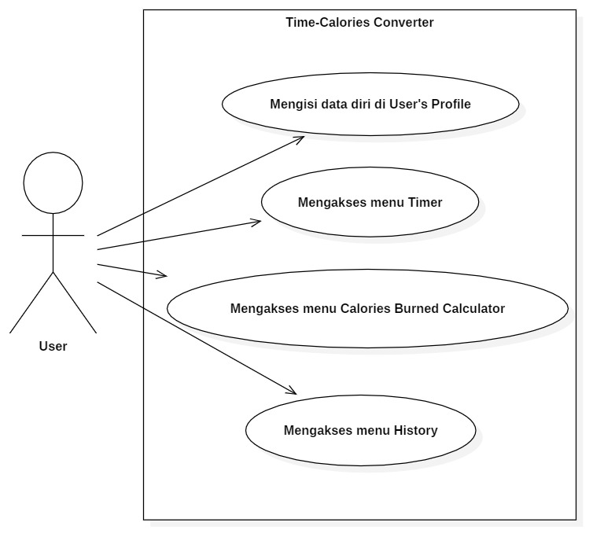

The concept of using this application is that this application will record the sports activities that you do and when you stop exercising, the application will display the results of wasted calories and display the length of time, after that the application will save the results in the application as history. This application is very suitable for use when doing sports like running, jogging and other sports activities.

**2.3 CONCEPT OF OPERATION**

The operation of this application has the ability to count calories removed within a certain time, this application will make it easier for you to find out how many calories have been wasted. This application is needed because with this application you do not need to count manually how many calories you have wasted, because This application will automatically count the calories wasted when you exercise.

This application supports the Android base, where Android when you exercise can be taken anywhere. This application is designed by reducing the cache that causes bugs and is also made with a small capacity and low Android RAM usage, this is sought so that this application can be used / used on Android with low / medium specifications.

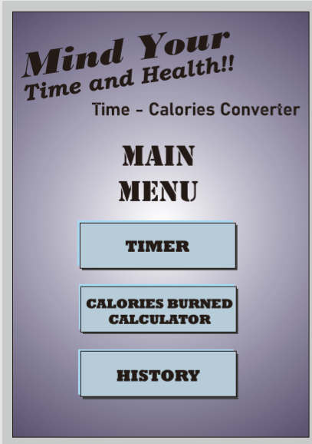**2.4 USER’S AND INTERFACE**

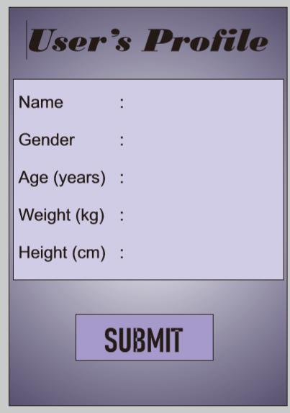

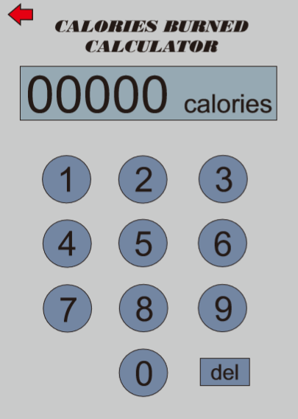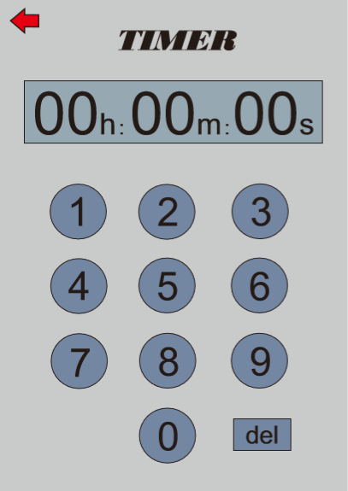

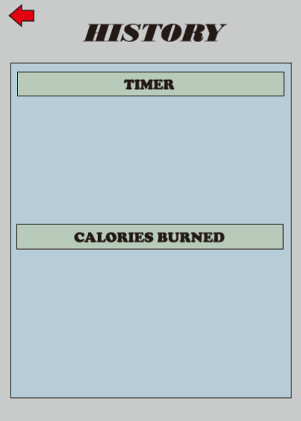

The characteristics of this application are that the user can set / change the language as desired, and the user can also change the background / appearance of the application screen as desired by the user.

**2.5 OPERATIONAL CHARACTERISTICS**

When sign in into the application, the application will display a stopwatch and calories, besides that the application will also display a menu where the menu will have a history menu. This will save the results of using the previous application and support and feedback.

This application is targeted to have a good performance / performance on android which mainly has a medium-to-lower specification, it is hoped that this application can be used by many people.

**2.6 CONTROL, SUPPORT, MAINTENANCE**

This application also has a help and support menu, which menu choices will make it easier to receive criticism from application users.

After the developer has received all the suggestions or criticisms from users, Maintenance / Repair will be done on this application, it is expected that after making improvements to the application, the application can run properly and normally in the latest version.

**2.7 SYSTEM ARCHITECTURE AND CONSTRUCTTION**

This sports application has development options such as being able to set how many calories will be wasted within a certain time. This choice must be given a limit where the developer must make this calorie calculation adjusted in general / standard such as 1 calorie will be wasted in 3 minutes.

**2.8 ASSUMPTION AND DEPENDENCIES**

The specifications of this android-based application that requires less than 70MB of storage and less than 2MB of RAM needed.

Assumed if there is a lag / bug when an application is especially android that have lower specifications, then some of the features of this application will be reduced and will be replaced with features that are not heavy or feature where the android who have low specs able to run this application.

# SPECIFIC REQUIREMENTS

**3.1 General**

Our application provides Android smartphone users facilities such as stopwatch, timer, and calories burned calculator that’s very beneficial for the users that frequently need to measure the time of the activities (especially jogging and running) and the calories burned at once.

**3.2 User facilities**

a. Stopwatch

• Start button​: start the time in stopwatch

• Pause button​: pause the time in stopwatch

• Lap button​: show the time of laps when

• Stop button​: stop the time in stopwatch

• Reset button​: reset the time in stopwatch to 0.00 second(s)

• Share button​: save and share the result of all the laps time

b. Timer

• Time setter​​: let user set the time in hh:mm:ss format

• Number button​: let user input the time to time setter

• Pause button​​: pause the time in timer

• Delete button​​: delete the on-going timer

• Add timer​​: add another timer while the previous timer is running

c. Calories Burned Calculator

• User profile​​: includes user’s name, gender, age (years), weight (kg) and height (cm)

• Activity​​: activity should be either jogging or running

• Duration of activity​: length of time the user did the activity in minutes

• Calculate button​: calculate the calories burned when the button tapped

d. History

• Stopwatch​​: show the stopwatch history for the last 25 uses​​

• Timer​​​: show the timer history for the last 25 uses

• Calories burned​: show the calories burned history for the last 15 uses

**3.3 System interfaces**

The system interfaces in this application is mostly can be seen from the history menu. The system automatically saved the time measured from stopwatch and timer then store it in the history database. Moreover, the calories burned that has been calculated also stored in there.

**3.4 Communications requirements**

There’s no any pre-existing and existing telecommunication capability to be supplied, so communication requirement isn’t needed.

**3.5 Hardware requirements**

Hardware ​: Android Smartphone

This application supports all Android smartphone that meet these following requirements :

• Minimum Android version 2.3.7 (Gingerbread), version 4.0 or higher is recommended

• Minimum RAM of 1 GB, 2 GB or higher is recommended

• Minimum available storage is 35 MB

**3.6​ CAPABILITY REQUIREMENTS**

• can count time

• can save the finished time and can share the results of the finished time

• can set a timer

• count calories burned

• has a history that has been saved

**3.7 SYSTEM MANAGEMENT FUNCTION**

• Settings in this application can set the language, change the appearance of the application.

• Monitoring calories burned, stopwatch, and can also set a timer.

• All completed data (such as calories burned, exercise time) can be saved and shared

• There is a menu for criticism and suggestions to see what improvements must be made

**3.8 CONSTRAINT REQUIREMENTS**

• Requirements for users: Using real names and real identities, for non-athletes, must be responsible for ensuring that your participation in the Platform does not affect your eligibility as an amateur athlete.

• Some platform parts allow you to send photos, videos, comments and other content, which we refer to as "User Content." WE are not responsible for User Content that others post to the Platform. User Content is owned by you or whoever created it.

• You represent that you have the right to post your User Content, and you grant a non-exclusive, enduring, transferable, sub-licensed, royalty-free license, worldwide to use any User Content that you post or are related to the Platform, including the appearance of people appearing on User Content, or any concepts or ideas contained in User Content, for any purpose, including commercial use, which includes the right to translate, display, reproduce, modify, create derivative works, sublicense, distribute and distribute assign these rights.

• You understand that deleted User Content can persist in the system and on the Platform as long as your User Content has been posted or shared publicly with others who have not deleted it, unless you or the individual concerned requests removal or blocking of personal data in accordance with applicable law.