**Alignment Tool Help**

Called align_ref.m in Matlab, the alignment tool is meant to assist the wavelet explorer (WaveEx) by providing the facility to adjust the temporal alignment of reflectivity with the seismic trace. Usually, align_ref is invoked through one of the three wavelet explorers (waveex_simple, waveex_match, waveex_rw) by right clicking in the white background of the “traces” axes. Once launched, the tool looks much like Figure 1.

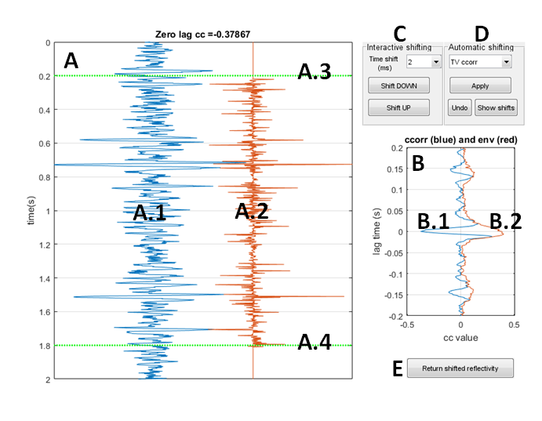

Figure 1: The alignment tool’s main window is shown. Denoted are: A: the trace panel, A.1: The seismic trace $s(t)$, A.2: the reflectivity trace $r(t)$, A.3: top of the correlation gate, A.4: bottom of the correlation gate, B: the correlation panel, B.1 the cross correlation $s⊗r$, B.2: the envelope of $s⊗r$, C: the interactive shifting controls, D: automatic shifting controls, and E: the return reflectivity button.

This tool provides basic facilities to study the alignment of $r$ with $s$ and to apply shifts to $r$ that will hopefully improve the subsequent wavelet estimation. Since most logs lack an overburden, the time coordinates of the reflectivity are likely suspect and hence any shifts are applied to $r$ not $s$.

**The Trace Panel**: Shown here are the seismic trace (A.1) then the reflectivity trace (A.2) as they are presently aligned in time. As the reflectivity is shifted or stretched and squeezed, the reflectivity with change but the seismic trace will not. Also shown are the top and bottom of the cross correlation gate (A.3 and A.4). The value of the cross correlation at zero lag is shown in the title of this panel and the central lags of the cross correlation function are displayed in the correlation panel (B). This correlation information is directly dependent upon the chosen correlation gate and the gate can be easily adjusted by clicking and dragging the green markers (A.3 and A.4).

**The Correlation Panel**: This panel (B) shows the central portion of the cross correlation between $s$ and $r$. At present it is hard wired to show lags times within the range $±0.2$ sec so it is important that the preliminary alignment of $s$ and $r$ be accurate to within this tolerance. Also shown is the Hilbert envelop of the cross correlation which is useful to judge the most significant point. In simple theory, suppose $s\left(t\right)=w\left(t\right)∙r(t)$ (the bullet denotes convolution and $w\left(t\right)$ is the wavelet, then the cross correlation $(s⊗r)(τ)$ can be shown to be equal to $w\left(-τ\right)∙A_{r}\left(τ\right)$ where $A_{r}\left(τ\right)$ is the autocorrelation of the reflectivity and $w\left(-τ\right)$ is the time-reverse wavelet. From this comes the expectation that the centermost lags of cross correlation should look like the time-reverse wavelet and this is the case in Figure 1 because it was built using a perfect stationary synthetic.

**Interactive shifting**: Interactive shifting is accomplished using the controls in panel C and also using right-clicking on the reflectivity in panel A. Interactive shifts can be either bulk shifts to the entire reflectivity or they can be confined to specific time zones. The magnitude of the shift is specified by choosing one of the predefined values in the time-shift popup in panel C. Available shift sizes range from ¼ of the sample rate up to 40 ms. Shifts for values not found in this list can be synthesized from multiple shifts. Once the shift size is chosen, then clicking either “Shift DOWN” or “Shift UP” shifts the reflectivity in the corresponding direction. After the shift the cross correlation will be recomputed and the display refreshed. If no additional action is taken, then the shift will be a bulk (constant) shift applied to the entire reflectivity. To confine the shift to a specific time interval, anchors must be defined at the boundaries of the interval. To define an anchor, right-click on the reflectivity in panel A at the desired anchor time and choose “Drop anchor”. This point is now immovable until the anchor is cleared. Then repeat this action to define a second anchor at the other interval boundary. Defining two anchors in this way segments the reflectivity into three parts.