

**كلية العلوم الحاسوبية والمعلوماتية**

Faculty of CSI

Library Management System (LMS)

*Students:*

|  |  |
| --- | --- |
| Bilal Alswid | 202110827 |
| Fayez Aliyan | 202110336 |
| Anas Aljawabra | 202130057 |

**Khalil Aljawabra 202210541**

**Mohammed Battah 202010117**

**Samar Abu Dayyeh 202010433**

*Supervisor:*

Dr. Alaa Abuthwabeh

*Amman - Jordan*

*2023/2024*

Table of Contents

1.1 Problem Statement and project Scope page 1

1.2 Project Plan and Schedule

2. System Analysis page 2

2.1 Functional Requirements

2.2 Use Case Diagram

3. System Design page 3

3.1 ER-Diagram (if a database will be used)

3.2 User Interface (prototype)

1.1 Problem Statement and Project Scope

The problem statement for this project is to create a Library Management System that can keep track of all the books available in a library, the students or members who have borrowed them, and the due dates for returning the books. The system should also allow users to search for books by title, author, or genre, and generate reports on overdue books, the most popular books, and the number of books borrowed by each member.

The project scope includes the following modules:

Book Module: This module will store information about all the books available in the library, such as the book title, author, genre, publication date, and availability status.

Member Module: This module will store information about the library members, such as their name, contact information, and membership status.

Borrowing Module: This module will keep track of which books have been borrowed, who borrowed them, and when they are due to be returned.

Search Module: This module will allow users to search for books by title, author, or genre.

Report Module: This module will generate reports on overdue books, the most popular books, and the number of books borrowed by each member.Project Plan and Schedule

1.2 Project Plan and Schedule

The project plan and schedule for this project are as follows:

Week 1: Requirements gathering and analysis

Week 2: System design and database schema creation

Week 3: Implementation of the Book Module

Week 4: Implementation of the Member Module

Week 5: Implementation of the Borrowing Module

Week 6: Implementation of the Search Module

Week 7: Implementation of the Report Module

Week 8: Testing and debugging

Week 9: Deployment and user training

Figure 1: Gantt Chart of project

* 1. 2. System Analysis

2.1 Functional Requirements

2.1.1 The system should allow users to add, update, and delete books from the library.

2.1.2 The system should allow users to add, update, and delete library members.

2.1.3 The system should allow users to borrow and return books.

2.1.4 The system should allow users to search for books by title, author, or genre.

2.1.5 The system should generate reports on overdue books, the most popular books, and the number of books borrowed by each member.

2.2 Use Case Diagram

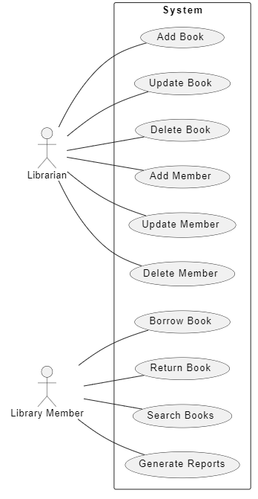

Figure 2: Use Case diagram of system

3. System Design

3.1 ER-Diagram

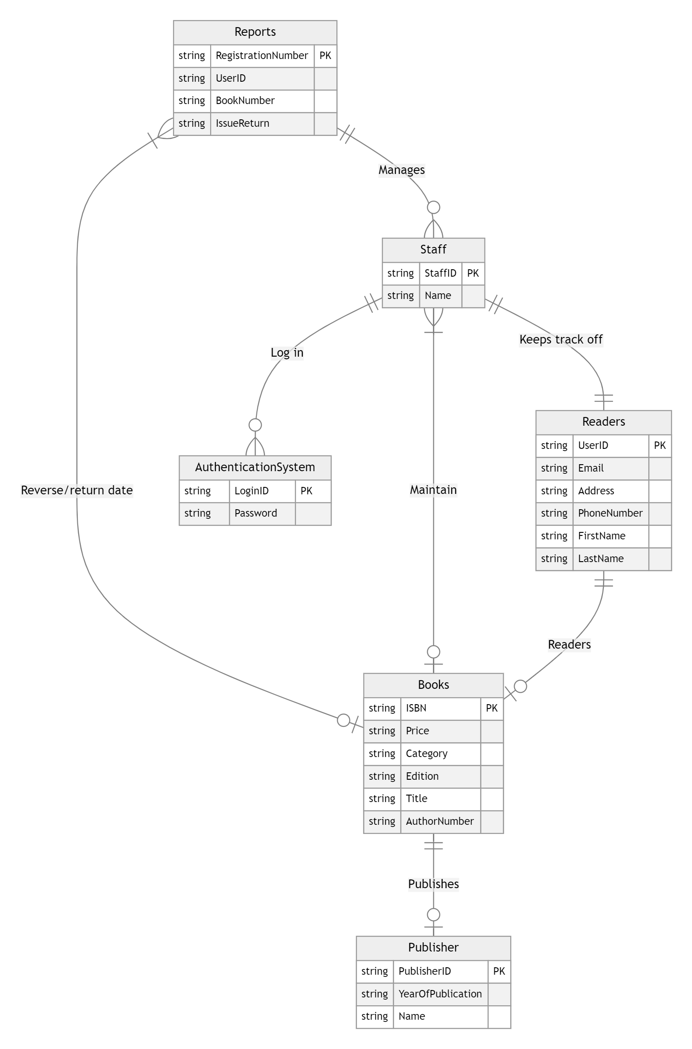

Figure 3: ER diagram of Appointment system

3.2 User Interface (prototype)

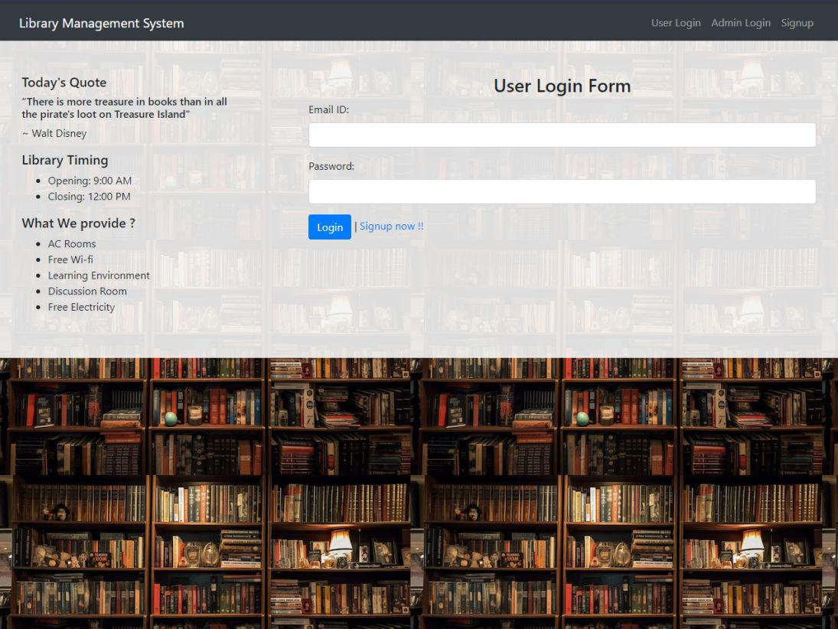

Figure 4: Main UI of Appointment system



Figure 5: Show All UI of system

