

**Report by: Saleh Marmash**

Online Meat Shop

Group Name: G2

Name of students:

Saleh Marmash 1193300 (Manager)

Wael Ziada 1191085 (Developer)

Mohammad AL-Halhuli 1191413 (Architecture)

Ahmad Abu Masood 1192647 (Tester)

Instructor: Prof.Adel Al-Taweel

1.7-Project management strategy (By Saleh):

We’ve been doing a meeting every week at Thursday at 5:00pm but then we did a group to decide which time is the best to meet since we needed more time to get done with the things.

I (Project Manager) was leading most of the tasks, discussing them with each member, sometimes (rarely) I was giving every member a task to do (like in phase 4), and then we were discussing them and approving them by voting, I’ve used Agile model since it’s a small project and we needed to make it user-friendless design.

- Contribution by each group member to the project (By Saleh):

|  |  |  |  |  |
| --- | --- | --- | --- | --- |
| **Task (GROUP WORK TASKS)** | **Leaded by** | **Contributed by** | **Drawn/**  **written by** | **Final edit by** |
| **User & System Requirements** | **Saleh** | **everyone** | **Saleh** | **Saleh** |
| **Effort/Time estimation** | **Mohammad** | **everyone** | **Mohammad** | **Mohammad** |
| **Actors/Analysis description** | **Mohammad** | **everyone** | **Mohammad** | **Mohammad** |
| **USE-CASE diagram** | **Saleh** | **Saleh,Mohammad** | **Saleh** | **Saleh** |
| **Main ACTIVITY diagram:** | **Saleh** | **everyone** | **Saleh** | **Saleh** |
| **System CLASS Diagrams** | **Saleh** | **Saleh,Mohammad** | **Saleh** | **Saleh** |
| **Design Goals** | **Saleh** | **Saleh,Mohammad** | **Saleh** | **Mohammad** |
| **Component Diagram** | **Wael** | **Wael** | **Wael** | **Wael** |
| **Overall architecture diagram** | **Mohammad** | **Mohammad** | **Mohammad** | **Mohammad** |
| **Deployment diagram** | **Ahmad** | **Ahmad** | **Ahmad** | **Ahmad** |

|  |  |  |  |  |
| --- | --- | --- | --- | --- |
| **Total** | **10** | **25** | **10** | **10** |
| **Saleh Marmash contribution %** | **50.00%** | **28%** | **50.00%** | **40.00%** |
| **Mohammad AL-Halhuli contribution %** | **30.00%** | **32%** | **30.00%** | **40.00%** |
| **Wael Ziada contribution %** | **10.00%** | **20%** | **10.00%** | **10.00%** |
| **Ahmad Abu Masood contribution %** | **10.00%** | **20%** | **10.00%** | **10.00%** |

-The most barrier that had faced me during managing the project is time, since everyone had no time to do anything, I should’ve made some time for our group to breath, the second barrier was leading tasks itself, and reviewing the work and editing most of the work to a final form.

-The project was totally disaster, it was about to fail absolutely, but the last week before final project submission, we were re-working in the project first-steps, improving everything, changing the final edit according to the feedback that you’ve gave us. I think the project is fine now and still needs some low-improvements.

Mohammad:

1. In my view of evaluating the project, I see that it is a successful project because of the ease of the site and its handling. It is possible to enter more than one customer and provide convenience to him and no fraud or fraud will be placed.

It also provides a payment method that suits the user.

1. We entered into a lot of discussions, such as the distribution of roles in the project. The first thing that was discussed was the requirements of the program.

We arranged the requirements, collected them, and tried them,

I also discussed (time estimation) with the team and wrote down the times,

I discussed with the team (actors analysis) and I wrote, and we discussed the use case with my colleague Saleh.

I also made plans (Overall architecture diagram)

The diagram has three layers, one for the graphical user interface and one for the application and infrastructure,

User interface classes are set as components of the application, and we set common technical elements

Categories for infrastructure components.

A couple between two classes means that these cases frequently cooperate.

To make the component diagram less complex, and each component serves one function,

I also wrote and edited the (General design goal).

Ahmad 'QA Tester ' Report :

What I learned from the course and what I done ?

First , I developed my communication and presentation skills because i connected and discussed a lot of things with group partners and Dr.Adel Taweel ,also on this course i learned to working hard under pressure and stress and doing my assignments or tasks in short time and make best performance .

Secondly , I think our project is successfully compared to this stress semester and the short time and pressure , and I learned and I done a lot of things in this course like :

- Write a make order scenario.

- make an use-case and use-case specification.

- draw a sequence diagram.

- draw an activity diagram.

- draw a deployment diagram.

- worked in presentation.

Wael:

I was there in all the meetings held by the group and I was giving my ideas and saying the wrong points in the tasks and helped in drawing some tasks.

2.1-Business description (outline): (Leaded by: Saleh) (Discussed by: everyone)

The Business is an online meat shop, that makes it easier to both customer and employee to reach each other by allowing them to do some features (like ordering for the customer and paying online, and editing products for employee and manager, displaying financial reports, etc..).

2.2-USER and SYSTEM requirements (Leaded by: Saleh)

(The old form was contributed by everyone, the new form is only by Saleh, Mohammad)

USER REQUIRMENTS:

UR.1-Customer shall be able to modify items in his order and confirm the order.

UR.2-Employee shall have the option to accept order.

UR.3-User shall be able to search a product and show the detailed info of available products.

UR.4-Employee and manager shall be able to modify a product from website.

UR.5-Manager shall be able to register employee accounts.

UR.6-Manager shall be able to undo a modify movement that an employee did.

UR.7-Customer shall be able to register account in the website.

UR.8-Manager shall be able to display financial report for any month of any year.

UR.9-Manager shall be able to modify an order of any customer.

UR.10-The user shall learn all system functionalities in less than an hour.

UR.11-System shall be able to serve at least 100 user at the same time.

System Requirements:

UR.1-Customer shall be able to modify items in his order and confirm the order.

SR-1.1-System shall restrict the customer from adding more than 10Kg and not less than 0.5Kg in each product for the order.

SR-1.2-System shall automatically update the product to "Unavailable" at the order if it's deleted by Employee and the customer still didn't confirm the order.

SR-1.3-An option shall be displayed for the customer before the confirmation weather to pay online or cash if he's registered.

UR.2-Employee shall have the option to accept order.

SR-2.1-System shall print total price required before accepting order (and if it's paid online or cash).

SR-2.2-Employee can't accept if the time is invalid (when the store is closed).

UR.3-User shall be able to search a product and show the detailed info of available products.

SR-3.1-Customer may search as many products as he wants.

SR-3.2-System shall display products if the search bar contains any sequence of words of a product.

UR.4-Employee and manager can add or edit or delete a product from website

SR-4.1-System shall not accept more than 1000Kg and less than 10Kg for each product added.

SR-4.2-A message shall be sent to manager for whom added or edited or deleted the product.

UR6.Manager shall be able to undo an add/edit/delete movement that an employee did.

SR-6.1-Manager shall be able to display all the details of each add/edit/delete movement on the system.

UR.7-Customer shall be able to register account in the webpage.

SR-7.1-Customer registration info shall be: username, password, a photo from card id, placement, phone number, and E-mail.

SR-7.2-A message shall be sent to the manager about register-details.

SR-7.3-manager shall be able to choose to accept the registration or reject the customer.

UR.8-Manager shall be able to display financial report for any month of any year.

SR-8.1-financial reports shall be automatically deleted after 5 years of release.

SR-8.2-financial reports shall include employee salaries.

SR-8.3-financial reports shall include total sales of each product.

2.3-SCENARIOS:

By: Saleh Marmash:

**Registration Scenario.**

Normal Scenario:

The customer clicks "register as a member" in the meat shop and then fill his info in the register form. The System validate the info written, the system sends info to the manager making him choose whether to accept or reject the info, the manager chooses to accept the registration, a user of type Customer will be created in the system.

Alternative scenario:

The manager clicks "register an employee" in the meat shop, and then fill his info in the registration form.

The System validates the registration info and accept the registration since it was valid info.

A user account of type employee will be created in the system.

Error scenario:

The customer clicks "register as a member" in the meat shop and fill a wrong and not valid info such as: a phone number that is only written as letters not numbers, or an email that already exists.

The system validates it as a valid info (while it's invalid) and send a message to the manager weather to accept or reject info, and manager accepts the registration info.

By: Ahmad Abu Masood:

Customer - make order scenario

Normal scenario :

Ahmad is access the website of meat shop then he login into his account . View the available items , he want 2 kg of sheep meat . Ahmad select sheep meat then enter the quantity 1-kilo . he want the order in 12 pm then add his payment method , he decided to pay by his VISA , enter his personal information , then he submit order .

Alternative scenario:

Mohammad is access the website of meat shop , stay as a guest then search about kind of meat "Steak" but he didn’t found it. Therefore, he call the shop to ask about Steak , They have Steak but The shop Employees forgot to put it on the site, so Mohammad ordered by phone not by website.

Error scenario:

Ali is open his account in meat shop .Check for Sheep meat , he want 10 kg of sheep meat . Ali select sheep meat then enter the quantity 6-kilo . he want the order in 6 pm then add his payment method but when he submit an error is displayed that this quantity of this type is not available .

By: Wael Ziada:

Normal - login use-case

Wael entered the meat shop page, then went to the login page, entered his information (username and password), then clicked on login. then displayed a message you have been successfully logged in.

Alternative - login use-case

Wael entered the meat store page, he did not have an account, so he logged in as a guest then displayed a message You can order meat, but the payment must be credit.

Error - login use-case

Wael entered the meat shop page, then went to the login page, entered his information (username and password), then clicked on login. then displayed an error message Invalid username or password.

By: Mohammad AL-Halhuli:

Modify Product (Add, remove, update in information)-scenario

Normal:

The employee / manager enters the site and logs into the account. He wants to introduce a new type of meat. Go to the meat page. Click the add button. A special page is presented to him to add, then he puts the information about the type of meat such as the name of the meat, its price and quantity, and then confirms the listing for display to customers.

Alternative:

The employee / manager enters the site and enters the account. He wants to adjust the price of meat. Goes to the meat page, clicks on the row inside the table that contains information about the meat, then on the edit button, the site goes to a special interface in the meat modification, the information appears in text fields as it is, and then chooses the item to be modified, then sets the price, then Confirm the modification.

Alternative:

The employee/manager enters the site and logs into the account after login, he wants to delete an item, he goes to the meat page and then chooses the row within the table by clicking on it and then on the delete button of the item he wants to delete, then confirms the deletion.

Error:

The employee / manager enters the site and enters the account after logging in, he wants to update the name of the type of meat, he goes to the meat page of the meat, then he chooses the meat that he wants to update from then to edit the page, he wants to update the name of the type, but when he updates it, the Displays an error because there is also an element with the same name, now the weft type is (unique) within the databases.

2.4- Effort/Time estimation calculation: (Leaded by: Mohammad AL-Halhuli)

(**Contributed by: everyone)**

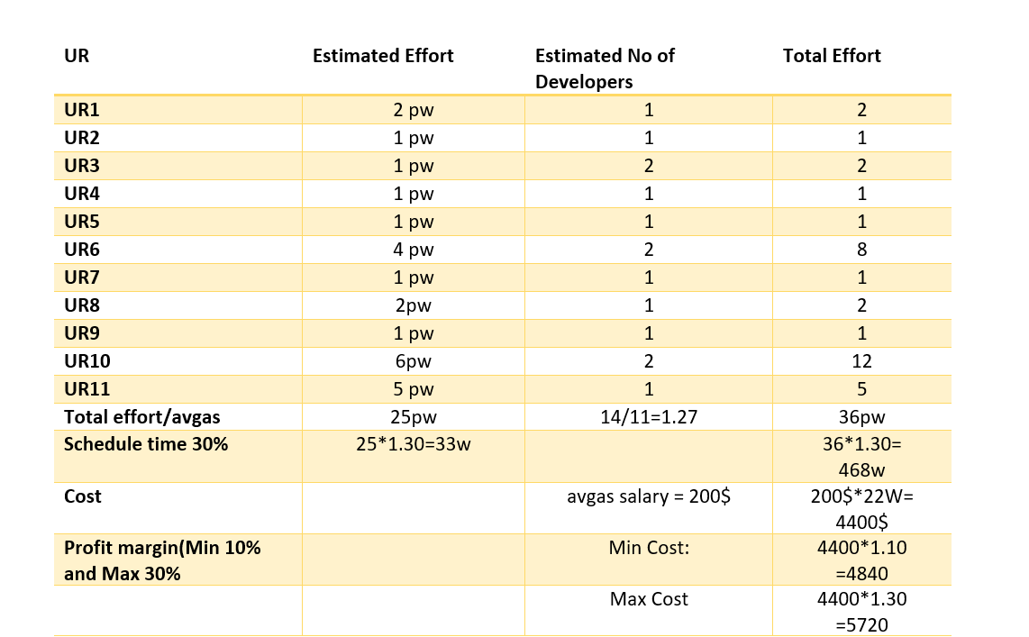

**We have 2 developers.**

If the work is divided in half between the two, we can finish the project within 19 weeks as the following equation displays UR1+UR4+UR5=2W , UR3 =1W , UR2+UR7=1W, UR6=4W UR10=6W, UR11+UR8+UR9=5W , to sum things up, we can finish the project in 19 week, multiplying time with 1.30 will give us a total of 25w. Instead of 33 weeks.

2.5- ACTORS analysis and their description (Leaded by: Mohammad AL-Halhuli)

(**Contributed by: everyone)**

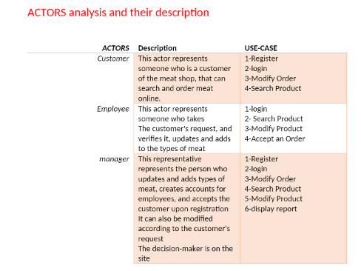

2.6-USE-CASE diagram (Leaded by: Saleh) Contributed by (Saleh, Mohammad) (for the new USE-CASE diagram) (The old one was by Ahmad Abo Masoud)

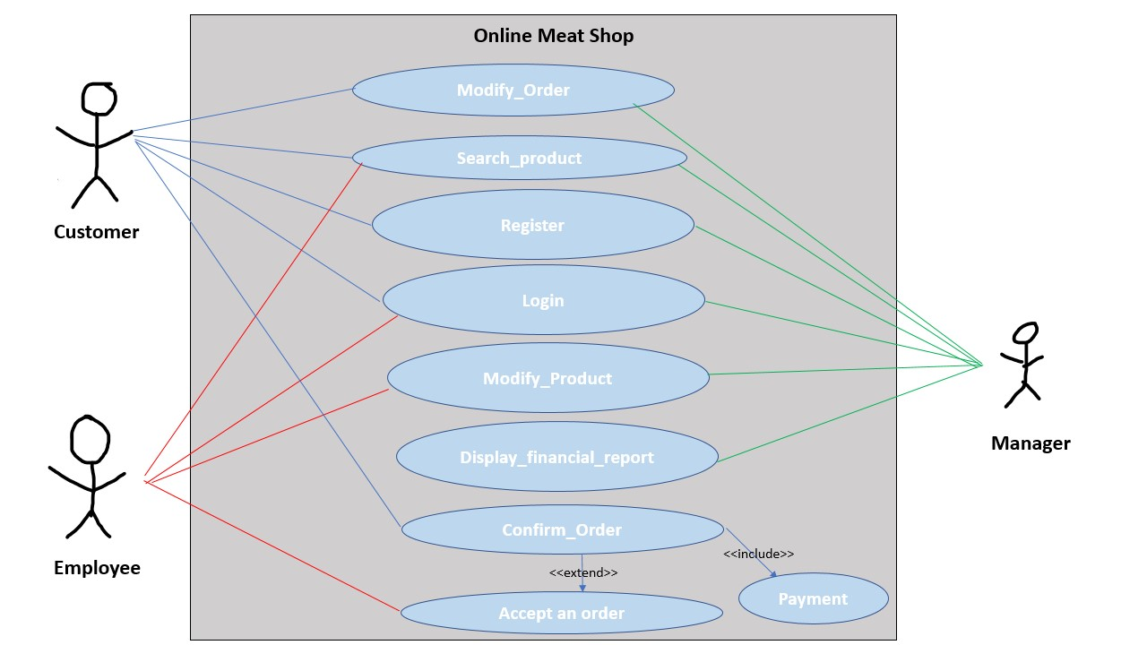

2.7- Detailed description of key USE-CASES:

By: Saleh Marmash:

|  |  |
| --- | --- |
| **use case name** | **Registering** |
| **actors** | **Customer/Manager** |
| **description** | **Customer/Manager registers a user account in the meat shop and the system , filling required information in the form and system saves all user's information into the database.** |
| **precondition** | **Customer opens the meat shop website at a web browser.** |
| **post condition** | **A new user with all its information is saved into the meat shop database.** |
| **basic flow of actions** | **1-The Customer clicks register button in the meat shop website.**  **2-The System display the registration form to let the Customer fill all his information in.**  **3-The Customer fill all the required fields (PhoneNo, Email, username, Password, placement) at the form and click "Save" button.**  **4-The System validates if the info filled as valid/invalid info.**  **5-The System asks the Customer to re-enter required invalid info only if the customer had invalid info.**  **6-The System sends the manager an E-mail message weather to accept or reject customer's info only if the info is valid.**  **7-The Manager weather click accept or click reject and send an E-mail message to the customer weather he's accepted or rejected with the reason of rejection.**  **8-A new user of type Customer is created in the database only if the manager accepted the customer.** |
| **Alternative flow of actions:** | **1-Manager logs into the meat shop website.**  **2-System show "Register an employee button".**  **3-Manager clicks on "Register an employee button".**  **4-The system shows the registration form allowing the manager to fill employee's info in.**  **5-The Manager fills the required information about the employee (PhoneNo, Email, username, Password, Salary) and click confirm.**  **6- the system validates the information sent by the manager.**  **7- the system asks the manager to re-enter info only if the info was invalid.**  **8-A new user of type Employee is created in the database only if the information was valid.** |
| **Error flow of actions:** | **1-The Customer clicks register button in the meat shop website.**  **2-The System display the registration form to let the Customer fill all his information in.**  **3-The Customer fill all the required fields (PhoneNo, Email, username, Password, placement) at the form and click "Save" button.**  **4-The System validates the info filled as valid info while it’s invalid info.**  **5-The System sends the manager an E-mail message weather to accept or reject customer's info.**  **6-The Manager clicks accept to the data sent by customer** |

By: Ahmad Abu Masood:

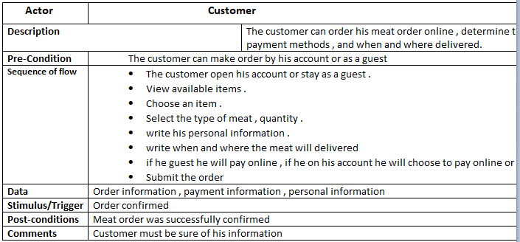

By: Wael Ziada:

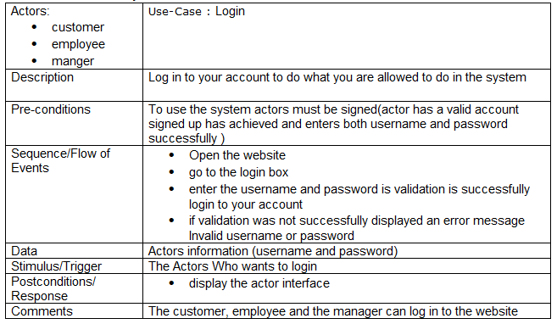

By: Mohammad AL-Halhuli:  
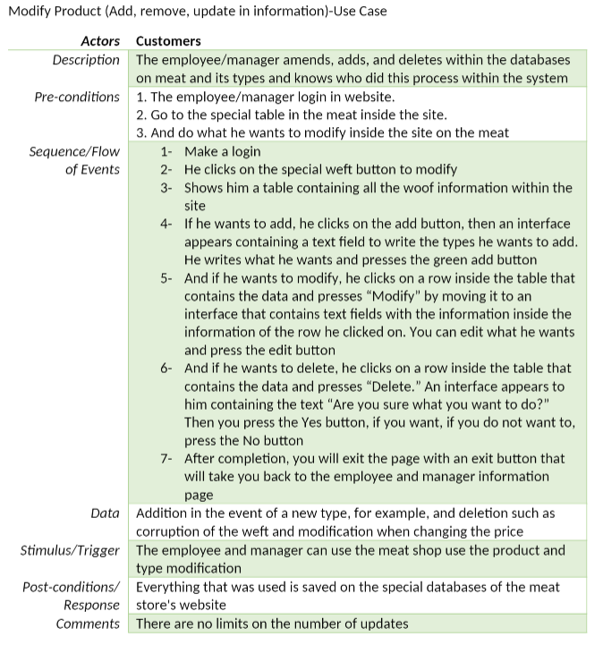

2.8- Main ACTIVITY diagram (Leaded By: Saleh) (Contributed by: everyone)

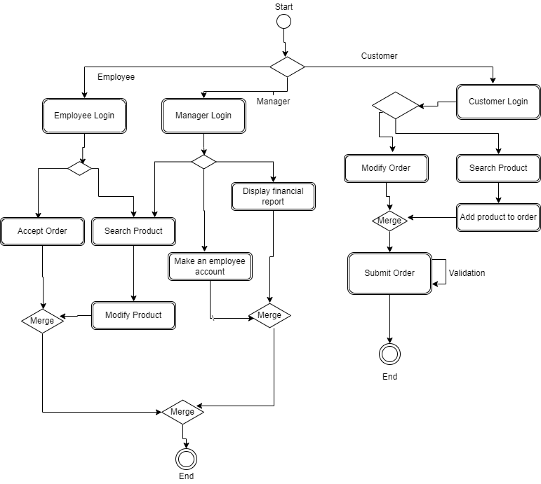

2.9- Instance Activity diagrams:

By: Saleh Marmash:

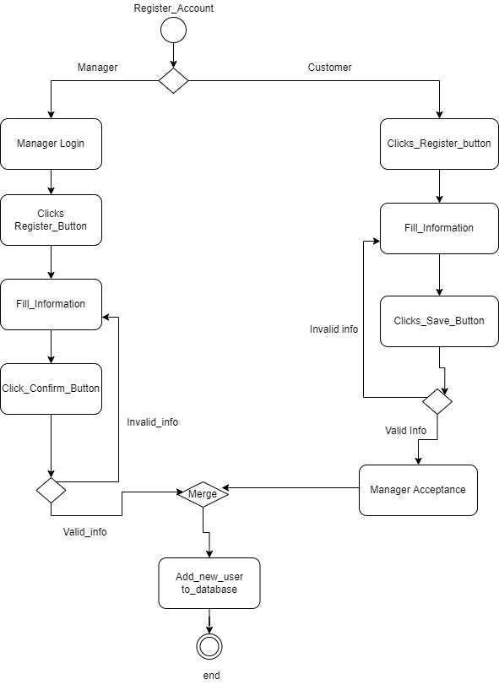

By: Ahmad Abu Masood:

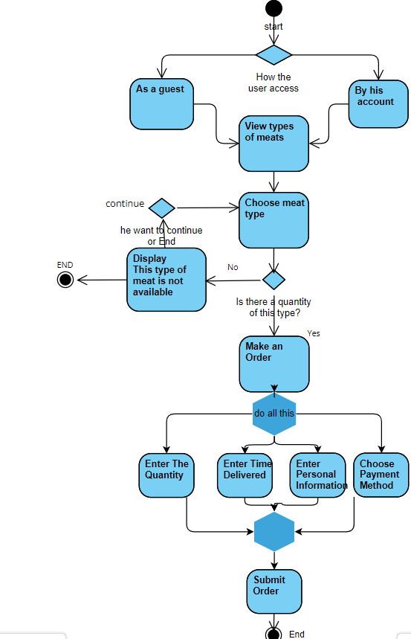

By: Wael Ziada:

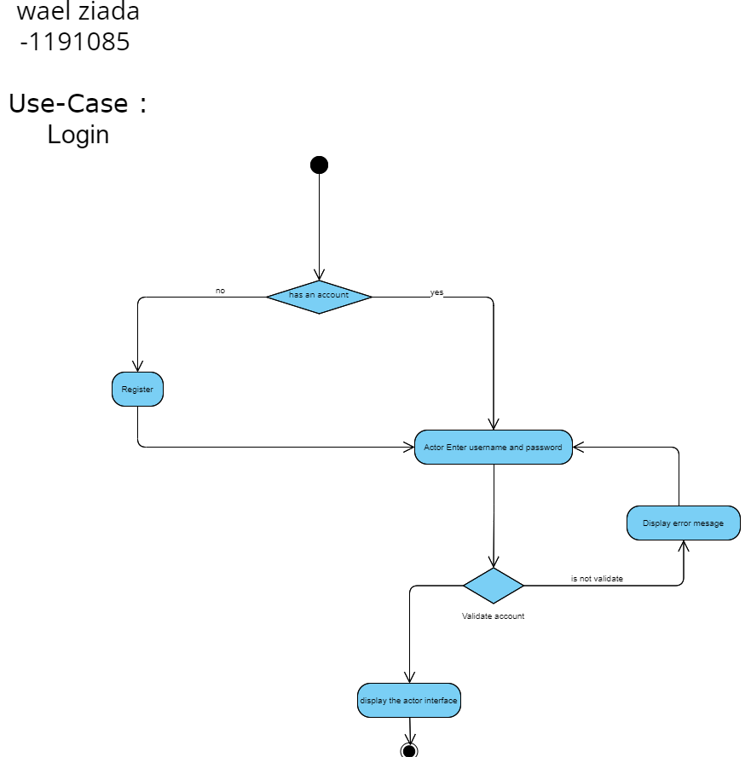

By: Mohammad AL-Halhuli:

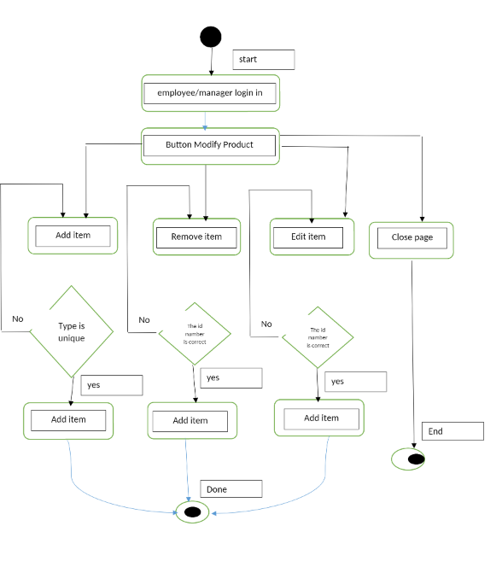

3.1-System CLASS Diagrams: BOTH:

Analysis class model (Leaded by: Saleh) (Contributed by: Saleh):

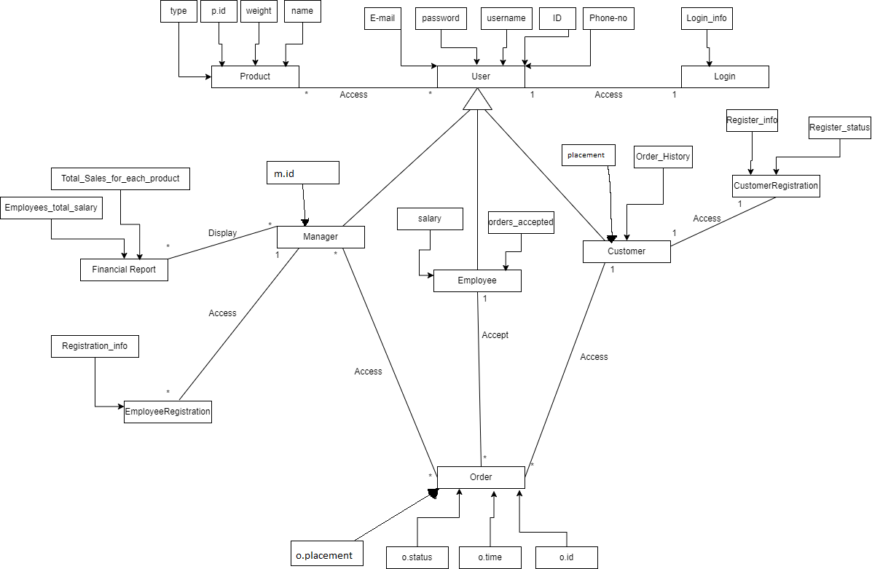

Detailed class model (Leaded by: Saleh) (Contributed by: Saleh, Mohammad):

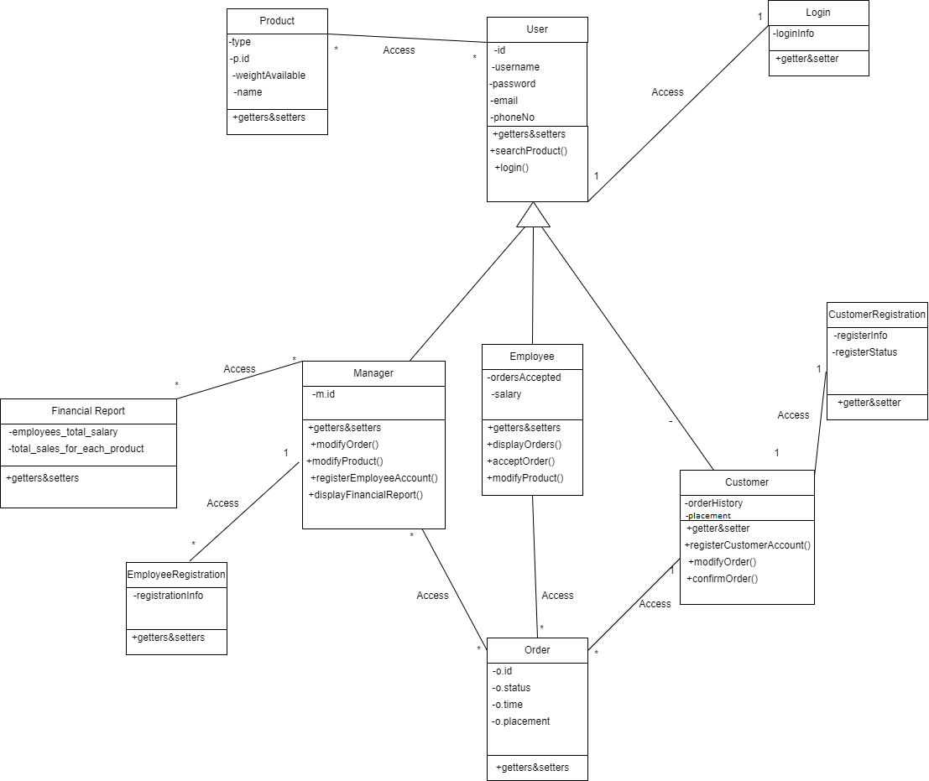

3.2-Sequence Diagrams:

By: Saleh Marmash:

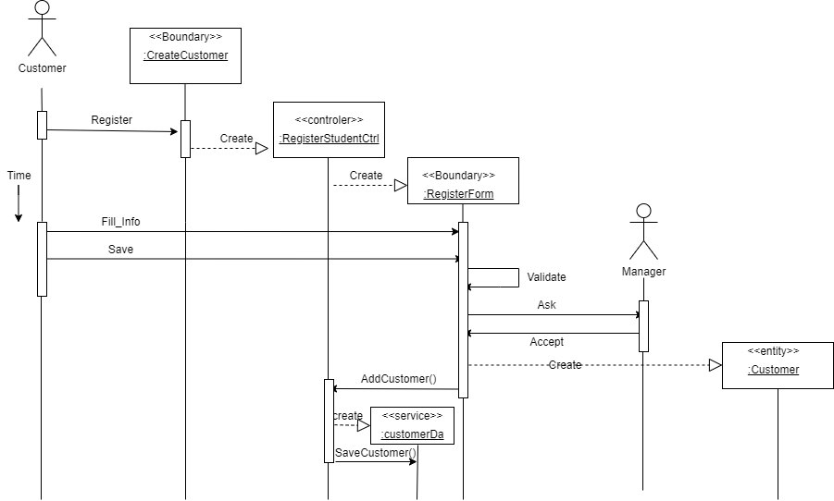

By: Ahmad Abu Masood:

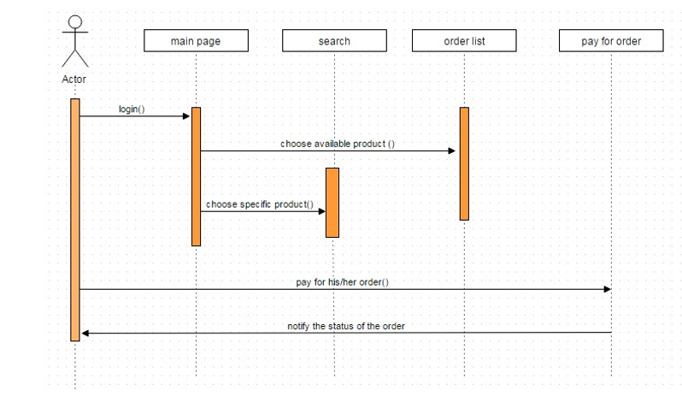

By: Wael Ziada:

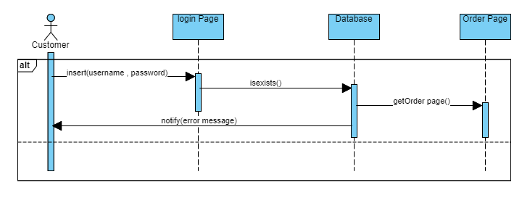

By: Mohammad AL-Halhuli:

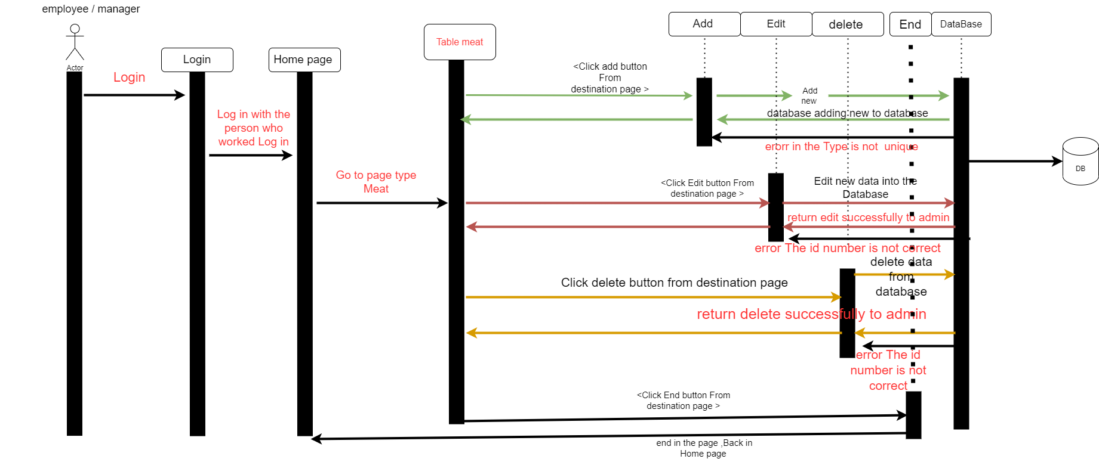

4.1-Description of chosen Design Goals (Leaded by: Saleh) (Contributed by: Saleh, Mohammad):

A- High cohesion: The system must have high cohesion so it must cooperate to do one function to make the component schema less complex, components perform logically related tasks, so they may use the same function in certain places, using the same data.

B- Low coupling: Couples between two classes mean that these issues frequently cooperate. Customer categories, meat and order list frequently cooperate which means they should be in the same domain class, so we grouped these classes into the same component (order database) and deals with it simply.

C- User-Friendliness: System should be easy to use and fast to learn, both customer and employee don't have to waste their time learning about the system

4.2-Component Diagram (Leaded by: Wael Ziada)

(Contributed by: Wael Ziada)

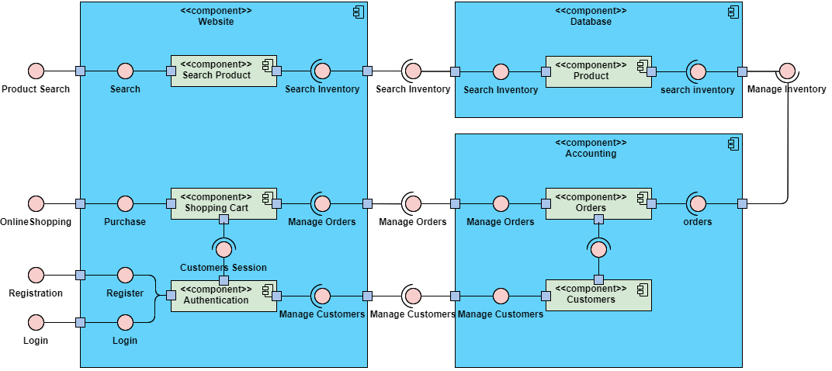

4.2-Component Diagram of your system components (Leaded by: Wael Ziada) (Contributed by: Wael Ziada)

4.3-Overall architecture diagram (Leaded by: Mohammad AL-Halhuli)

(Contributed by: Mohammad AL-Halhuli)

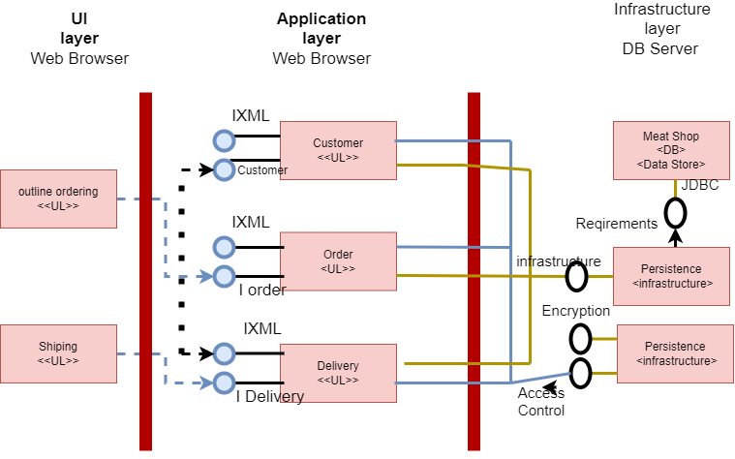

4.4-Deployment diagram (Leaded by: Ahmad Abu Masood)

(Contributed by: Ahmad Abu Masood)

