**Task 4.1 (by Saleh)**

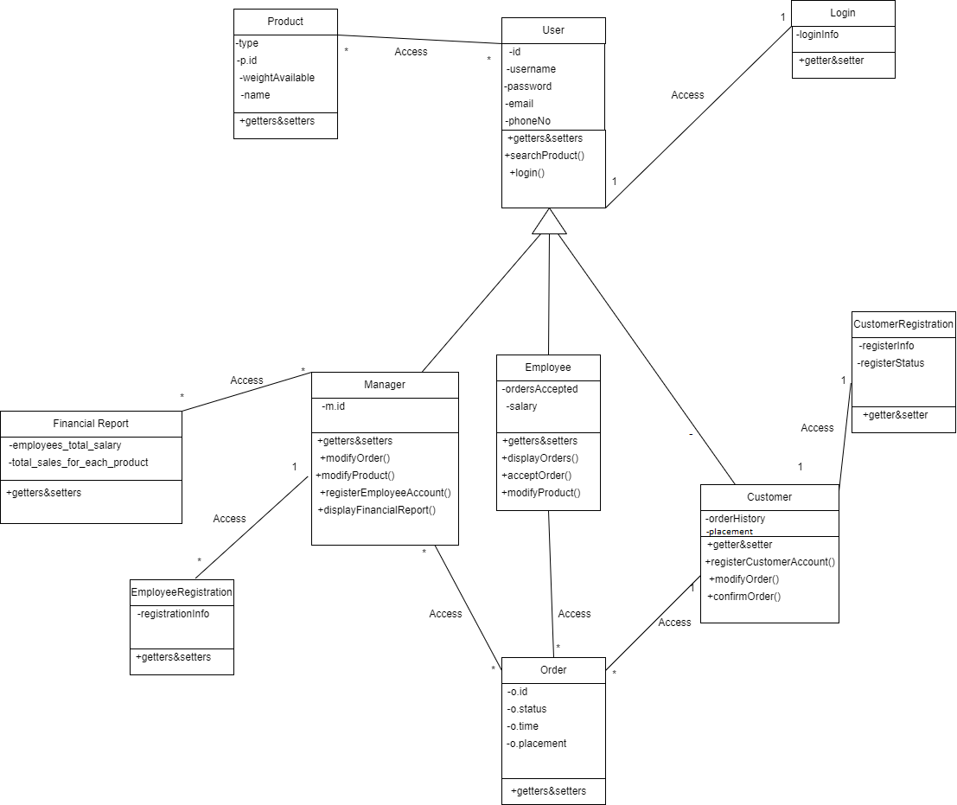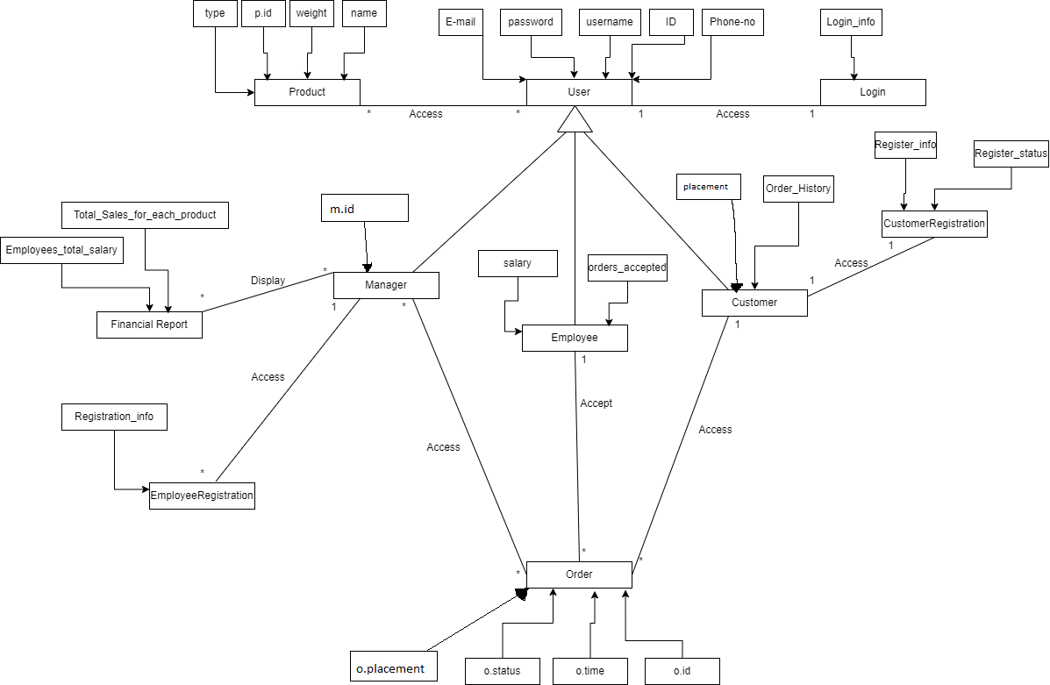

**Task 4.2**

**1-saleh**

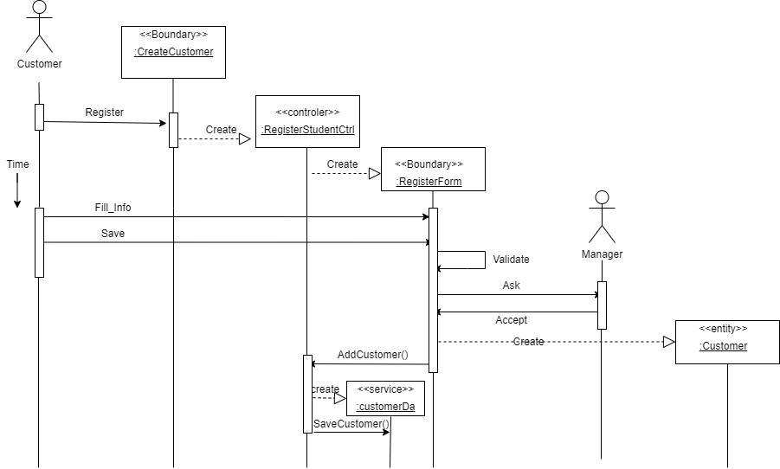

2-Mohammad

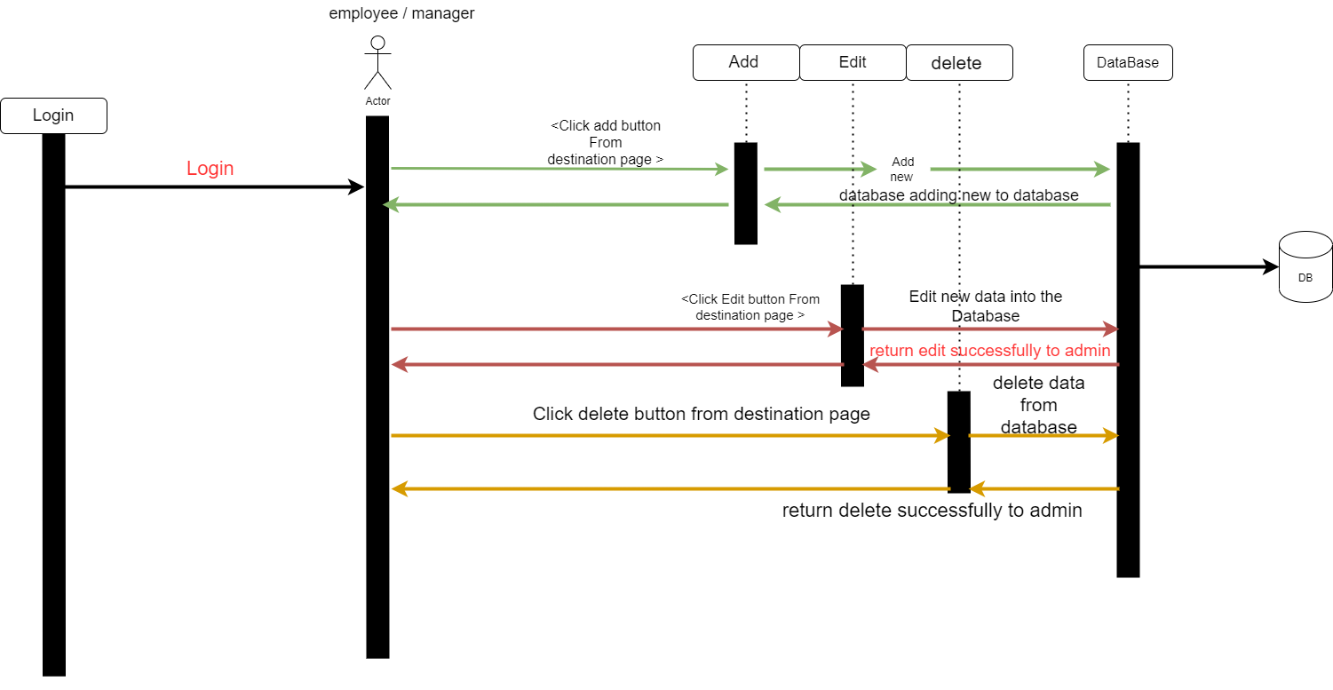

3-Ahmad

4-Weal

**Task 4.3**

**Task 4.5**

**Task 4.6**