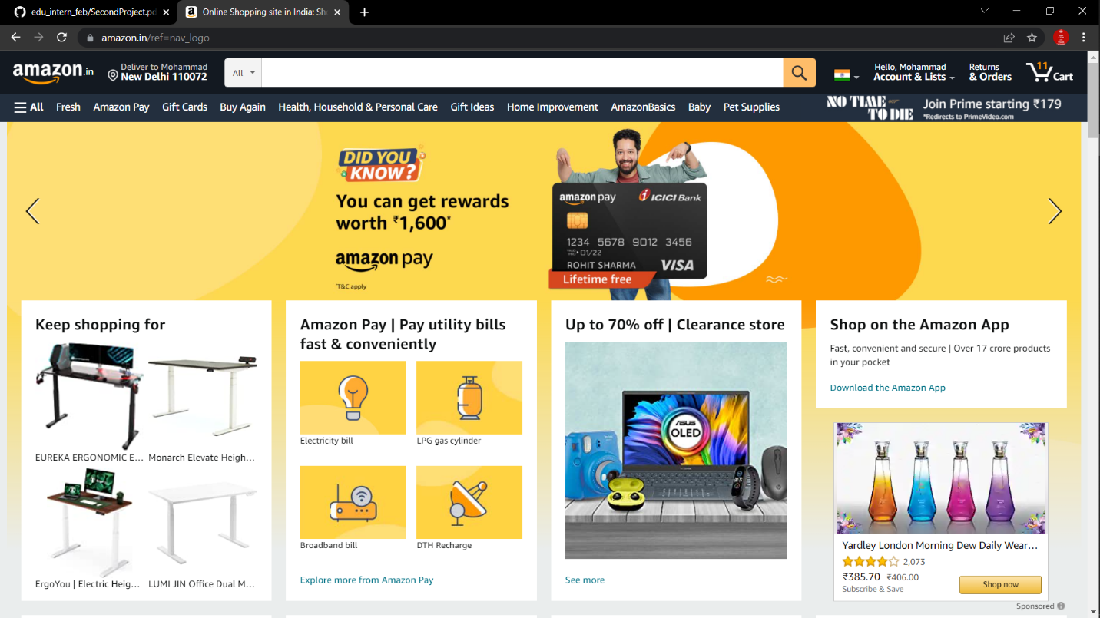

***Project Name: Amazon***

Mohammad kaif

Edureka Intern

**Overview**

Amazon, is an international online shopping website with variety of products available online which make shopping easy and save time.

Its also have amazon prime membership option which give additional benefits to the customers. Like early delivery, access to amazon prime movies and many more.

**Goals**

1. Login and logout page
2. Home page
3. Products details
4. Membership page
5. Filter option
6. Cart page
7. Payment and checkout page

**History**

As we all want to save our time and want more option in shopping ,Jeff Bezos came up with the idea of amazon. It became so much popular today that every person knows about it and people used to of shopping on it.

Earlier amazon is meant to sell books but people also want market products on it. So, amazon is not selling every market products today.

Technologies used in Amazon

Front-End:

1. Html
2. Css
3. Bootstrap
4. React

Dynamics:

1. Javascript
2. Ci/Cd with aws
3. Login and Logout(oauth and jwt)

Database:

1. MongoDB
2. Json Data

Code compilers:

1. Visual studio code
2. GIt bash
3. Git Hub
4. Nodejs

k